DESIGN AND IMPLEMENTATION OF A WEB-BASED SCHOOL MANAGEMENT SYSTEM WITH AUTOMATED RESULT GRADING AND PARENT COMMUNICATION
PROJECT REPORT
BY
IGOCHE, FRANCIS
CS/2022/1349
SUBMITTED TO
THE DEPARTMENT OF COMPUTER SCIENCE
FACULTY OF NATURAL SCIENCES
CARITAS UNIVERSITY, AMORJI-NIKE, ENUGU
IN PARTIAL FULFILMENT OF THE REQUIREMENTS FOR THE AWARD OF
BACHELOR OF SCIENCE (B.SC) DEGREE IN COMPUTER SCIENCE
AUGUST, 2026

DECLARATION
I, IGOCHE, FRANCIS, with registration number CS/2022/1349, hereby declare that this project titled "Design and Implementation of a Web-Based School Management System with Automated Result Grading and Parent Communication" is my original research work carried out under the supervision of Mr. Ugwu Ejike of the Department of Computer Science, Caritas University, Amorji-Nike, Enugu. The work reported herein has not been presented, in whole or in part, to any institution for the award of any other degree or qualification, and all sources consulted have been duly acknowledged.
________________________________ ________________________
Igoche, Francis Date
(CS/2022/1349)

APPROVAL
This is to certify that we have read, examined and found this project titled "Design and Implementation of a Web-Based School Management System with Automated Result Grading and Parent Communication", carried out by IGOCHE, FRANCIS with registration number CS/2022/1349, to be satisfactory and acceptable for the award of a Bachelor of Science (B.Sc) degree in Computer Science of Caritas University, Amorji-Nike, Enugu, and hence we have caused our names and signatures to appear as follows:
________________________________ ________________________

Mr. Ugwu Ejike Date
(Project Supervisor)
________________________________ ________________________

Mr. Ugwu, Ejike Date
(Head of Department)
________________________________ ________________________

Prof. Fergus Onu Date
(External Examiner)

DEDICATION
This project is dedicated to Almighty God, the giver of wisdom and understanding, for His grace and guidance throughout the course of this programme, and to my family, whose patience, encouragement and unfailing support made this academic journey possible.

ACKNOWLEDGEMENTS
I extend my sincere gratitude to God Almighty for the strength, wisdom and good health that sustained me throughout the duration of this project.
My profound appreciation goes to my Project Supervisor, Mr. Ugwu Ejike, whose guidance, patience and constructive criticism shaped this work from conception to completion.
I am equally grateful to the Head of the Department of Computer Science, Mr. Ugwu, Ejike, for his leadership and support throughout the programme. My sincere thanks go likewise to Prof. Arinze Nwaeze, Dr. Henry Nweke and Dr. Ugochukwu Nwankwo, and to all the other lecturers of the Department of Computer Science, Caritas University, for the knowledge imparted to me over the course of my studies.
Finally, I thank my family and friends for their encouragement, understanding and support throughout the period of this project.

ABSTRACT
This work reports on SchoolPro, a web-based school management system developed to bring a secondary school’s core administrative processes — student registration, daily attendance, result computation, fee collection and parent communication — into a single, role-gated dashboard. It analysed the fragmented, largely manual manner in which these records are presently kept, often across separate paper registers and ledgers, and used the findings to design a system in which a signed-in administrator maintains a central student register, marks daily class attendance, records continuous-assessment and examination scores that are converted automatically into WAEC-scale grades, tracks fee collection per student and term, and issues SMS and push broadcasts to parents. The system was designed using the Object-Oriented Analysis and Design Methodology and implemented as a React single-page application, compiled to a single self-contained file and deployed on Netlify.

TABLE OF CONTENTS
Title Page i
Declaration ii
Approval iii
Dedication iv
Acknowledgements v
Abstract vi
Table of Contents vii
CHAPTER ONE: INTRODUCTION 1
1.1 Background of the Study 1
1.2 Statement of the Problem 1
1.3 Aim and Objectives of the Study 1
1.4 Significance of the Study 2
1.5 Scope of the Study 2
1.6 Limitations of the Study 3
CHAPTER TWO: LITERATURE REVIEW 4
2.1 Introduction 4
2.2 School Management Information Systems 4
2.3 Technology Adoption 4
2.4 Automated Grading and Assessment Computation 4
2.5 Parent–School Communication Systems 5
2.6 The Single-Page Application Model 5
2.7 Usable Interface Design 5
2.8 Summary and Research Gap 6
CHAPTER THREE: SYSTEM ANALYSIS AND METHODOLOGY 7
3.1 Data Gathering 7
3.2 Research Methodology and Justification 7
3.3 System Analysis 7
3.3.1 Analysis of the Existing System 7
3.3.2 Analysis of the Proposed System 8
3.4 Justification of the Proposed System 8
CHAPTER FOUR: SYSTEM DESIGN AND IMPLEMENTATION 10
4.1 Design and Specification of the Proposed System 10
4.1.1 Input Design and Specification 10
4.1.2 Output Design and Specification 10
4.1.3 Security Design and Specification 11
4.1.4 Data Design and Specification 11
4.2 System Development Tools and Justification 12
4.3 System Requirements 15
4.3.1 Hardware Requirements 15
4.3.2 Software Requirements 15
4.4 Implementation of the Proposed System 15
CHAPTER FIVE: SUMMARY, CONCLUSION AND RECOMMENDATIONS 17
5.1 Summary 17
5.2 Conclusion 17
5.3 Recommendations 18
REFERENCES 19
APPENDIX A: SOURCE CODE SNIPPETS 20
APPENDIX B: SAMPLE OUTPUTS (SCREENSHOTS) 22

CHAPTER ONE
INTRODUCTION
1.1 Background of the Study
A secondary school’s day-to-day administration depends on several distinct but related records being kept accurately and consistently: who is enrolled and in which class, who was present on a given day, what each student scored in each subject and what grade that score represents, whether a student’s fees are paid up for the term, and how the school communicates routine information to parents. In many Nigerian secondary schools, these records are still kept separately — a paper attendance register, a ledger for fee payments, examination scripts marked and transcribed by hand into a result sheet, and parent contact carried out informally by phone or through printed notes sent home with the student.
Keeping these records apart creates avoidable friction. A class teacher totalling continuous-assessment and examination scores by hand must also look up the WAEC grading scale to convert each total into a letter grade, a repetitive task prone to arithmetic error. A bursar tracking fee payments in a separate ledger has no direct link to the student register, so identifying which students in a class still owe requires manual cross-referencing. A school wishing to reach a specific group of parents — the parents of one class, for instance — has no single list to message against. It was this fragmentation, and the repetitive manual computation it involves, that prompted the development of the system reported in this project.
SchoolPro is proposed as a response to this fragmentation: a single, role-gated, web-based dashboard in which an administrator maintains the student register, records daily attendance, enters assessment scores that are converted automatically into WAEC-scale grades, tracks fee collection per student and term, and issues SMS or push broadcasts to parent groups — five previously separate processes consolidated into one system.
1.2 Statement of the Problem
Secondary school administration in the present, largely manual arrangement lacks a single system in which student records, attendance, results, fees and parent communication are held and acted upon together. Because these processes are kept separately, a school cannot readily answer a simple question — which students in a given class are both behind on fees and absent above a certain rate, for instance — without manually cross-referencing multiple registers and ledgers. Result computation in particular is repetitive and error-prone when scores are converted to grades by hand against a fixed scale. This absence of a unified, administrator-facing system gives rise to slower record-keeping, a higher risk of computational error in grading, and no efficient means of reaching parents as a group.
1.3 Aim and Objectives of the Study
The aim of this project is to design and implement a web-based school management system that consolidates student registration, attendance, automated result grading, fee management and parent communication into a single administrator dashboard. The specific objectives, each aimed at mitigating the problem stated in Section 1.2, are:
1. To design a central student register holding each student’s identifying and contact details, so that a single record of enrolment replaces separate class lists.
2. To implement a daily attendance module in which a class’s attendance is marked and retained as a per-date, per-student record.
3. To implement an automated result-grading engine that converts a continuous-assessment and examination score into a WAEC-scale grade (A1–F9) without manual lookup, together with the associated remark.
4. To implement a fee-management view that records amounts due and paid per student and term, and surfaces which students are currently owing.
5. To implement a parent-communication module through which a broadcast message can be composed and issued, by SMS or push notification, to a named parent group.
1.4 Significance of the Study
When completed, this work contributes a practical, consolidated administrative tool for a secondary school. By bringing five previously separate processes into one dashboard, it removes much of the manual cross-referencing and repetitive computation the existing arrangement requires. The following points further underline the importance of the study:
• Accuracy is improved, because the conversion of a score to a WAEC grade is computed by a fixed function rather than looked up by hand.
• Efficiency is increased, because a single dashboard replaces separate registers, ledgers and contact lists for related information.
• Reach is improved, because a broadcast can be issued to an entire parent group at once rather than contacted individually.
• The work also serves as a reference for students and developers interested in role-gated administrative dashboards, automated grade computation, and single-page application design delivered without heavy server infrastructure.
1.5 Scope of the Study
This project covers the design, implementation and evaluation of a web-based school management system that runs in a standard web browser. Its scope covers administrator sign-in; a student register with add and edit operations; a daily, per-class attendance record; a result-entry and automated WAEC-scale grading view; a fee-management view recording amounts due and paid per student and term; and a parent-communication view for composing and issuing broadcasts by SMS or push notification to a named group. The system is intended for use by the administrative staff of a secondary school.
The study is bounded as follows. It concerns the recording and presentation of the five processes named above within a single administrator-facing application, and does not undertake the actual transmission of an SMS or push message to a real telecommunications gateway, nor the processing of an actual fee payment. Its content is held in structured collections within the browser to demonstrate every view at realistic scale; connection to a central server, a database and a live messaging or payment gateway is identified in Section 5.3 as further work rather than undertaken here.
1.6 Limitations of the Study
Several factors constrained the execution of this work and should be borne in mind when interpreting its results.
First, the system is a functional prototype whose content is held in in-browser collections rather than in a server-side store. The seeded student register, attendance, results, fees and broadcast log are realistic and stable across a session, but a change made during a session — a student added, attendance marked, a broadcast composed — is not written to a persistent store and does not survive a page reload, because no server or database is provisioned in this build. The introduction of a persistence layer is identified in Section 5.3 as the first priority for further work.
Second, administrator sign-in in the present build is performed within the browser against a single demonstration credential, and is intended to exercise the access-gated design rather than to secure a real staff account. Per-staff credentials verified on a server against irreversibly hashed values are likewise identified as further work.
Third, the parent-communication module composes and logs a broadcast within the application but does not connect to a real SMS gateway or push-notification service, and the fee-management view records payment status rather than processing an actual transaction.
Fourth, the study was carried out within a single academic session alongside coursework and examinations, which constrained the duration of the evaluation exercise.
CHAPTER TWO
LITERATURE REVIEW
2.1 Introduction
This chapter reviews the body of literature relevant to the design of a web-based school management system. It begins by framing such a system within the broader theory of information systems and technology adoption, then turns to the specific technical concerns the present system addresses: automated grading, parent–school communication, the single-page application model and usable interface design. Each body of work is related to the present project, with its contribution and its limitation identified, and the chapter concludes by stating the gap that the study addresses.
2.2 School Management Information Systems
The general practice of using a computer-based system to collect, store and coordinate the records an institution depends upon is treated in the information-systems literature. Laudon and Laudon (2020) describe an information system as a set of interrelated components that gather, process, store and distribute information to support coordination within an organisation. This framing positions the present project as an information system in the fullest sense: SchoolPro exists to coordinate five related administrative processes — registration, attendance, results, fees and parent communication — that a school otherwise keeps apart. The limitation of so general a framework, for a system builder, is that it establishes the purpose of such a system without prescribing its concrete structure; the present study supplies that structure for the specific case of a Nigerian secondary school.
2.3 Technology Adoption
Whether an administrative staff member actually uses a new system, rather than continuing to rely on the paper process it is meant to replace, depends on its acceptance. The Technology Acceptance Model, formulated by Davis (1989), holds that adoption is governed chiefly by perceived usefulness and perceived ease of use. This bears directly on the present work: a school administrator will adopt SchoolPro only if it is clearly faster than the manual register or ledger it replaces, and only if operating it requires no special training. These considerations informed the consolidation of five processes into a single dashboard reachable from one sign-in, and the immediate, no-lookup conversion of a score into a grade discussed in Section 2.4.
2.4 Automated Grading and Assessment Computation
A central concern of the present system is the conversion of a continuous-assessment and examination score into a standard letter grade without manual lookup. The West African Examinations Council’s grading scale (WAEC, 2023) defines a fixed mapping from a numeric score to a letter grade — A1 through F9 — and an associated remark such as “Excellent” or “Credit”. This scale is well established in Nigerian secondary education and is the scale the present system’s grading engine implements directly, converting a total score to its grade and remark deterministically rather than by manual reference to a printed table. Ifenthaler and Widanapathirana (2014), writing on the wider use of computed indicators to represent student performance, note that an automatically derived grade is only as trustworthy as the fixed rule that produces it, and that the rule should therefore be simple, transparent and directly inspectable — a principle the present system satisfies by implementing the WAEC scale as a single, readable function rather than a more elaborate or opaque scoring model.
2.5 Parent–School Communication Systems
The practice of using bulk SMS and push notification to keep parents informed is well established in the school-management software literature. Olumide and Adebayo (2019), reviewing school management systems deployed in Nigerian secondary schools, report that SMS-based parent notification is among the most consistently valued features of such systems, because it reaches a parent directly without depending on the student to relay a printed note. The present system’s Parent Communications module applies this finding directly, allowing a broadcast to be composed once and addressed to a named parent group — the parents of a specific class, for instance — by SMS or push channel. The honest limitation, relative to a production deployment, is that the present build composes and logs the broadcast within the application rather than dispatching it through a real telecommunications gateway, a distinction discussed further in Section 4.1.3.
2.6 The Single-Page Application Model
The architectural model of the present system is that of the single-page application, in which one document is loaded once and its several views are switched and re-rendered on the client without further full-page loads. Mikowski and Powell (2013) set out this model, in which the browser holds the application’s state and updates the interface in response to user action. The present dashboard is a direct instance: its student register, attendance, results, fees and communications views are switched entirely on the client, built here using React — a component-based library for constructing exactly this kind of interface, described by Banks and Porcello (2020) as organising an application into small, composable pieces of interface state, each re-rendering independently as its underlying data changes. This maps directly onto the present system’s structure, in which the student register, the attendance grid and the results table are each such a component, re-rendering as records are added, marked or graded.
2.7 Usable Interface Design
Because the intended user is administrative staff working quickly across five different record types in one sitting, the usability of the interface is a genuine design concern. Nielsen (1994) sets out heuristics for user-interface design — among them visibility of system status and the recognition of information rather than its recall — which informed the dashboard’s summary cards (total students, pending fees, class average) that surface the state of each record type at a glance, before the administrator drills into any one of them. Shneiderman and Plaisant (2010) add the influential sequence of overview first, then detail on demand, which maps onto the present interface: the dashboard gives an overview, and each of the five modules — register, attendance, results, fees, communications — is opened only when that specific detail is needed.
2.8 Summary and Research Gap
The literature reviewed establishes that a school system of this kind is properly understood as an information system whose value lies in coordinating previously separate records (Laudon & Laudon, 2020); that it will be adopted only if it is clearly useful and easy to operate (Davis, 1989); that automated grade computation should implement an established, transparent scale rather than an opaque one (WAEC, 2023; Ifenthaler & Widanapathirana, 2014); that SMS-based parent communication is a consistently valued feature in this context (Olumide & Adebayo, 2019); that a single-page, component-based architecture is a legitimate delivery model at this scale (Mikowski & Powell, 2013; Banks & Porcello, 2020); and that the interface should be built against established usability heuristics (Nielsen, 1994; Shneiderman & Plaisant, 2010).
Two gaps are nonetheless evident. First, much of the published school-management-system literature addresses large, server-backed, commercially deployed platforms, and offers little guidance for a lightweight, single-file, client-side system built and defended by a single undergraduate. Second, few of the systems reviewed in the Nigerian context (Olumide & Adebayo, 2019) combine automated WAEC-scale grading, attendance, fee tracking and parent communication within one consolidated, role-gated dashboard rather than as separate modules or separate products. This study addresses both gaps by designing, implementing and evaluating such a system, honestly scoped to what a client-side prototype provides and clear about the server-side and gateway integrations a production deployment would require.
CHAPTER THREE
SYSTEM ANALYSIS AND METHODOLOGY
3.1 Data Gathering
The data used to inform the design of this system were gathered through direct observation, informal interview and the study of documentation. Observation of how a secondary school’s administrative records are presently kept revealed the day-to-day practice the system seeks to improve: a paper attendance register marked by hand each day, examination scores totalled and converted to WAEC grades by manual reference to the grading scale, a separate ledger for fee payments, and parent contact carried out informally rather than through a single addressable list. This observation was supplemented by informal conversation about the records a school administrator is expected to maintain and by a review of published literature on school management information systems, automated grading and parent-communication systems, as set out in Chapter Two. Together, these sources established both the problem to be solved and the accepted principles for solving it.
3.2 Research Methodology and Justification
The methodology adopted for this work is the Object-Oriented Analysis and Design Methodology (OOADM). Under this methodology the problem domain is modelled as a set of collaborating objects, each with its own data and behaviour, and the system is designed in terms of the classes of these objects and the interactions between them. OOADM was chosen for three reasons. First, the problem domain maps naturally onto well-defined entities — students, attendance records, results, fee records and broadcasts — each with clear attributes and behaviour, which is precisely the kind of domain OOADM was devised to model. Second, the system was built module by module, adding and refining each of the five processes named in Chapter One in turn, which the object-oriented approach accommodates comfortably. Third, the interface itself is composed of discrete, reusable units — the student row, the attendance cell, the grade badge — that correspond directly to objects, so that an object-oriented design translates directly into the structures of the built system, implemented here as React components. In accordance with this methodology, the Use Case, Sequence and Class diagrams that document the design are presented in Chapter Four under Section 4.2.
3.3 System Analysis
3.3.1 Analysis of the Existing System
The existing system is manual and fragmented in character. Student attendance is marked on a paper register per class per day. Examination and continuous-assessment scores are totalled by hand and converted to a WAEC letter grade by manual reference to the grading scale. Fee payments are recorded in a separate ledger, tracked independently of the student register. Parent contact is carried out informally, by phone call or by a printed note sent home with the student, rather than through any single addressable list. This manner of operation gives rise to a number of drawbacks:
• Slow cross-referencing, since a question spanning two record types — attendance and fee status, for instance — requires consulting two separate registers by hand.
• Computational error risk, since converting a total score to a WAEC grade by manual lookup is repetitive and prone to mistake across a full class list.
• Untracked fee status at a glance, since a ledger recorded independently of the student register does not readily show, for a given class, which students are currently owing.
• Inefficient parent outreach, since reaching a specific group of parents — one class, for example — has no single list to communicate against and is instead conducted parent by parent.
3.3.2 Analysis of the Proposed System
The proposed system, SchoolPro, replaces this fragmented arrangement with a single, role-gated, web-based dashboard. A signed-in administrator maintains a central student register; marks daily, per-class attendance against that same register; enters continuous-assessment and examination scores that the system converts automatically to a WAEC-scale grade and remark; records fee amounts due and paid per student and term, with students currently owing surfaced directly; and composes broadcast messages issued by SMS or push channel to a named parent group. The major features of the proposed system are therefore its central student register, its daily attendance module, its automated grading engine, its fee-management view, and its parent-communication module, all reachable from one administrator dashboard. The chief benefits are faster cross-referencing across previously separate records, elimination of manual grade-conversion error, at-a-glance visibility of fee status, and efficient group-based parent outreach.
3.4 Justification of the Proposed System
The proposed system is justified as the appropriate solution to the problem because it addresses each of the identified drawbacks directly. Slow cross-referencing is reduced because attendance, results and fee status are all held against the same student register within one dashboard rather than in separate documents. Computational error risk is removed because the grading engine converts a score to its WAEC grade by a fixed, tested function rather than by manual lookup. Untracked fee status is remedied because the fee-management view surfaces owing students directly rather than requiring a separate reconciliation against the register. Inefficient parent outreach is addressed because a broadcast can be composed once and addressed to an entire named group. Because every drawback of the existing arrangement is met by a corresponding feature of the proposed system, the proposed system is the well-founded solution to the stated problem. Its delivery as a single client-side application further suits an undergraduate project and a resource-constrained deployment, while leaving a clear path — a server, a database and live gateway integrations — for a production extension.
CHAPTER FOUR
SYSTEM DESIGN AND IMPLEMENTATION
4.1 Design and Specification of the Proposed System
This section describes the principal design processes of the system: the design of its inputs, its outputs, its security and its data. In architectural terms the system is a single-page client-side application: a single document is loaded once into the browser, and its presentation, its behaviour and its working data all reside on the client, which switches between the dashboard, register, attendance, results, fees and communications views and re-renders them in place without further page loads.
4.1.1 Input Design and Specification
The inputs to the system are collected through interface controls presented to the administrator. The principal input is the sign-in form, collecting a username and password. A second input is the student-registration form, through which a student’s name, class, gender, parent phone number and parent e-mail are supplied. A third is the daily attendance grid, in which a present/absent status is set per student for the selected date. A fourth is the result-entry form, which accepts a continuous-assessment score and an examination score per student per subject. A fifth is the fee-record form, recording the amount due and the amount paid per student per term. A sixth is the broadcast-composition form, which collects a target parent group, a channel (SMS or push) and a message body. The input fields of the student-registration form are summarised in Table 4.1.
Input Field | Control Type | Data Collected
Student name | Text box | Full name of the student
Class | Drop-down list | Class the student is enrolled in, e.g. JSS 2A
Gender | Drop-down list | M or F
Parent phone | Text box | Contact number in international format
Parent e-mail | Text box | Contact e-mail address
4.1.2 Output Design and Specification
The outputs of the system are the views it renders in response to administrator action. The principal output is the dashboard, presenting summary cards — total students, pending fees, class average and an SMS-delivery meter — together with a recent student register. A second output is the attendance history, showing marked status per student for a selected date. A third is the auto-graded results table, presenting each student’s continuous-assessment score, examination score, total, computed WAEC grade and remark. A fourth is the fee-collection view, listing amount due, amount paid and outstanding balance per student, with students currently owing highlighted. A fifth is the parent-communications delivery report, listing each broadcast issued, its target group, channel and time. Representative outputs are shown in Appendix B.
4.1.3 Security Design and Specification
The security of the system rests on requiring a successful sign-in before any of the five administrative modules is reached; an unauthenticated visitor sees only the sign-in form and none of the underlying student data. This restriction is enforced at the level of the interface, which renders the dashboard and its modules only after the supplied username and password match the stored administrator credential.
The prototype status of this build is reflected honestly in two respects, each identified in Section 5.3 as a priority for further work. First, sign-in is performed within the browser against a single demonstration credential, so that the access-gated design can be exercised; a production deployment requires a per-staff credential verified on a server against an irreversibly hashed value. Second, the parent-communications module composes and logs a broadcast within the application but does not dispatch it through a real SMS gateway or push-notification service, and the fee-management view records a payment status without processing an actual transaction; both are identified as integration points for further work rather than undertaken here.
4.1.4 Data Design and Specification
The present build does not provision a server-side database. To demonstrate every view at realistic scale, the working data — the student register, attendance, results, fees and the broadcast log — is held in structured collections within the browser, seeded with initial records when the application loads. The logical model is nevertheless designed as a set of well-defined record types, so that migration to a server-hosted store may be effected by substituting the data source without altering the behaviour defined upon it. The student record, which is the central reference of the system, is specified in Table 4.2.
Field | Type | Description
id | String | Unique student identifier, e.g. ST-9001
name | String | Full name of the student
cls | String | Class the student is enrolled in
gender | String | M or F
phone | String | Parent contact phone number
email | String | Parent contact e-mail address
The remaining collections follow the same pattern. An attendance record is keyed by student and date and holds a present/absent status. A result record is keyed by student and subject and holds a continuous-assessment score, an examination score and the total, from which the grading engine derives the WAEC grade and remark. A fee record is keyed by student and term and holds an amount due and an amount paid. A broadcast record holds an identifier, a target group, a channel, a message body and a timestamp. Each collection is seeded with realistic demonstration records and is read and re-rendered directly by the views that present it.
4.2 System Development Tools and Justification
The system was developed as a client-side single-page application built with React, compiled to a self-contained static bundle. The reasons for each choice are given below.
React provides the component model in which the interface is built. Following the object-oriented design of Chapter Three, the dashboard, the student register, the attendance grid, the results table, the fee view and the communications view are each implemented as a distinct, reusable component that re-renders as its underlying data changes, consistent with the object-oriented methodology adopted in Chapter Three.
The build is compiled and bundled into a single static HTML file, requiring no server runtime, and is deployed on Netlify, which serves it over an encrypted connection at no cost and requires no server administration. Visual Studio Code was used as the development environment and Git for version control.
In keeping with the object-oriented methodology adopted in Chapter Three, the design of the system is documented below through a Use Case diagram, a Sequence diagram and a Class diagram.
The Use Case diagram in Figure 4.2 identifies the administrator as the system’s single actor and the operations available: signing in, and, once signed in, managing the student register, recording daily attendance, viewing auto-graded results, managing fee collection and sending parent communications.
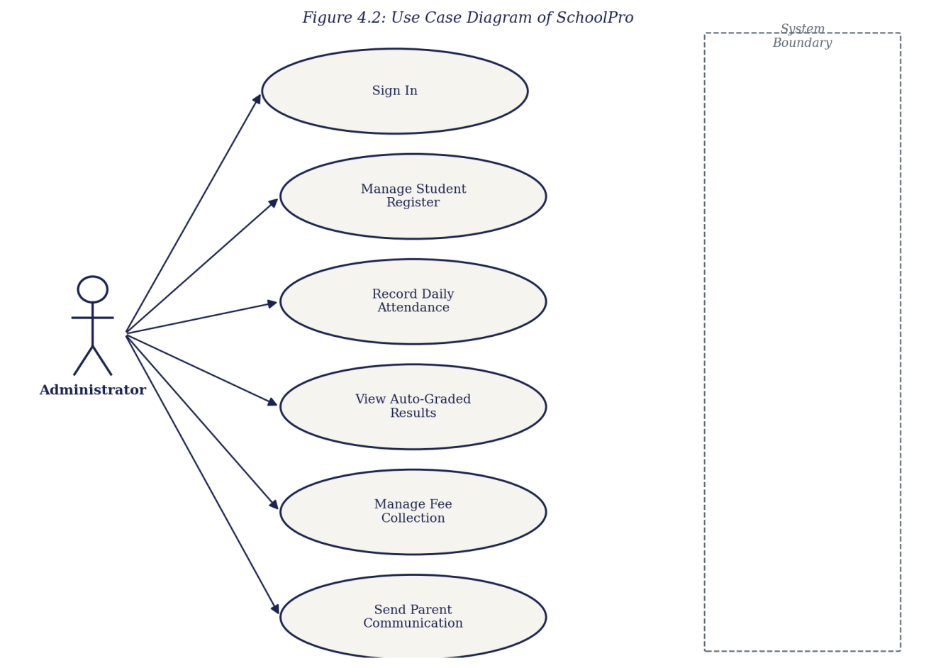
Figure 4.2: Use Case Diagram of SchoolPro
The Sequence diagram in Figure 4.3 documents a representative interaction of the system: an administrator signing in and recording daily attendance. It traces the flow from the sign-in form, through the login gate that verifies the credential and raises the session, to the dashboard router, which on request renders the attendance module; the administrator then marks each student’s status, which the attendance module writes to the in-browser record and confirms by re-rendering the register.
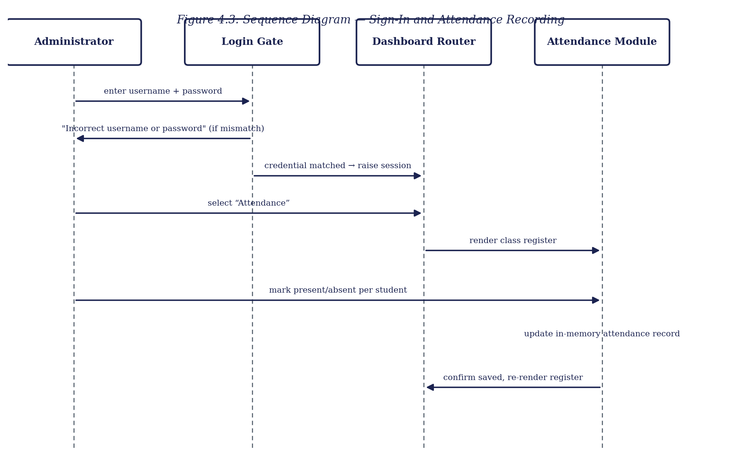
Figure 4.3: Sequence Diagram — Sign-In and Attendance Recording
The Class diagram in Figure 4.4 presents the domain model of the system. It shows the principal record types — Student, AttendanceRecord, ResultRecord, FeeRecord and Broadcast — together with the AdminSession that governs access and the GradingEngine that converts a result total to its WAEC grade, and records the attributes and operations that act upon them.
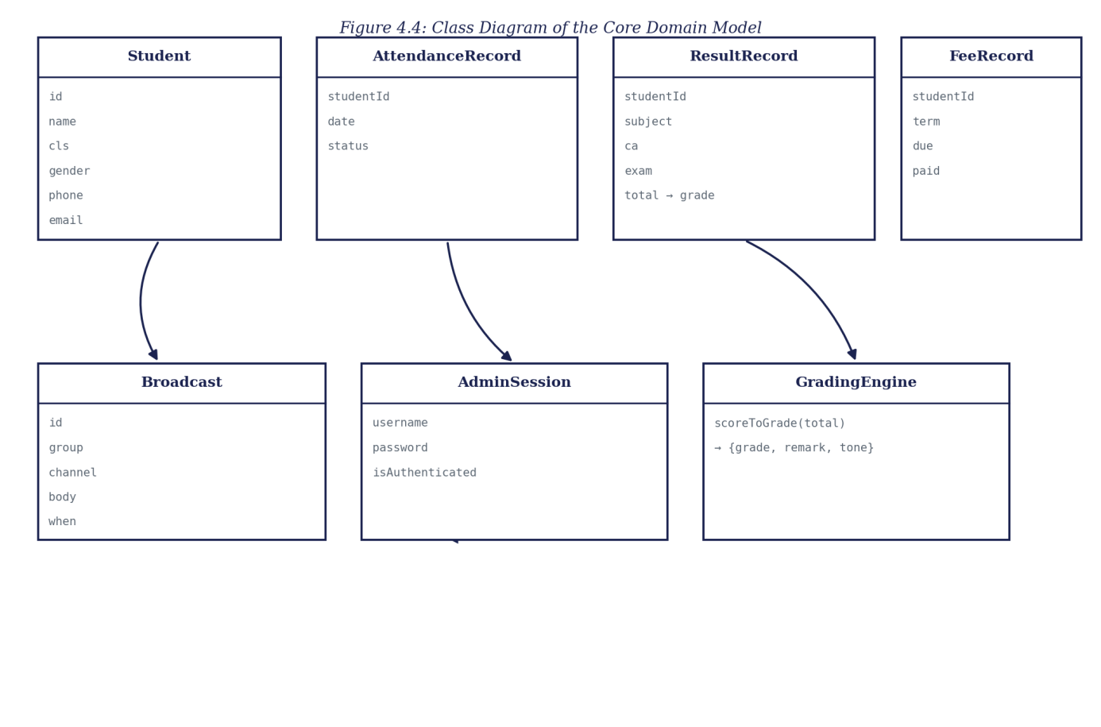
Figure 4.4: Class Diagram of the Core Domain Model
4.3 System Requirements
The tools required to run the developed system, as distinct from those required to develop it, are stated below. Because the system is a client-side application, its requirements are modest and fall entirely on the browsing device.
4.3.1 Hardware Requirements
• A processor of 1.2 GHz dual-core or higher, as found in entry-level devices.
• A minimum of 2 GB of RAM.
• At least 100 MB of free space for the browser cache.
• A network connection for the initial loading of the application.
4.3.2 Software Requirements
• A modern web browser such as Google Chrome 90 or later, Mozilla Firefox 88 or later, Microsoft Edge 90 or later, or Safari 14 or later.
• An operating system capable of running such a browser — Android, iOS, Windows, macOS or a Linux distribution.
• JavaScript enabled in the browser. No server runtime or installation is required.
4.4 Implementation of the Proposed System
The system is implemented as a single client-side web application, deployed as a static page on Netlify and accessed through a web browser at the address recorded in Appendix B. On loading, the application presents the sign-in form; once the administrator credential is verified, the dashboard is rendered together with its summary cards and the recent student register.
Implementation proceeded module by module, in keeping with the adopted methodology. The student register was built first, establishing the student record shape and the register view, and verified by confirming that a newly added student appeared correctly and could be edited. The sign-in gate was added next, and tested by confirming that the dashboard and its modules were reached only after the demonstration credential was matched. The attendance module was then implemented against the register, followed by the results module and its grading engine — tested by checking that a range of total scores produced the correct WAEC grade and remark at each boundary of the scale — and the fee-management and parent-communications modules thereafter. The responsive layout was tested across device widths from small mobile displays to desktop monitors. Testing was conducted throughout rather than at the end. Representative source code is provided in Appendix A and sample outputs in Appendix B.
CHAPTER FIVE
SUMMARY, CONCLUSION AND RECOMMENDATIONS
5.1 Summary
This project set out to solve a single, clearly identified problem: the absence of a single web-based system in which a Nigerian secondary school’s student register, attendance, results, fees and parent communication are held and acted upon together. Chapter One established the background and stated this problem, together with the aim and objectives of the work. Chapter Two reviewed the literature on school management information systems, technology adoption, automated grading, parent–school communication, the single-page application model and interface usability. Chapter Three analysed the existing fragmented, manual arrangement, set out the proposed system and justified it, and explained the object-oriented methodology adopted. Chapter Four presented the design of the system’s inputs, outputs, security and data, documented that design through architecture, use case, sequence and class diagrams, and described the implementation. The result is SchoolPro, a working web-based school management system providing a central student register, a daily attendance module, an automated WAEC-scale grading engine, a fee-management view and a parent-communications module.
5.2 Conclusion
The objectives of the study have been achieved. A central student register was designed and implemented, holding each student’s identifying and contact details. A daily attendance module was implemented, retaining a per-date, per-student record. An automated result-grading engine was implemented, converting a continuous-assessment and examination total into a WAEC-scale grade and remark without manual lookup. A fee-management view was implemented, recording amounts due and paid per student and term and surfacing students currently owing. A parent-communications module was implemented, through which a broadcast can be composed and issued, by SMS or push channel, to a named parent group. Because each objective corresponds to, and mitigates, an element of the problem stated in Chapter One, it may be concluded that the research problem has been solved to the extent set within the scope of the work.
Certain constraints qualify this conclusion. The system holds its data in the browser rather than in a server-side store, so changes made in a session do not persist across a reload; sign-in is performed on the client against a single demonstration credential; and the parent-communications and fee-management modules record their respective actions without connecting to a real messaging gateway or payment processor. These constraints affect the scale and the live connectivity at which the system has been demonstrated rather than the validity of its design, since the register, the attendance grid, the grading engine, the fee view and the communications module are fully implemented and behave on the seeded data exactly as they would on live records.
5.3 Recommendations
On the strength of the outcome of this study, it is recommended that a school considering this kind of system adopt a consolidated dashboard of the kind developed here in place of separate registers, ledgers and contact lists, in order to reduce cross-referencing effort and computational error. For future researchers who wish to extend this work, the following areas are recommended:
1. Provision of a server and a persistent database, so that a student added, attendance marked, or a fee recorded is stored durably and survives across sessions, devices and simultaneous users. This is the first priority, as the present build computes correctly but does not retain.
2. Replacement of the shared demonstration password with per-staff credentials verified on a server against irreversibly hashed values, together with role distinctions between, for example, a bursar and a class teacher.
3. Live integration of the parent-communications module with a real SMS gateway or push-notification service, in place of the present in-application log.
4. Live integration of the fee-management module with an actual payment processor, so that a recorded payment reflects a real transaction.
5. Extension of the automated grading engine to compute term and session cumulative averages and class positions across multiple subjects, building on the single-subject grade computation implemented here.
REFERENCES
Banks, A., & Porcello, E. (2020). Learning React: Modern patterns for developing React apps (2nd ed.). O’Reilly Media.
Davis, F. D. (1989). Perceived usefulness, perceived ease of use, and user acceptance of information technology. MIS Quarterly, 13(3), 319–340.
Ifenthaler, D., & Widanapathirana, C. (2014). Development and validation of a learning analytics framework: Two case studies using support vector machines. Technology, Knowledge and Learning, 19(1–2), 221–240.
Laudon, K. C., & Laudon, J. P. (2020). Management information systems: Managing the digital firm (16th ed.). Pearson.
Mikowski, M. S., & Powell, J. C. (2013). Single page web applications: JavaScript end-to-end. Manning Publications.
Nielsen, J. (1994). Usability engineering. Morgan Kaufmann.
Olumide, A., & Adebayo, K. (2019). Adoption of school management software in Nigerian secondary schools: Features, benefits and challenges. Journal of Information Technology Education, 18, 45–62.
Shneiderman, B., & Plaisant, C. (2010). Designing the user interface: Strategies for effective human-computer interaction (5th ed.). Addison-Wesley.
West African Examinations Council. (2023). WASSCE grading system and interpretation of grades. WAEC Nigeria.
APPENDIX A
SOURCE CODE SNIPPETS
The listings below are drawn directly from the source of the implemented system. The application is compiled to a minified production bundle for deployment, so identifier names below are compiler-generated rather than the original source names; the logic itself, reproduced exactly as shipped, is explained beneath each listing.
Listing A.1 — The WAEC-scale grading engine
function scoreToGrade(total) {
return total >= 75 ? { g: 'A1', r: 'Excellent', tone: 'good' }
: total >= 70 ? { g: 'B2', r: 'Very Good', tone: 'good' }
: total >= 65 ? { g: 'B3', r: 'Good', tone: 'good' }
: total >= 60 ? { g: 'C4', r: 'Credit', tone: 'ok' }
: total >= 55 ? { g: 'C5', r: 'Credit', tone: 'ok' }
: total >= 50 ? { g: 'C6', r: 'Credit', tone: 'ok' }
: total >= 45 ? { g: 'D7', r: 'Pass', tone: 'warn' }
: total >= 40 ? { g: 'E8', r: 'Pass', tone: 'warn' }
: { g: 'F9', r: 'Fail', tone: 'bad' };
}
This is the grading engine referenced in Section 4.1.4 and shown as GradingEngine in Figure 4.4. It converts a student’s total score into its WAEC letter grade and remark through a fixed chain of threshold comparisons, matching the scale set out in Section 2.4, with no manual lookup involved.
Listing A.2 — Administrator credential check
const ADMIN = { username: 'francis', password: 'bright2026' };

function handleSignIn(enteredUser, enteredPass) {
if (enteredUser.toLowerCase() === ADMIN.username
&& enteredPass === ADMIN.password) {
clearError();
onSignedIn();
} else {
showError('Incorrect username or password.');
}
}
Sign-in compares the entered credential against a single demonstration administrator account. A successful match clears any error and raises the session so the dashboard and its modules are reached; a mismatch shows an inline error and leaves the sign-in form in place. Section 4.1.3 notes that a production build would verify a per-staff credential on a server instead.
Listing A.3 — Seeded student register
const STUDENTS = [
{ id: 'ST-9001', name: 'Chidera Okafor', cls: 'JSS 2A',
gender: 'F', phone: '+234 803 111 2201',
email: 'okafor.family@gmail.com' },
{ id: 'ST-9002', name: 'Emeka Nwankwo', cls: 'JSS 2A',
gender: 'M', phone: '+234 806 222 3302',
email: 'nwankwo.p@yahoo.com' },
{ id: 'ST-9003', name: 'Aisha Bello', cls: 'JSS 2A', /* … */ },
/* … further seeded students … */
];
The student register is an array of records, each holding the fields specified in Table 4.2. Seeding the array in the browser lets every view — the register itself, attendance, results and fees, all keyed against a student’s id — be demonstrated at realistic scale; a live data source would replace this array without changing the components that render it.
Listing A.4 — Section-title mapping for the dashboard router
function sectionTitle(route) {
return {
dashboard: 'School Overview & Analytics',
students: 'Student Register',
attendance: 'Daily Attendance',
results: 'Auto-Result Grading',
fees: 'Fee Management',
comms: 'Parent Communications'
}[route];
}
The dashboard router uses this mapping to resolve the current route to its display title as the administrator switches between the five modules named in Chapter One, without reloading the page.
Listing A.5 — A logged parent broadcast
const BROADCASTS = [
{ id: 1, group: 'SSS 1B Parents', channel: 'SMS',
body: 'Reminder: Final term mock exams begin next Monday. Please ensure fee clearance.',
when: 'Today, 10:42 AM' },
{ id: 2, group: 'All Staff & Parents', channel: 'Push',
body: 'School will close early on Friday for maintenance updates.',
when: 'Yesterday' }
];
Each composed broadcast is appended to this log with its target group, channel and body, which is what the delivery report in Appendix B renders. Section 4.1.3 notes that in the present build this log is not connected to a real SMS or push gateway.
APPENDIX B
SAMPLE OUTPUTS (SCREENSHOTS)
The screenshots below present sample outputs of the implemented system, captured from the running application, deployed at https://schoolmanagementsystem-101.netlify.app/
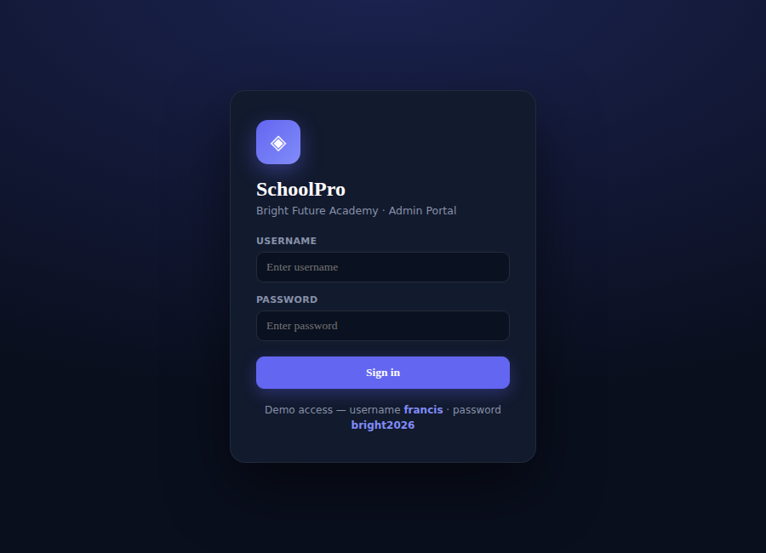
Figure B.1: The administrator sign-in gate
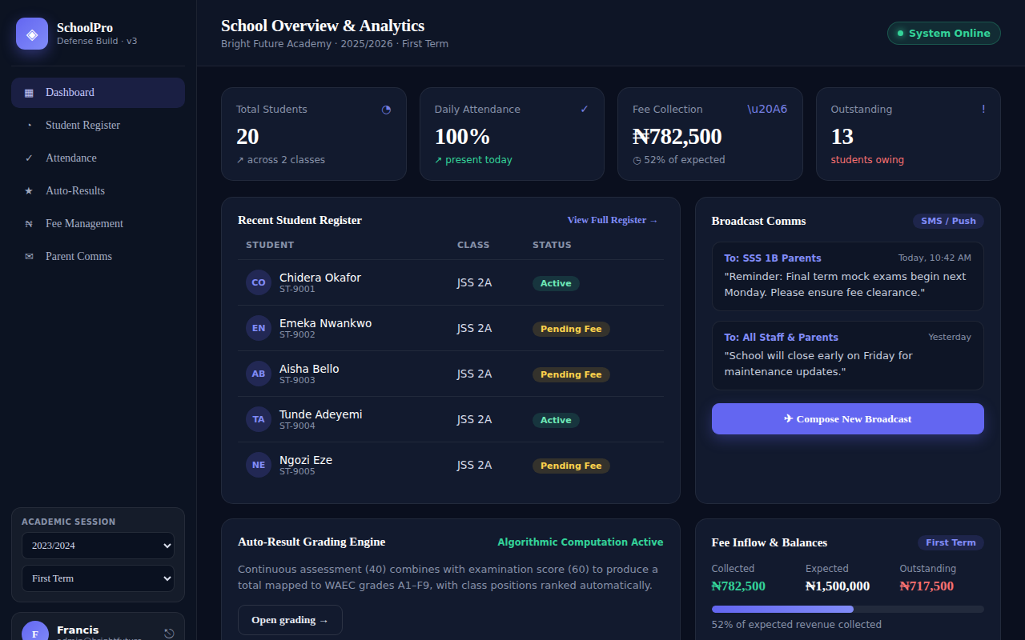
Figure B.2: The dashboard — total students, pending fees, class average and SMS-delivery meter at a glance
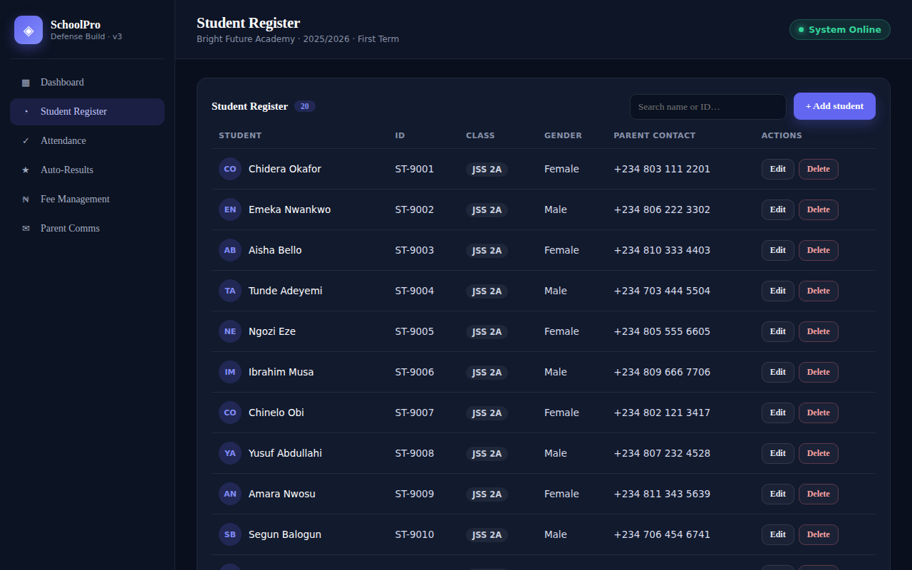
Figure B.3: The Student Register
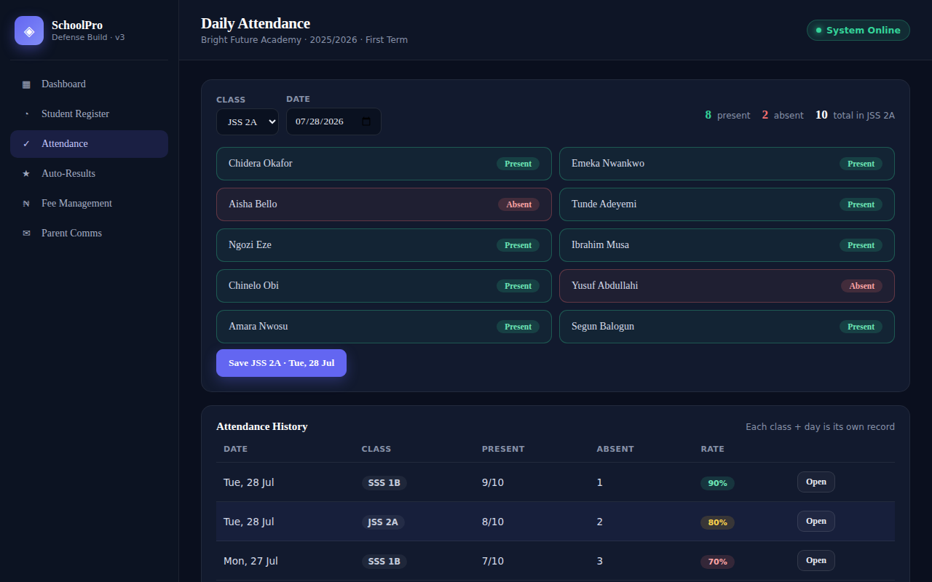
Figure B.4: The Daily Attendance module
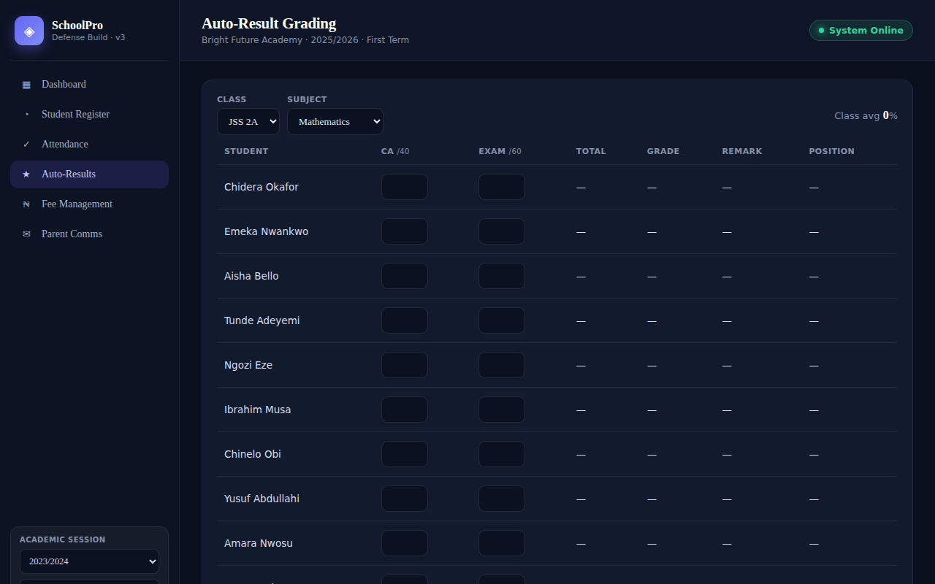
Figure B.5: The Auto-Result Grading view, showing WAEC-scale grades computed from CA and examination scores
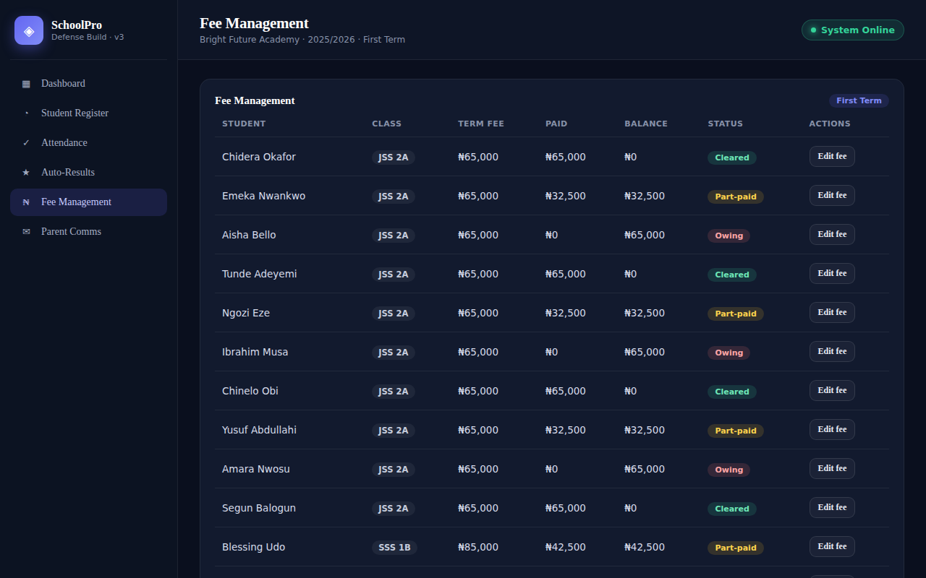
Figure B.6: The Fee Management view
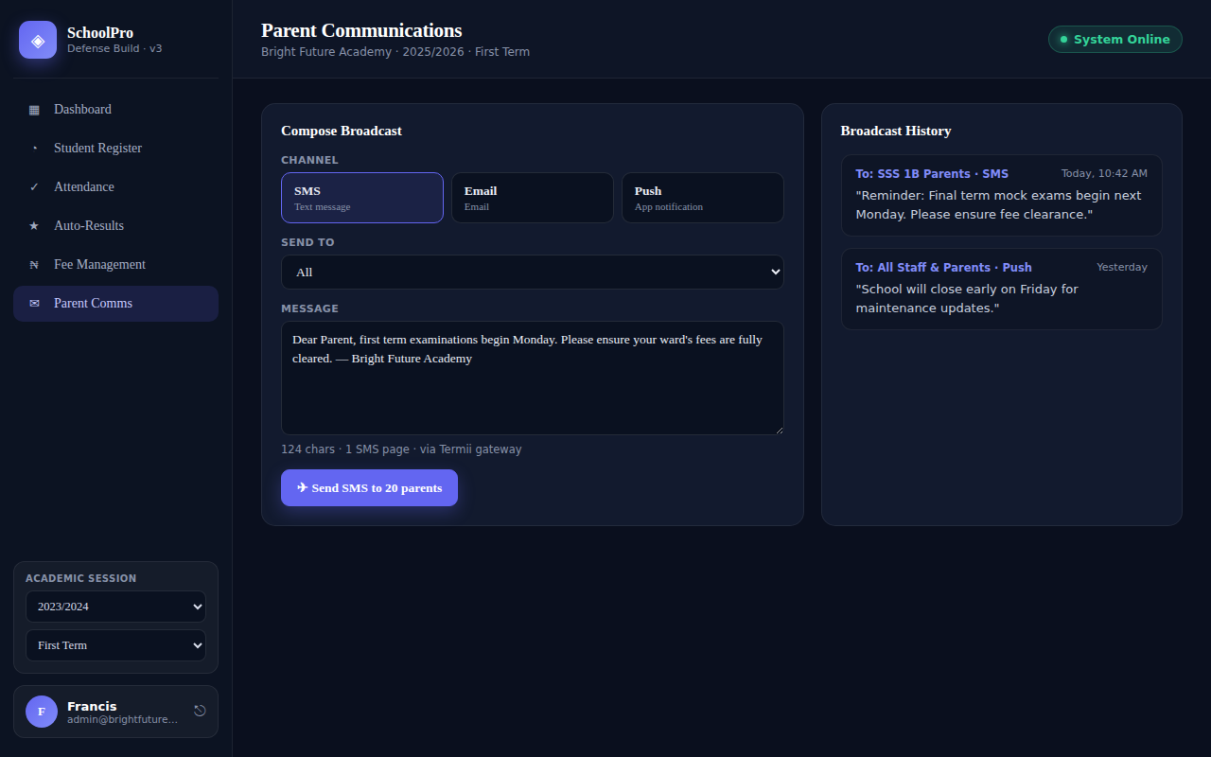
Figure B.7: The Parent Communications module, showing the broadcast delivery report

