CSIS 212 Assignment #8: Custom Sort

Daniel Dickson

Output:

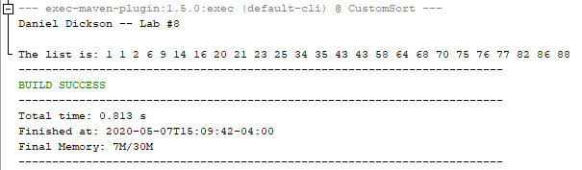

Integrity Statement:

1. I assert that I have not shared the source code for my program with anyone else without the instructor’s approval.
2. In addition, I have not used source code from another student or from any other unauthorized source, regardless of whether they have been modified.
3. If any source code or documentation were obtained from other sources, such as textbooks or course notes, they would have been clearly noted with proper citation in the comments of my program.
4. Most importantly, I have not knowingly designed this program to interfere with any machine it is graded on, nor have I designed it to produce seemingly good results if they are indeed wrong.