

Original Image

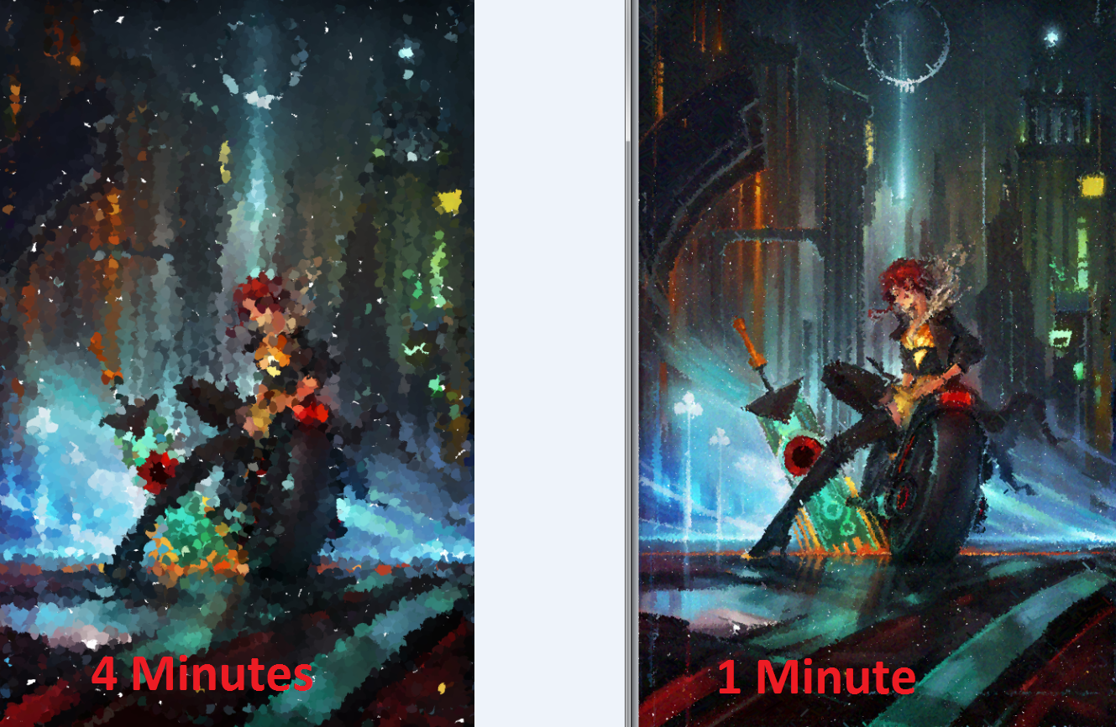

Random Strokes vs Litwinowicz’s algorithm

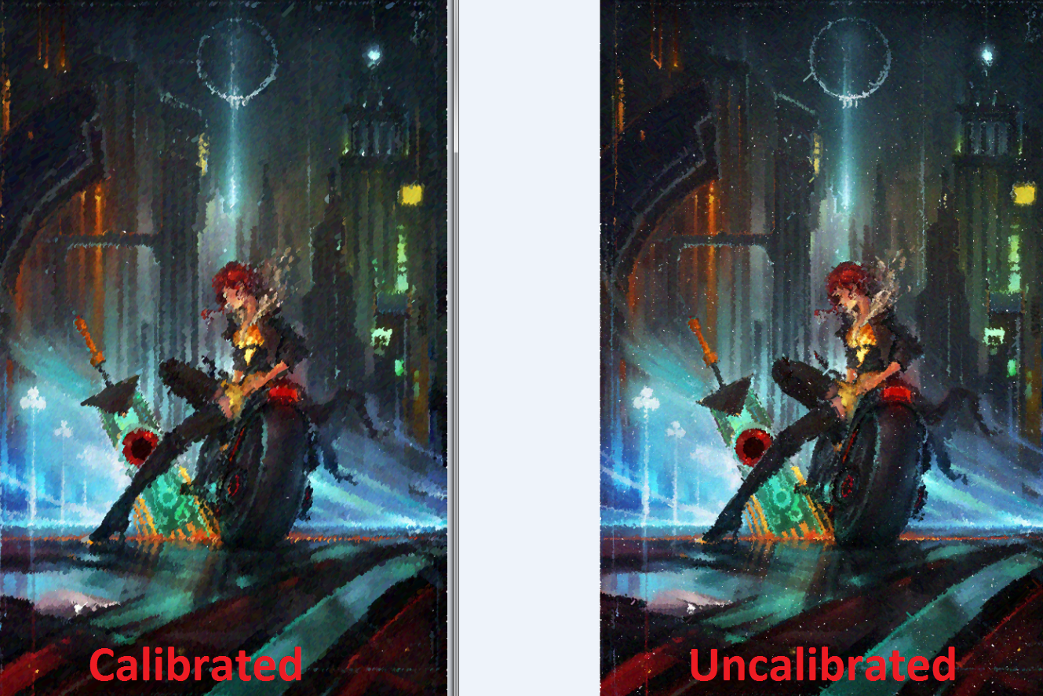

Litwinowicz’s algorithm with parameters “calibrated” for better look