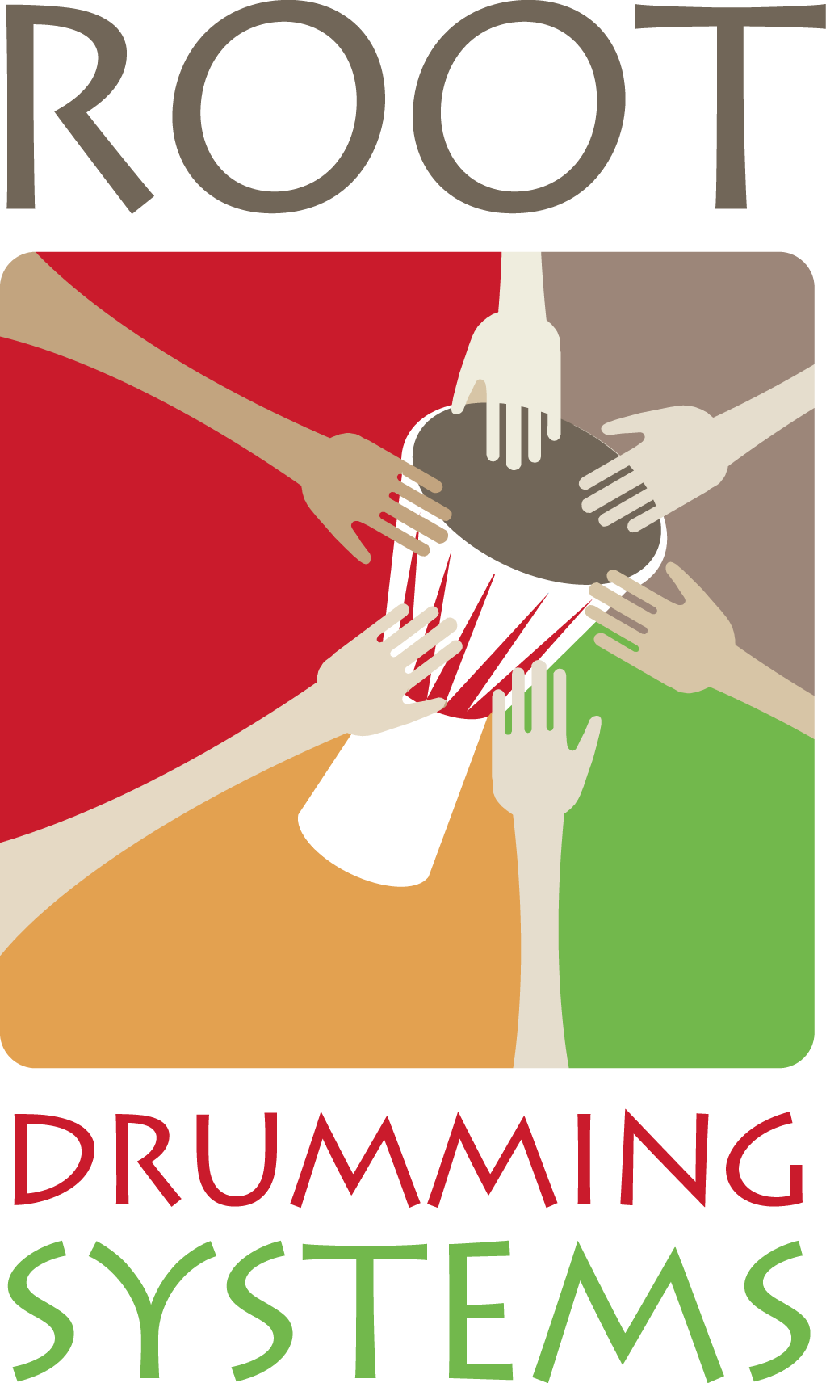
CERTIFICATE OF COMPLETION

This certifies that
________________________________________________
Participant Name
has successfully completed
Drumming for SEL Success
SEL In-Service Professional Development Training

Date of Training  ______________________________  Location  ______________________________ | Hours Completed  __________  PD Credits Earned  __________  CEU Value  __________ | CASEL Competencies Addressed  Self-Awareness · Social Awareness  Relationship Skills · Responsible Decisions  Self-Management

___________________________________________  Steve Ferraris, Founder  Root Drumming Systems, LLC · Norwich, Vermont |  | ___________________________________________  Administrator / Principal  School / District

Root Drumming Systems, LLC · Norwich, Vermont · www.sel-success.com
Qualifies for PD credit per Vermont Agency of Education guidelines. 1 contact hour = 1 PD credit. CEU = total hours ÷ 10 (IACET Standard)

