Project: Connect

Design

Daniel Ferguson, Ballarat Grammar

Software Development SAT, 2016

Table of Contents

[Design Options 3](#_Toc452935534)

[Design Option One 3](#_Toc452935535)

[Design Option Two 4](#_Toc452935536)

[Design Option Criteria 5](#_Toc452935537)

[Comments 5](#_Toc452935538)

[Written Descriptions 5](#_Toc452935539)

[Design Option One 5](#_Toc452935540)

[Design Option Two 5](#_Toc452935541)

[Data Dictionary 6](#_Toc452935542)

[Object Descriptions 6](#_Toc452935543)

[Pseudocode 7](#_Toc452935544)

# Design Options

## /Users/danielferguson/Desktop/Images-UXPin-Design_Option_One-Export/Default-2-Dashboard-Continued-53452625.png/Users/danielferguson/Desktop/Images-UXPin-Design_Option_One-Export/Default-1-Dashboard-53452624.pngDesign Option One

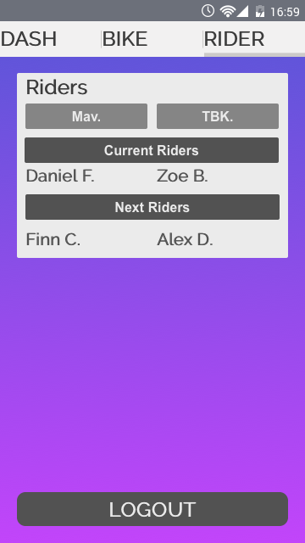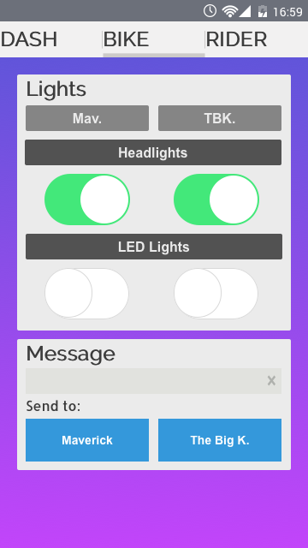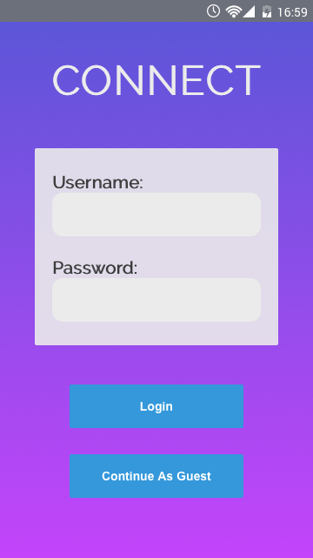

## /Users/danielferguson/Desktop/Images-UXPin-Design_Option_Three-Export/Default-1-Dashboard-53457605.pngDesign Option Two

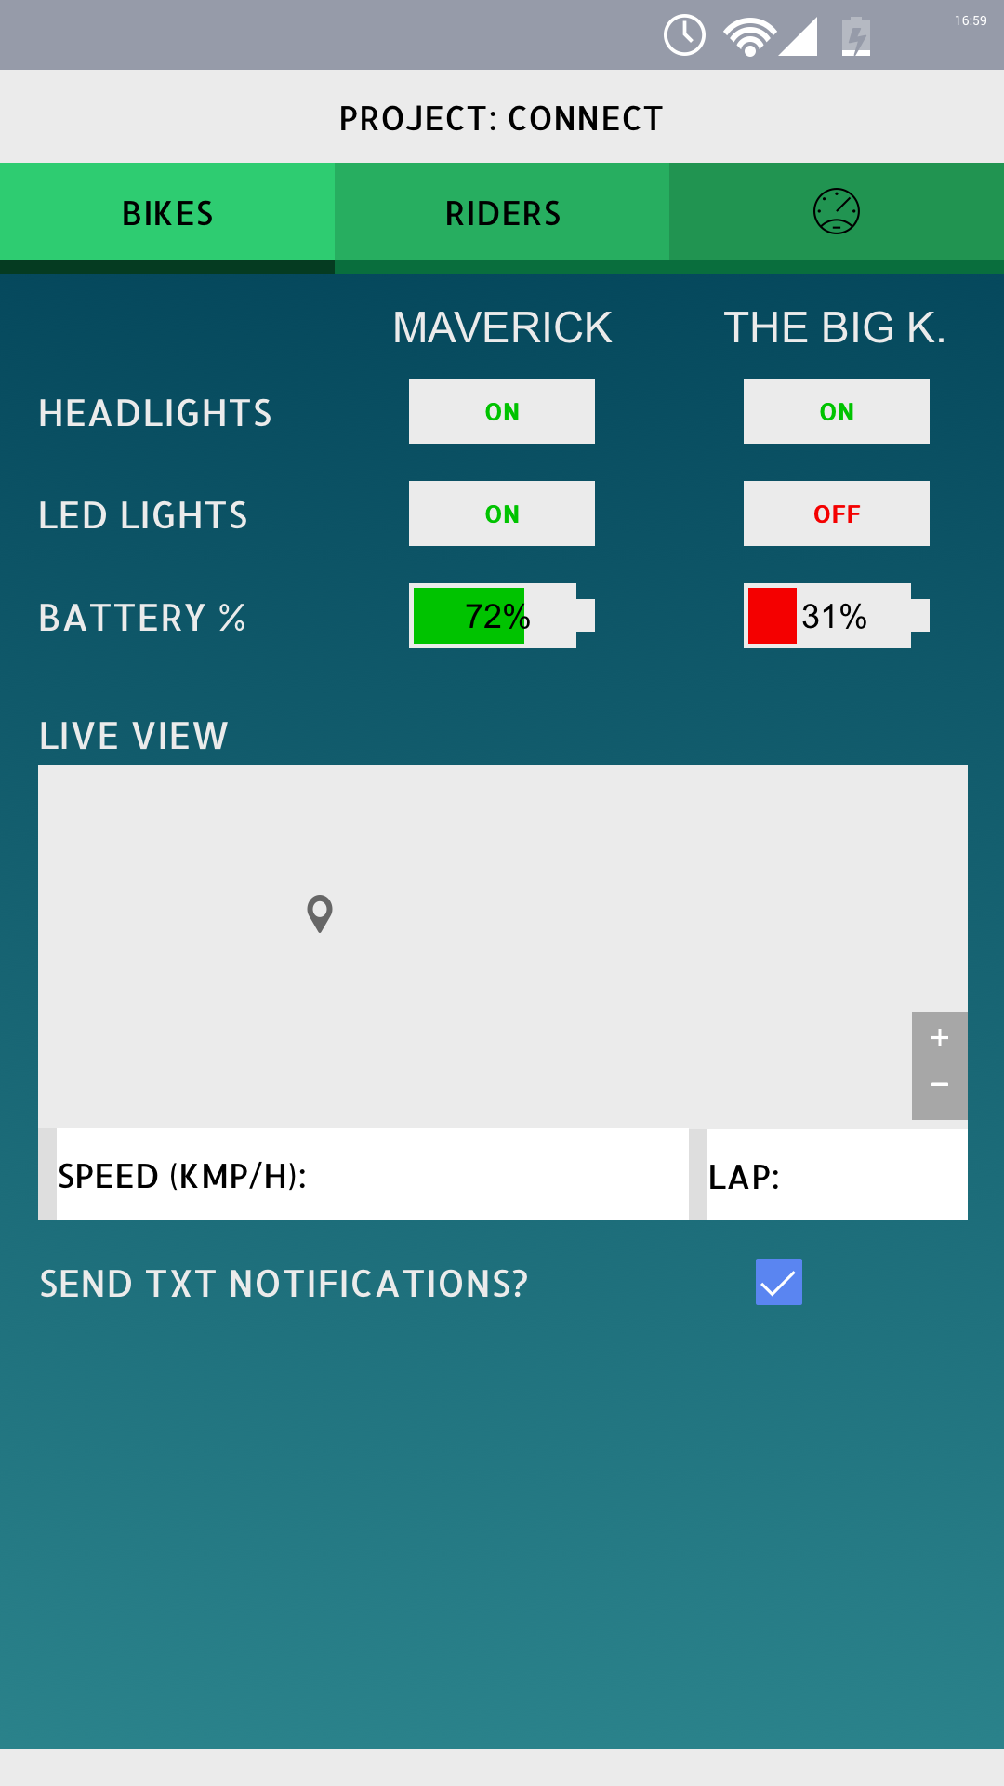

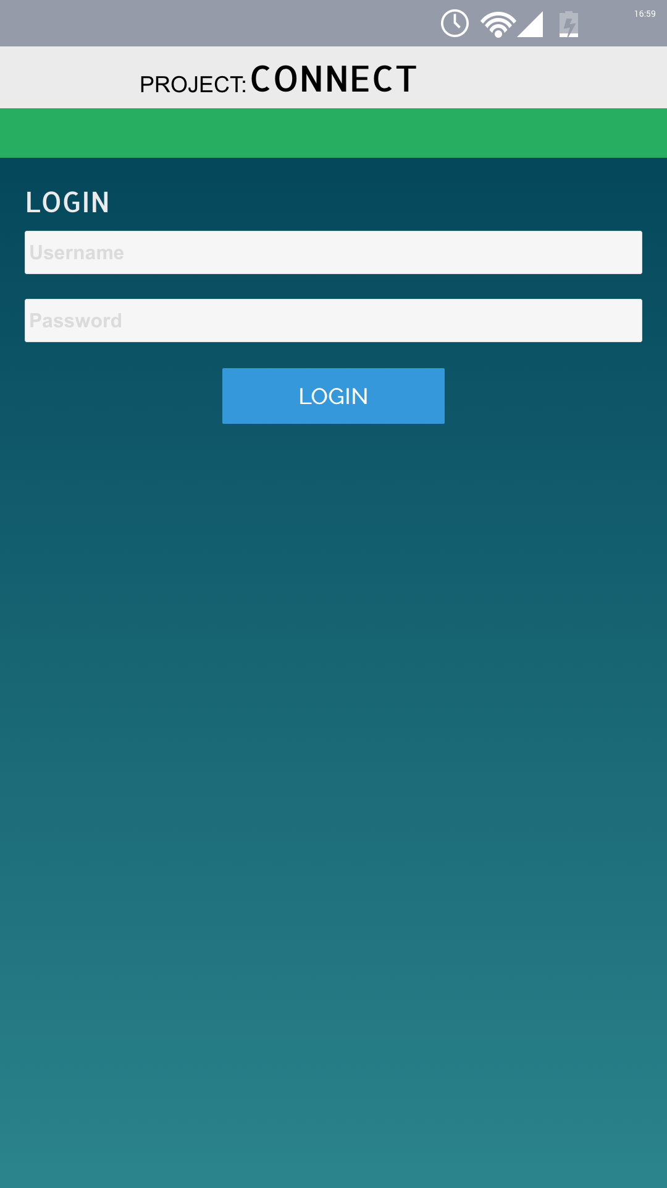

# Design Option Criteria

|  |  |  |
| --- | --- | --- |
| Criteria | DO ONe | DO Two |
| Speed of operation (10) | 9 | 9 |
| Ease of use (10) | 9 | 8 |
| Readability (5) | 5 | 4 |
| attractiveness (5) | 4.5 | 3 |
| accessibility (5) | 5 | 4 |
| usability (5) | 5 | 5 |
| total (40) | 37.5 | 33 |

Design Option Criteria Table

|  |  |  |  |  |
| --- | --- | --- | --- | --- |
| **DO ONE** |  |  | **DO TWO** |  |
| **Pros** | **Cons** |  | **Pros** | **Cons** |
| Effective / Efficient | Multiple pages |  | Very Lightweight | Layout |
| Lightweight |  |  | Concise | Sparse |
| Layout / Readability |  |  |  |  |

Design Option Weights

## Comments

I chose only to do two designs, as I strongly felt that the clients would be pleased with it, and that it would fulfil their needs better than any other option I could give them. I took Design Option One and Two to the clients, and they agreed that Design Option One will suit them best.

After asking for any changes required to further assist them, they didn’t have any to add to the current design, and were extremely happy with the original. They expressed that they want Design Option One.

## Written Descriptions

### Design Option One

Design Option One is meant to bring both the importance of good presentation, with the aspects of being functional as well – championing neither function, nor form over the other. Doing so achieved a well balanced design, making the user feel that they are getting a rewarding experience whistle using the application – all the while they are getting the information that they need to better succeed in their races.

### Design Option Two

Design Option Two was a trial of championing function over form, in an attempt to make the application as concise as possible, while still having some form about. Both designs have the same features, the main difference is how they present their information.

Its clear to see that the clients want an application that holds both function and form in high value – choosing Design Option Two as their favourite.

# Data Dictionary

|  |  |  |  |  |
| --- | --- | --- | --- | --- |
| Variable Name | Data Type | Size | Scope | Description |
| *VariableValues* | *Boolean* | *4* | *Global* | *Booleans that hold the statuses of the headlights and LED lights.* |

Data Dictionary

*[Majority of the variables will be directly hosted on an external Cloud Server.]*

# Object Descriptions

|  |  |  |
| --- | --- | --- |
| Object | Type | Description |
| usernameInput | EditText | String value for username |
| passwordInput | EditText | String value for password |
| loginButton | Button | Attempts to login the user |
| continueAsGuestButton | Button | Continues to Dashboard, with no option to change Headlights or LED Lights |

LoginPage Objects

|  |  |  |
| --- | --- | --- |
| Object | Type | Description |
| mavHeadlightsToggle | ToggleSwitch | Toggles Maverick’s Headlights |
| mavLEDLightsToggle | ToggleSwitch | Toggles Maverick’s LEDs |
| tbkHeadlightsToggle | ToggleSwitch | Toggles TBK’s Headlights |
| tbkLEDLightsToggle | ToggleSwitch | Toggles TBK’s LEDs |
| messageInput | EditText | Message to be sent to a bike |
| sendToMavButton | Button | Send the message to Maverick |
| sendToTBKButton | Button | Send the message to TBK |

BikePage Objects

|  |  |  |
| --- | --- | --- |
| Object | Type | Description |
| currentMavRider | Text | Displays current rider in Maverick |
| nextMavRider | Text | Displays next rider in Maverick |
| currentTBKRider | Text | Displays current rider in TBK |
| nextTBKRider | Text | Displays next rider in TBK |
| logoutButton | Button | Logs the user out of their local session |

RiderPage Objects

|  |  |  |
| --- | --- | --- |
| Object | Type | Description |
| notificationsBox | notificationBox | Displays notifications sent by Server |
| liveGPS | GPSTraceMap | Displays live GPS of bikes |
| statsMavSpeed | Text | Shows speed of Maverick |
| statsMacBattLv | Text | Shows battery levels of Maverick |
| statsMavLaps | Text | Shows current laps of Maverick |
| statsTBKSpeed | Text | Shows speed of TBK |
| statsTBKBattLv | Text | Shows battery levels of TBK |
| statsTBKLaps | Text | Shows current laps of TBK |
| ridersMavCurrent | Text | Shows current rider of Maverick |
| ridersMavNext | Text | Shows next rider of Maverick |
| ridersTBKCurrent | Text | Shows current rider of TBK |
| ridersTBKNext | Text | Shows next rider of TBK |
| chargingStationBatt1 | ProgressBar | Shows charging status of Battery Charging Station 1 |
| chargingStationBatt2 | ProgressBar | Shows charging status of Battery Charging Station 2 |

DashboardPage Objects

# Pseudocode

## LoginScreen / LoginActivity

### User Authentication

BEGIN

When Login is Activated

Create New User

Check Server for User.UserCredentials

If (User.UserCredentials exist) {

Change views to Dashboard

} else{

Display error message

}

ENDIF

### ContinueAsGuest

BEGIN

When ContinueAsGuent is Activated

Set Privilege to false (Cannot control bike)

Change views to Dashboard

Display message containing constraints of Guest

ENDIF

## DashboardScreen / DashboardActivity

### Check For Notifications

BEGIN

When Dashboard is Loaded

FETCH newInformation from Server

If (newInformation contains Notifications) {

Notification.Clear()

Notification.Refresh()

Notifications.Show()

} else {

Continue

}

ENDIF

### Update GPS Location

BEGIN

When Dashboard is Loaded OR Server.NewInformation is available

FETCH GPS Location Information

Update liveGPS

ENDIF

### Update Stats

BEGIN

When Dashboard is Loaded OR Server.NewInformation is available

FETCH information

Update InformationDisplays (Stats, Riders, Charging Stations)

ENDIF

## BikeScreen / BikeActivity && RiderScreen / RiderActivity

### Update RiderStats

BEGIN

When Dashboard is Loaded OR Server.NewInformation is available

FETCH information

Update InformationDisplays (Stats, Riders, Charging Stations)

ENDIF

### Toggle Lights

BEGIN

When Headlights || LEDLights bool values change from Server values

Update Server with new values

ENDIF

### Message

BEGIN

When SendTo… Button is Activated

Check if Message is not Empty

If not null 🡪 send MessageInput to …bike

Else, display inputError

ENDIF

### Logout User

BEGIN

When logoutButton is Activated

Delete UserSession

Change Views to LoginScreen

ENDIF