**Molecular generative model based on conditional variational autoencoder for novel molecular design**

Abstract

Background

Method

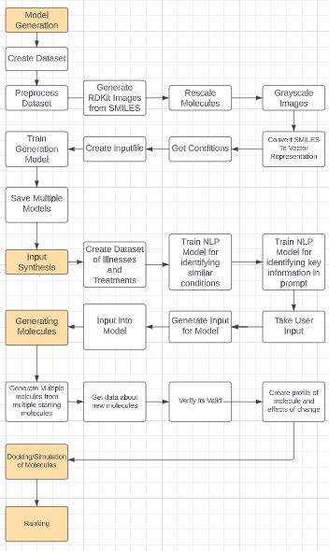

Results

Conclusion

References

<https://github.com/DanielFlockhart/Molecular-Generation>

<https://www.nature.com/articles/s41597-022-01142-7>

<https://arxiv.org/pdf/2209.01712.pdf>

<https://jcheminf.biomedcentral.com/articles/10.1186/s13321-018-0286-7>