MILESTONE 1 · TEAM PLAN
Who does what, by when
FEMA Assistance Prediction · CAI 4105 · Report due Wed, Sep 30

Sections
§ | SECTION | OWNER | PAGES | POINTS
2 | Business Understanding | Mateo | 2–3 | 5
3 | Data Understanding | Anthony | 3–4 | 7
4 | Data Preparation Plan | Danny | 2–3 | 3
5 | Modeling Approach | Danny | 2–3 | —
6 | Project Timeline | Together | 1 | —
1 | Executive Summary | Together, last | 1 | 3 (whole report)

Deadlines
WHEN | DONE BY THEN
Mon 9/28, 11:59 PM | §2 (Mateo), §3 (Anthony), §4 and §5 (Danny) rewritten in your own words
Tue 9/29, evening | Call: write §6 together, then the Executive Summary. Proofread once, export the PDF
Wed 9/30 | Final check, zip, submit

Loose ends
TASK | WHO
Team name and member names on the title line | Anthony
Confirm the §2.2 targets and the $700 assumption (§2.5) | Mateo
Final model list in §5.1 (add or cut k-NN, neural net) | Danny
Re-run the EDA notebook and check every number | Anthony
Log your AI use in docs/AI_USAGE.md | Everyone
Delete owner notes and leftover [TEAM] tags; export the PDF and notebook HTML; zip and submit | Tue call

Rules
- Only edit your own section. For anyone else's, leave a comment.
- Rewrite it in your own words. The draft is a starting point, and the course requires original work.
- Don't hand-edit numbers. They come from the notebook. If one looks off, say so in the group chat.
- Keep every "ML takeaway" box. They link findings to modeling decisions, which graders look for.
ROUGH DRAFT
Predicting FEMA Disaster-Assistance Eligibility
Hurricane Ian, Lee County, FL
CAI 4105 Machine Learning, Fall 2026 · Milestone 1: Initial Report · [TEAM: team name] · Anthony, Mateo, Danny [TEAM: full names]

1. Executive Summary
TOGETHER, LAST 1 page · written after §2–6 are final
OWNER NOTE Rewrite on the Tuesday call so it matches the final sections. If a number changes anywhere, change it here too.
Overview. In September 2022, Hurricane Ian hit southwest Florida. Lee County alone produced 194,482 valid applications to FEMA's Individuals and Households Program (IHP), which gives money to survivors for housing and other urgent needs. We frame FEMA's award decision as a binary classification problem and predict whether an applicant will be awarded IHP aid (ihpEligible).
Dataset. Public OpenFEMA data (IHP Valid Registrations v2), filtered to disaster DR-4673 and Lee County: 194,482 applications and 100 columns of mixed numeric, yes/no and categorical data. The target is balanced (50.7% awarded, 49.3% not).
Findings so far.
- Leakage is the main risk. 43 of 100 columns are results of the decision. One (ihpAmount) is identical to the target. We separate them from the start.
- Two honest prediction moments. Tier 1 uses what the applicant reports at registration (26 features). Tier 2 adds what FEMA learns after inspection (40 features).
- The problem is learnable. Untuned baselines reach ROC-AUC of about 0.90 (Tier 1) and 0.94 (Tier 2), against 0.50 for guessing. Much of the decision follows mechanical rules (46% of awards are exactly $700).
- Data quality is good but imperfect. Some columns are mostly blank, damage amounts are heavily skewed, about 3% of census blocks fall outside Lee County, and city names are hand-typed.
Approach. Clean the data and split it once (stratified 60/20/20). Compare logistic regression, a decision tree, a random forest and gradient boosting with stratified cross-validation. Judge them on ROC-AUC, F1 and error rates across age and income groups, with a person making every final decision.

2. Business Understanding
MATEO 2–3 pages · 5 pts
OWNER NOTE Graders want a clear problem statement, measurable success criteria, stakeholders and risks. The [TEAM: confirm] items are yours.

2.1 Problem definition and motivation
After a major hurricane, tens of thousands of households apply for federal aid within days. In Lee County, applications peaked on September 30, 2022 (15,240 in one day), and 94% had arrived by the end of October (Figure 2.1). Each application goes through referral, document checks, sometimes an inspection, and a decision. About half end without an award: 30% of unsuccessful applicants had insurance, 19% had no eligible damage, 13% did not respond or withdrew, and 35% were never referred (Figure 2.2).
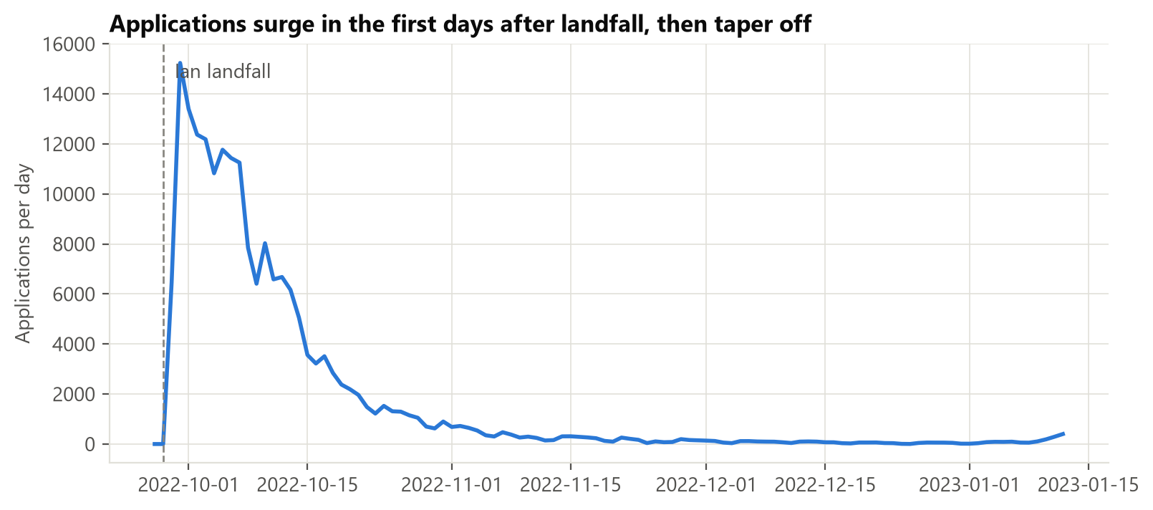
Figure 2.1. Daily applications; the peak is Sep 30, 2022.
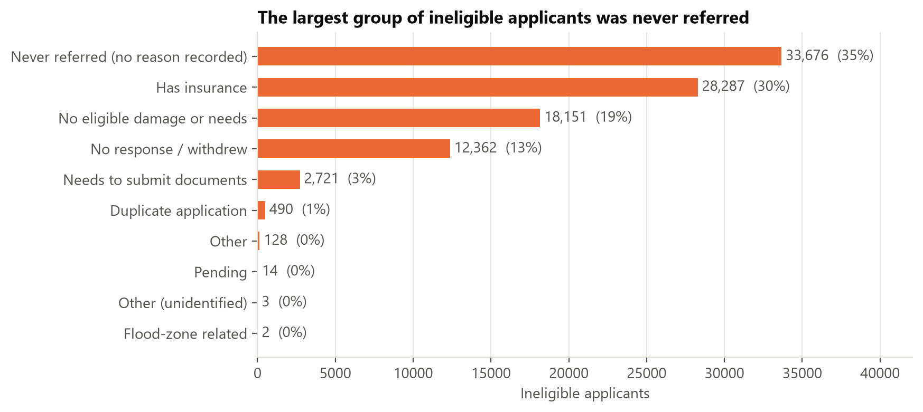
Figure 2.2. Why applicants were not awarded aid.
The question our model answers: given what we know about an applicant, will FEMA award them IHP aid?
Why it matters. Survivors wait while caseworkers are overloaded. A reliable prediction could help FEMA:
- fast-track likely-eligible applications;
- flag likely-ineligible ones early, so staff can say what is missing (for example, insurance documents);
- decide where to send inspectors first;
- plan staffing and budget for the next disaster.
What it is not. The model supports decisions. It never denies anyone aid automatically; a person makes every final call.

2.2 Objectives and success criteria
OBJECTIVE | MEASURE | TARGET [TEAM: CONFIRM]
Predict at registration (Tier 1) | ROC-AUC, F1 on held-out test set | ROC-AUC ≥ 0.90, F1 ≥ 0.83
Predict after inspection (Tier 2) | Same | ROC-AUC ≥ 0.94
Beat naive approaches | vs majority class and logistic regression | Clear win over both (50.7% accuracy; LR AUC 0.84)
Fair across groups | Error rate by age and income band | No group > 5 pts above overall
Explainable | Feature importance, partial-dependence plots | Top drivers match FEMA's stated rules

These targets come from untuned baselines (§5.1). They are goals for the tuned models, not promises.

2.3 Stakeholders
STAKEHOLDER | WANTS | COST OF A WRONG PREDICTION
Applicants | Fast, fair, clear decisions | Wrongly flagged "ineligible" (false negative), may give up on a valid claim
FEMA caseworkers, managers | Throughput, defensible decisions | Wasted inspections (false positives) or missed eligible people
Lee County, State of Florida | Recovery speed, planning | Misjudged demand
Congress, auditors, taxpayers | Proper use of funds | Improper payments or unexplained denials
Equity and legal-aid groups | No group treated worse | Systematic bias by age, income or place

2.4 Expected impact
A tuned, audited model gives FEMA an early, explainable signal at registration, when acting on information is cheapest. Its value is speed and prioritization, not replacing judgment. Because outcomes partly follow FEMA's own rules, the model also works as a consistency check: cases where it strongly disagrees with the outcome deserve a second look.

2.5 Risks and assumptions
- Selection bias: only valid registrations are in the data.
- Generalization: one storm, one county; results may not transfer.
- Label noise: "not eligible" mixes insurance, missing documents, withdrawal and never referred.
- Fairness: age, income and location can correlate with vulnerable groups, so we audit error rates by group.
- Assumption: the flat $700 payment looks like an emergency-needs payment. We will confirm this in FEMA documentation. [TEAM: confirm]

3. Data Understanding
ANTHONY 3–4 pages · 7 pts (largest)
OWNER NOTE Order: what the data is → the target → what we must not use → distributions → relationships → problems → what it means for modeling. Every subsection ends with an ML takeaway.
Full analysis: notebooks/eda/01_initial_eda.ipynb (exported as eda_notebook.html). Column definitions: docs/data_dictionary.md (Appendix A).
Rows | 194,482 applications, one household each
Columns | 100 raw → 26 features at Tier 1, 40 at Tier 2
Target | ihpEligible, balanced 50.7% / 49.3%
Leakage columns removed | 43
Columns > 10% missing | 6
Best honest single feature | ROC-AUC ≈ 0.70 (vs 1.000 for the leaky ihpAmount)

3.1 Source and collection
- Source: FEMA OpenFEMA, IHP Valid Registrations v2, a public dataset from FEMA's NEMIS system.
- Collection: pulled 2026-09-21 from the public OpenFEMA API with src/data/fetch_fema.py, filtered to DR-4673 and Lee County. FEMA refreshes weekly, so counts can drift slightly.
- Grain: one row per household application, dated 2022-09-27 to 2023-01-12.
- Requirements met: ≥ 10 features, ≥ 1,000 rows, numeric and categorical variables.
- FEMA caveat: raw operational data, "subject to a small percentage of human error."
ML takeaway large enough for a three-way split plus k-fold CV, but a single disaster limits generalization.

3.2 Target variable
ihpEligible is True when the applicant received a housing or other-needs award: 98,648 eligible (50.7%) vs 95,834 not (49.3%) (Figure 3.1).
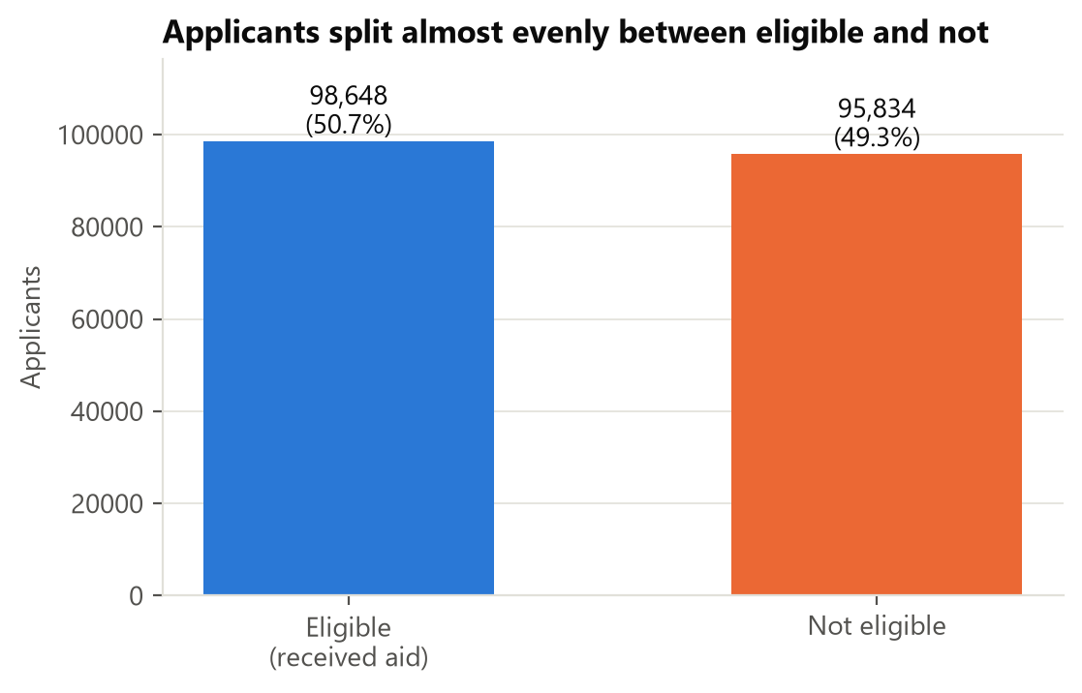
Figure 3.1. Class balance of ihpEligible.
ML takeaway balanced classes, so accuracy is meaningful and no resampling (SMOTE) or class weights are needed. We still stratify every split.

3.3 Feature roles and data leakage
Every column is assigned a role in src/utils/columns.py, the team's single source of truth:
ROLE | COLS | MEANING
Target | 1 | ihpEligible
Tier 1: application-time | 27 | Self-reported at registration
Tier 2: later-stage | 14 | Learned after inspection or verification
Leakage | 43 | Results of the decision; never used
ID / constant | 15 | Identifiers or the same on every row

Tier 1 has 27 raw columns but 26 features: cleaning drops `damagedCity` and turns `appliedDate` into `daysSinceLandfall`.
Leakage test. We scored each column alone with a small model (Figure 3.2). Outcome columns are near-perfect (ihpAmount 1.000, onaEligible 0.97, ineligibleReason 0.83); the best honest column reaches about 0.70.
Borderline case. currentLocation includes consequences of aid ("FEMA-provided unit" is 99% eligible), so we moved it from Tier 1 to Tier 2. Cost: 0.013 AUC.
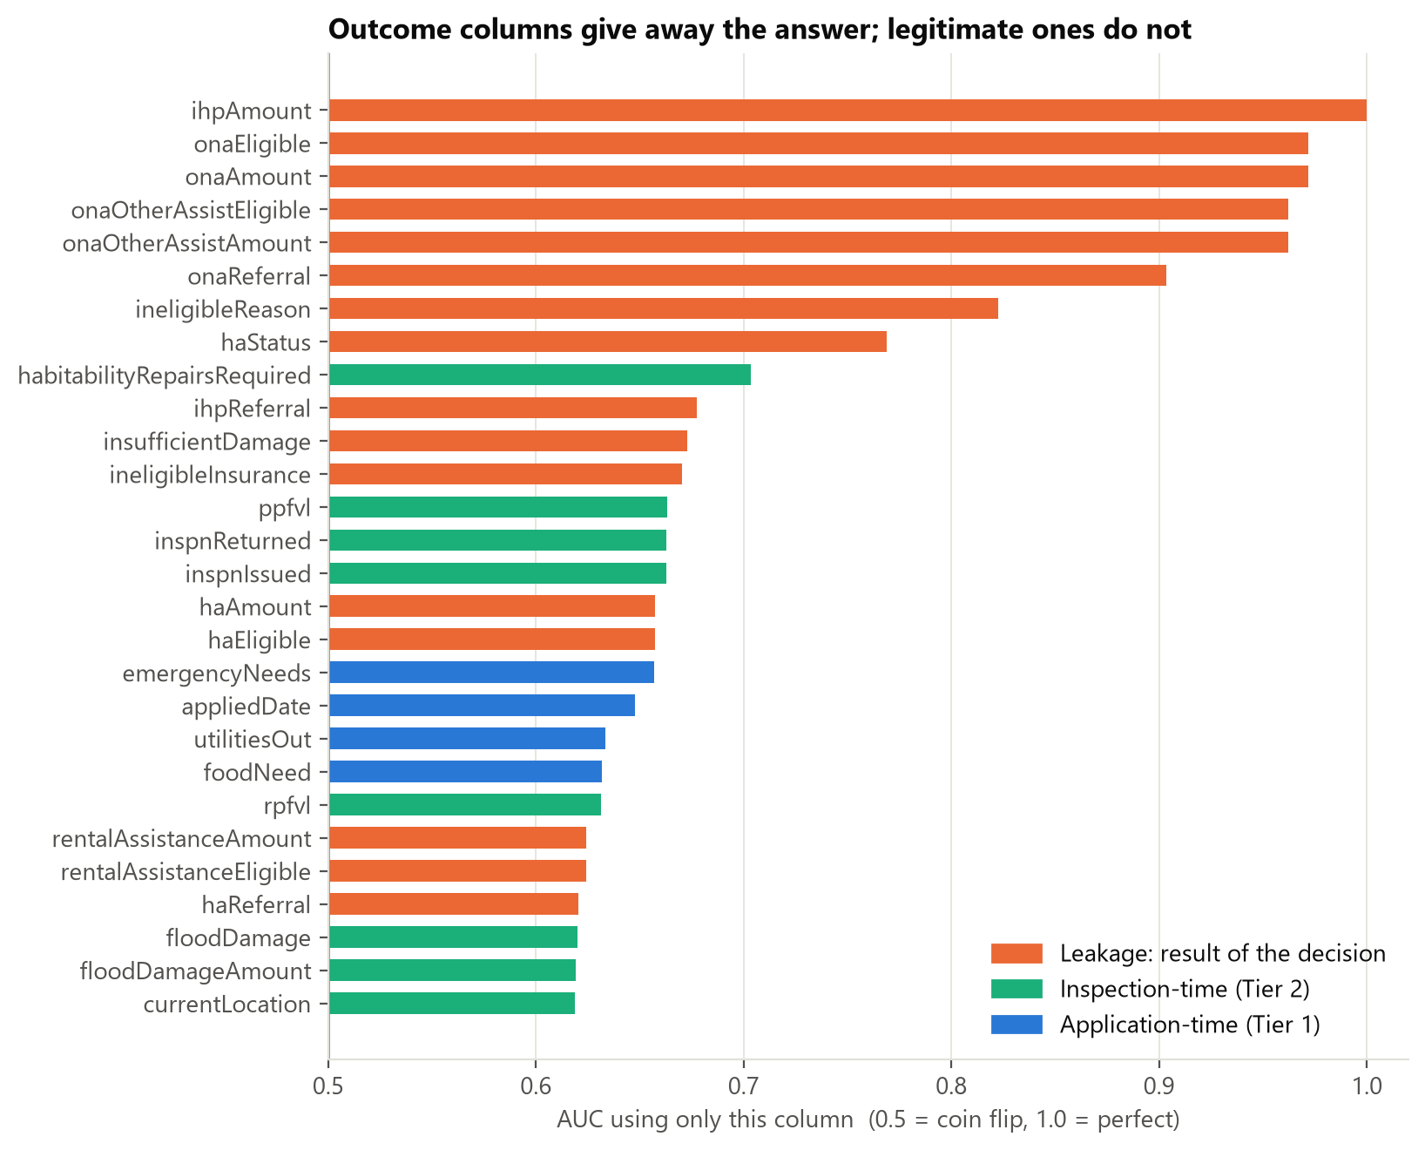
Figure 3.2. Each column scored alone. Leakage columns cluster near AUC = 1.
ML takeaway a high score means nothing if the features would not exist at prediction time. Tier 1 / Tier 2 turns that rule into two testable feature sets.

3.4 Distributions
Applicants are mostly older, small, home-owning households: 57% are 50+, most households have one or two people, 65% own the home, and 77% applied online or by app (Figure 3.3).
- Skew: damage measures like rpfvl (verified real-property loss) are zero for 83% of applicants and heavily right-skewed for the rest.
- High cardinality: ZIP (about 560 values) and census block group (about 3,000).
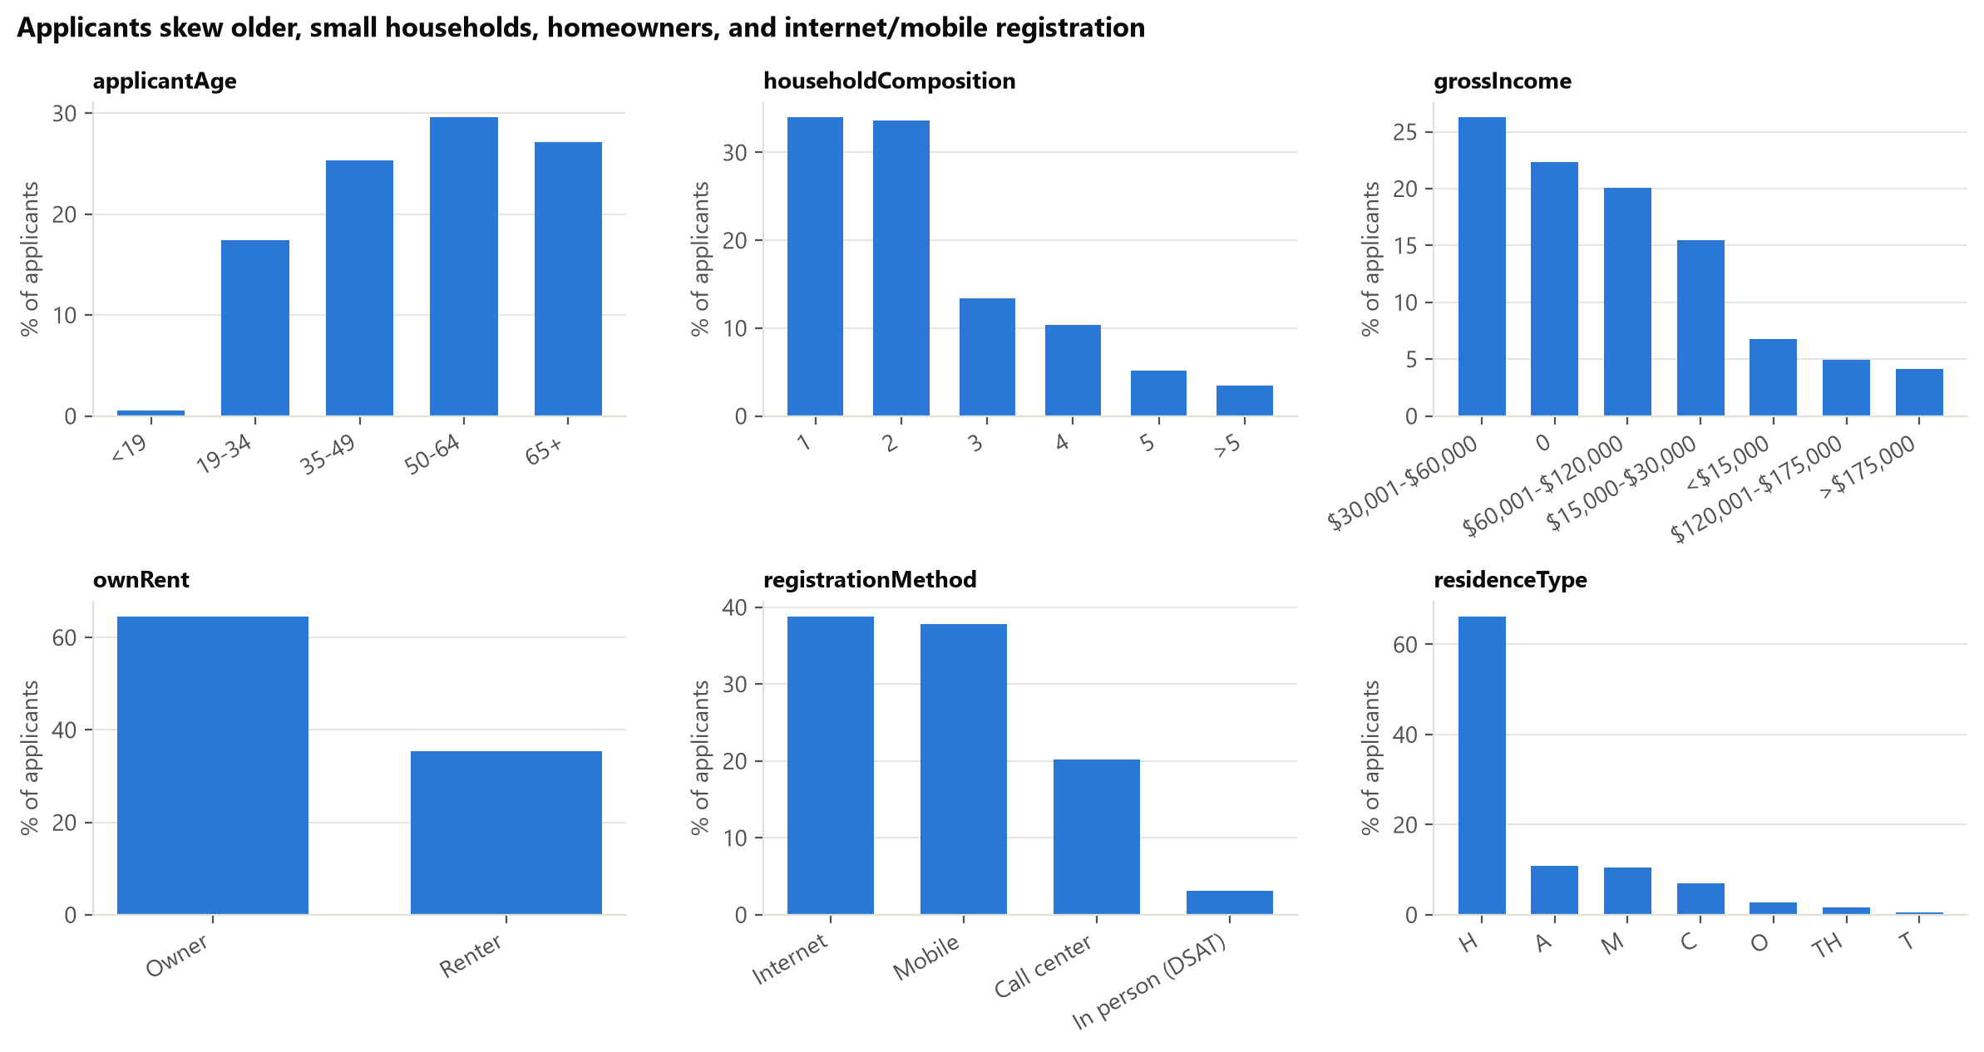
Figure 3.3. Age, household size, ownership and registration method.
ML takeaway log-transform skewed columns and add "has damage" flags; use frequency or target encoding instead of one-hot for geography (§4.2).

3.5 Relationships with the target
- Primary residence acts like a hard rule: non-primary homes are about 0.4% eligible.
- Emergency needs reported: 66% eligible vs 34% if not.
- Homeowners insurance lowers eligibility (47% vs 55%); flood insurance barely matters.
- Income: eligibility falls from 61% (under $15k) to 45% (over $175k), but the "$0" group is lowest (42%).
- Owner vs renter: almost no difference (51% vs 50%).
- Inspection (Tier 2): 73% eligible if completed vs 38% otherwise; unverified occupancy is under 1%.
- Place and time: 43% to 62% across the 22 largest ZIPs (Figure 3.5), and it shifts by week (Figure 3.6).
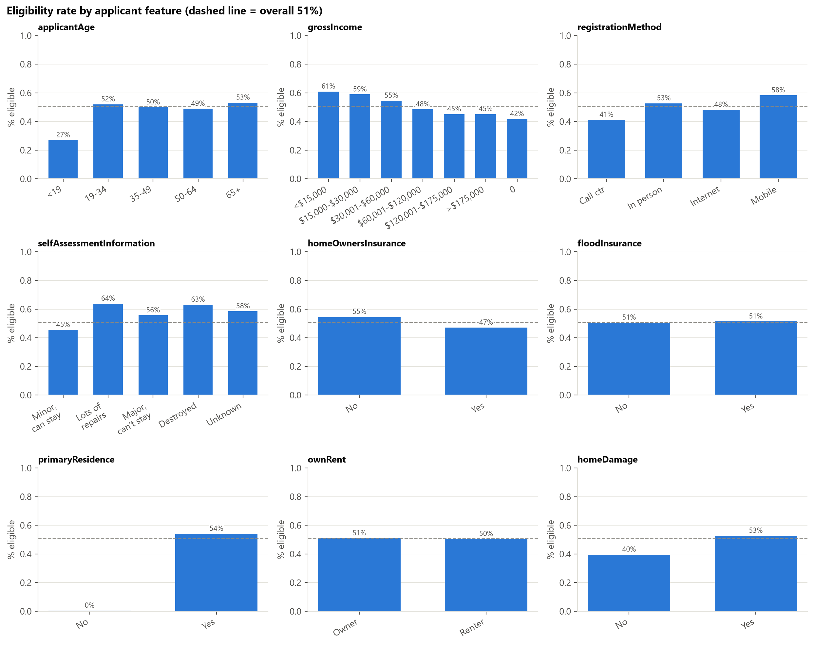
Figure 3.4. Eligibility rate within each category of key features.
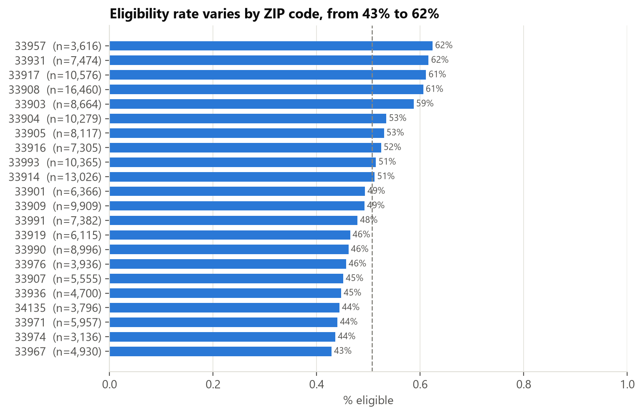
Figure 3.5. Eligibility across the 22 largest ZIP codes.
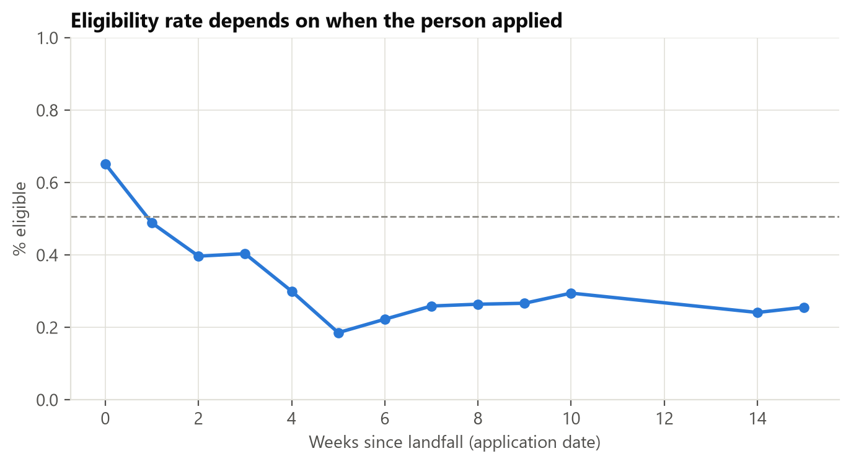
Figure 3.6. Eligibility by week of application.
ML takeaway strong signals are rule-like and non-linear (the "$0" income break, the residence cutoff), which favors trees. Income stays an unordered category.

3.6 Missing values
19 columns have blanks, 11 of them candidate features (Figure 3.7). Six are over 10% missing:
COLUMN | MISSING | LIKELY REASON
renterDamageLevel | 96% | Only for renter dwellings
highWaterLocation | 88% | Only where there was a flood mark
shelterNeed | 82% | Almost always True when present, so blank ≈ not reported
habitabilityRepairsRequired | 73% | Mostly unfilled; being filled is itself a signal [TEAM: confirm]
foodNeed | 52% | Same pattern as shelterNeed
selfAssessmentInformation | 15% | Applicant's own rating, sometimes skipped

Many blanks are structural (question doesn't apply) or informative (blank = "not reported"), so the data is not missing at random.
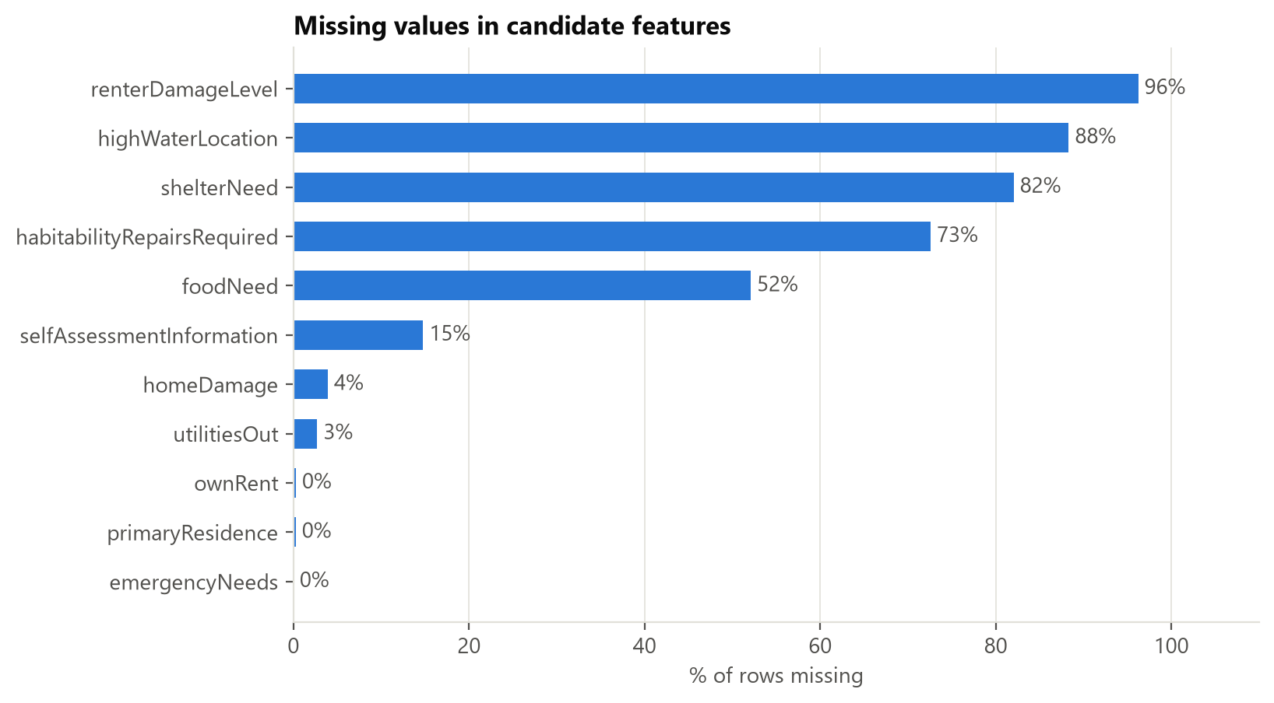
Figure 3.7. Share of missing values per column.
ML takeaway mean-filling would erase real signal. Add missing-indicator features and impute inside the pipeline, fit on training data only.

3.7 Correlations
No single numeric feature is strongly correlated with eligibility (max ≈ 0.36, Figure 3.8). Several pairs are near-duplicates (Figure 3.9): inspection issued vs completed (1.00), real-property loss vs flood damage (0.97), reported damage vs home damage (0.83).
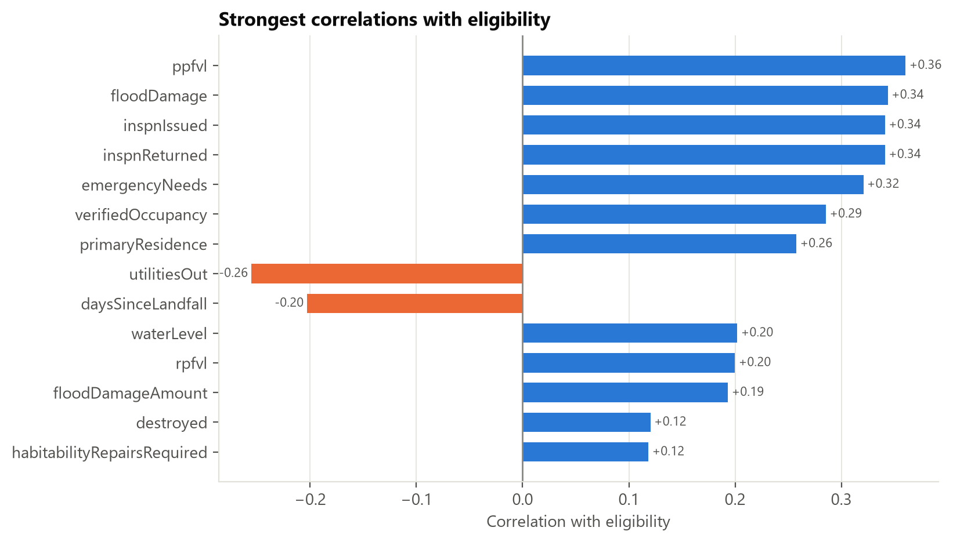
Figure 3.8. Correlation of each numeric feature with the target.
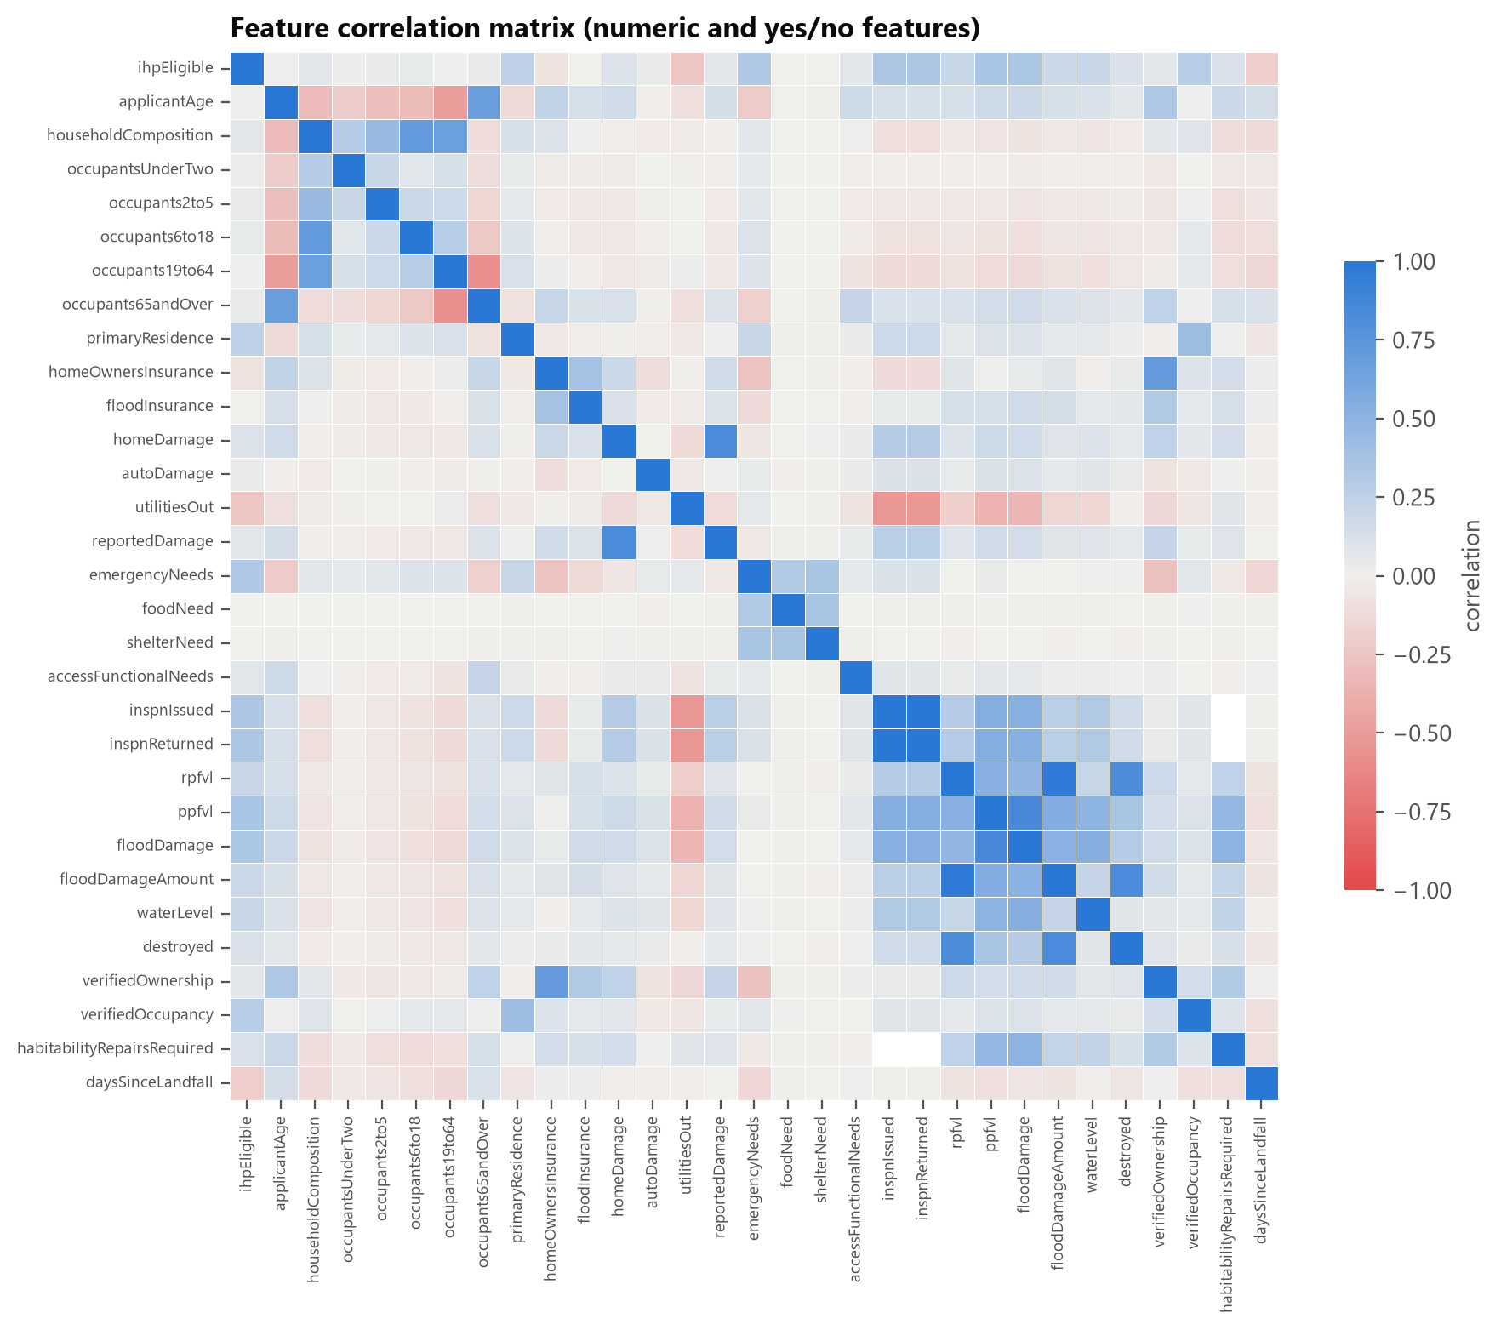
Figure 3.9. Feature-to-feature correlations.
ML takeaway weak single correlations but a 0.90 AUC baseline means the signal lives in interactions. Drop one of each duplicate pair for linear models; trees don't care.

3.8 Data quality
CHECK | RESULT | DECISION
Constant columns | 14 columns, one value each (one disaster, one county) | Drop
Duplicates | 407 rows (0.21%) identical on non-ID columns; likely different households | Keep
Location errors | 6,357 rows (3.3%) with a block outside Lee (2,707 NO_INTERSECT); 17 non-FL ZIPs | Keep; NO_INTERSECT as a category
City names | Hand-typed variants (FT MYERS, FT MYERS BCH) | Drop column
Implausible values | Water depth of 960 in (80 ft) | Cap
Dates | 2 applications before the declaration | Keep

ML takeaway quality is good overall, and every issue has a documented fix in §4.1.

3.9 Challenges and limitations
CHALLENGE | WHY IT MATTERS FOR ML
Data leakage | Inflated, meaningless scores
One disaster, one county | Limited generalization
Valid registrants only | Selection bias
Label bundles many denial reasons | Label noise
Skew, structural missingness | Needs transforms and missing indicators
High-cardinality geography | Encoding can overfit unless fit inside CV folds
Near-duplicate features | Multicollinearity for linear models
Outcomes follow FEMA rules | A high score isn't proof the model understands need

4. Data Preparation Plan
DANNY 2–3 pages · 3 pts
OWNER NOTE Each row in 4.1 should answer a problem from §3. The cleaning code already exists: src/features/prepare.py.

4.1 Cleaning
ISSUE (FROM §3) | DECISION
Leakage, IDs, constants (58 cols) | Drop (list in src/utils/columns.py)
damagedCity (hand-typed) | Drop; use ZIP and census block
Yes/No stored as text with blanks | Convert to 0/1; blanks stay missing, not 0
Ordered ranges (age, household counts) | Ordinal encoding (">5" becomes 6)
Income bracket | Unordered category (the "$0" group breaks the order)
Missing values | Not filled during cleaning. Indicators + median (linear) or native handling (boosting), fit on train only
Implausible values (waterLevel = 960) | Cap at a high percentile
Out-of-county blocks | Keep; NO_INTERSECT as its own category
Duplicate-looking rows | Keep (§3.8)

4.2 Feature engineering
- daysSinceLandfall from the application date (built).
- log1p on skewed dollar and damage columns, plus "has damage" flags.
- Missing indicators where blanks carry meaning.
- ZIP and census block: frequency encoding (used in baselines), target encoding tested inside CV folds.
- Group rare categories; drop one of each near-duplicate pair for linear models.
- Possible interaction: emergency needs × residence status.

4.3 Transformation
Scaling and one-hot encoding only for models that need them (logistic regression, distance-based methods); trees get unscaled data. Everything that learns from data (imputation, scaling, encoding) is fit on the training split inside a scikit-learn Pipeline, which prevents train–test contamination.

4.4 Train / validation / test
- Stratified 60 / 20 / 20 with seed 42, so everyone gets the same split (split_data()).
- The test set is used once, at the end of Milestone 2.
- Cross-validation runs on the 80% development set; the test set stays sealed.
- Temporal check: train on early applicants, test on later ones.
- Applications from the same household can't be linked; noted as a limitation.

5. Modeling Approach
DANNY 2–3 pages
OWNER NOTE Justify each model by a property of our data from §3 (skew, interactions, rule-like signals), not by reputation.

5.1 Algorithms
MODEL | WHY IT FITS THIS DATA
Logistic regression | Simple, interpretable; the baseline to beat
Decision tree | Readable rules, and FEMA's process is rule-like
Random forest | Handles skew, mixed types, outliers; bagging cuts variance
Gradient boosting | Best preliminary results; captures the interactions from §3.7
[TEAM: k-NN? neural net?] | Add or cut based on what the course covers

Preliminary baselines (untuned, validation split, src/models/baseline.py):
FEATURES | MODEL | ROC-AUC | ACCURACY | F1
Tier 1 (26) | Gradient boosting | 0.900 | 0.824 | 0.837
Tier 1 | Logistic regression | 0.843 | 0.764 | 0.771
Tier 1 + 2 (40) | Gradient boosting | 0.938 | 0.870 | 0.882
Tier 1 + 2 | Logistic regression | 0.898 | 0.818 | 0.825
any | Majority class | 0.500 | 0.507 | 0.000

5.2 Metrics
METRIC | WHY
ROC-AUC (primary) | Ranking quality regardless of threshold; fine with balanced classes
Precision, recall, F1 | False "ineligible" and false "eligible" cost different things; we pick the threshold explicitly
Accuracy | Fair here because classes are balanced
Confusion matrix | Shows where the errors fall
Group error rates | Fairness audit (target in §2.2)

5.3 Cross-validation and tuning
5-fold stratified CV on the development set, with randomized hyperparameter search inside the folds. Every model uses the same folds. The test set is used once, for the final score.

5.4 Challenges and mitigation
CHALLENGE | MITIGATION
Hidden leakage as scores rise | Roles file as single source of truth; rerun the drop-a-group ablation for every final feature set (it caught currentLocation)
High-cardinality geography | Frequency / target encoding fit inside folds; compare with and without
Skewed, mostly-zero damage | Log transform + flags; prefer trees
Model just relearns FEMA rules | Say so; treat model–outcome disagreements as the interesting cases
Fairness | Report group error rates; investigate gaps > 5 pts
One storm only | State scope; run the temporal check

6. Project Timeline
TOGETHER 1 page · Tuesday call
OWNER NOTE Fill the [TEAM] owners on the call.
DATES | WORK | OWNER
Sep 22–25 | Agree on target, success criteria and roles; everyone re-runs the EDA notebook | All
Sep 26–29 | Write, proofread, export PDF, assemble zip | All
Sep 30 | Milestone 1 due | All
Oct 1–14 | Finish the preprocessing pipeline and notebook | [TEAM]
Oct 15–31 | Train all models, cross-validate, tune | [TEAM]
Nov 1–10 | Evaluation: comparison, feature importance, leakage ablations, fairness audit | [TEAM]
Nov 11–18 | Final report, presentation, rehearsal | All
Nov 19 | Freeze: code runs top to bottom, PDF exported | All
Nov 21 | Milestone 2 due | All
Nov 23 / Dec 2 | Presentation (15 min + Q&A) | All

Roles. [TEAM: name] data and EDA · [TEAM: name] modeling · [TEAM: name] evaluation and report. Everyone contributes to every phase.

Risks and contingencies
RISK | CONTINGENCY
A teammate is unavailable | Everything is in Git with documented code; weekly check-ins
Scores drop after removing leaky features | Report it; the leakage story is itself a finding
Notebook merge conflicts | One person per notebook; small commits; pull first
Running out of time | Freeze the model set by Oct 31; cut optional models first

Appendices
Not counted in the page limit.
- A. Data dictionary (docs/data_dictionary.md)
- B. EDA notebook export (reports/milestone_1/eda_notebook.html)
- C. AI usage log (docs/AI_USAGE.md)
- D. Additional figures (reports/figures/)

References
FEMA. OpenFEMA Dataset: Individuals and Households Program – Valid Registrations v2. https://www.fema.gov/openfema-data-page/individuals-and-households-program-valid-registrations-v2

AI-use disclosure
Portions of the code, analysis and this draft were produced with Claude Code (Anthropic) and reviewed by the team. See docs/AI_USAGE.md for the full log.

