Predicting FEMA Disaster-Assistance Eligibility: Hurricane Ian, Lee County, FL
CAI 4105 Machine Learning, Fall 2026, Project Milestone 1: Initial Report
Team FEMA | Anthony Stoneking, Daniel Ortiz, Nandor Laar | Due Wednesday, October 7, 2026

1. Executive Summary
Our project is trying to predict whether FEMA gives a household aid after Hurricane Ian, specifically in Lee County, FL. The data that we're using is directly from FEMA, the 194,482 applications and 100 columns, with a near 50/50 split of those who received aid and those who didn't.
One of the most important things we found was that 43 out of the 100 columns are results of FEMA's decision, leakage, so we can't use them. We separate it into two tiers. Tier 1: 25 features known at registration, and Tier 2: 39 features that are known after inspection.
The plan is to do a 60% train, 20% validation, and 20% test split, try four models to see how it changes, do a 5-fold cross-validation, and score with ROC-AUC. We cross-validate so that we can see how much the score changes from run to run, so that we aren't basing our model off of one run. What's next is to build and test models for Milestone 2.

2. Business Understanding

2.1 Problem definition and motivation
After a big hurricaine like Ian back in 2022, tens of thousands of people and households applied for federal aid within days of the disaster. In Lee county, applications peaked September 30th, 2022 (15,240 in one day), and 94% arrived by the end of October (Figure 2.1). Each application goes through a referral, documentation checks, with sometimes an inspection and a decision. Around half of the people end without an award and for various reasons: 30% of those had insurance, 19% had no eligible damage or needs and 13% did not respond or just withdrew from the application, and 35% were never referred to the program (Figure 2.2).
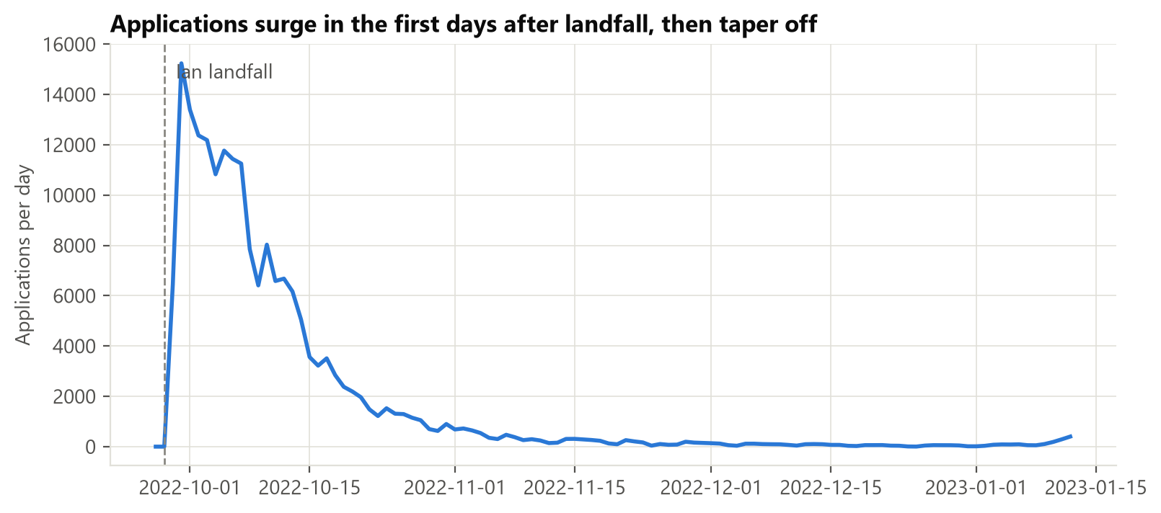
Figure 2.1. Daily applications; the peak is Sep 30, 2022.
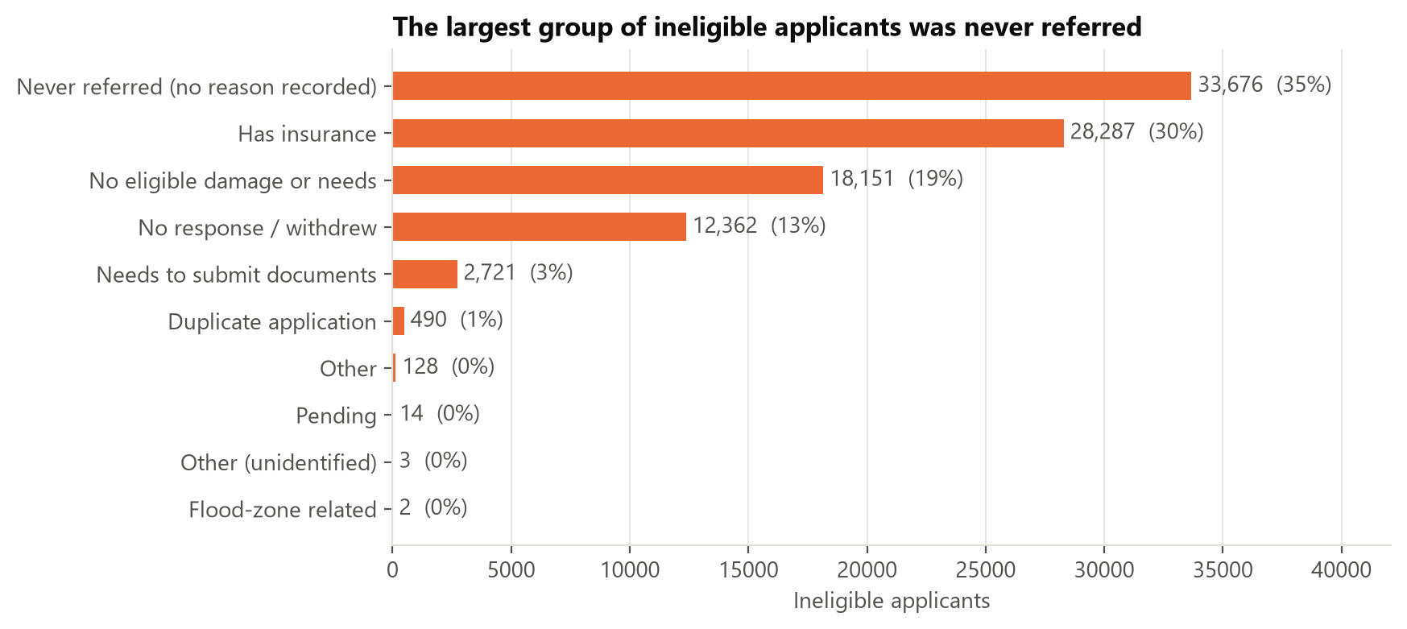
Figure 2.2. Why applicants were not awarded aid.
The question our model answers: Given what we know about an applicant, will FEMA award them IHP aid?
Why it matters. Applicants wait for answers while caseworkers are overloaded. A reliable prediction could help FEMA:
- (a) route likely eligible applications to fast track;
- (b) flag applications that are likely ineligible early, so staff can tell people what is missing (for example, insurance documents);
- (c) decide where to send inspectors first;
- (d) plan staffing and budget for the next disaster.
What it is not. The model is decision support. It must never automatically deny anyone aid. A person makes every final decision.

2.2 Business objectives and success criteria
Objective | How we will measure it | Proposed target
Predict if someone gets aid right when they apply (Tier 1) | ROC-AUC and F1 on the held-out test set | Beat the untuned baseline: ROC-AUC ≥ 0.90, F1 ≥ 0.91
Predict if someone gets aid after the inspection (Tier 2) | Same as above | ROC-AUC ≥ 0.94
Do better than the simple approaches | Compare against just guessing the majority class and against logistic regression | Clearly beat both (guessing the majority class gets 50.7% accuracy; the logistic-regression reference is re-run on the verified data, see Section 5.1)
Be fair to every group | Error rates for each age band and income band | No group's error rate is more than 5 percentage points above the overall rate
Be explainable | Feature-importance and partial-dependence plots that a caseworker could actually read | The main drivers line up with FEMA's own eligibility rules

Note. These targets were set from earlier untuned baselines that must be re-run on the verified data (Section 5.1) before they are confirmed. They are goals for the tuned models, not promises.

2.3 Stakeholder analysis
Stakeholder | Interest | Cost of a wrong prediction
Applicants (survivors) | Quick and fair decisions that they can understand | A household wrongly flagged as "ineligible" (a false negative) might just give up on a claim they deserve
FEMA caseworkers and program managers | Getting through applications fast and accurately, with decisions they can defend | Wasted inspections (false positives), or eligible people getting missed
Lee County emergency management, State of Florida | Faster recovery and being able to plan their resources | Misjudging how much help is needed
Congress, auditors, taxpayers | Federal money being used properly | Improper payments or denials that nobody can explain
Equity and legal-aid organizations | No group being treated worse than another | Bias against certain ages, income levels, or places
Our team / instructor | A solid method and honest reporting | n/a

2.4 Expected impact and value proposition
A tuned, audited model would give FEMA an explainable signal at registration that also comes in early, when information is cheapest to act on. Its value is speed and prioritization, not replacing judgment. Because the outcome depends partially on FEMA's own screening rules, the model also works as a consistency check: applications where the model strongly disagrees with the outcome deserve a second check.

2.5 Risks and assumptions
- Selection bias: only valid registrations are in the data, so we can say nothing about invalid applications.
- Scope / generalization: one storm and one county, so results may not transfer to other disasters.
- Label noise: "not eligible" mixes many reasons (insurance, missing documents, withdrawal, never referred).
- Fairness: age, income, and location can correlate with vulnerable groups, so we will audit error rates by group.
- The flat $700 payment (confirmed): the $700 award is FEMA's Serious Needs Assistance, a one time and flexible payment per household for urgent needs: food, water, and medication, approved soon after registration (FEMA, Serious Needs Assistance fact sheet). Because it can be approved early and follows a simple rule, part of what our model learns is this screening part.

3. Data Understanding
Full analysis: notebooks/eda/01_initial_eda.ipynb (exported as reports/milestone_1/eda_notebook.html). Column-by-column definitions: docs/data_dictionary.md (Appendix A).

3.1 Dataset description and source
Our data comes from FEMA's Individuals and Households Program – Valid Registrations (v2), a public government dataset drawn from FEMA's National Emergency Management Information System (NEMIS). We downloaded the data from FEMA's public data site using our script src/data/fetch_fema.py, keeping it to Hurricane Ian (DR-4673) and to applicants in Lee County. The data was pulled with a Python script and then looked at and summarized. An AI tool wrote the first pass of the analysis. We then re-ran it on the verified data and checked every number against the data file. The size of the data is 194,482 rows by 100 columns, with applications dated 2022-09-27 to 2023-01-12, and it has both numeric and categorical columns. One row is one household's application, which is our unit of observation. FEMA warns that this is raw data that has human error. It includes only valid registrations. Overall, the dataset is large enough for k-fold cross-validation with plenty of rows in every fold, but because it covers a single disaster, it limits generalization.

3.2 The target variable
Our target is ihpEligible, which is True when FEMA awarded the household housing and/or other-needs aid. Whether or not FEMA gives a household aid, yes or no, is the answer our model tries to predict. The classes are almost even, with 98,648 eligible (50.7%) and 95,834 not eligible (49.3%) (Figure D.1). Overall, about half got aid and half didn't, so the accuracy is a fair score and no SMOTE is required for this dataset. Each piece of the data we train and test on is stratified, so it keeps that same 50.7 / 49.3 mix.

3.3 Feature roles and data leakage
We sorted all 100 columns into roles, recorded in src/utils/columns.py, which is the one file the whole team uses for this:
Role | Columns | Meaning
Target | 1 | ihpEligible
Tier 1: application-time | 26 | Self-reported at registration
Tier 2: later-stage | 14 | Learned after inspection or verification
Leakage | 43 | Results of the decision; never used
ID / constant | 15 | Identifiers, or identical on every row
Under review | 1 | utilitiesOut, held out of both tiers for now

Tier 1 has 26 columns, but only 25 features, because damagedCity gets dropped and appliedDate turns into daysSinceLandfall. Tier 2 is Tier 1 with an additional 14 columns, resulting in 39 features total. We're not using utilitiesOut yet. It's almost never blank, but when it is, nearly everyone gets approved. That's suspicious and looks like leakage, as it is blank for only 2.7% of rows, but 99.9% of those rows were approved.
We checked each column one at a time to see how closely it matches the answer (Figure 3.1). The score is called Cramér's V, where 0 is no match and 1 is a perfect match. Three columns that are results of FEMA's decision score very high: ihpAmount 1.00, onaEligible 0.95, ineligibleReason 0.70. However, the best normal column only gets 0.46, so anything scoring near 1 is leakage.
The borderline case is the currentLocation variable. It includes things that happen because of aid ("FEMA-provided unit" is 99% eligible), so it was moved from Tier 1 to Tier 2 to keep the model honest. Overall, a good score only means something if the model uses information that would actually be available when the prediction is made, which is why we split the features into two tiers.
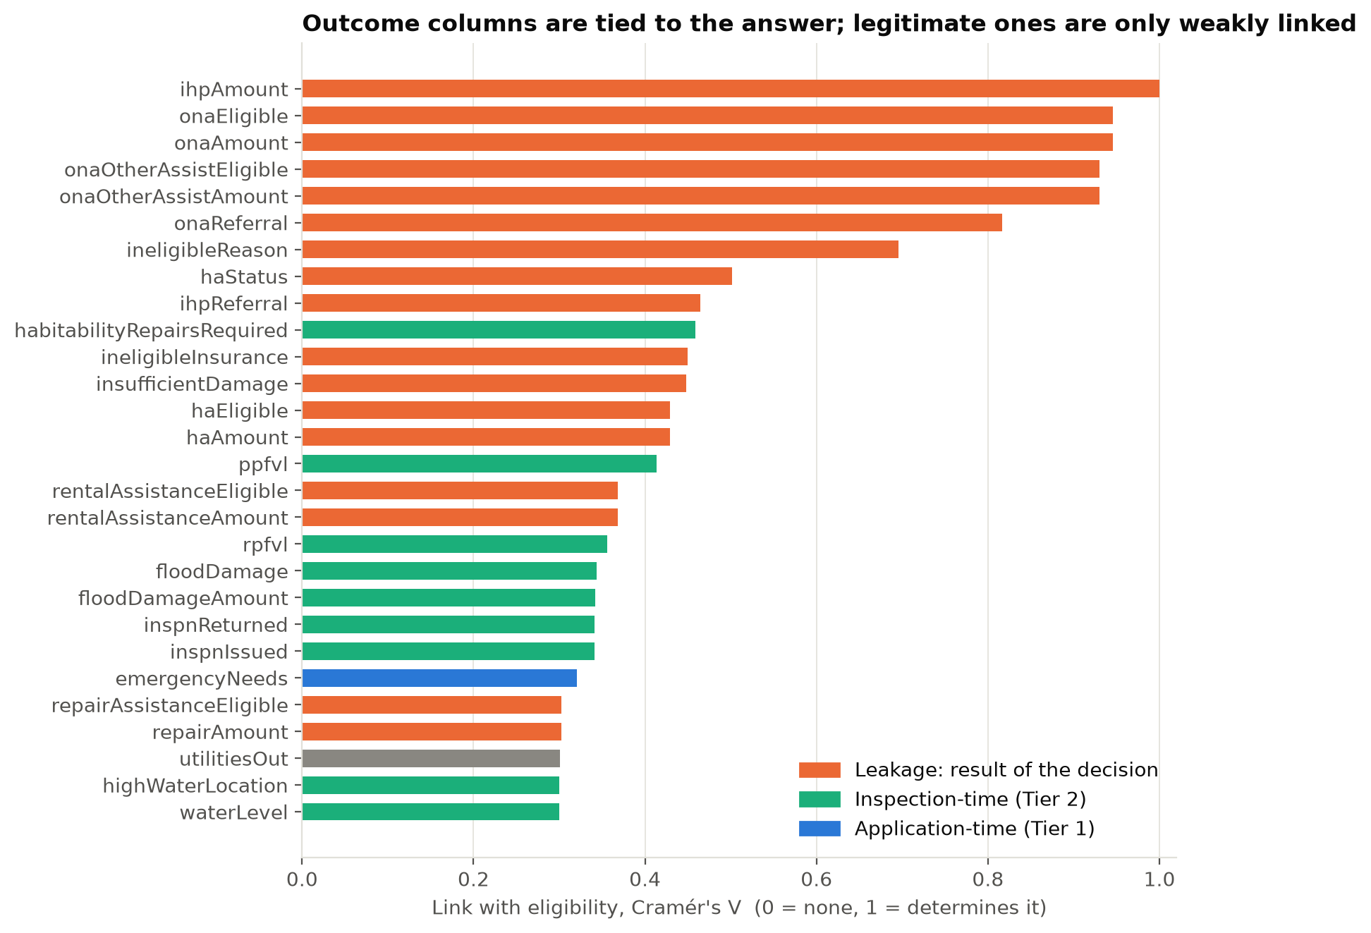
Figure 3.1. Each column's link with eligibility (Cramér's V). Leakage columns sit at the top.

3.4 Summary statistics and distributions
Most applicants were older people in small households who owned their homes and applied online: 57% are 50 or older, most households have one or two people, 64% own their home, and 77% registered online or through the mobile app (Figure D.2). The damage numbers are skewed. rpfvl, the real-property loss FEMA verified, is $0 for about 83% of applicants, and the other 17% are spread out with some very large amounts. ZIP code has high cardinality, with about 560 different values, which is too many to give each one its own column. Overall, we log transform the damage columns to shrink the skew and add a yes/no "has damage" flag, and we frequency-encode ZIP codes instead of giving each ZIP its own column.

3.5 Relationships with the target
Some features change the chance of approval a lot (Figure 3.2). If the home isn't the applicant's primary residence, they are basically never approved (about 0.4%). Reporting emergency needs makes approval more likely (66% vs. 34%). Having homeowners insurance makes it less likely (47% vs. 55%), since FEMA doesn't pay for damage that insurance already covers. Higher income also lowers the odds, from 61% under $15k to 45% above $175k, although the $0-income group is the lowest at 42%. At Tier 2, applicants whose inspection was completed were approved 73% of the time versus 38% otherwise. Approval also varies by ZIP code, and it falls from 65% for people who applied in the first week after landfall to 19% by week 5 (Figures D.3 and D.4). Overall, several of the strongest signals work more like yes/no rules than gradual trends, so tree-based models such as decision trees and random forests should fit this data well. Income stays an unordered category, because the $0 group breaks the usual "more income, less aid" pattern.
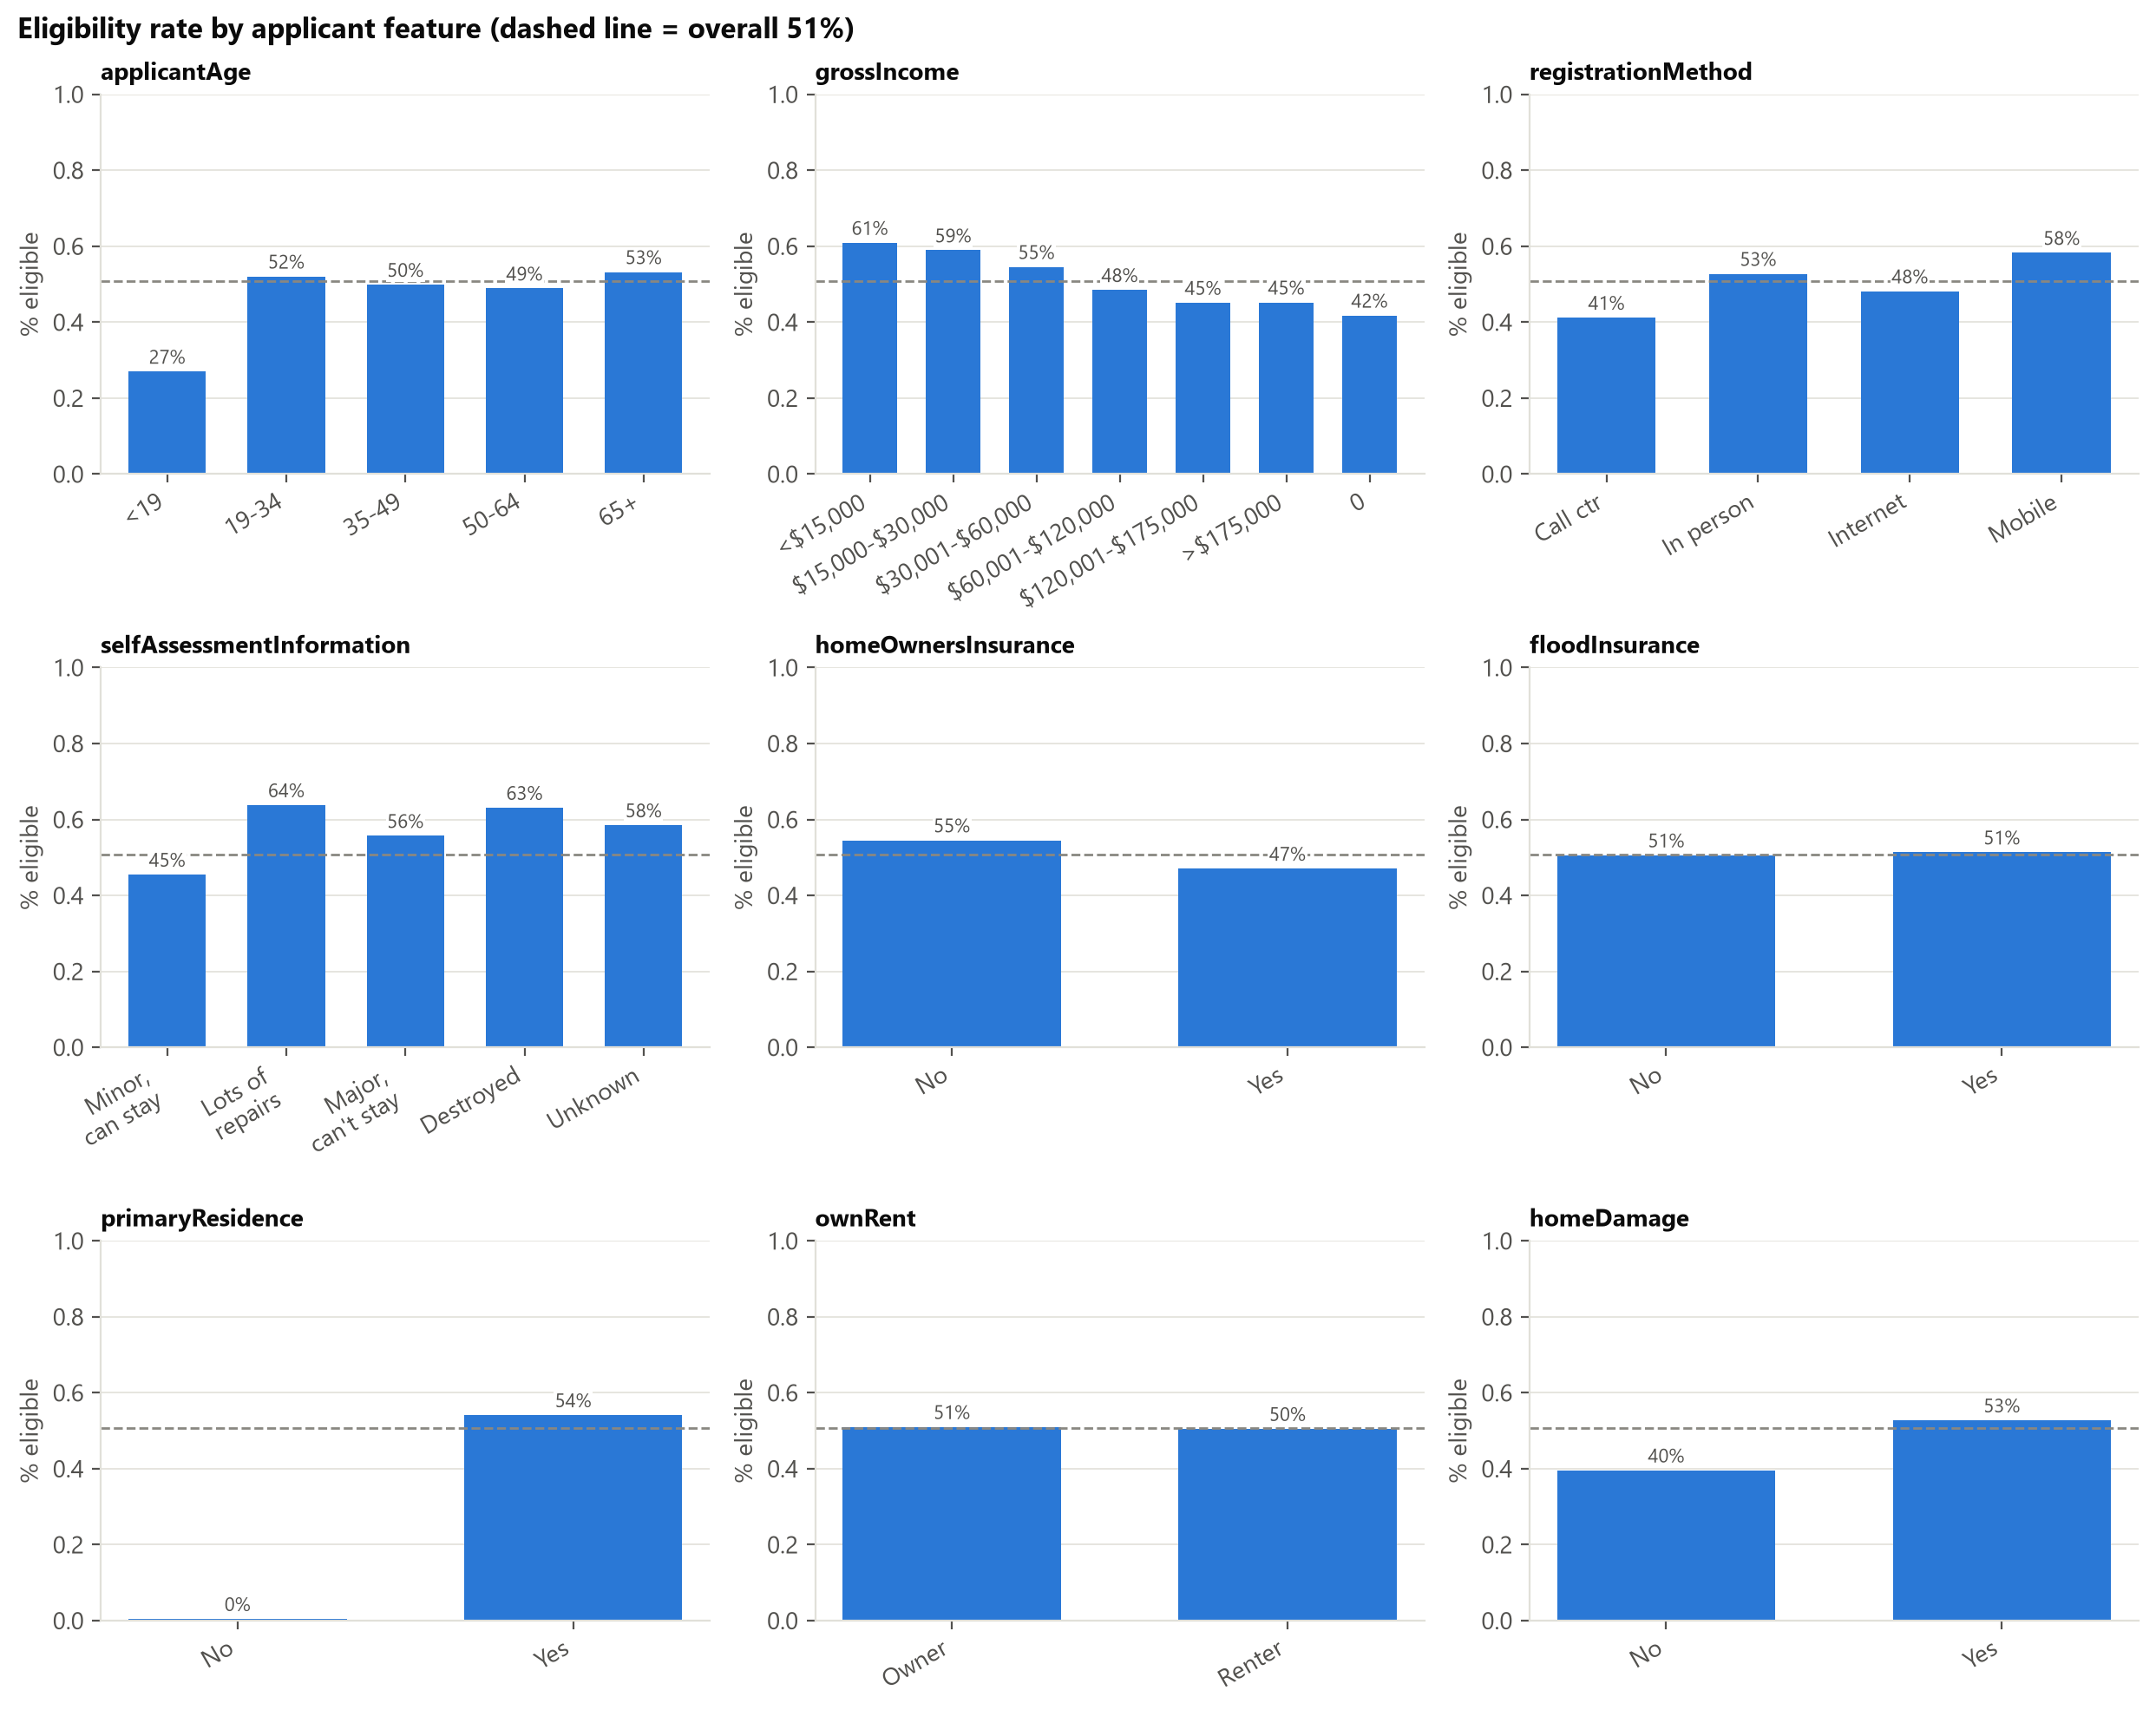
Figure 3.2. Eligibility rate within each category of key features.

3.6 Missing values
Nineteen columns have missing values. Eleven of them are columns we could use as features, and six are more than 10% missing (Figure D.7):
Column | Missing | Likely reason it's blank
renterDamageLevel | 96% | Only applies to renters
highWaterLocation | 88% | Only applies where there was a flood mark
shelterNeed | 82% | Almost always "yes" when filled in, so blank ≈ not reported
habitabilityRepairsRequired | 73% | Not filled in for most applicants (reason not confirmed)
foodNeed | 52% | Almost always "yes" when filled in, so blank ≈ not reported
selfAssessmentInformation | 15% | Applicant's own damage rating, left blank by some

Many of these blanks mean something, so the data is not missing completely at random. Overall, filling the blanks with an average would throw away that information, so we add a yes/no "was this blank?" column for these features, and fill any remaining gaps inside the pipeline using only the training data.

3.7 Correlation analysis
No single numeric feature has a strong straight-line relationship with approval. The strongest correlation is only about 0.36 (Figure D.5). Not a single column predicts the answer confidently alone, so the model will probably need several columns working together, which will be tested in Milestone 2. Some features are near-copies of each other (Figure D.6): inspection issued vs. inspection completed (1.00), verified home damage vs. flood damage amount (0.97), and reported damage vs. home damage (0.83). Overall, the near-copy pairs are multicollinearity, so we drop one from each pair for linear models like logistic regression, while tree-based models can keep both.

3.8 Data quality assessment
Check | What we found | What we do
Constant columns | 14 columns have the same value on every row (one disaster, one county) | Drop them
Duplicates | 407 rows (0.21%) match on every non-ID column, likely different households with the same answers | Keep them
Location errors | 6,357 rows (3.3%) have a census block outside Lee County (2,707 are NO_INTERSECT); only 17 have a non-Florida ZIP | Keep them; treat NO_INTERSECT as its own category
Hand-typed city names | Many spellings (FT MYERS, FT MYERS BCH) | Drop the city column
Impossible values | A flood depth of 960 inches (80 feet) | Cap it at a reasonable max
Dates | Only 2 applications dated before the disaster was declared | Keep them

Overall, the data quality is good, and every problem has a specific fix that carries into the Data Preparation Plan (Section 4).

3.9 Challenges and limitations
Leakage, skew, meaningful blanks, and near-copy features are covered above. The remaining limits are:
Challenge | Why it matters for the model
One storm, one county | A model trained here may not work for other disasters (generalization)
Valid registrations only | Selection bias: we can't say anything about applications that never made it in
"Not eligible" covers many reasons | Label noise: one "no" can mean very different things
Approval partly follows FEMA's own rules | A high score doesn't prove the model understands who actually needs help

Overall, none of these issues bring the project to a halt, but it does affect how we build/score the model. Sections 4 and 5 explain how we deal with them.

4. Data Preparation Plan
✏️ Owner note. Each row in 4.1 should answer a problem raised in Section 3. The cleaning code already exists and is shared: src/features/prepare.py.

4.1 Data cleaning strategy
Issue (from §3) | Decision
Leakage, IDs, constants (58 columns) | Drop (listed in §3.3)
utilitiesOut (under review) | Hold out of both tiers until FEMA confirms when it is filled in (§3.6)
damagedCity (hand-typed) | Drop; use ZIP and census block instead
Yes/No columns stored as text with blanks | Convert to 0/1; keep blanks as truly missing (not 0)
Ordered ranges (applicantAge, household counts) | Ordinal encoding (>5 becomes 6)
Income bracket | Keep as an unordered category (the "$0" group breaks the ordering)
Missing values | Do not fill in during cleaning. Use missing indicators plus median imputation (linear models) or native handling (boosting), fit on training data only
Implausible values (waterLevel = 960 in) | Cap at a high percentile
Out-of-county blocks | Keep; treat NO_INTERSECT as its own category
Duplicate-looking rows | Keep (see §3.8)

4.2 Feature engineering
- daysSinceLandfall from the application date (already built).
- Log transform (log1p) of the skewed dollar and damage columns, plus "has damage" yes/no flags.
- Missing-value indicators for the columns whose blanks carry meaning.
- ZIP and census block: frequency encoding first, with target encoding tested inside cross-validation folds.
- Group rare categories together; drop one of each near-duplicate pair for linear models.
- Possible interaction features, such as emergency needs × primary residence, to test in Milestone 2.

4.3 Data transformation
Scaling (standardization) and one-hot encoding are applied only for models that need them (logistic regression, and any distance-based method). Tree-based models use the unscaled data. Every transformation that learns from data (imputation, scaling, encoding) is fit on the training split only, inside a scikit-learn Pipeline, to prevent a second kind of leakage (train–test contamination).

4.4 Train / validation / test strategy
- Stratified split, 60% train / 20% validation / 20% test, with fixed random seed 42 so everyone gets the same split. Each part keeps the same 50.7% / 49.3% mix. Implemented in split_data().
- The test set is touched once, at the very end of Milestone 2.
- Cross-validation (Section 5.3) uses the 80% development set (train + validation); the 20% test set stays sealed.
- Robustness check (temporal validation): because applications arrive over time, we will also train on early applicants and test on later ones to see whether performance holds up.
- We cannot link applications from the same household, so we note this as a limitation.

5. Modeling Approach
✏️ Owner note. Justify each model by a property of our data from Section 3 (skew, interactions, rule-like signals), not by general reputation.

5.1 Algorithm selection and justification
Model | Why it fits this data
Logistic regression | Simple, fast, interpretable coefficients; the baseline to beat
Decision tree | Human-readable rules, and FEMA's process is rule-like
Random forest | Robust to skew, mixed types, and outliers; bagging reduces a single tree's variance (overfitting)
Gradient boosting | Captures the feature interactions suggested in §3.7 and the rule-like thresholds in §3.5
[TEAM: add or remove models based on what the course has covered, e.g. k-NN or a neural network]

Baselines are not yet re-run on the verified data. The earlier untuned results came from src/models/baseline.py on an earlier download, and the EDA notebook no longer reproduces them. [TEAM: re-run the baselines on the verified data and insert ROC-AUC, accuracy, and F1 for Tier 1 and Tier 2 here.]
Reference | ROC-AUC | Accuracy | F1
Always guess the majority class (50.7% eligible) | 0.500 | 0.507 | 0.000

5.2 Evaluation metrics
Metric | Why we use it
ROC-AUC (primary) | Measures ranking quality regardless of the decision threshold; suitable because the classes are balanced
Precision, Recall, F1 | A false "ineligible" and a false "eligible" have different real-world costs, so we report both and choose the decision threshold explicitly
Accuracy | Fair here because of the class balance
Confusion matrix | Shows exactly where the errors fall
Group error rates (age, income) | Fairness audit (target in §2.2)

5.3 Cross-validation and hyperparameter tuning
Five-fold stratified cross-validation on the development set. Randomized hyperparameter search runs inside the folds. Every model uses the same folds so comparisons are fair. The test set is used once, for the final score.

5.4 Expected challenges and mitigation
Challenge | Mitigation
Hidden leakage as scores get high | Keep the roles file as the single source of truth; repeat the "drop a feature group and see what moves" ablation study for every final feature set (the EDA's location check is what moved currentLocation out of Tier 1)
Very high-cardinality geography | Frequency / target encoding fit inside folds; compare with and without
Skewed, mostly-zero damage columns | Log transform plus flags; prefer tree models
Model just re-learns FEMA's rules | Say so honestly; report cases where the model disagrees with outcomes as the interesting ones
Fairness across age / income / place | Report group error rates; investigate any gap over 5 points
Results specific to one storm | State the scope; run the temporal robustness check

6. Project Timeline
Dates | Work | Owner
Sep 14–27 | Project setup, data download, first EDA and report draft | All
Sep 28–Oct 6 | Section writing; EDA notebook rebuilt on the verified data | All
Oct 7 | Milestone 1 due | All
Oct 8–21 | Finish the preprocessing pipeline (feature engineering, encoders) and the notebooks/preprocessing notebook | All
Oct 22–31 | Re-run baselines, train all models, cross-validate, tune hyperparameters | All
Nov 1–10 | Evaluation: model comparison, interpretation (feature importance), leakage ablations, fairness audit | All
Nov 11–18 | Write the final report; build the presentation; rehearse | All
Nov 19 | Internal freeze: code runs top to bottom, PDF exported | All
Nov 21 | Milestone 2 due | All
Nov 23 / Dec 2 | Presentation (15 min + Q&A) | All

Team responsibilities for Milestone 2. Daniel Ortiz leads data preparation and model training. Anthony Stoneking leads the data analysis updates, leakage checks, and model evaluation. Nandor Laar leads the business value and fairness review and the final report. Everyone contributes to every phase and attends the presentation.
Risks and contingencies
Risk | Contingency
A teammate is unavailable | Everything is in Git with documented code, so work can be picked up; weekly check-ins
Scores drop below the baseline after removing leaky features | Report honestly; the leakage-removal story is itself a finding
Merge conflicts in shared notebooks | One person per notebook at a time; small commits; pull before starting
Running out of time before Nov 21 | Freeze the model set by Oct 31; drop optional models first

Appendices
- A. Data dictionary (docs/data_dictionary.md)
- B. EDA notebook export (reports/milestone_1/eda_notebook.html)
- C. AI usage log (docs/AI_USAGE.md)
- D. Additional figures (reports/figures/)

Appendix D. Additional figures for Section 3
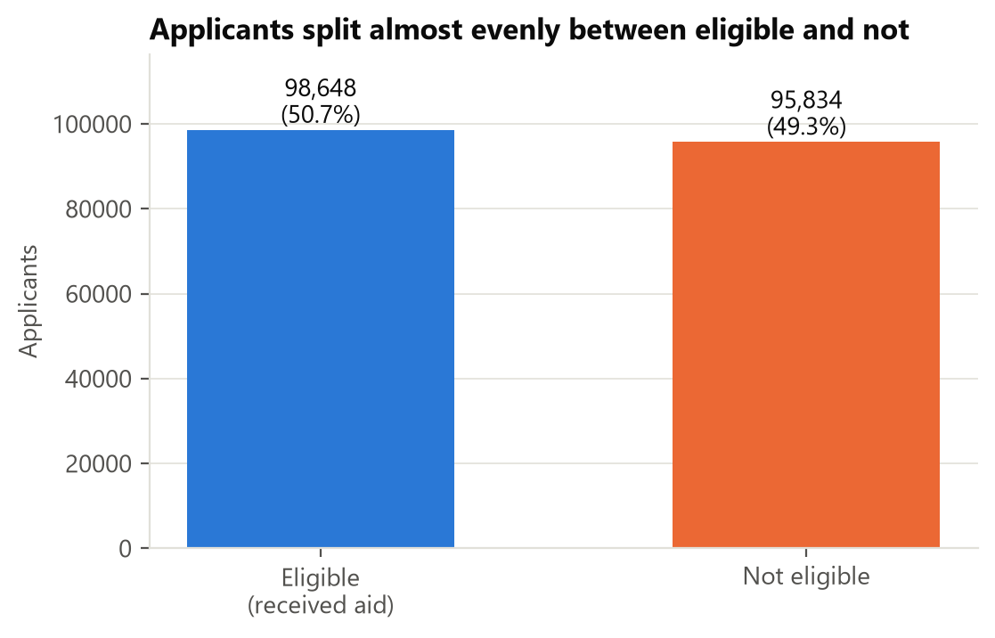
Figure D.1. Class balance of ihpEligible.
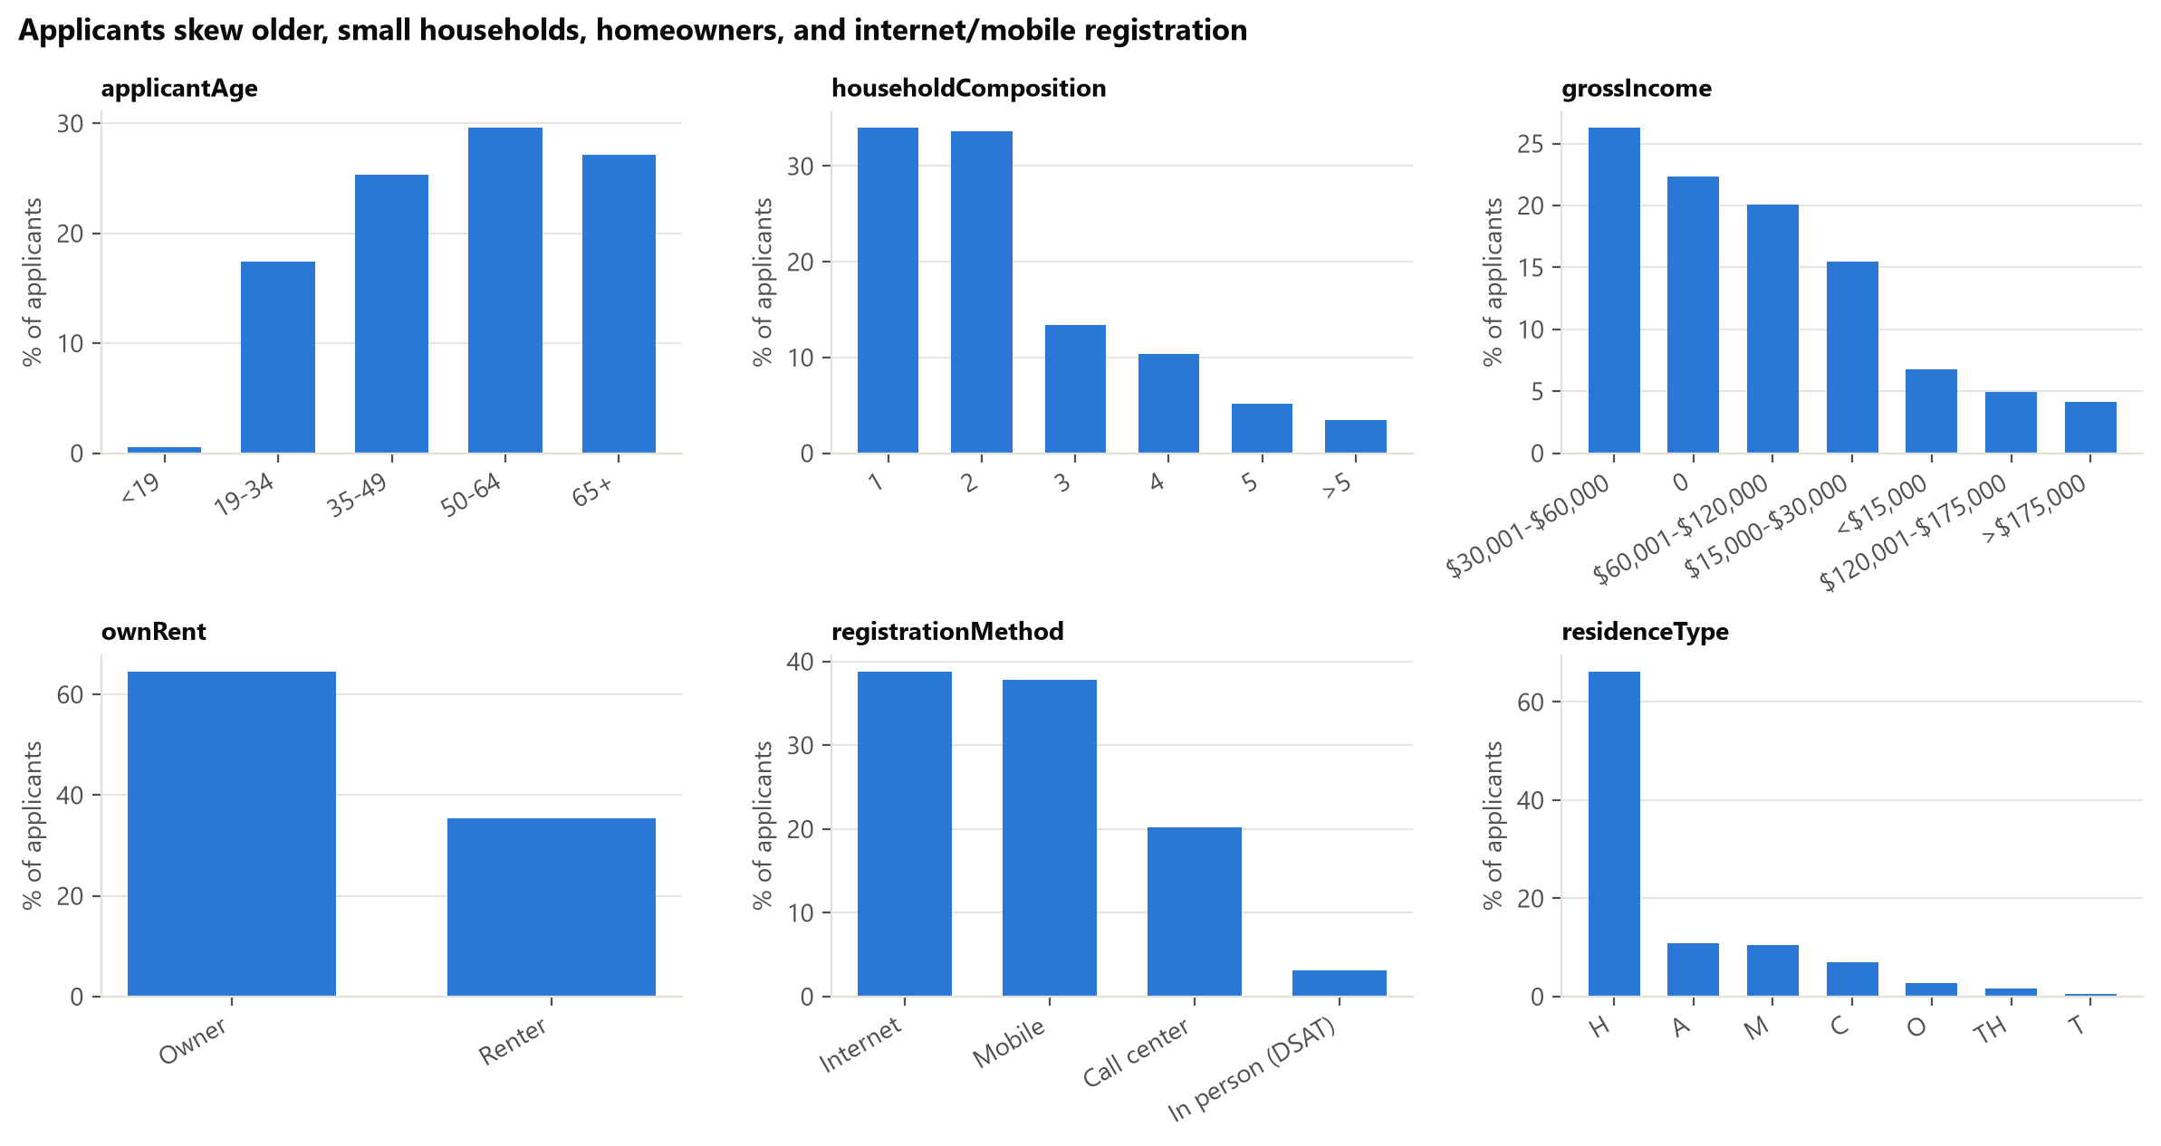
Figure D.2. Age, household size, ownership, and registration method.
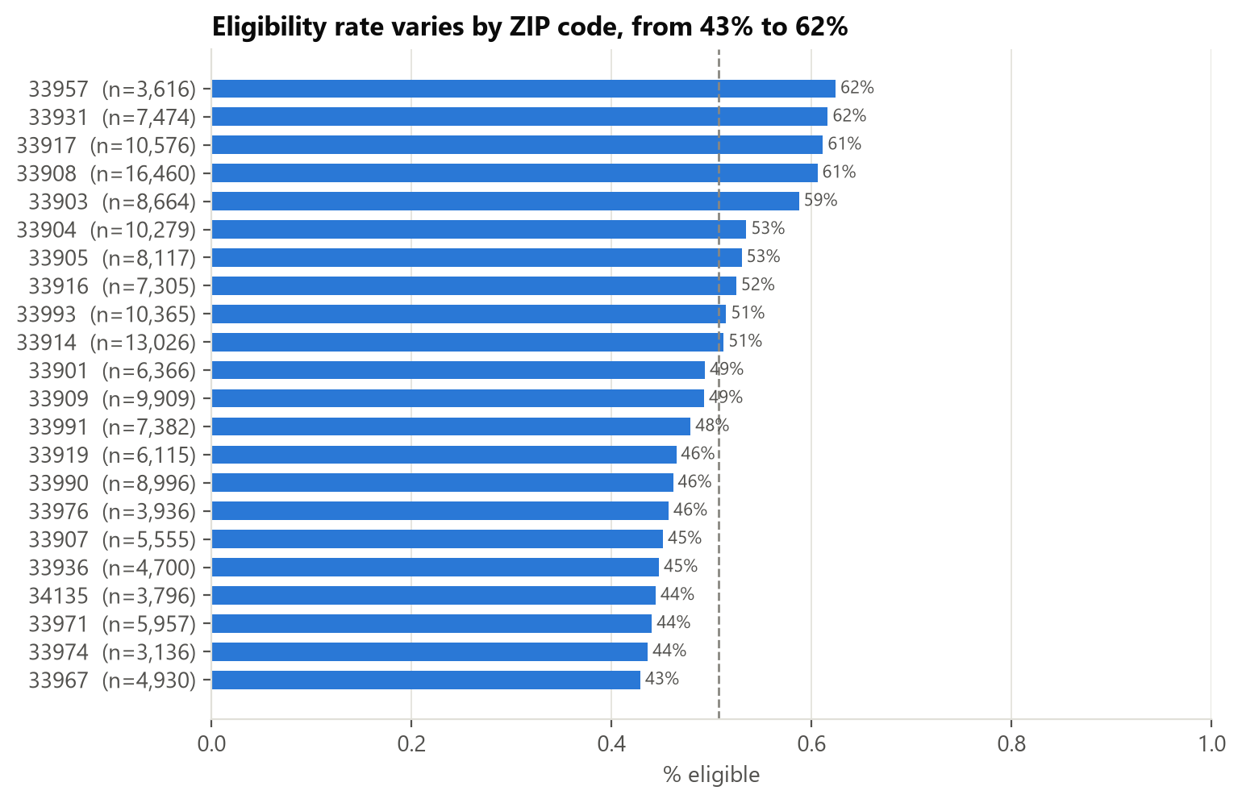
Figure D.3. Eligibility across the 22 largest ZIP codes.
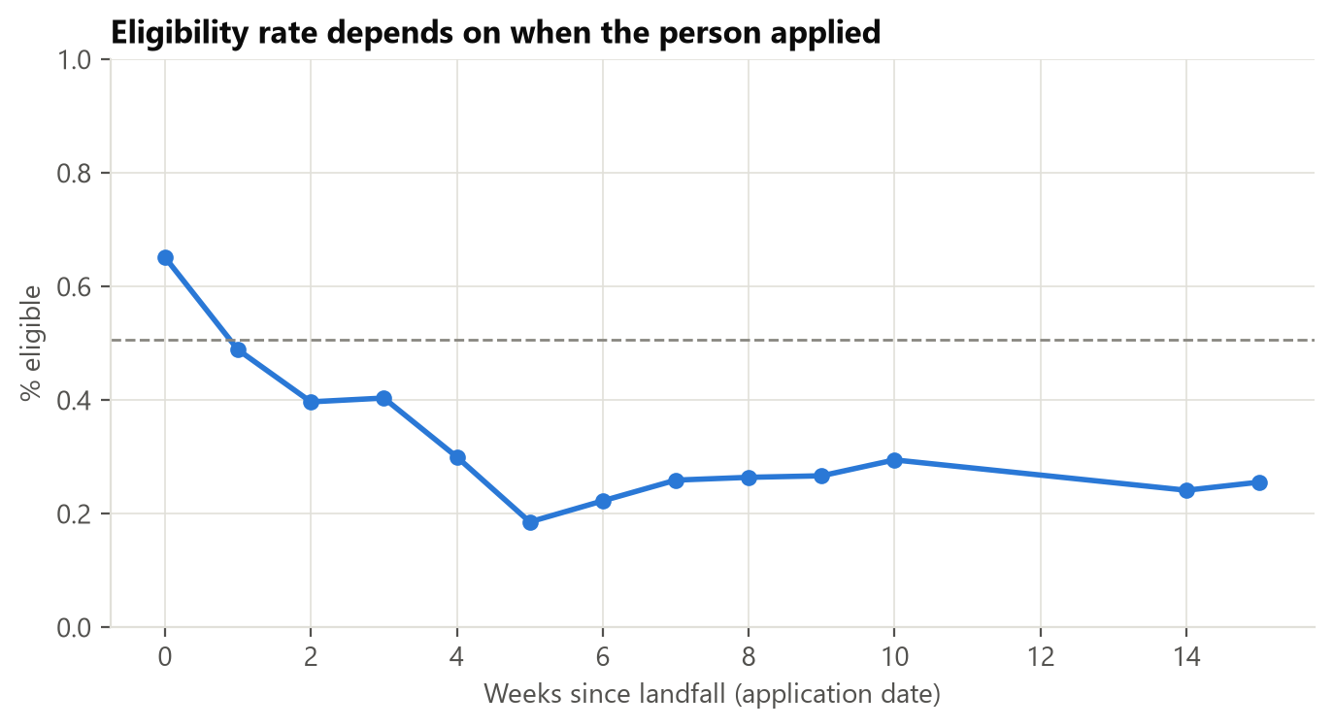
Figure D.4. Eligibility by week of application.
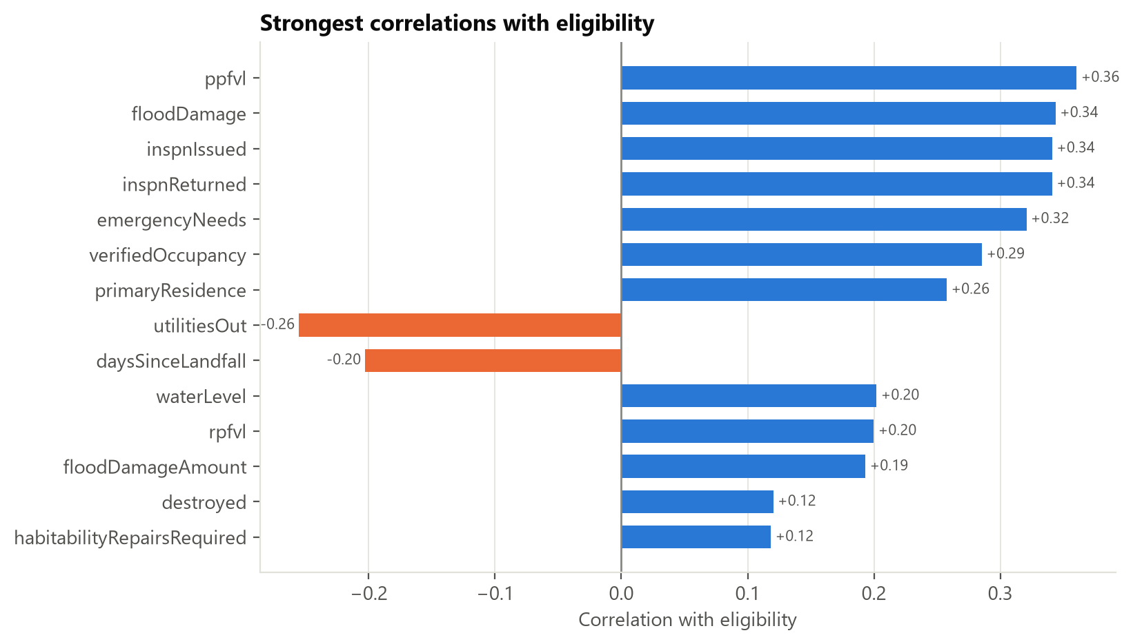
Figure D.5. Correlation of each numeric feature with the target.
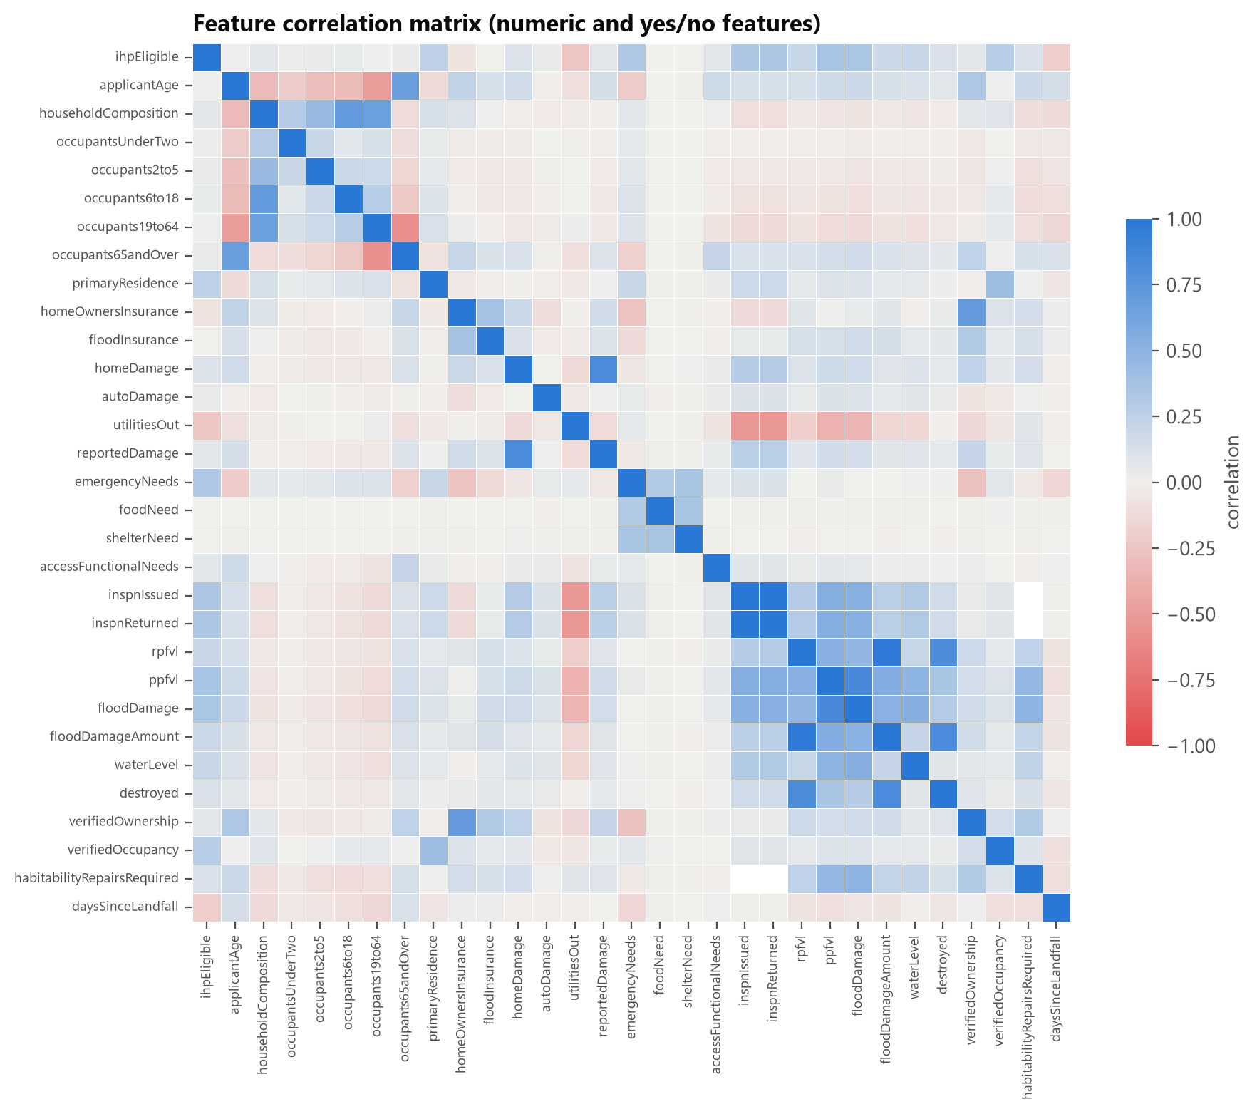
Figure D.6. Feature-to-feature correlations.
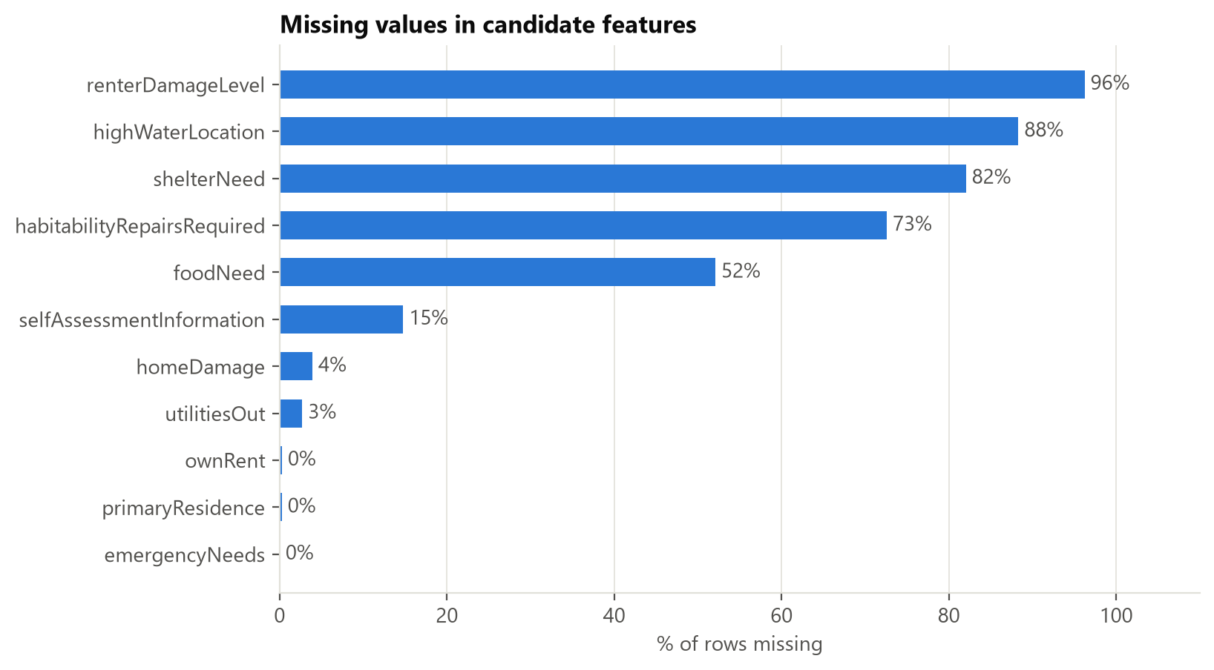
Figure D.7. Share of missing values per column.

References
FEMA. OpenFEMA Dataset: Individuals and Households Program – Valid Registrations v2. https://www.fema.gov/openfema-data-page/individuals-and-households-program-valid-registrations-v2
FEMA. Serious Needs Assistance (fact sheet). https://www.fema.gov/fact-sheet/serious-needs-assistance-0

AI-use disclosure
Portions of the code, analysis, and this draft were produced with Claude Code (Anthropic) and reviewed by the team. See docs/AI_USAGE.md for the full log.

