Predicting FEMA Disaster-Assistance Eligibility: Hurricane Ian, Lee County, FL
CAI 4105 Machine Learning, Fall 2026, Project Milestone 1: Initial Report
Team FEMA | Anthony Stoneking, Daniel Ortiz, Nandor Laar | Due Wednesday, October 7, 2026

1. Executive Summary
Our project is trying to predict whether FEMA gives a household aid after Hurricane Ian, specifically in Lee County, FL. The data that we're using is directly from FEMA, the 194,482 applications and 100 columns, with a near 50/50 split of those who received aid and those who didn't.
One of the most important things we found was that 43 out of the 100 columns are results of FEMA's decision, leakage, so we can't use them. We separate it into two tiers. Tier 1: 25 features known at registration, and Tier 2: 39 features that are known after inspection.
The plan is to do a 60% train, 20% validation, and 20% test split, try four models to see how it changes, do a 5-fold cross-validation, and score with ROC-AUC. We cross-validate so that we can see how much the score changes from run to run, so that we aren't basing our model off of one run. What's next is to build and test models for Milestone 2.

2. Business Understanding

2.1 Problem definition and motivation
Our analysis
After a big hurricaine like Ian back in 2022, tens of thousands of people and households applied for federal aid within days of the disaster. In Lee county, applications peaked September 30th, 2022 (15,240 in one day), and 94% arrived by the end of October (Figure 2.1). Each application goes through a referral, documentation checks, with sometimes an inspection and a decision. Around half of the people end without an award and for various reasons: 30% of those had insurance, 19% had no eligible damage or needs and 13% did not respond or just withdrew from the application, and 35% were never referred to the program (Figure 2.2).
The question our model answers: Given what we know about an applicant, will FEMA award them IHP aid?
Why it matters. Applicants wait for answers while caseworkers are overloaded. A reliable prediction could help FEMA:
- (a) route likely eligible applications to fast track;
- (b) flag applications that are likely ineligible early, so staff can tell people what is missing (for example, insurance documents);
- (c) decide where to send inspectors first;
- (d) plan staffing and budget for the next disaster.
What it is not. The model is decision support. It must never automatically deny anyone aid. A person makes every final decision.
AI-assisted analysis
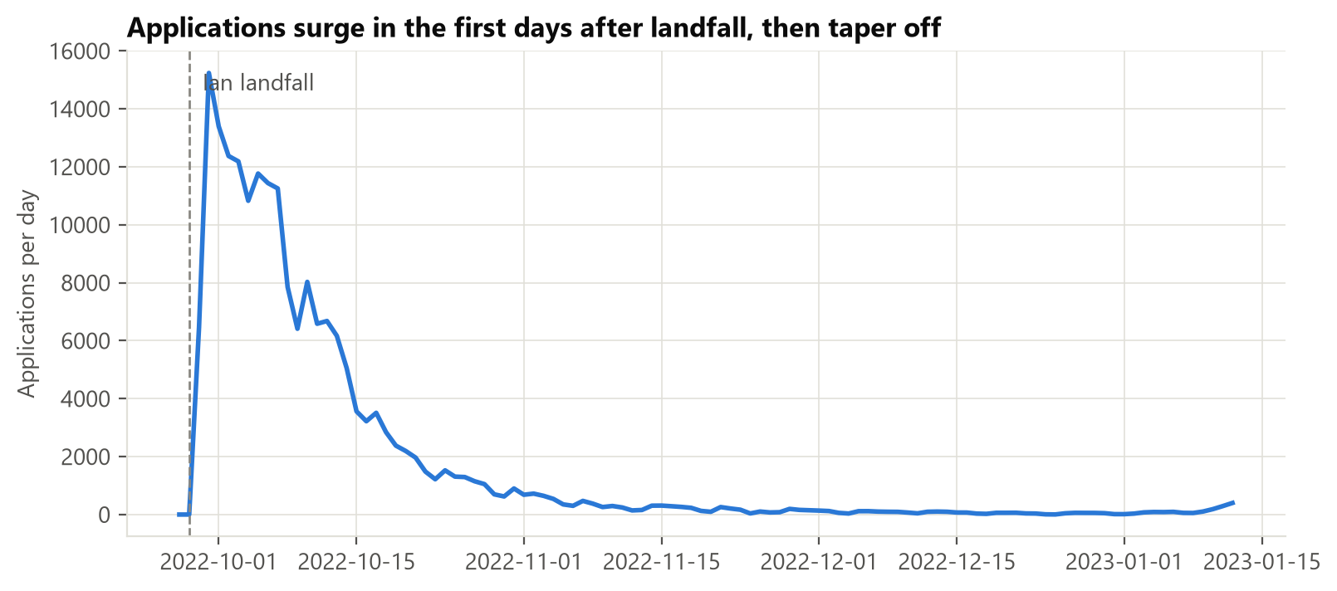
Figure 2.1. Daily applications; the peak is Sep 30, 2022.
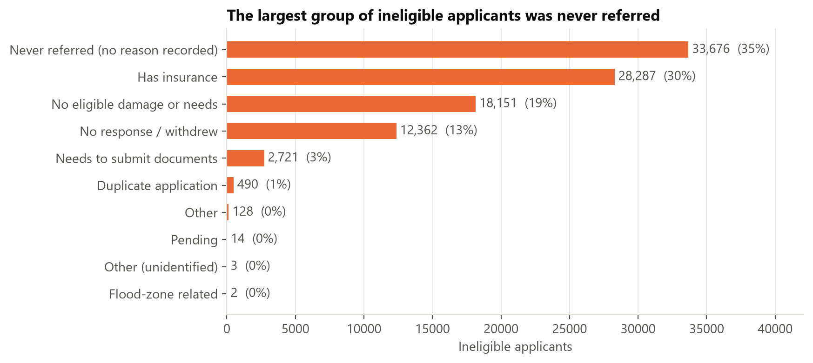
Figure 2.2. Why applicants were not awarded aid.

2.2 Business objectives and success criteria
AI-assisted analysis
Objective | How we will measure it | Proposed target
Predict if someone gets aid right when they apply (Tier 1) | ROC-AUC and F1 on the held-out test set | Beat the untuned baseline: ROC-AUC ≥ 0.90, F1 ≥ 0.91
Predict if someone gets aid after the inspection (Tier 2) | Same as above | ROC-AUC ≥ 0.94
Do better than the simple approaches | Compare against just guessing the majority class and against logistic regression | Clearly beat both (guessing the majority class gets 50.7% accuracy; the logistic-regression reference is re-run on the verified data, see Section 5.1)
Be fair to every group | Error rates for each age band and income band | No group's error rate is more than 5 percentage points above the overall rate
Be explainable | Feature-importance and partial-dependence plots that a caseworker could actually read | The main drivers line up with FEMA's own eligibility rules

Note. These targets were set from earlier untuned baselines that must be re-run on the verified data (Section 5.1) before they are confirmed. They are goals for the tuned models, not promises.

2.3 Stakeholder analysis
AI-assisted analysis
Stakeholder | Interest | Cost of a wrong prediction
Applicants (survivors) | Quick and fair decisions that they can understand | A household wrongly flagged as "ineligible" (a false negative) might just give up on a claim they deserve
FEMA caseworkers and program managers | Getting through applications fast and accurately, with decisions they can defend | Wasted inspections (false positives), or eligible people getting missed
Lee County emergency management, State of Florida | Faster recovery and being able to plan their resources | Misjudging how much help is needed
Congress, auditors, taxpayers | Federal money being used properly | Improper payments or denials that nobody can explain
Equity and legal-aid organizations | No group being treated worse than another | Bias against certain ages, income levels, or places
Our team / instructor | A solid method and honest reporting | n/a

2.4 Expected impact and value proposition
Our analysis
A tuned, audited model would give FEMA an explainable signal at registration that also comes in early, when information is cheapest to act on. Its value is speed and prioritization, not replacing judgment. Because the outcome depends partially on FEMA's own screening rules, the model also works as a consistency check: applications where the model strongly disagrees with the outcome deserve a second check.

2.5 Risks and assumptions
Our analysis
- Selection bias: only valid registrations are in the data, so we can say nothing about invalid applications.
- Scope / generalization: one storm and one county, so results may not transfer to other disasters.
- Label noise: "not eligible" mixes many reasons (insurance, missing documents, withdrawal, never referred).
- Fairness: age, income, and location can correlate with vulnerable groups, so we will audit error rates by group.
AI-assisted analysis
- The flat $700 payment (confirmed): the $700 award is FEMA's Serious Needs Assistance, a one time and flexible payment per household for urgent needs: food, water, and medication, approved soon after registration (FEMA, Serious Needs Assistance fact sheet). Because it can be approved early and follows a simple rule, part of what our model learns is this screening part.

3. Data Understanding
Each subsection has two parts so it's clear which analysis is ours and which was AI-assisted: Our analysis (written by me) and AI-assisted analysis (written with Claude from my answers). Some sentences in "Our analysis" started as AI drafts that I rewrote in my own words; the AI log (docs/AI_USAGE.md) lists them. Numbers come from notebooks/eda/01_initial_eda.ipynb.

3.1 Dataset description and source
Our analysis
Our data comes from FEMA's Individuals and Households Program – Valid Registrations (v2), a public government dataset drawn from FEMA's National Emergency Management Information System (NEMIS). We downloaded the data from FEMA's public data site using our script src/data/fetch_fema.py, keeping it to Hurricane Ian (DR-4673) and to applicants in Lee County. The data was pulled with a Python script and then looked at and summarized. An AI tool wrote the first pass of the analysis. We then re-ran it on the verified data and checked every number against the data file. Because FEMA refreshes the data weekly, the row count can drift slightly over time. The size of the data is 194,482 rows by 100 columns, with applications dated 2022-09-27 to 2023-01-12. One row is one household's application, which is our unit of observation. FEMA warns that this is raw data that has human error. It includes only valid registrations.
ML takeaway: The dataset is large enough for k-fold cross-validation without starving any fold, but because it covers a single disaster, it limits generalization.
AI-assisted analysis
None for this part beyond grammar fixes and checking the row and column counts against the data file.

3.2 The target variable
Our analysis
Our target is ihpEligible, which covers eligibility for housing and other-needs awards. Whether or not FEMA gives a household aid, yes or no, is the answer our model tries to predict. It is balanced, with 98,648 eligible (50.7%) and 95,834 not eligible (49.3%) (Figure D.1).
About half got aid and half didn't, so the accuracy is a fair score and no SMOTE is required for this dataset. Each piece of the data we train and test on is stratified, so it keeps that same 50.7 / 49.3 mix.
AI-assisted analysis
ihpEligible is True when FEMA gave the household money for housing or other needs. Stratifying means each piece of the data keeps the same mix of yes and no.

3.3 Feature roles and data leakage
We sorted all 100 columns into roles. They are listed in src/utils/columns.py, which is the one file the whole team uses for this:
Role | Columns | Meaning
Target | 1 | ihpEligible
Tier 1: application-time | 26 | What the applicant reports when signing up
Tier 2: later-stage | 14 | Learned after FEMA inspects or checks the application
Leakage | 43 | Results of the decision, so never used
ID / constant | 15 | ID numbers, or the same on every row
Under review | 1 | utilitiesOut, held out of both tiers for now

Our analysis
Tier 1 has 26 columns, but only 25 features, because damagedCity gets dropped and appliedDate turns into daysSinceLandfall. Tier 2 is Tier 1 with an additional 14 columns, resulting in 39 features total. We're not using utilitiesOut yet. It's almost never blank, but when it is, nearly everyone gets approved. That's suspicious and looks like leakage, as it is blank for only 2.7% of rows, but 99.9% of those rows were approved.
We checked each column one at a time to see how closely it matches the answer (Figure 3.1). The score is called Cramér's V, where 0 is no match and 1 is a perfect match. Three columns that are results of FEMA's decision score very high: ihpAmount 1.00, onaEligible 0.95, ineligibleReason 0.70. However, the best normal column only gets 0.46, so anything scoring near 1 is leakage.
The borderline case is the currentLocation variable. It includes things that happen because of aid ("FEMA-provided unit" is 99% eligible), so it was moved from Tier 1 to Tier 2.
ML takeaway: A score only counts if every feature would exist at the moment you make the prediction. That's why we divided the features into two tiers: Tier 1 at registration, Tier 2 after inspection.
AI-assisted analysis
This kind of check is called a univariate leakage test, which means testing one column at a time. No honest column gets close to 1 by itself, so a column that scores near 1.00 is almost surely part of the answer. Moving currentLocation also made the model more honest.
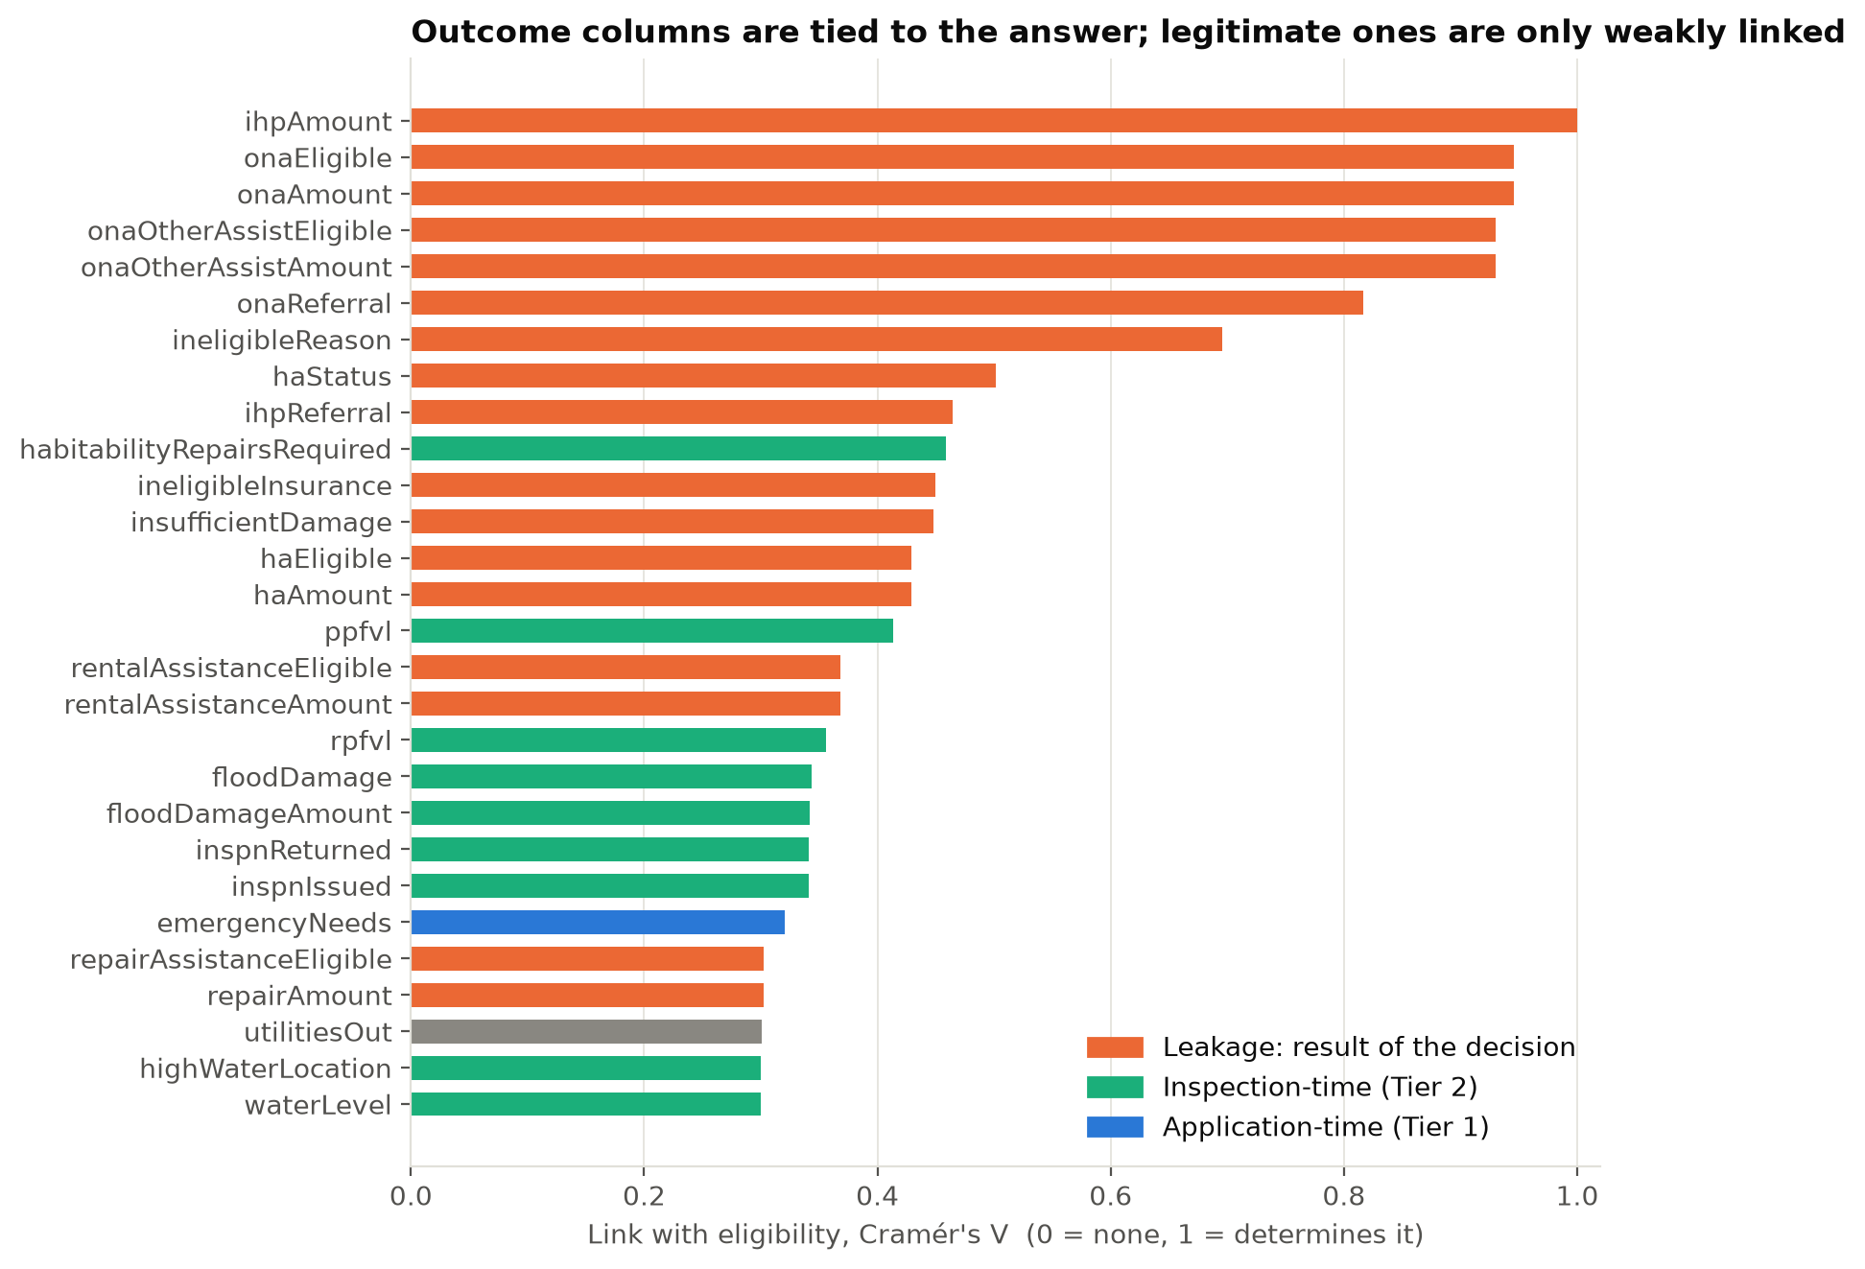
Figure 3.1. Each column's link with eligibility (Cramér's V). Leakage columns sit at the top.

3.4 Summary statistics and distributions
Our analysis
Most applicants were older people in one- or two-person households who owned their homes and applied online (Figure D.2). rpfvl reports $0 in damages for about 83% of people, and the other 17% are widely skewed with large amounts. There are too many ZIP codes in the data, so we log transform the damage skew and frequency-encode the ZIP codes.
AI-assisted analysis
In numbers: 57% of applicants are 50 or older, most households have one or two people, 64% own their home, and 77% signed up online or on the mobile app. There are about 560 different ZIP codes, which is called high cardinality. That is too many to give each one its own column. Frequency encoding swaps each ZIP for how often it shows up, so the model gets one number column instead of hundreds.
ML takeaway: We log transform the damage columns to shrink the skew and add a yes/no "has damage" column. We frequency-encode ZIP codes instead of giving each ZIP its own column.

3.5 Relationships with the target
Our analysis
If the home isn't the applicant's main home, they basically never get approved. Reporting emergency needs makes approval more likely. Having homeowners insurance makes it less likely, and so does higher income. Owning vs. renting doesn't matter.
AI-assisted analysis
The numbers behind this (Figure 3.2): homes that aren't the main home are approved about 0.4% of the time. Reporting emergency needs raises approval from 34% to 66%. Homeowners insurance lowers it from 55% to 47%, since FEMA doesn't pay for damage that insurance already covers. Approval goes from 61% for incomes under $15k down to 45% above $175k, but the $0-income group is the lowest at 42%. Owners and renters are almost the same (51% vs. 50%). At Tier 2, people whose inspection was finished were approved 73% of the time, compared to 38% for everyone else. Approval also runs from 43% to 62% across the 22 biggest ZIP codes (Figures D.3 and D.4).
ML takeaway: Some of the strongest features work like yes/no rules instead of slow trends, like the main-home rule and the $0-income group. So tree-based models like decision trees and random forests should fit this data well. Income stays a category with no order, because the $0 group breaks the usual "more income, less aid" pattern.
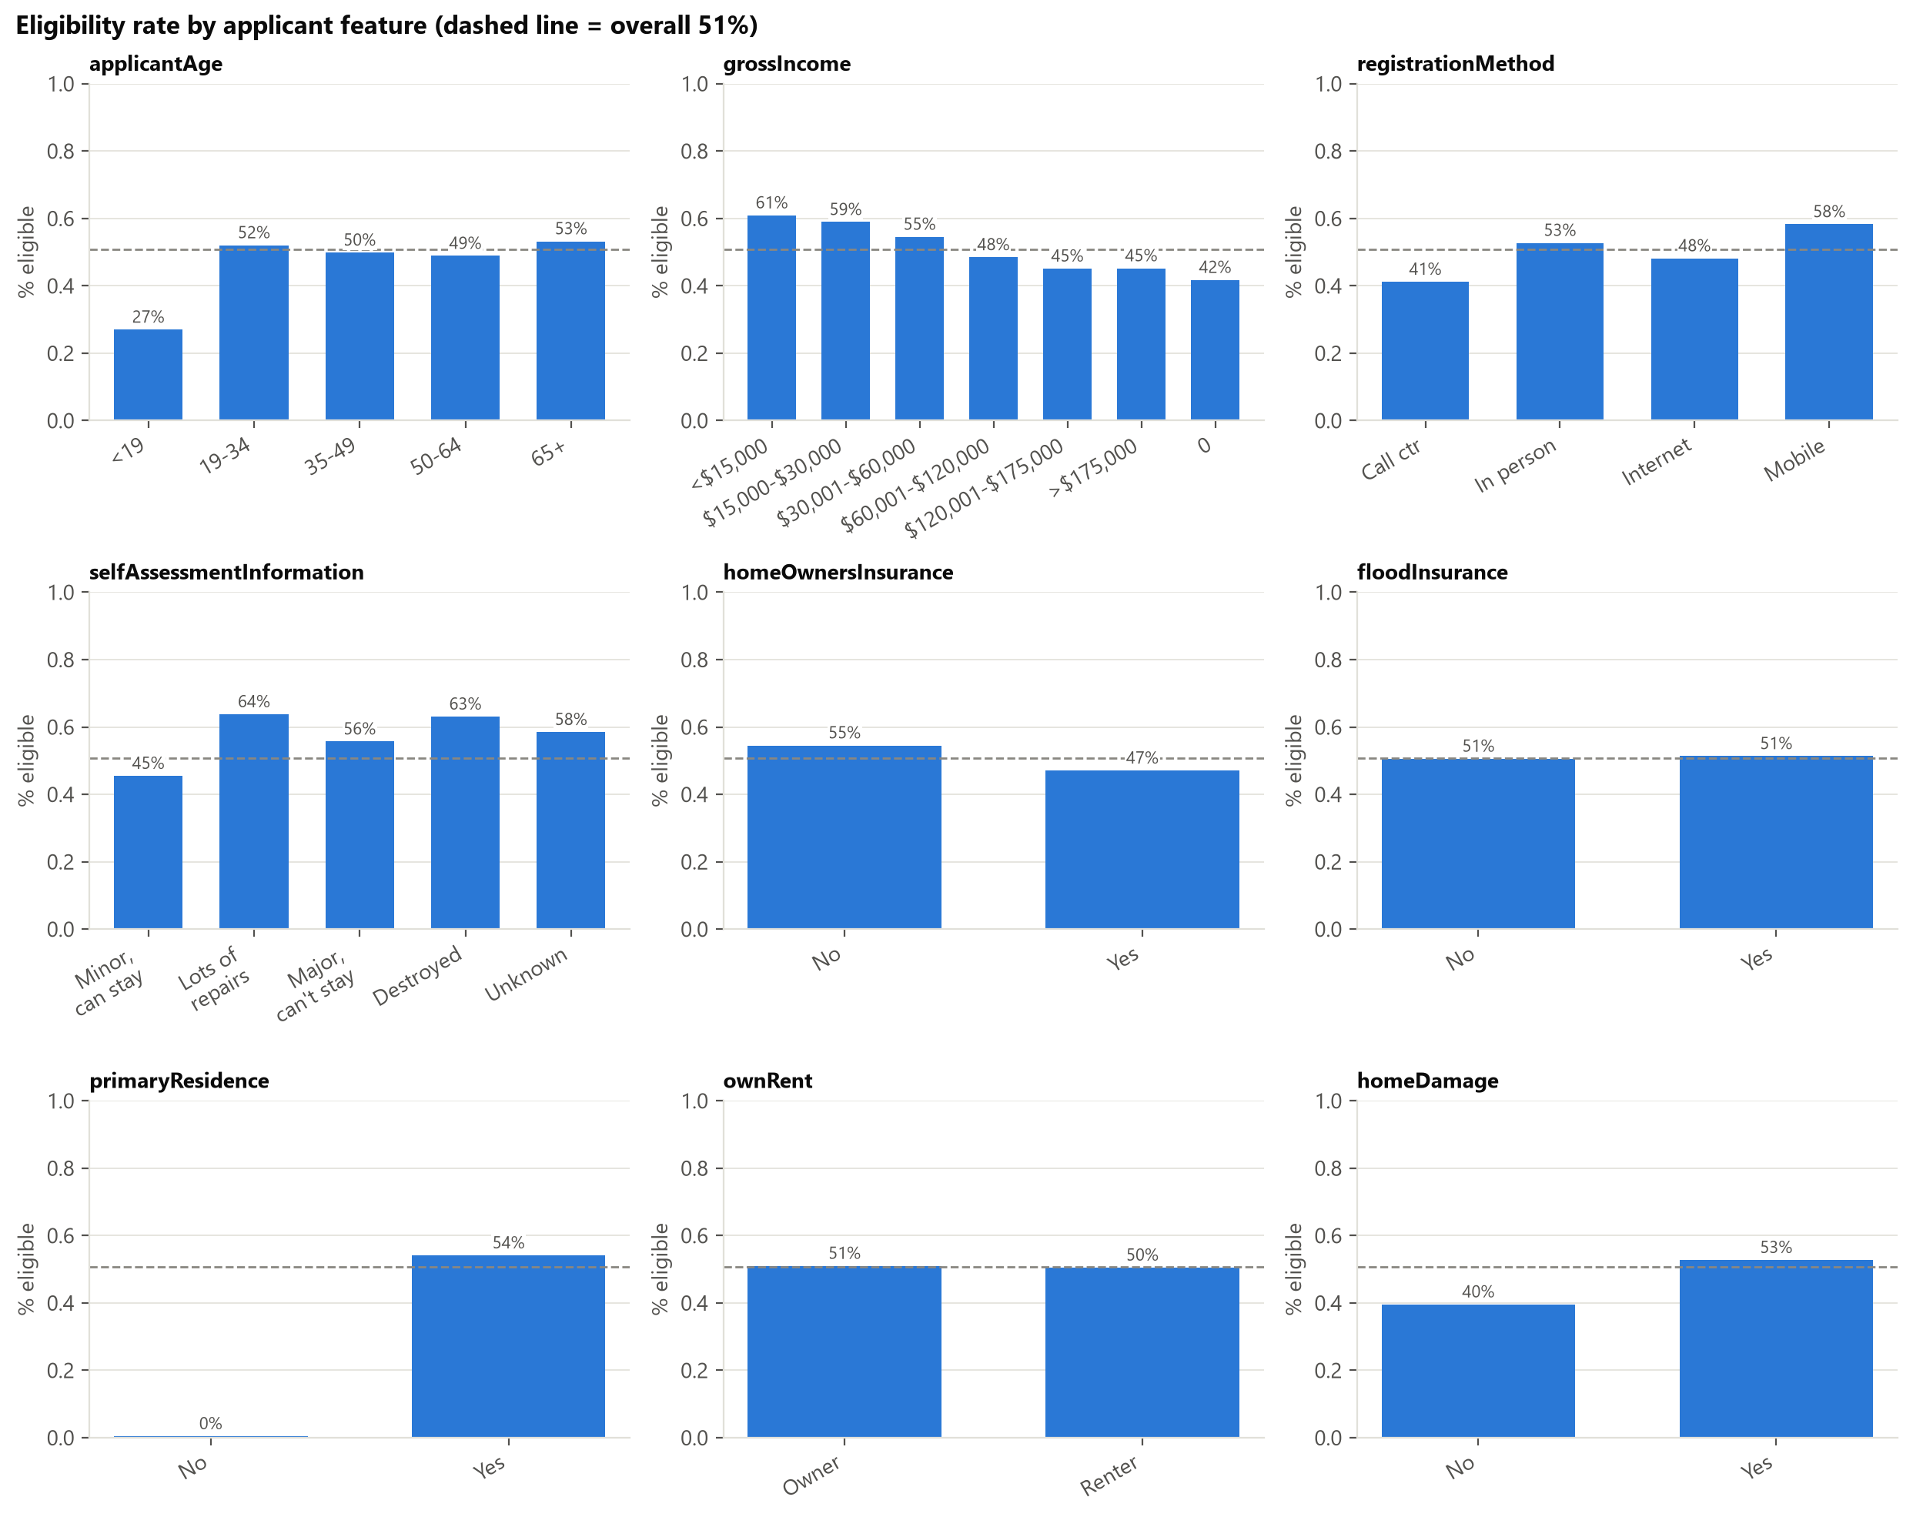
Figure 3.2. Eligibility rate within each category of key features.

3.6 Missing values
Column | Missing | Likely reason it's blank
renterDamageLevel | 96% | Only applies to renters
highWaterLocation | 88% | Only applies where there was a flood mark
shelterNeed | 82% | Almost always "yes" when filled in, so a blank likely means not reported
habitabilityRepairsRequired | 73% | Not filled in for most applicants (reason not confirmed)
foodNeed | 52% | Almost always "yes" when filled in, so a blank likely means not reported
selfAssessmentInformation | 15% | Applicant's own damage rating, left blank by some

Our analysis
When foodNeed is blank, it means the applicant just didn't say they need food. Since the blank tells us something, we shouldn't fill it in with the average.
AI-assisted analysis
Nineteen columns have missing values. Eleven of those are columns we could use, and six are more than 10% missing (Figure D.7). Some blanks are there because the question doesn't apply, like renterDamageLevel for people who aren't renters. So the data is not missing completely at random.
ML takeaway: Filling the blanks with an average would throw away what the blank tells us. So we add a yes/no "was this blank?" column for these features, and fill any other gaps using only the training data.

3.7 Correlation analysis
Our analysis
Not a single column predicts the answer confidently alone, so the model will probably need several columns working together, which will be tested in Milestone 2.
AI-assisted analysis
The strongest single correlation with the target is only about 0.36 (Figure D.5). Some features are almost copies of each other (Figure D.6): inspection issued and inspection completed (1.00), verified home damage and flood damage amount (0.97), and reported damage and home damage (0.83).
ML takeaway: Features that are almost copies of each other are called multicollinearity. We drop one from each pair for linear models like logistic regression. Tree-based models can keep both.

3.8 Data quality assessment
Check | What we found | What we do
Constant columns | 14 columns have the same value on every row | Drop them
Duplicates | 407 rows (0.21%) are the same in every column except the ID | Keep them
Location errors | 6,357 rows (3.3%) have a census block outside Lee County (2,707 are NO_INTERSECT). Only 17 have a ZIP outside Florida | Keep them, with NO_INTERSECT as its own category
Hand-typed city names | Many spellings (FT MYERS, FT MYERS BCH) | Drop the city column
Impossible values | A flood depth of 960 inches (80 feet) | Cap it at a sensible maximum
Dates | Only 2 applications dated before the disaster was declared | Keep them

Our analysis
A flood depth of 960 inches (80 feet) has to be a typo, so we cap it instead of letting one bad row throw off the data.
AI-assisted analysis
The data quality is good overall. Every problem has a fix, and the fixes carry into the Data Preparation Plan (Section 4).

3.9 Challenges and limitations
Our analysis
Our data is only Hurricane Ian in Lee County, so a model trained on it won't necessarily work as well for a hurricane somewhere else, like Texas. None of these issues bring the project to a halt, but it does affect how we build/score the model. Sections 4 and 5 explain how we deal with them.
AI-assisted analysis
Challenge | Why it matters for the model
Data leakage | Scores look perfect but mean nothing if we don't control it
One storm, one county | The model may not work for other disasters (generalization)
Valid registrations only | We can't say anything about applications that never made it in (selection bias)
"Not eligible" covers many reasons | One "no" can mean very different things (label noise)
Heavy skew and blanks that mean something | Needs log transforms and "was this blank?" columns
Too many ZIP codes and census blocks | Encoding them can overfit if it isn't done inside the cross-validation folds
Near-copy features | A problem for linear models (multicollinearity)
Approval partly follows FEMA's own rules | A high score doesn't prove the model understands who needs help

4. Data Preparation Plan

4.1 Data cleaning strategy
Our analysis
We drop the leakage columns because they are results of FEMA's decision, so they would make our model's accuracy look better than it really is.
AI-assisted analysis
Problem (from Section 3) | What we do
Leakage, ID and constant columns (58 columns) | Drop them (listed in Section 3.3)
utilitiesOut (under review) | Leave it out of both tiers until FEMA confirms when it is filled in (Section 3.6)
damagedCity (typed by hand) | Drop it and use ZIP and census block instead
Yes/No columns stored as text with blanks | Change to 1 and 0, and keep blanks as blank (not 0)
Ordered ranges (applicantAge, household counts) | Turn into numbers in order, called ordinal encoding (>5 becomes 6)
Income bracket | Keep as a category with no order (the "$0" group breaks the order)
Missing values | Don't fill them in during cleaning. Add "was this blank?" columns, then fill with the median for linear models. Boosting models can handle blanks themselves. Anything learned comes from the training data only
Impossible values (waterLevel = 960 in) | Cap at a high percentile
Blocks outside the county | Keep, with NO_INTERSECT as its own category
Rows that look like duplicates | Keep (see Section 3.8)

4.2 Feature engineering
Our analysis
Filling the blanks with the average would hide the fact that the answer was blank, and the blank itself tells us something. So we add a "yes/no" column that says whether it was blank.
AI-assisted analysis
- daysSinceLandfall, made from the application date (already built).
- Log transform (log1p) of the skewed dollar and damage columns, plus yes/no "has damage" columns.
- "Was this blank?" columns for the features where a blank means something.
- ZIP and census block: frequency encoding first. We will also try target encoding, done inside the cross-validation folds.
- Group rare categories together, and drop one of each near-copy pair for linear models.
- Maybe combine features, like emergency needs together with primary residence (an interaction feature), to test in Milestone 2.

4.3 Data transformation
Our analysis
The model only learns from the training piece because if it knows what to expect, it defeats the whole purpose.
AI-assisted analysis
Scaling (putting numbers on the same scale) and one-hot encoding (one yes/no column per category) are only used for the models that need them, like logistic regression and distance-based methods. Tree-based models use the data as it is. Anything that learns from the data, like filling blanks, scaling, and encoding, is learned from the training piece only, inside a scikit-learn Pipeline. This stops a second kind of leakage, where the test data affects training.

4.4 Train / validation / test strategy
Our analysis
Because that is our final score for the model. If we used the test set more than once, we would start adjusting the model to it and the score wouldn't be honest.
AI-assisted analysis
- Stratified split: 60% train, 20% validation, 20% test, with random seed 42 so everyone gets the same split. Each piece keeps the same 50.7% / 49.3% mix. This is done in split_data().
- The test set is used once, at the very end of Milestone 2.
- Cross-validation (Section 5.3) uses the train and validation pieces together (80%). The 20% test set stays untouched.
- Time check: applications came in over time, so we will also train on early applicants and test on later ones to see if the model still holds up.
- We can't link applications from the same household, so we list this as a limit.

5. Modeling Approach

5.1 Algorithm selection and justification
Our analysis
We start with logistic regression because it's a very simple and quick model, making it a good baseline for testing other models. Some of our strongest features work like yes/no rules, like whether the home is the primary residence, and that's exactly what tree models are good at.
AI-assisted analysis
Model | Why it fits this data
Logistic regression | Simple, fast, and easy to explain. The baseline to beat
Decision tree | Makes rules a person can read, and FEMA's process works like rules
Random forest | Handles skew, mixed data types, and outliers. Using many trees makes it less likely to overfit than one tree
Gradient boosting | Can pick up features working together (Section 3.7) and the yes/no cutoffs (Section 3.5)

The baselines have not been re-run on the verified data yet. The earlier results came from src/models/baseline.py on an older download, and the EDA notebook doesn't produce them anymore. We will re-run the baselines on the verified data in Milestone 2 and report ROC-AUC, accuracy, and F1 for Tier 1 and Tier 2 then.
Reference | ROC-AUC | Accuracy | F1
Always guess the majority class (50.7% eligible) | 0.500 | 0.507 | 0.000

5.2 Evaluation metrics
Our analysis
Telling someone they'll get aid when they won't is arguably worse because it delays the amount of preparation that they'll have to do as a result of waiting for support from FEMA.
AI-assisted analysis
Metric | Why we use it
ROC-AUC (main) | Shows how well the model ranks eligible above not eligible, no matter where the cutoff is. A good fit because the classes are balanced
Precision, Recall, F1 | A wrong "not eligible" and a wrong "eligible" cost different things in real life, so we report both and pick the cutoff on purpose
Accuracy | Fair here because the classes are balanced
Confusion matrix | Shows exactly where the mistakes are
Group error rates (age, income) | Fairness check (target in Section 2.2)

5.3 Cross-validation and hyperparameter tuning
Our analysis
Testing five times lets us see how much the model's score changes with each run, so one lucky or unlucky split doesn't fool us.
AI-assisted analysis
We use five-fold stratified cross-validation on the train and validation data. The search for the best settings (randomized hyperparameter search) runs inside the folds. Every model uses the same folds so the comparison is fair. The test set is used once, for the final score.

5.4 Expected challenges and mitigation
AI-assisted analysis
Challenge | What we do about it
Hidden leakage when scores get high | Keep one roles file for the whole team. For every final feature set, drop a group of features and see what changes (an ablation study). The EDA's location check is how currentLocation got moved out of Tier 1
Too many ZIP codes and census blocks | Do frequency and target encoding inside the folds, and compare with and without
Skewed damage columns that are mostly zero | Log transform plus yes/no columns, and lean on tree models
Model just re-learns FEMA's rules | Say so honestly, and look closely at cases where the model disagrees with the outcome
Fairness across age, income, and place | Report error rates by group and look into any gap over 5 points
Results only apply to one storm | Say what the scope is, and run the time check

6. Project Timeline
Dates | Work | Owner
Sep 14–27 | Project setup, data download, first EDA and report draft | All
Sep 28–Oct 6 | Section writing; EDA notebook rebuilt on the verified data | All
Oct 7 | Milestone 1 due | All
Oct 8–21 | Finish the data preparation code and the notebooks/preprocessing notebook | All
Oct 22–31 | Re-run baselines, train all models, cross-validate, and tune settings | All
Nov 1–10 | Evaluation: compare models, see which features matter most, check for leakage, check fairness | All
Nov 11–18 | Write the final report, build the presentation, and rehearse | All
Nov 19 | Team deadline: code runs start to finish, PDF made | All
Nov 21 | Milestone 2 due | All
Nov 23 / Dec 2 | Presentation (15 min + Q&A) | All

Team responsibilities for Milestone 2. Daniel Ortiz leads data preparation and model training. Anthony Stoneking leads the data analysis updates, leakage checks, and model evaluation. Nandor Laar leads the business value and fairness review and the final report. Everyone contributes to every phase and attends the presentation.
Risks and contingencies
Risk | Contingency
A teammate is unavailable | Everything is in Git with comments in the code, so someone else can pick it up. Weekly check-ins
Scores drop below the baseline after removing leakage columns | Report it honestly. Removing leakage is a finding too
Conflicts when two people edit the same notebook | One person per notebook at a time, small commits, pull before starting
Running out of time before Nov 21 | Lock the list of models by Oct 31 and drop the optional ones first

Appendices
- A. Data dictionary (docs/data_dictionary.md)
- B. EDA notebook export (reports/milestone_1/eda_notebook.html)
- C. AI usage log (docs/AI_USAGE.md)
- D. Additional figures (reports/figures/)

Appendix D. Additional figures for Section 3
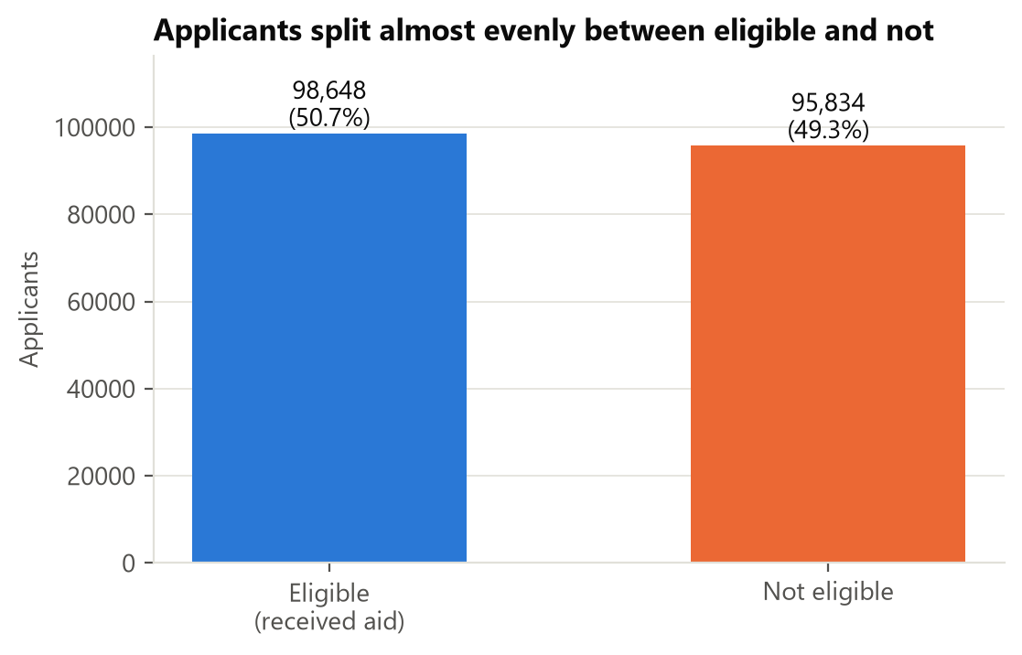
Figure D.1. Class balance of ihpEligible.
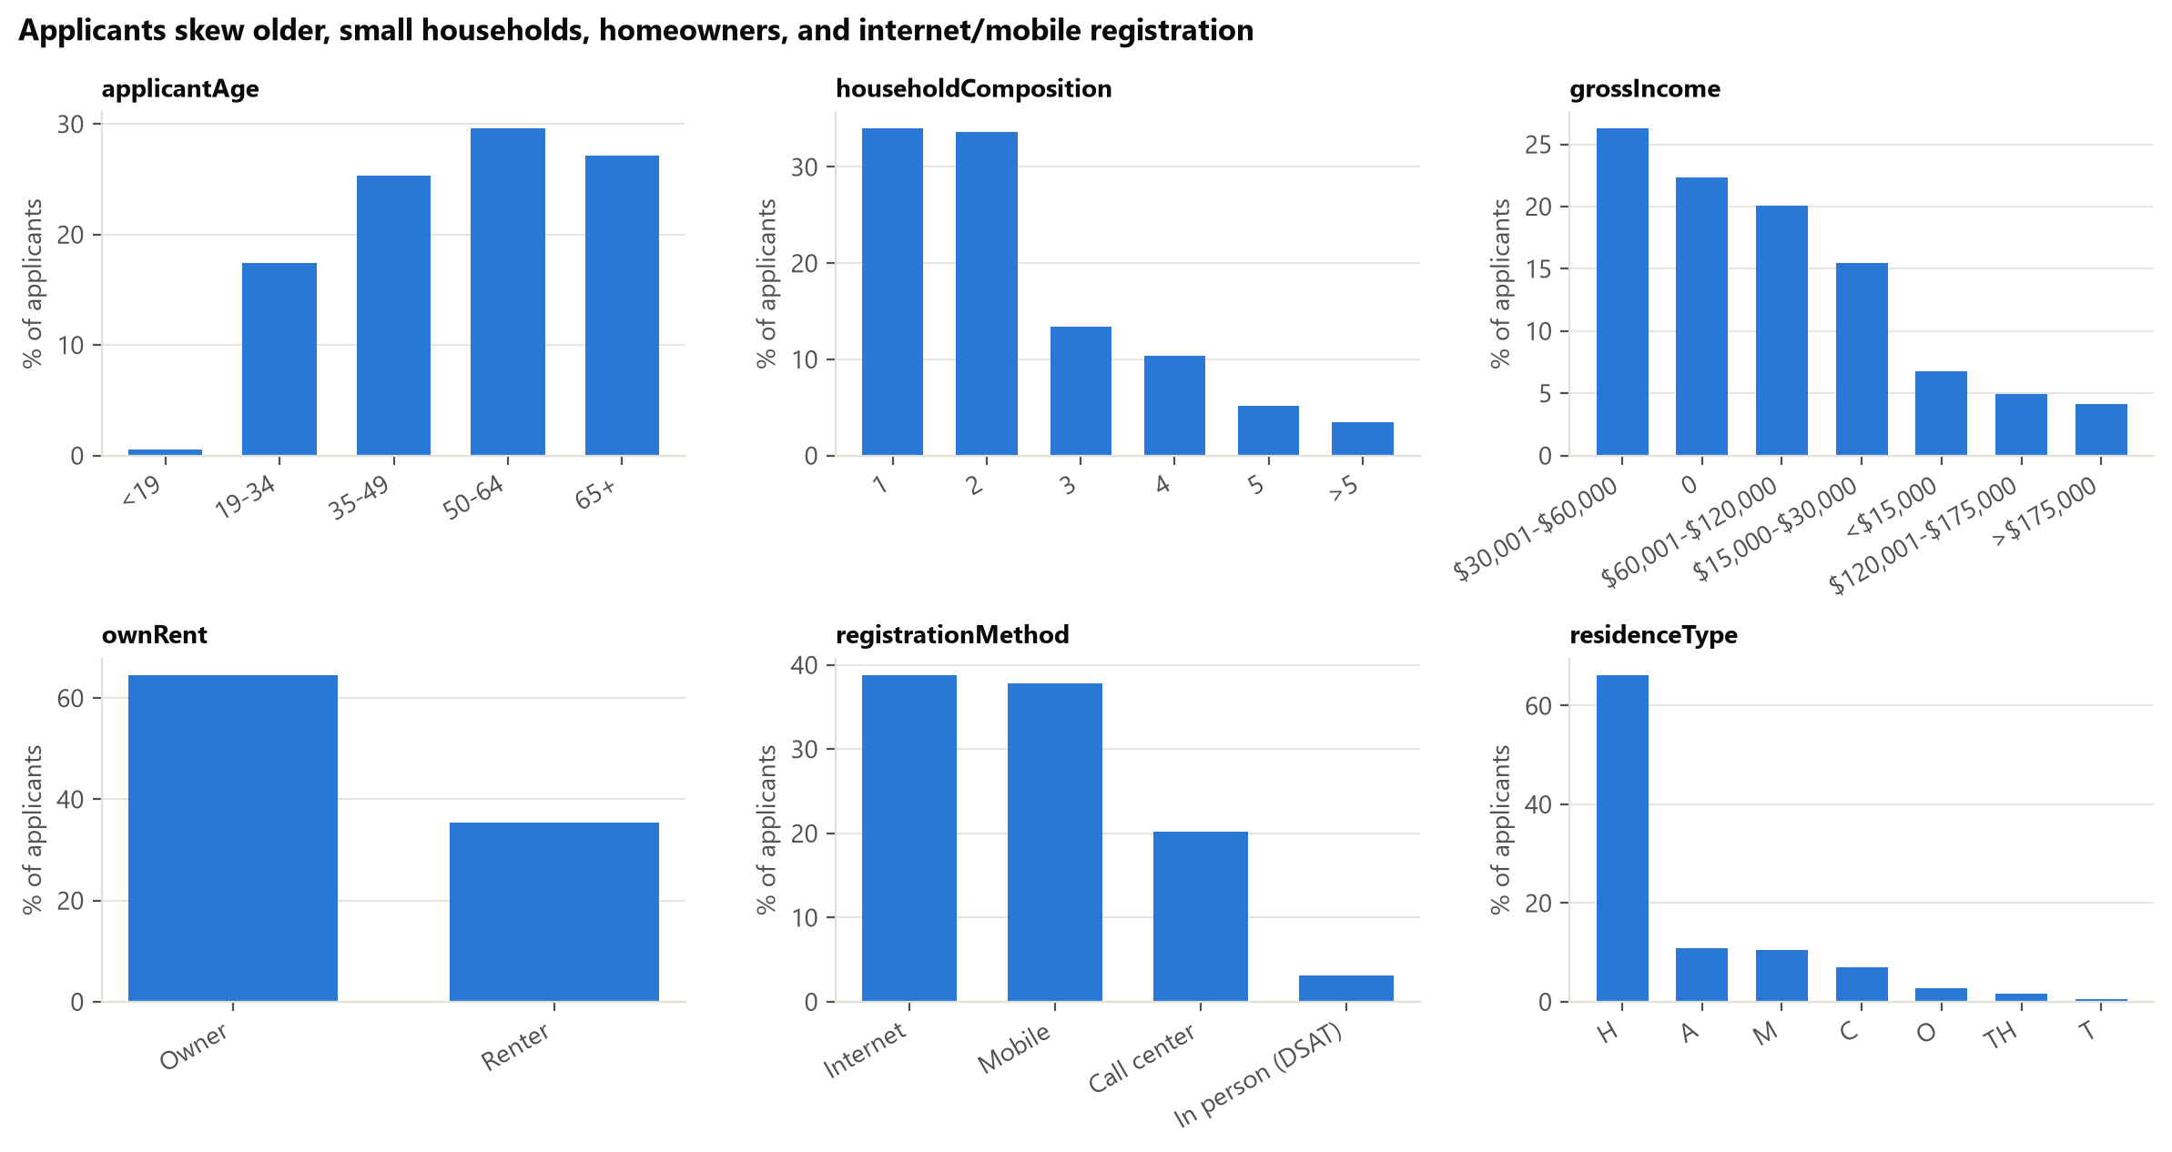
Figure D.2. Age, household size, ownership, and registration method.
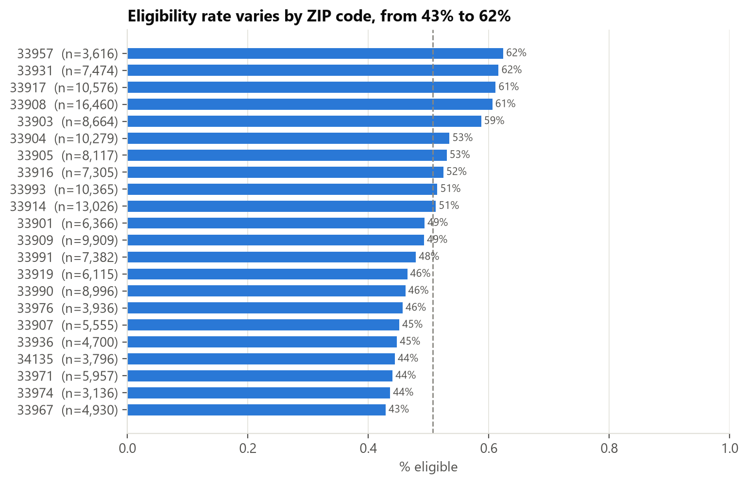
Figure D.3. Eligibility across the 22 largest ZIP codes.
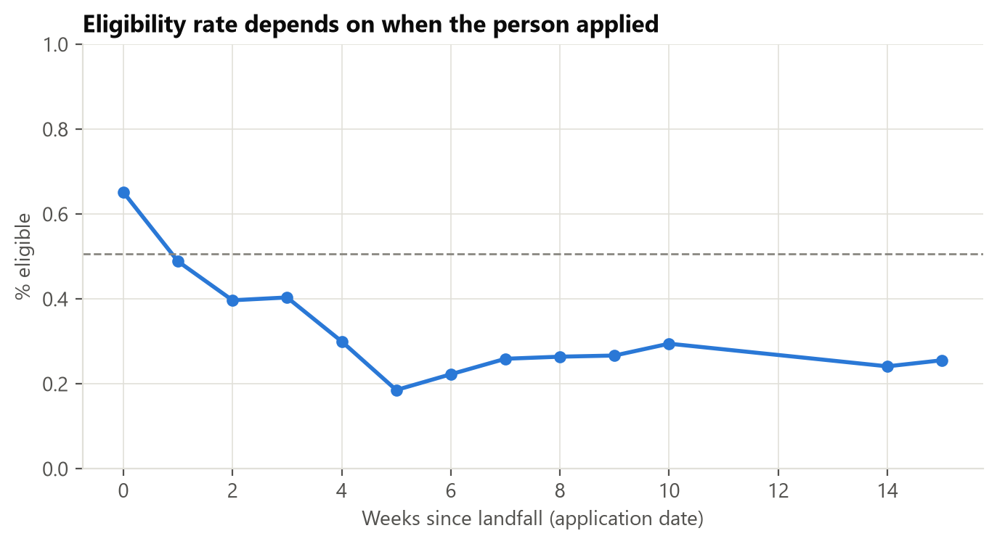
Figure D.4. Eligibility by week of application.
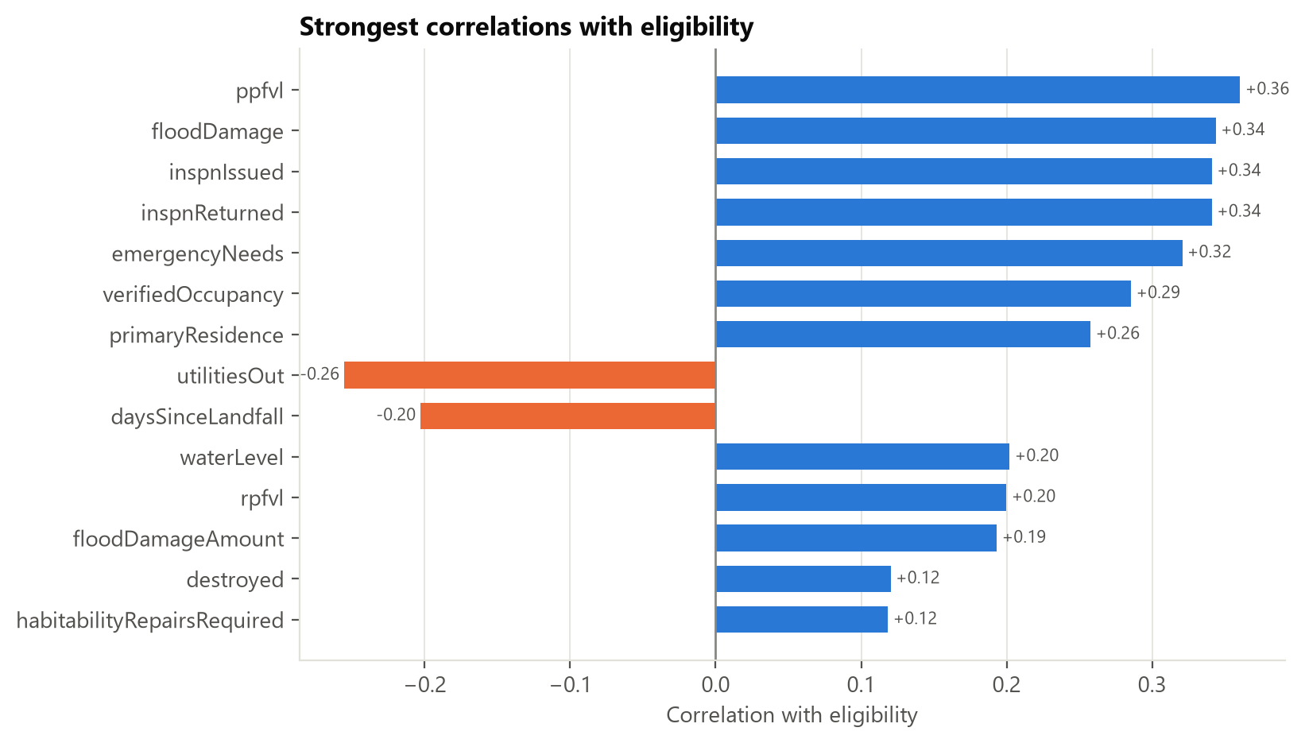
Figure D.5. Correlation of each numeric feature with the target.
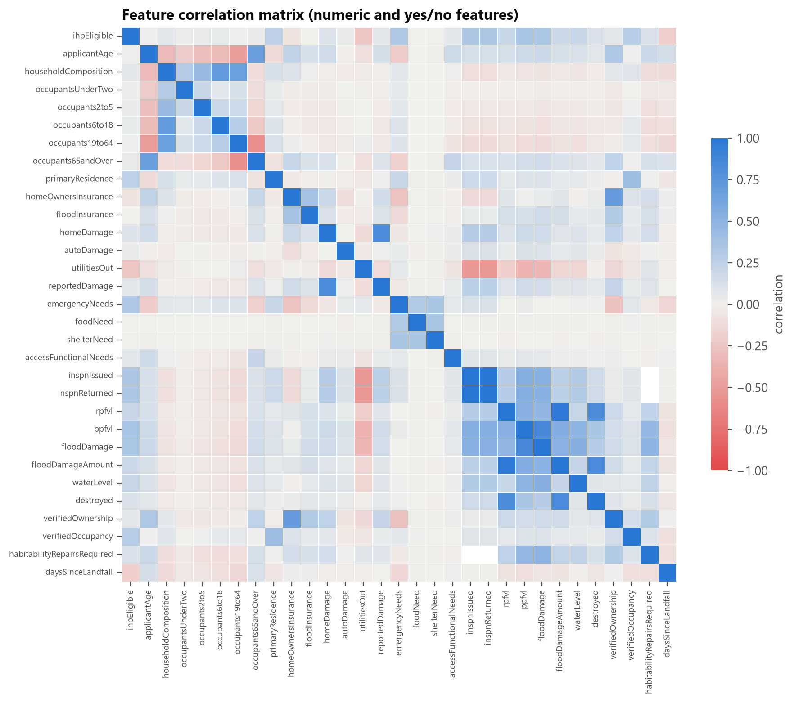
Figure D.6. Feature-to-feature correlations.
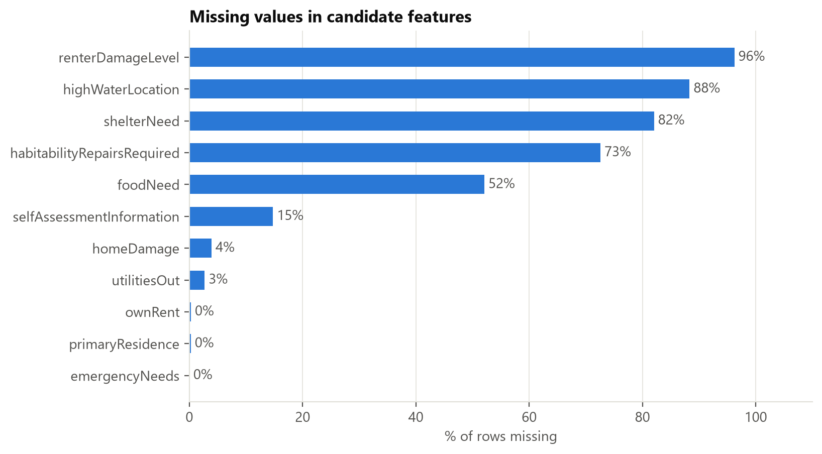
Figure D.7. Share of missing values per column.

References
FEMA. OpenFEMA Dataset: Individuals and Households Program – Valid Registrations v2. https://www.fema.gov/openfema-data-page/individuals-and-households-program-valid-registrations-v2
FEMA. Serious Needs Assistance (fact sheet). https://www.fema.gov/fact-sheet/serious-needs-assistance-0

AI-use disclosure
Portions of the code, analysis, and this draft were produced with Claude Code (Anthropic) and reviewed by the team. See docs/AI_USAGE.md for the full log.

