The Pretzelmen

**Group Leader:** Kemo Allen

**Secondary Leader:** Tong Duangboudda

**Members:** Daniel Geiser, Tyler Cadena

**Front End (Angular):** Tong Duangboudda

**Back End (Rest Api):** Daniel Geiser

**DevOps:** Tyler Cadena

**Tests:** Tyler Cadena

**Sales Description**

Our project will allow users to collect *Magic: The Gathering* cards and play a simple game of *Magic: The Gathering*. A website will be deployed to house user accounts that contain their card collection, profile information, and win/loss record. The user will start off with a certain amount of tokens when they sign-up. Those can then be used to buy card packs. There is also a log-in bonus for signing into the website. Another way to earn more tokens is to participate in the Memory Game.

In the Memory Game a few cards are shown on screen for a certain amount of time, showing an illustration, then they are flipped over and shuffled. The objective of the game is to find as many matches as possible. The player who picks the most matching pairs wins the game. In the game there will be a reward system where both players get a bonus for playing in a match. Both the winner and losing player will receive tokens. A player will be able to see the result of the past games that they were in.

A user can simply look up cards by their name or card id, but the user won’t officially own them. The user will be able to post a possible trade by selecting one of their cards. The user can offer up one of their cards as a response to the poster. The poster will then accept or decline the trade.

**Minimum Viable Product**

A website that allows users to have a digital collection of *Magic: The Gathering* cards. On the website, users will be able to trade their cards with one another. A player would post up the possible trade and others can view the trade. If the viewer likes the cards they can then offer their own cards for the trade. A sense of community can be built from players engaging in trades with one another.

You will also be able to play the Memory Game. The Memory Game has a predetermined number of cards. The cards are laid out in a grid pattern. One player starts by picking two cards. If the cards match then the player gets a point for finding a matching pair. Whoever gets the most found pairs wins the match. Both players get some tokens for playing the game. The winner will get five times as much as the losing player. The wins and losses are recorded under each player's account.

**External API**

This is a mapper which wraps around the magicthegathering.io for .Net

<https://github.com/MagicTheGathering/mtg-sdk-dotnet> so we can call the API. This API will allow a user to look up a card by their Ids or just by name.

**User Stories**

* As a *Magic: The Gathering* player, I want to be able to have a digital collection of *Magic: The Gathering* cards.
* As a Video Game Player of Online Games, I like the ability to gain in-game tokens as a reward for visiting and logging in.
* As a user, I should have the ability to look up the cards that are available or be able to search for them by their card id.
* As a user, I want to customize decks using the cards that I own.
* As a user, I want to be able to trade cards with others on the website.

**Stretch Goals**

1. Making a digital storefront so users can buy more things with their tokens, like mega packs, stickers,or effects on matching card pairs.
2. To up the challenge both players put up an agreed upon number of cards and play a memory game with those cards up for grabs.
3. Have the ability to play a game with rules similar to *Magic: The Gathering* against another player. Also, the winner gets a random card from the losers deck.

**User Interaction Model**

Users will navigate to web pages that present this data and allow interaction with those web pages.

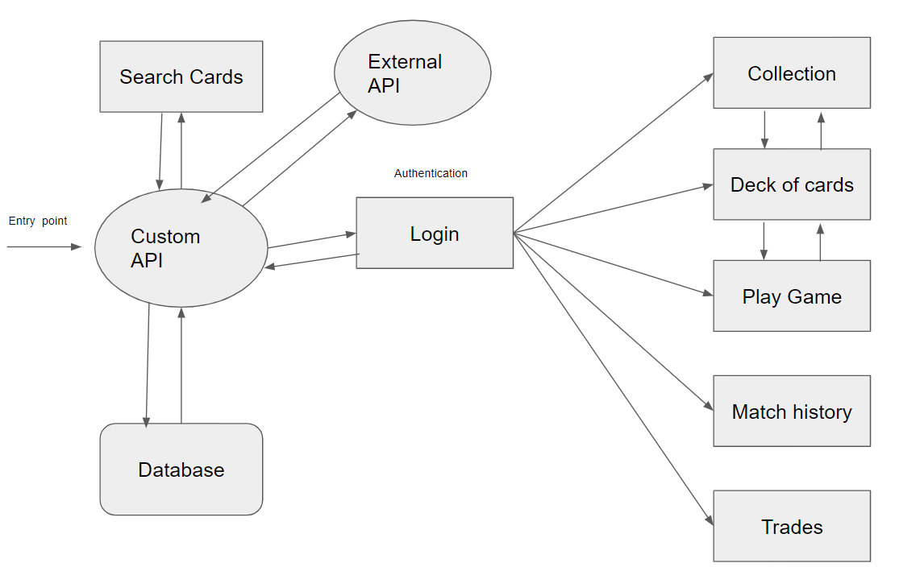

**Kanban Board**

<https://trello.com/b/r1GmKzPd/the-pretzelman-kanban-board>

**Group Repo**

<https://github.com/12142020-dotnet-uta/P2_the-pretzelmen>

**Database Schema**

SG = stretch goals

