Descriptive Epidemiology

* **Data source:** SGSS
* **Date report produced**: 28/03/2017
* **Organism:** Cryptosporidium parvum
* **End of reporting period:** 24/01/2017
* **Centre:** South West
* **Sex:** Not restricted
* **Age:** Not restricted
* **Local authority:** Not restricted
* **Laboratory:** Not restricted
* **Requesting organisation:** Not restricted
* **Specimen type:** Not restricted
* **Travel status:** Not restricted

##### 

# Recent cases

This section describes cases with specimen dates between 14/11/2016 to 24/01/2017.

## Figure 1: Epidemic curve of cases 14/11/2016 to 24/01/2017 by day

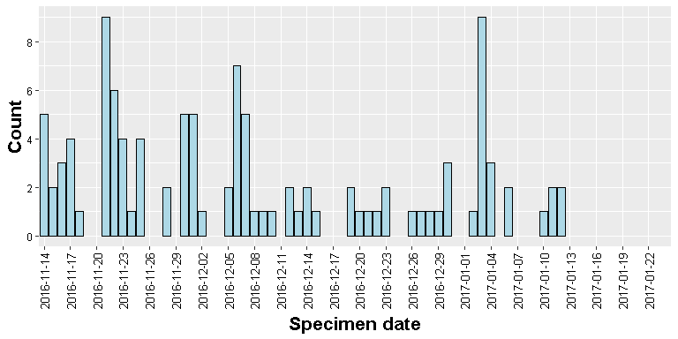

## Figure 3: Epidemic curve of cases 14/11/2016 to 24/01/2017 by week

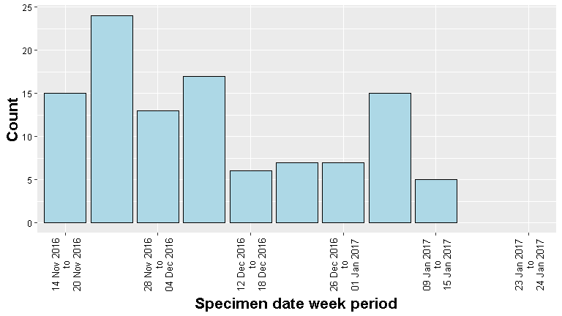

##### 

## Figure 5: Tile plot of cases 14/11/2016 to 24/01/2017 by week

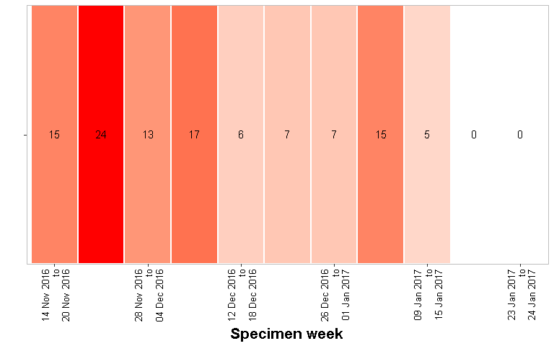

##### 

## Figure 5: Epidemic curve of cases 14/11/2016 to 24/01/2017 by sex by day

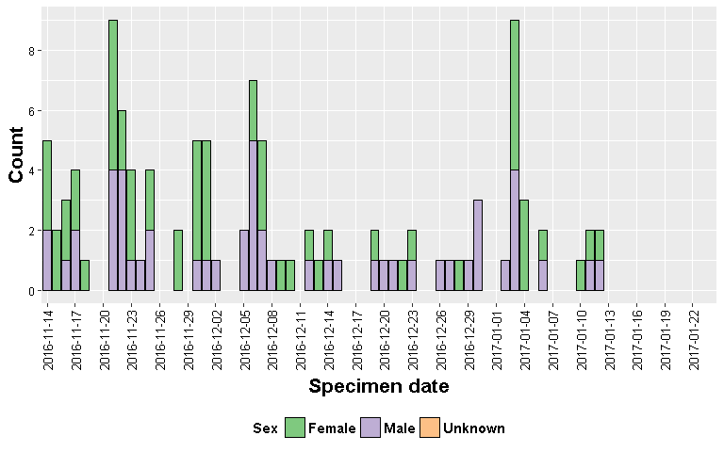

## Figure 7: Epidemic curve of cases 14/11/2016 to 24/01/2017 by sex by week

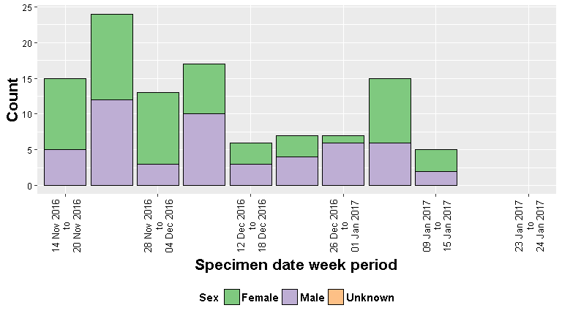

##### 

## Figure 5: Tile plot of cases 14/11/2016 to 24/01/2017 by sex by week

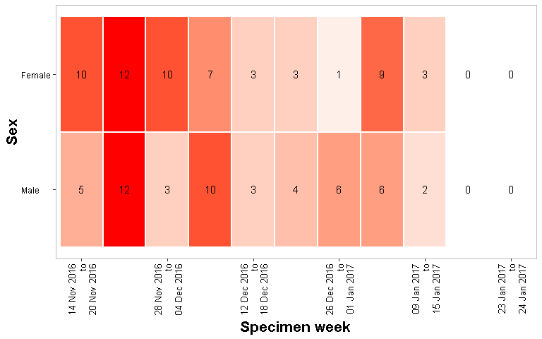

##### 

## Figure 9: Epidemic curve of cases 14/11/2016 to 24/01/2017 by age group by day

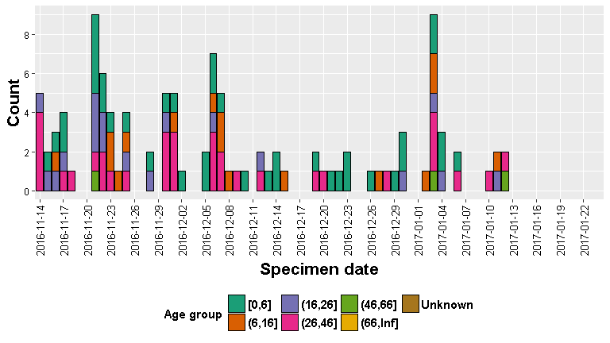

## Figure 11: Epidemic curve of cases 14/11/2016 to 24/01/2017 by age group by week

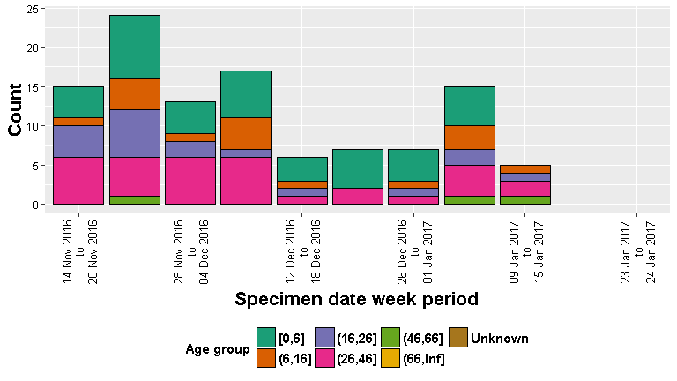

##### 

## Figure 13: Tile plot of cases 14/11/2016 to 24/01/2017 by age group by week, shading according to relative count across all tiles

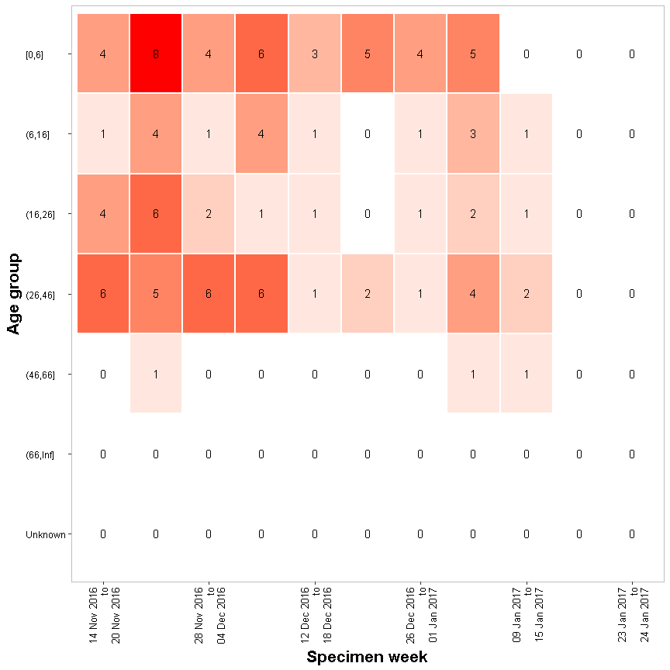

##### 

## Figure 16: Age-sex distribution of cases, 14/11/2016 to 24/01/2017

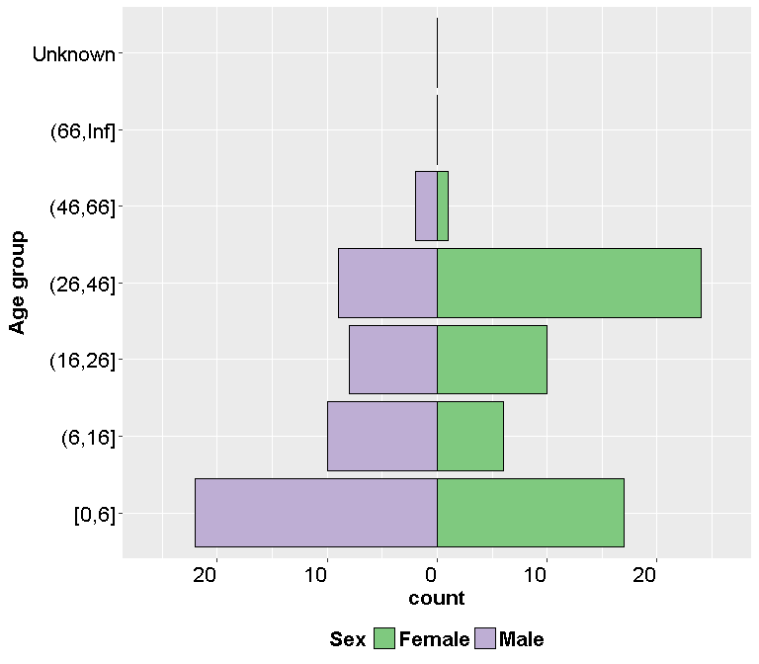

A total of 0 cases are missing in the figure above due to either missing sex and age group information.

##### 

## Figure 19: Tile plot of cases 14/11/2016 to 24/01/2017 by local authority by week, shading according to relative count across all tiles

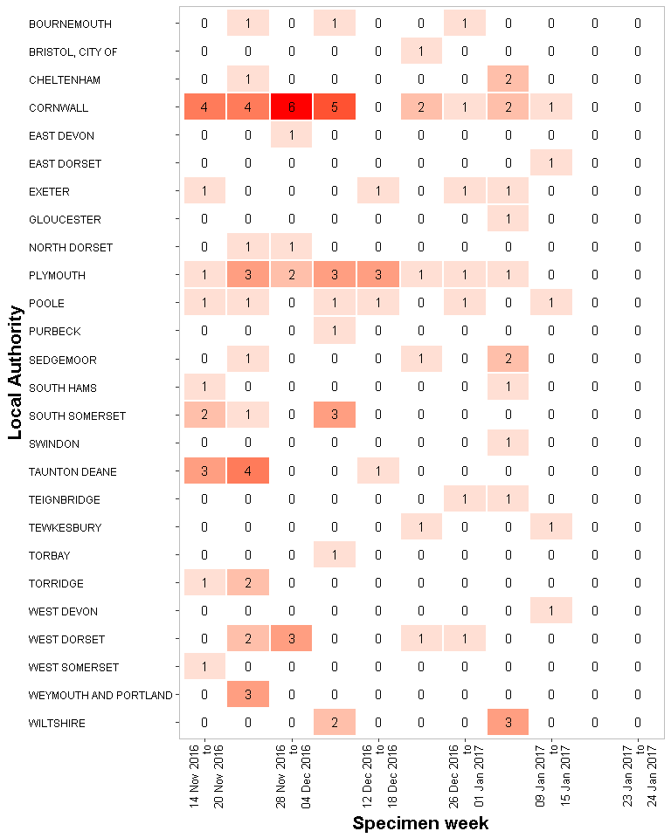

##### 

## Figure 20: Tile plot of cases 14/11/2016 to 24/01/2017 by local authority by week, shading according to relative count across tiles within the same rows

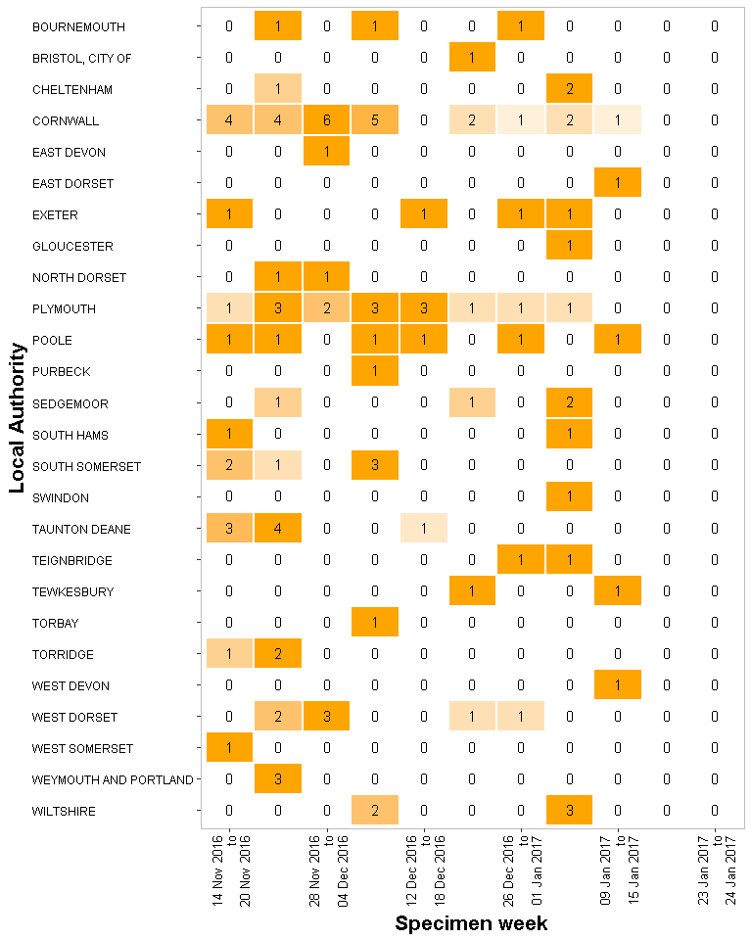

##### 

## Figure 5: Tile plot of cases 14/11/2016 to 24/01/2017 by laboratory by week, shading according to relative count across all tiles

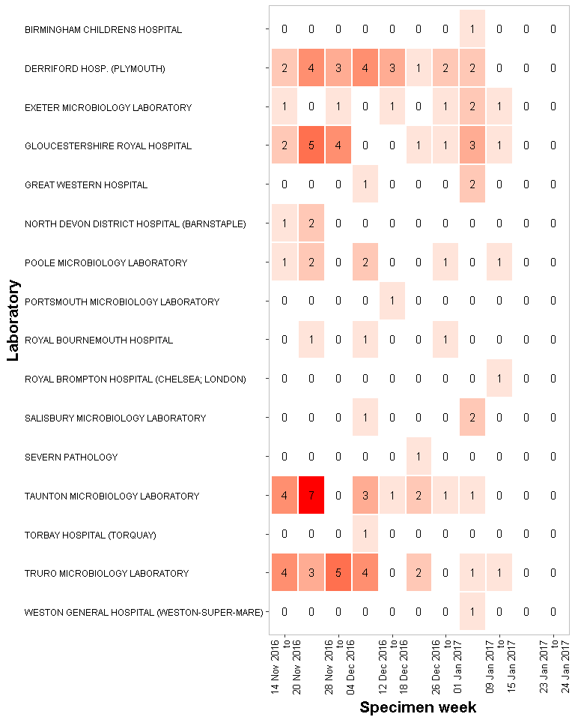

##### 

## Figure 5: Tile plot of cases 14/11/2016 to 24/01/2017 by laboratory by week, shading according to relative count across tiles within the same rows

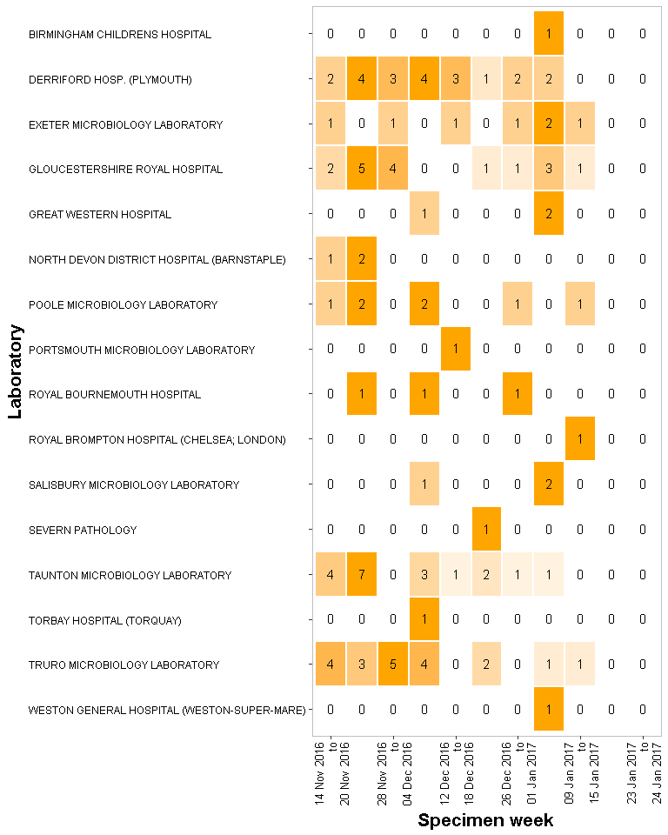

##### 

## Figure 13: Tile plot of cases 14/11/2016 to 24/01/2017 by requesting organisation by week, shading according to relative count across all tiles

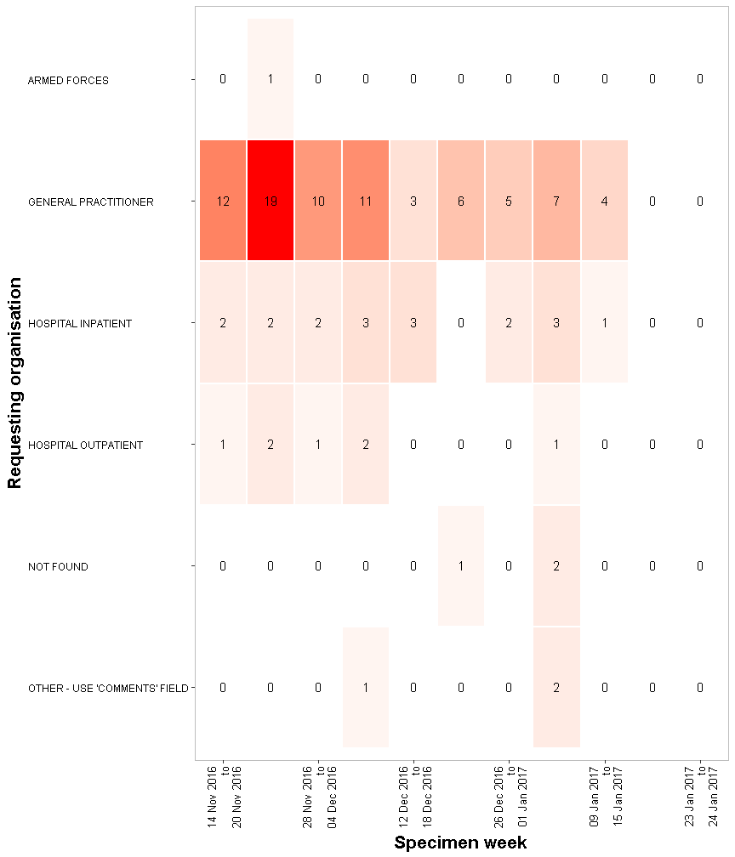

##### 

## Figure 13: Tile plot of cases 14/11/2016 to 24/01/2017 by requesting organisation by week, shading according to relative count across tiles within the same rows

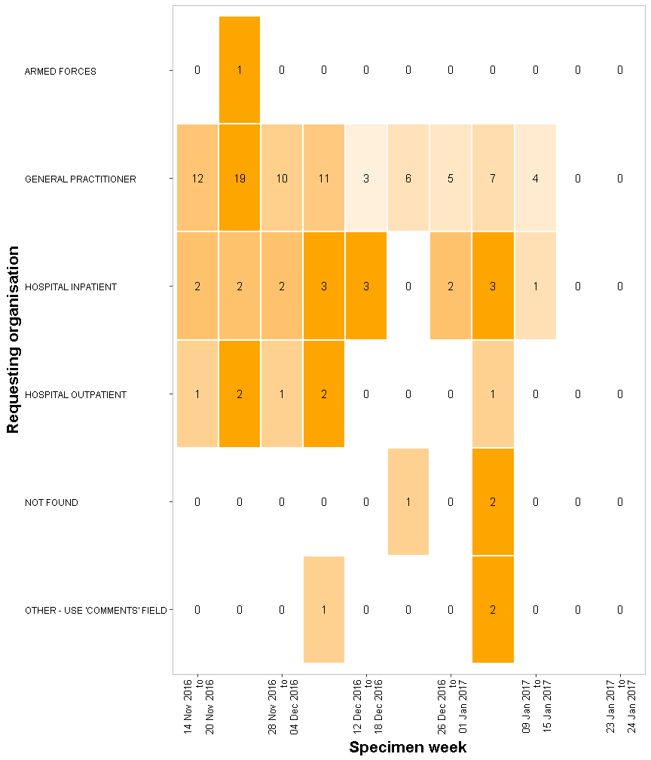

##### 

## Figure 13: Tile plot of cases 14/11/2016 to 24/01/2017 by specimen type by week, shading according to relative count across all tiles

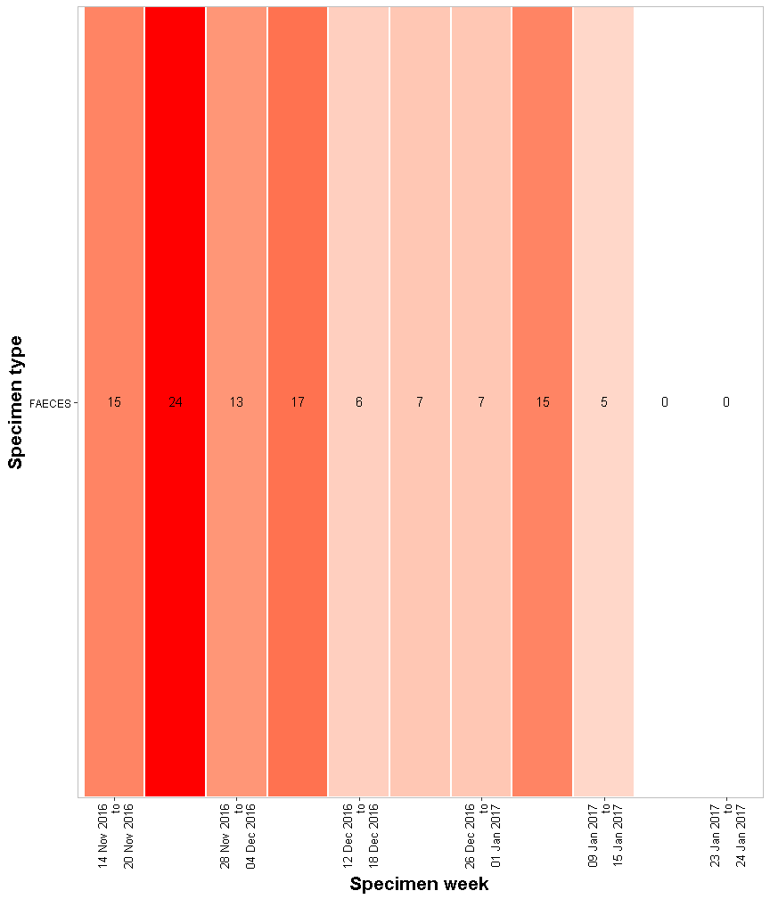

##### 

## Figure 13: Tile plot of cases 14/11/2016 to 24/01/2017 by specimen type by week, shading according to relative count across tiles within the same rows

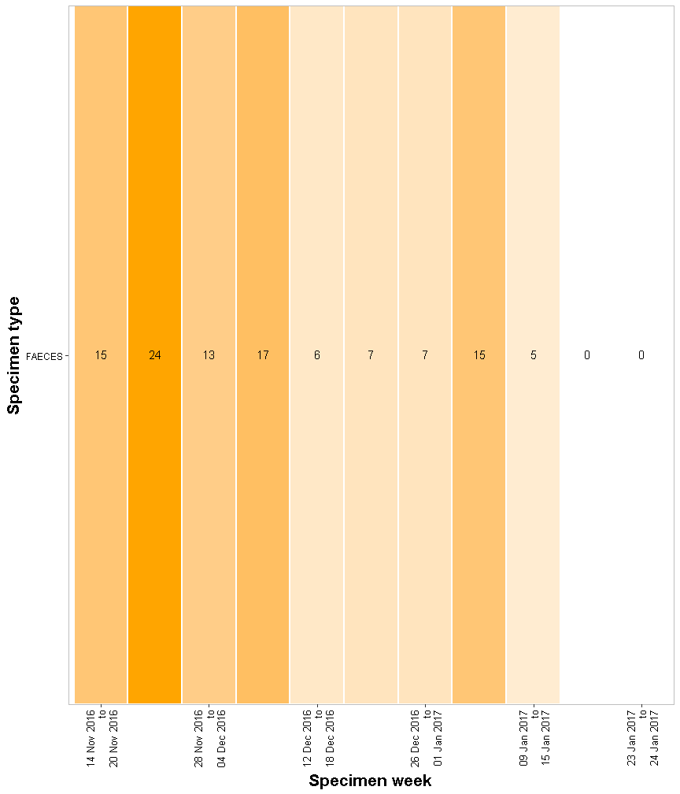

##### 

## Figure 5: Epidemic curve of cases 14/11/2016 to 24/01/2017 by travel status by day

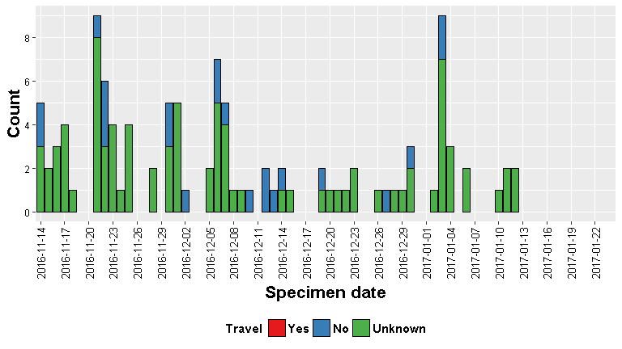

## Figure 7: Epidemic curve of cases 14/11/2016 to 24/01/2017 by travel status by week

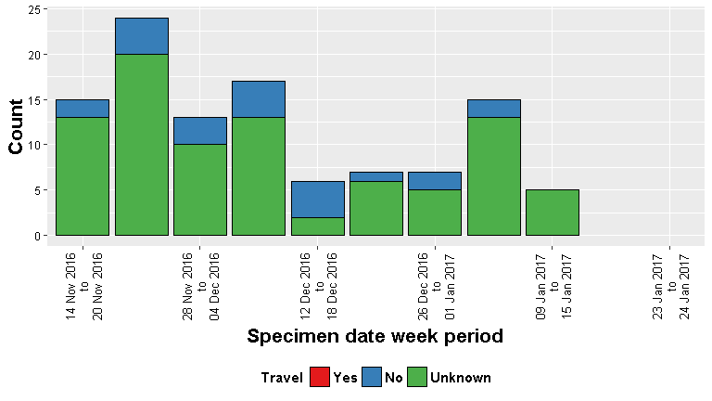

##### 

## Figure 13: Tile plot of cases 14/11/2016 to 24/01/2017 by travel status by week, shading according to relative count across all tiles

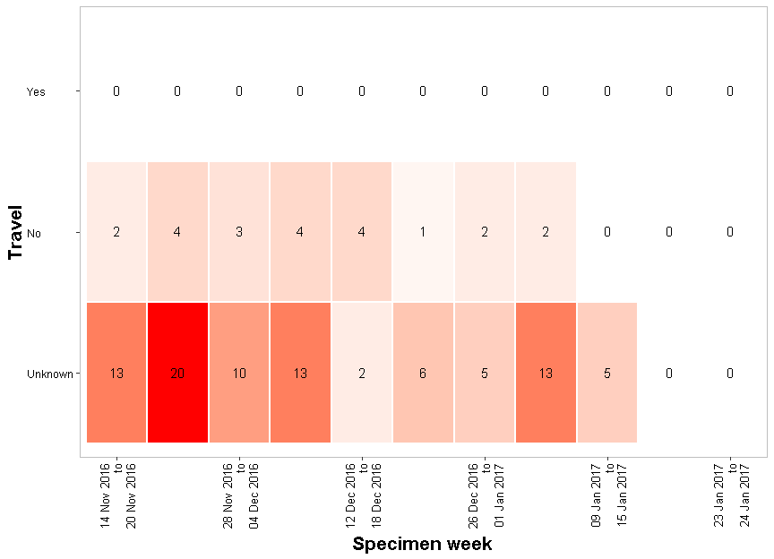

##### 

# Historic cases

## Figure 17: Line graph of cases by year-month, 14/11/2012 to 24/01/2017

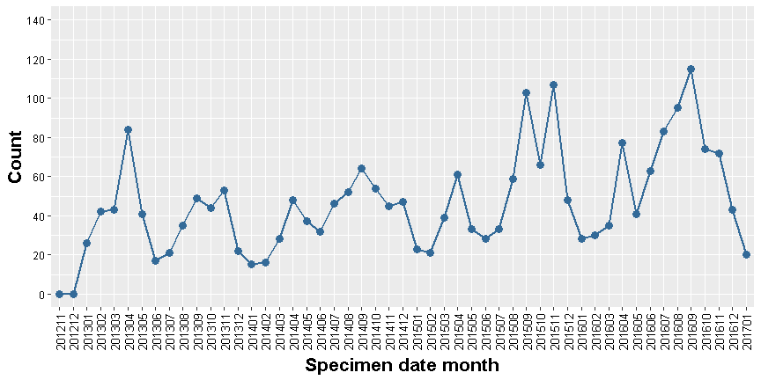

## Figure 17: Cumulative line graph of cases by year-month, 14/11/2012 to 24/01/2017

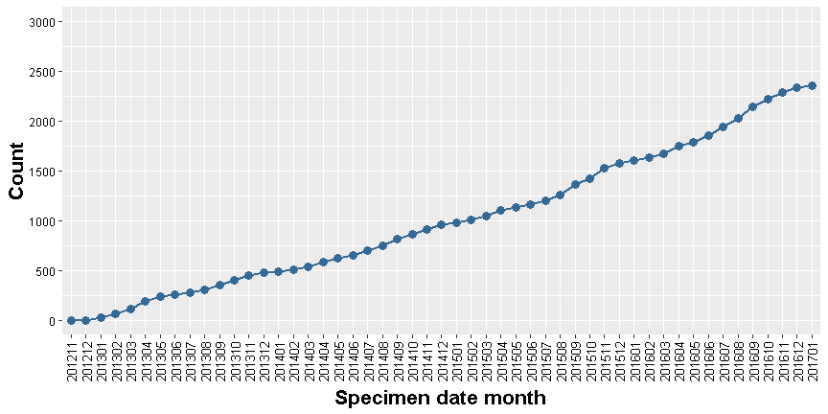

##### 

## Figure 13: Tile plot of cases 14/11/2012 to 24/01/2017 by year-month, shading according to relative count across all tiles

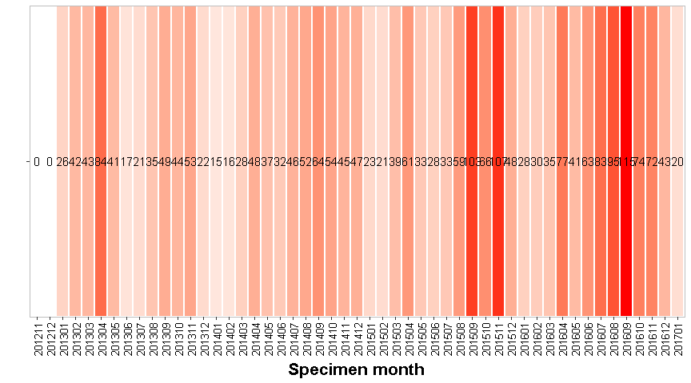

##### 

## Figure 17: Line graph of cases by sex by year-month, 14/11/2012 to 24/01/2017

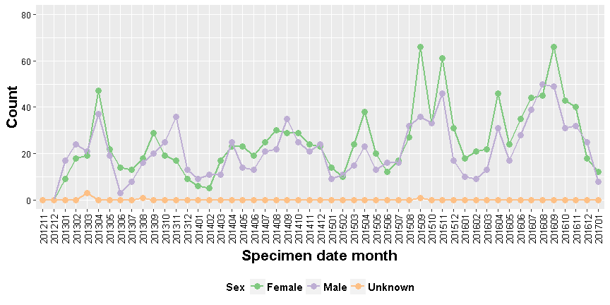

## Figure 17: Cumulative line graph of cases by sex by year-month, 14/11/2012 to 24/01/2017

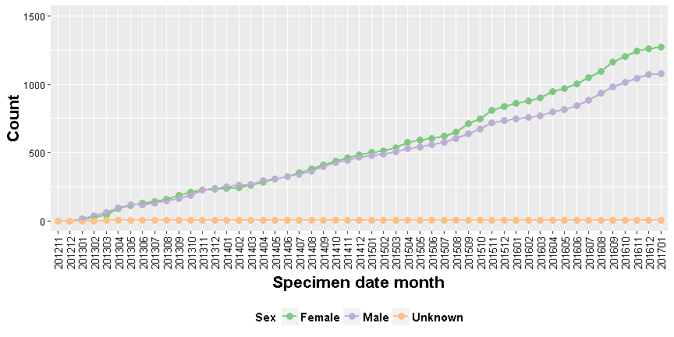

##### 

## Figure 13: Tile plot of cases 14/11/2012 to 24/01/2017 by sex by year-month, shading according to relative count across all tiles

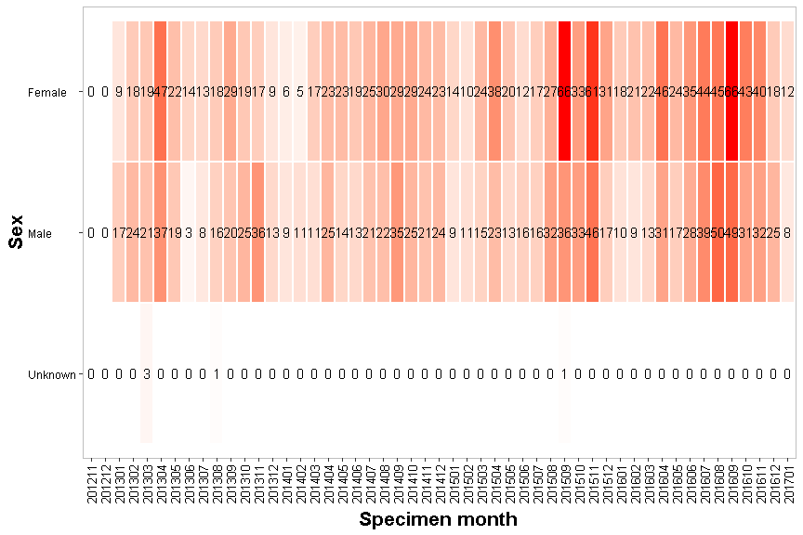

##### 

## Figure 13: Tile plot of cases 14/11/2012 to 24/01/2017 by sex by year-month, shading according to relative count across tiles within the same rows

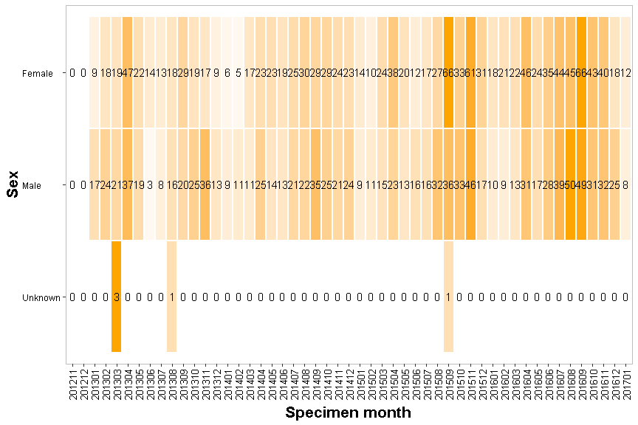

##### 

## Figure 17: Line graph of cases by age group by year-month, 14/11/2012 to 24/01/2017

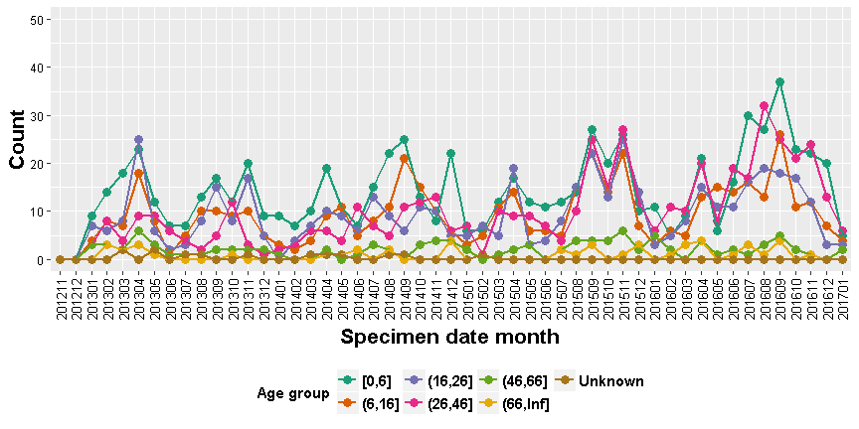

## Figure 17: Cumulative line graph of cases by age group by year-month, 14/11/2012 to 24/01/2017

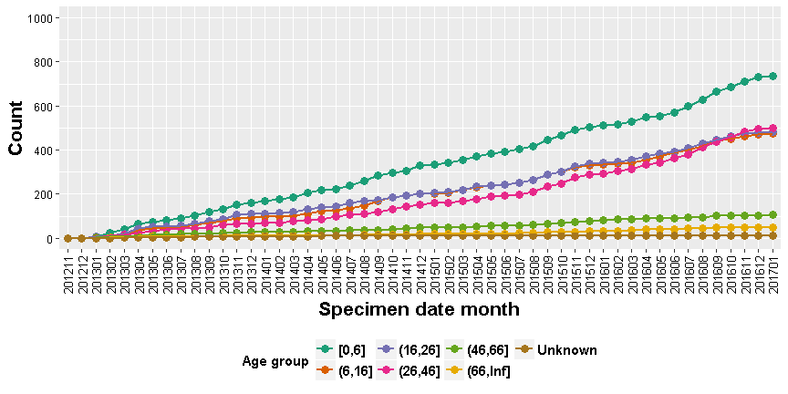

##### 

## Figure 13: Tile plot of cases 14/11/2012 to 24/01/2017 by age group by year-month, shading according to relative count across all tiles

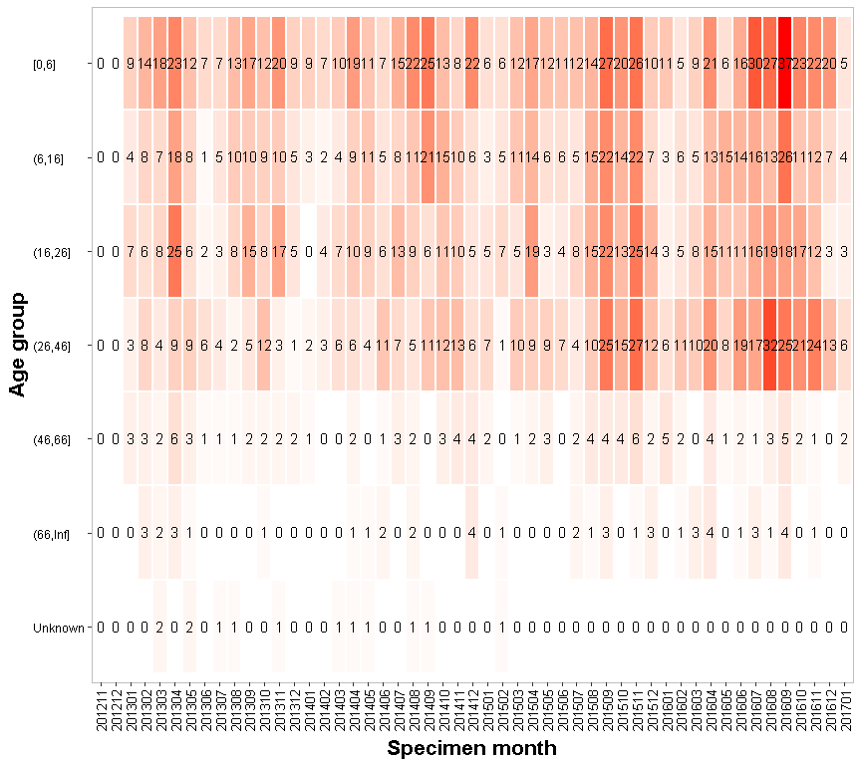

##### 

## Figure 13: Tile plot of cases 14/11/2012 to 24/01/2017 by age group by year-month, shading according to relative count across tiles within the same rows

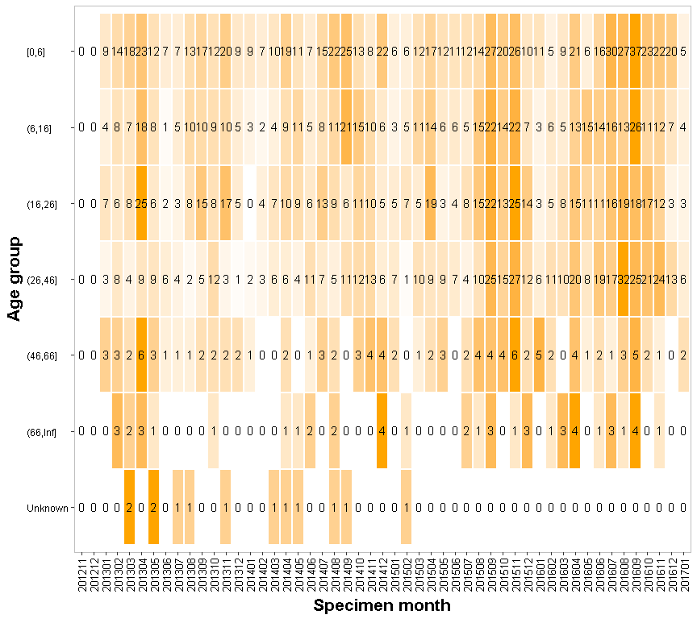

##### 

## Figure 13: Tile plot of cases 14/11/2012 to 24/01/2017 by local authority by year-month, shading according to relative count across all tiles

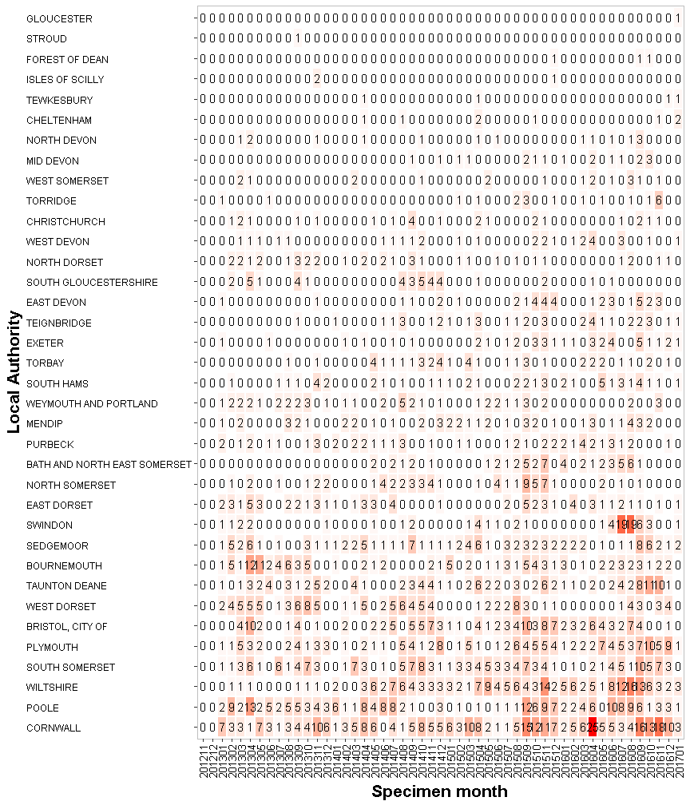

##### 

## Figure 13: Tile plot of cases 14/11/2012 to 24/01/2017 by local authority by year-month, shading according to relative count across tiles within the same rows

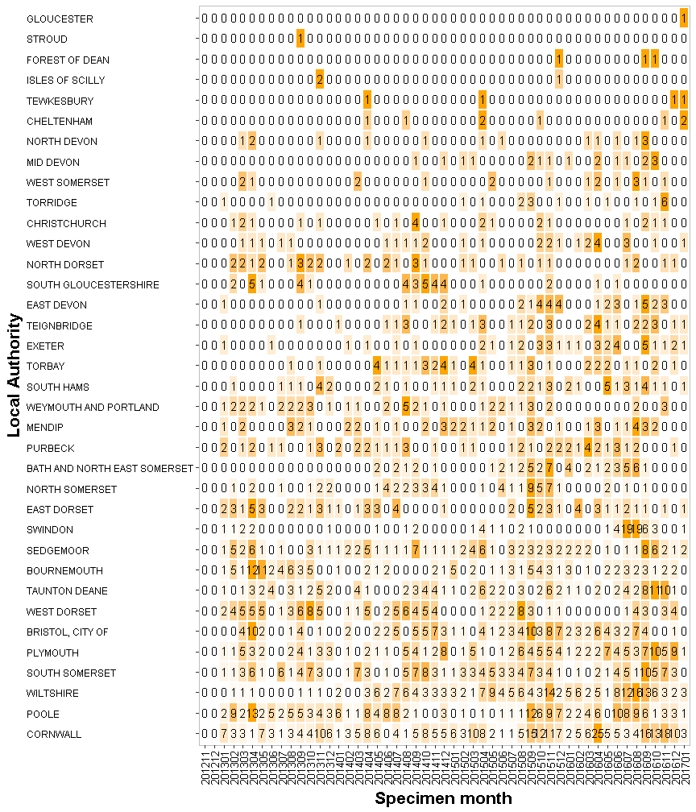

##### 

## Figure 13: Tile plot of cases 14/11/2012 to 24/01/2017 by laboratory by year-month, shading according to relative count across all tiles

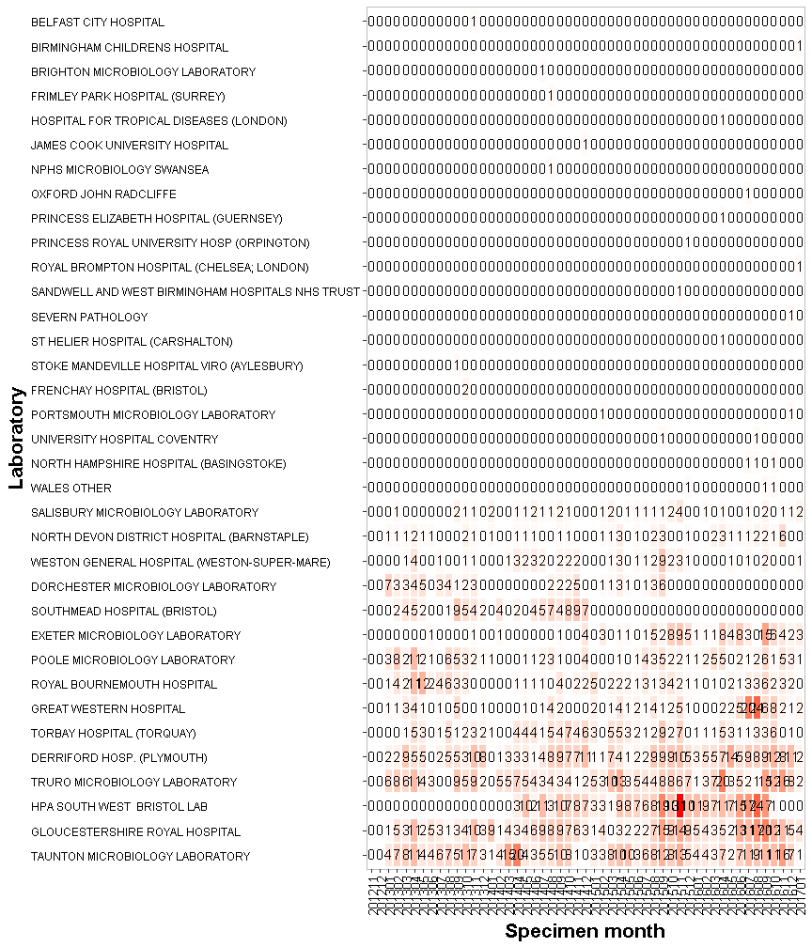

##### 

## Figure 13: Tile plot of cases 14/11/2012 to 24/01/2017 by laboratory by year-month, shading according to relative count across tiles within the same rows

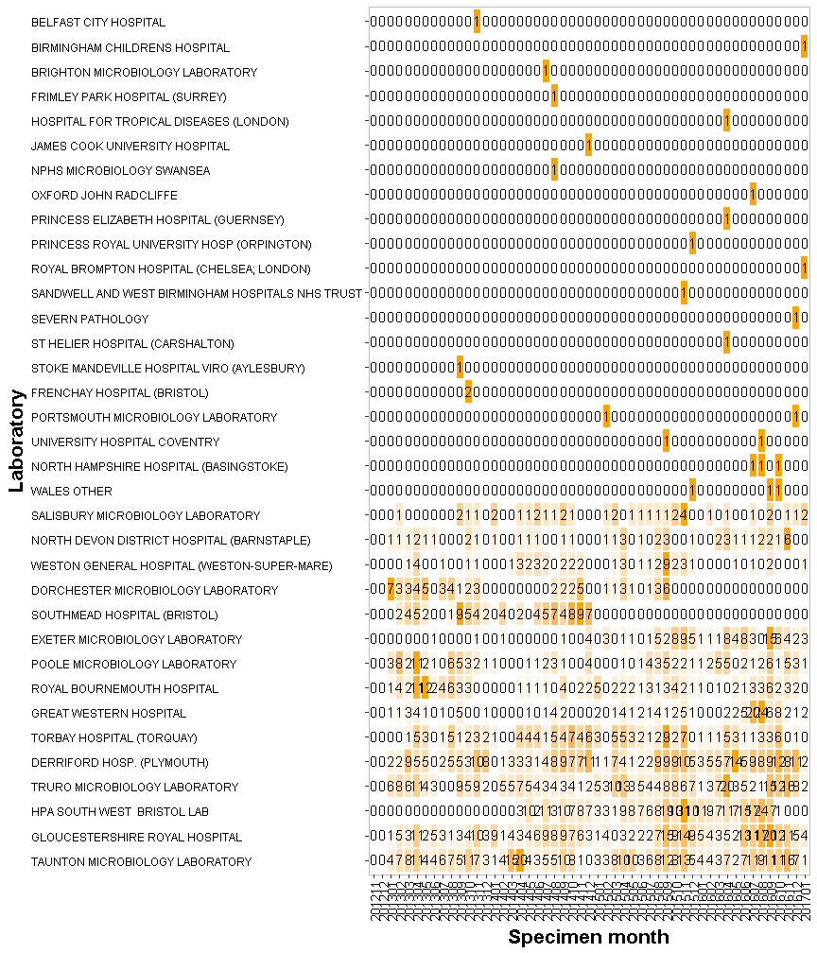

##### 

## Figure 13: Tile plot of cases 14/11/2012 to 24/01/2017 by requesting organisation by year-month, shading according to relative count across all tiles

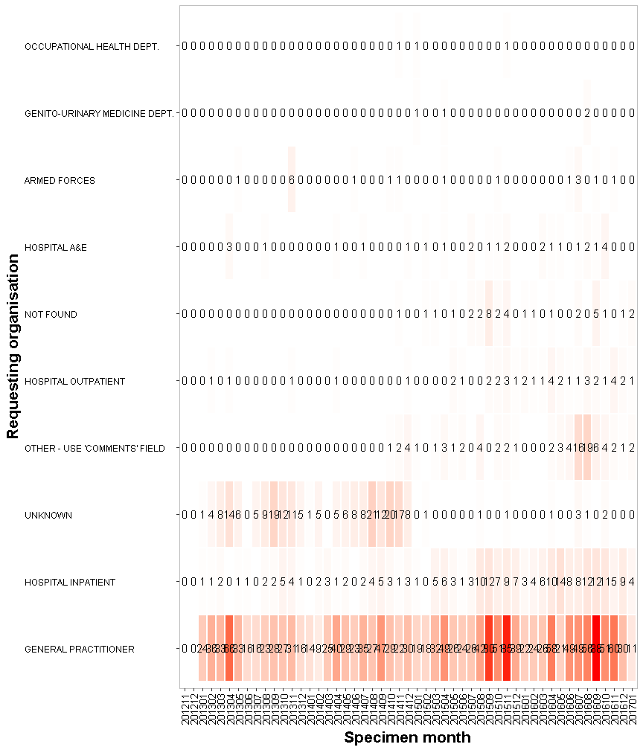

##### 

## Figure 13: Tile plot of cases 14/11/2012 to 24/01/2017 by requesting organisation by year-month, shading according to relative count across tiles within the same rows

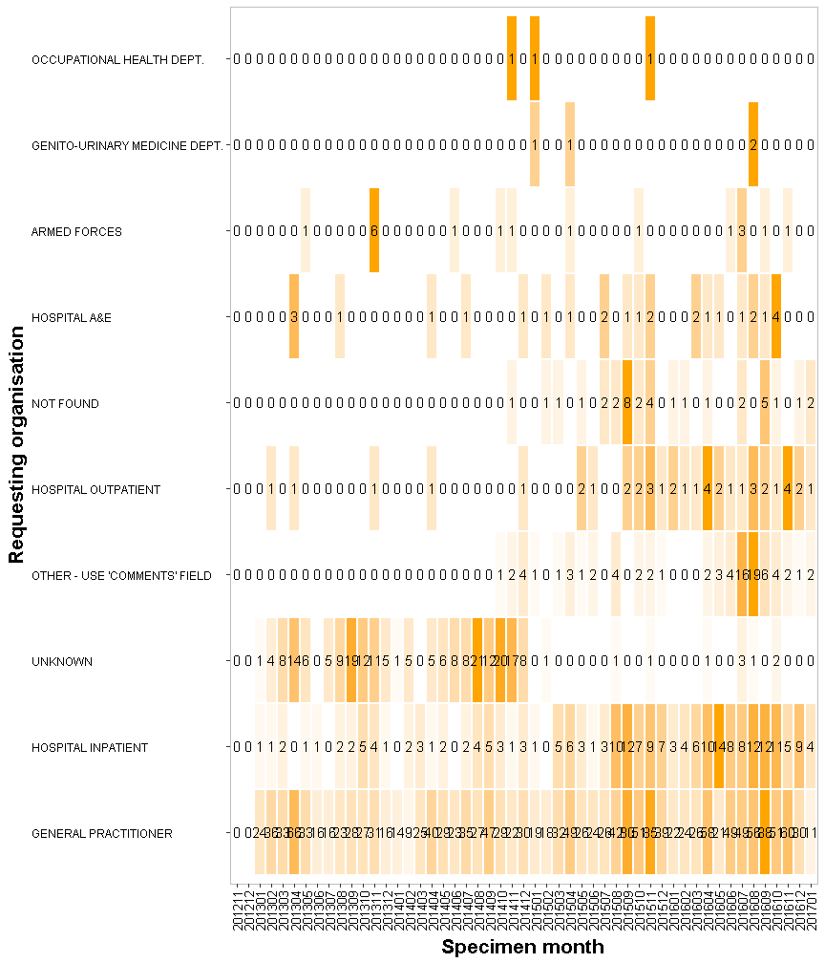

##### 

## Figure 13: Tile plot of cases 14/11/2012 to 24/01/2017 by specimen type by year-month, shading according to relative count across all tiles

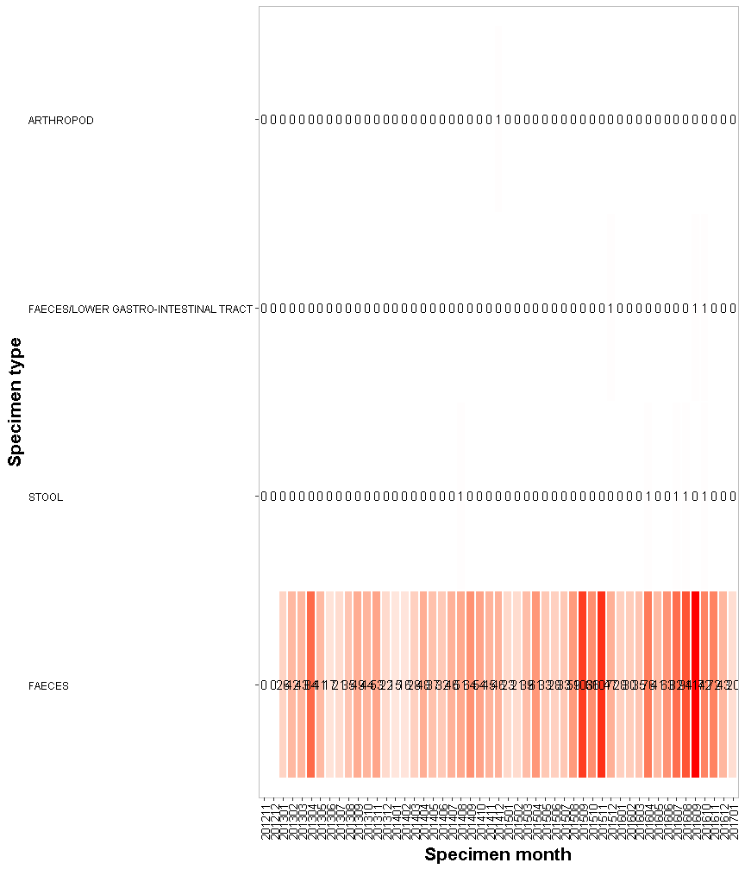

##### 

## Figure 13: Tile plot of cases 14/11/2012 to 24/01/2017 by specimen type by year-month, shading according to relative count across tiles within the same rows

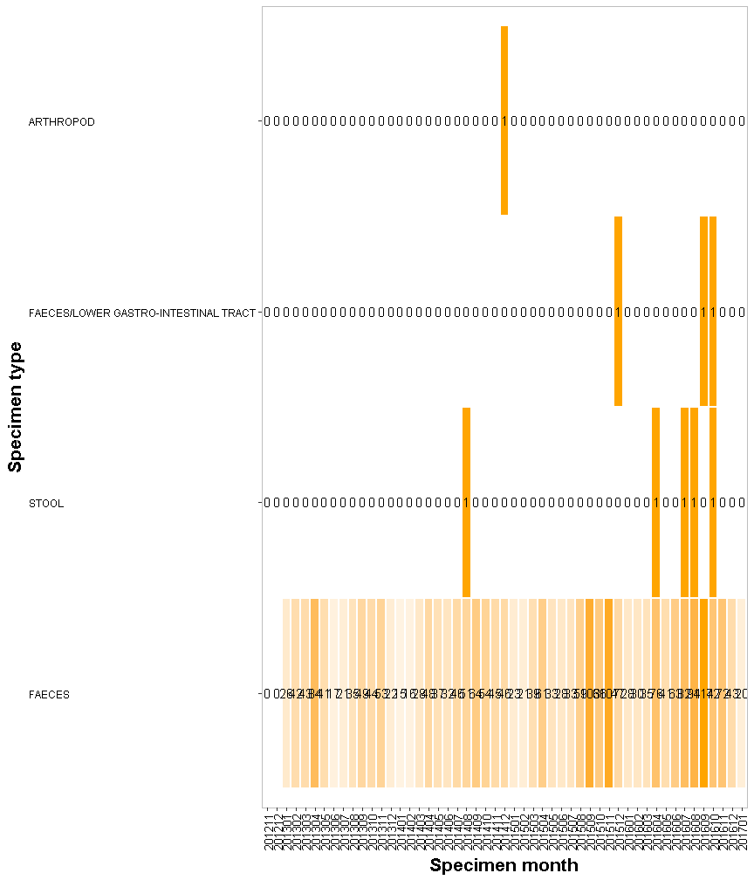

##### 

## Figure 17: Line graph of cases by travel status by year-month, 14/11/2012 to 24/01/2017

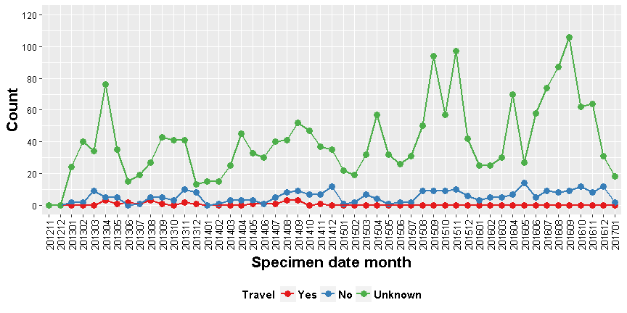

## Figure 17: Cumulative line graph of cases by travel status by year-month, 14/11/2012 to 24/01/2017

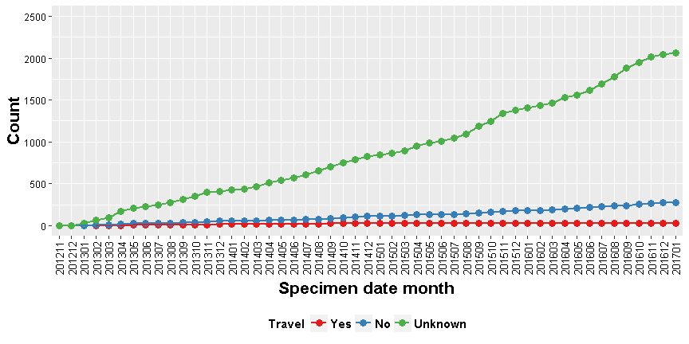

##### 

## Figure 13: Tile plot of cases 14/11/2012 to 24/01/2017 by travel status by year-month, shading according to relative count across all tiles

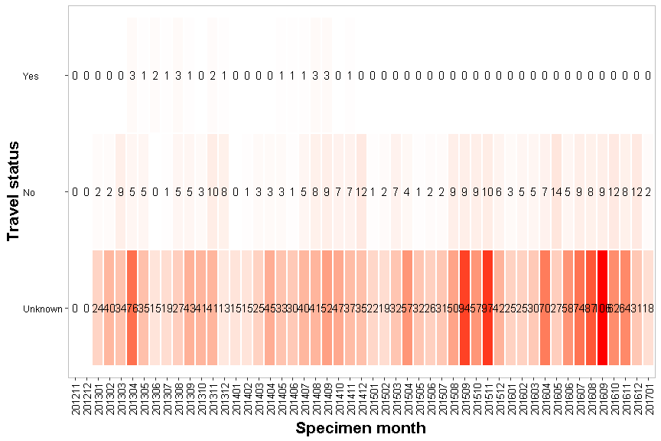

##### 

## Figure 13: Tile plot of cases 14/11/2012 to 24/01/2017 by travel status by year-month, shading according to relative count across tiles within the same rows

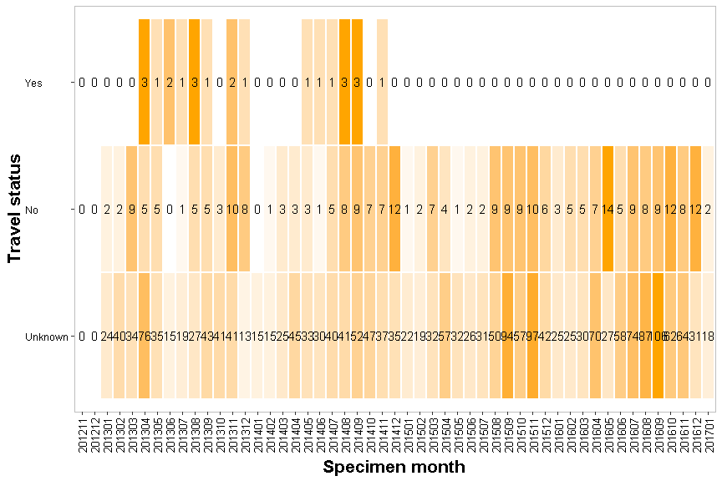

##### 

# Recent vs Historic cases

## Figure 27: Epidemic curve of cases comparing recent cases to histroic cases within 14 Nov to 24 Jan between 14/11/2012 to 24/01/2017 by yearly period

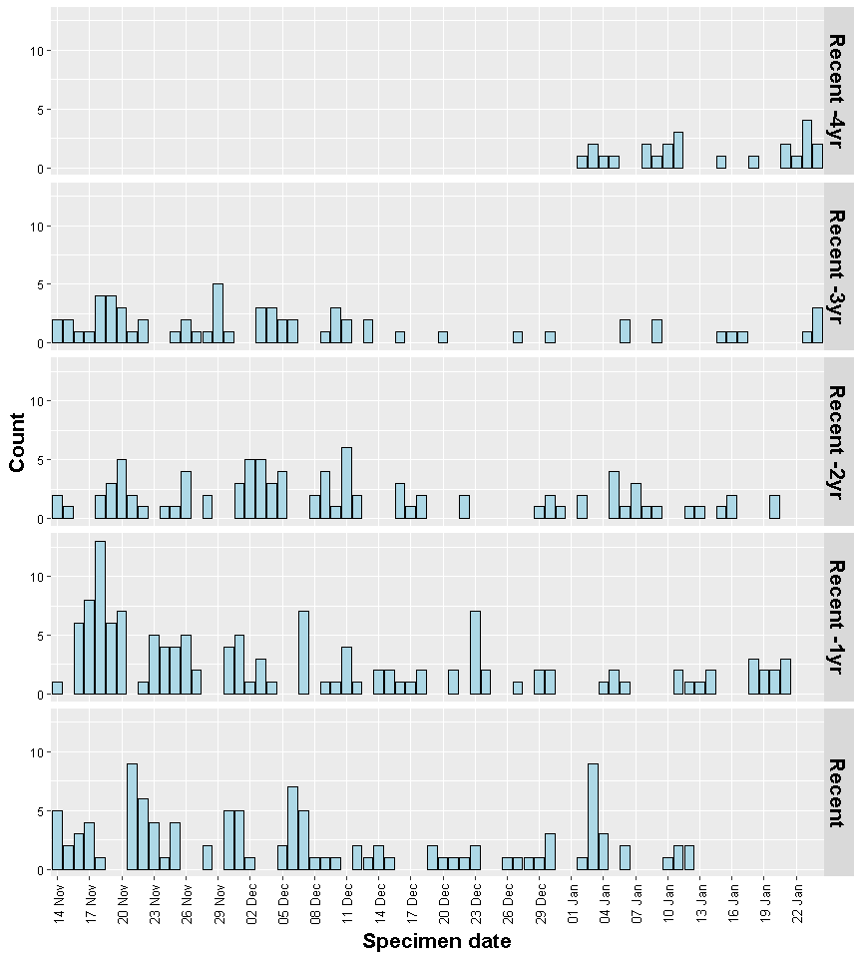

##### 

## Figure 29: Epidemic curve of cases comparing recent cases to histroic cases within 14 Nov to 24 Jan between 14/11/2012 to 24/01/2017 by week by yearly period

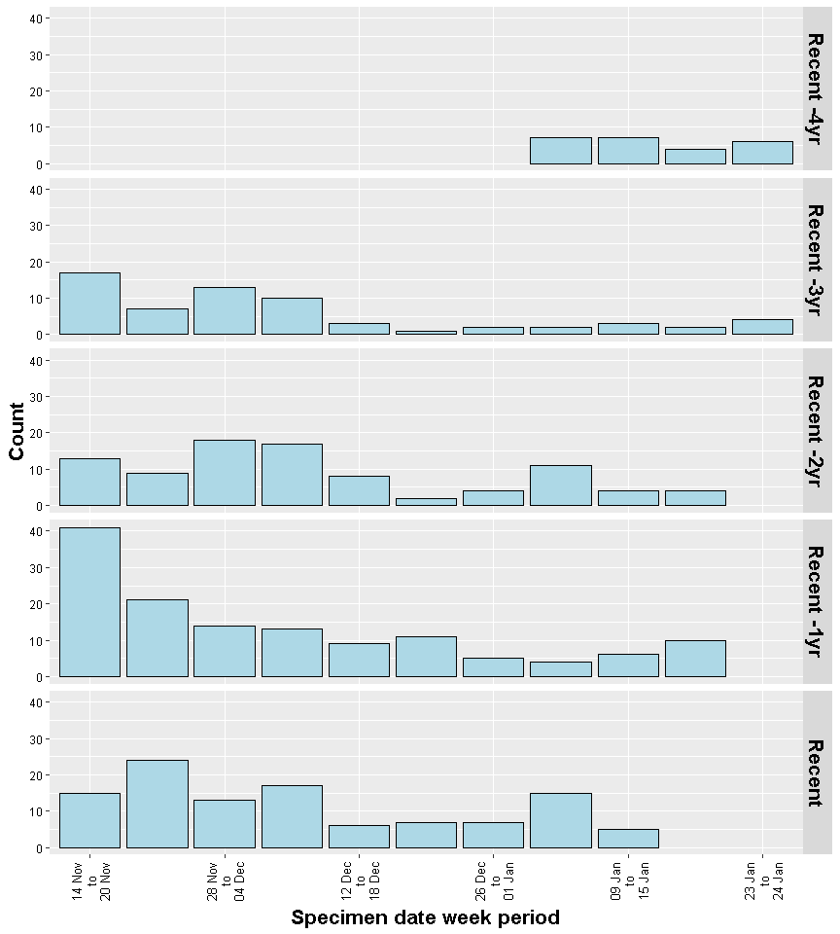

##### 

## Figure 28: Cumulative line graph of cases comparing recent cases to histroic cases within 14 Nov to 24 Jan between 14/11/2012 to 24/01/2017 by yearly period

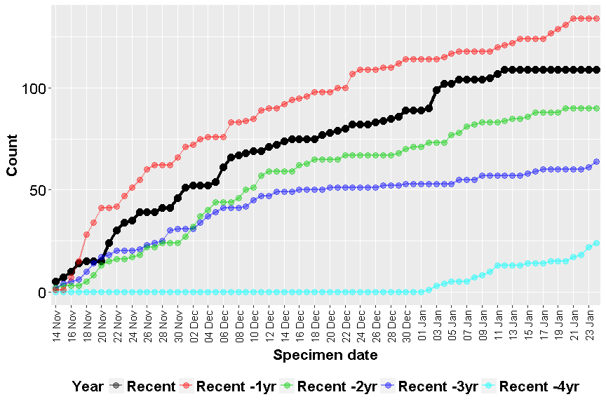

##### 

## Figure 28: Tile plot comparing recent cases to histroic cases within 14 Nov to 24 Jan between 14/11/2012 to 24/01/2017 by sex by yearly period, shading according to relative count across all tiles

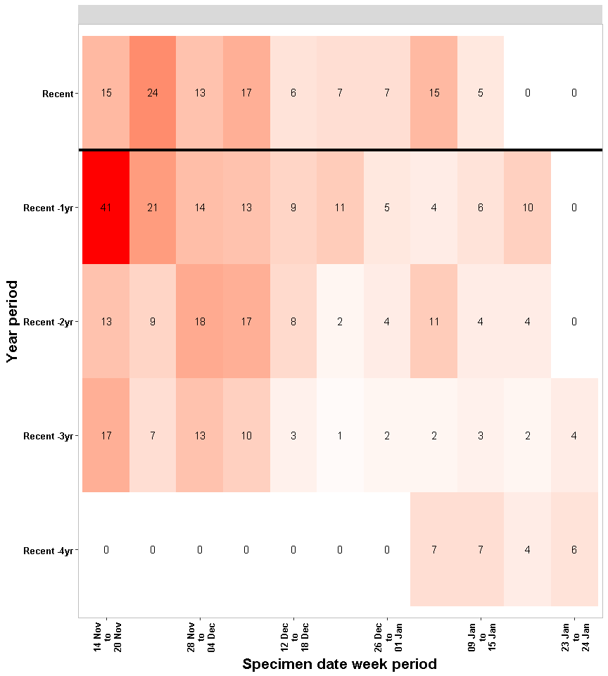

##### 

## Figure 27: Epidemic curve of cases comparing recent cases to histroic cases within 14 Nov to 24 Jan between 14/11/2012 to 24/01/2017 by sex by yearly period

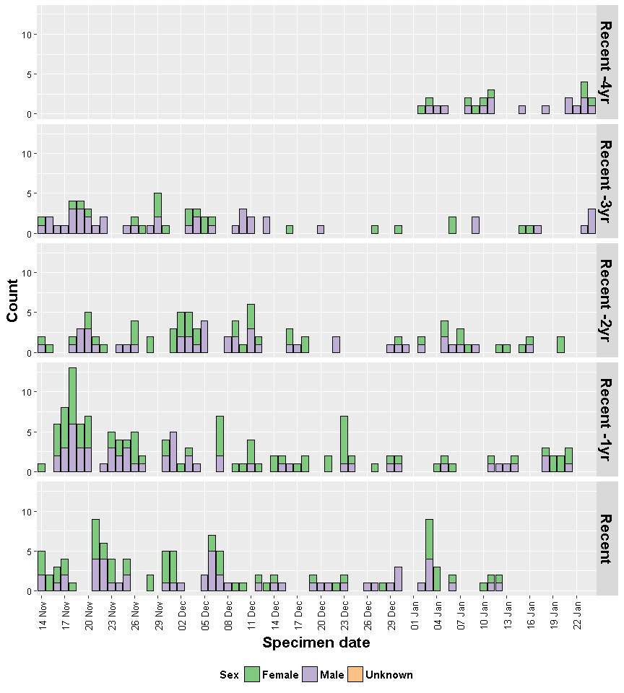

##### 

## Figure 30: Epicurve of cases comparing recent cases to histroic cases within 14 Nov to 24 Jan between 14/11/2012 to 24/01/2017 by sex by week by yearly period

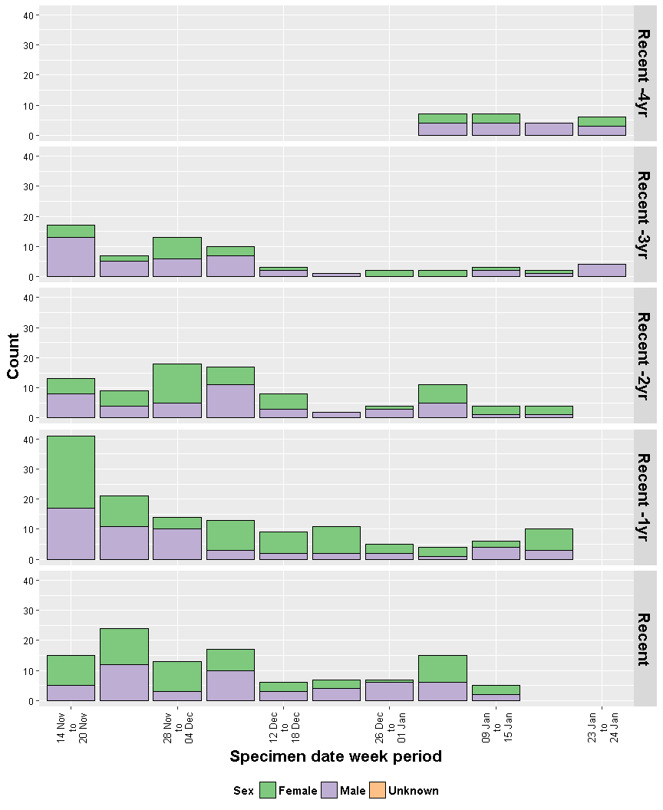

##### 

## Figure 29: Epidemic curve of cases comparing recent cases to histroic cases within 14 Nov to 24 Jan between 14/11/2012 to 24/01/2017 by age group by week by yearly period

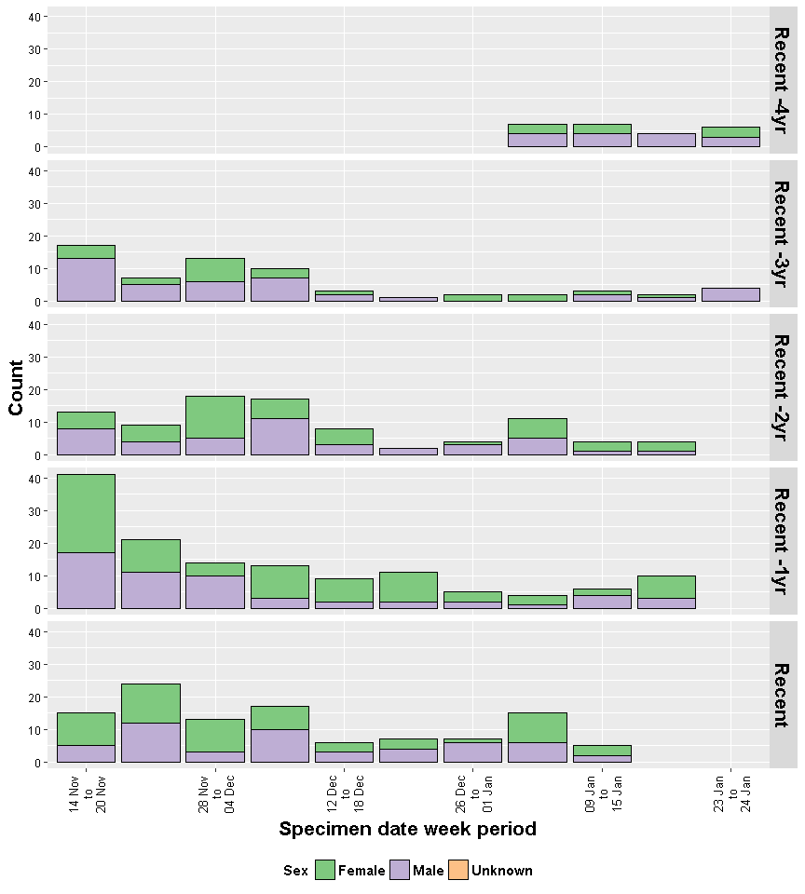

##### 

## Figure 27: Cumulative line graph of cases comparing recent cases to histroic cases within 14 Nov to 24 Jan between 14/11/2012 to 24/01/2017 by sex by yearly period

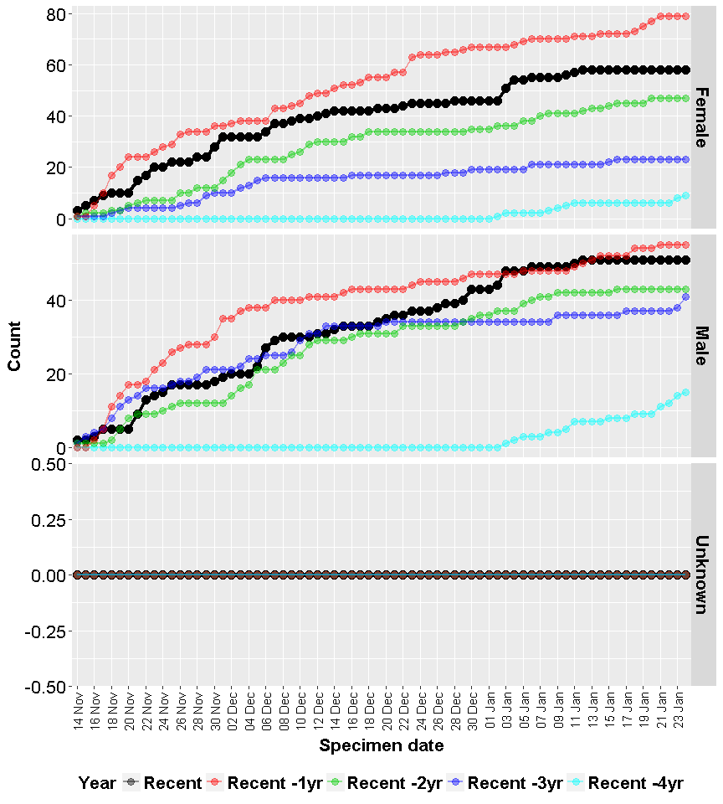

##### 

## Figure 28: Tile plot comparing recent cases to histroic cases within 14 Nov to 24 Jan between 14/11/2012 to 24/01/2017 by sex by yearly period, shading according to relative count across all within the same group

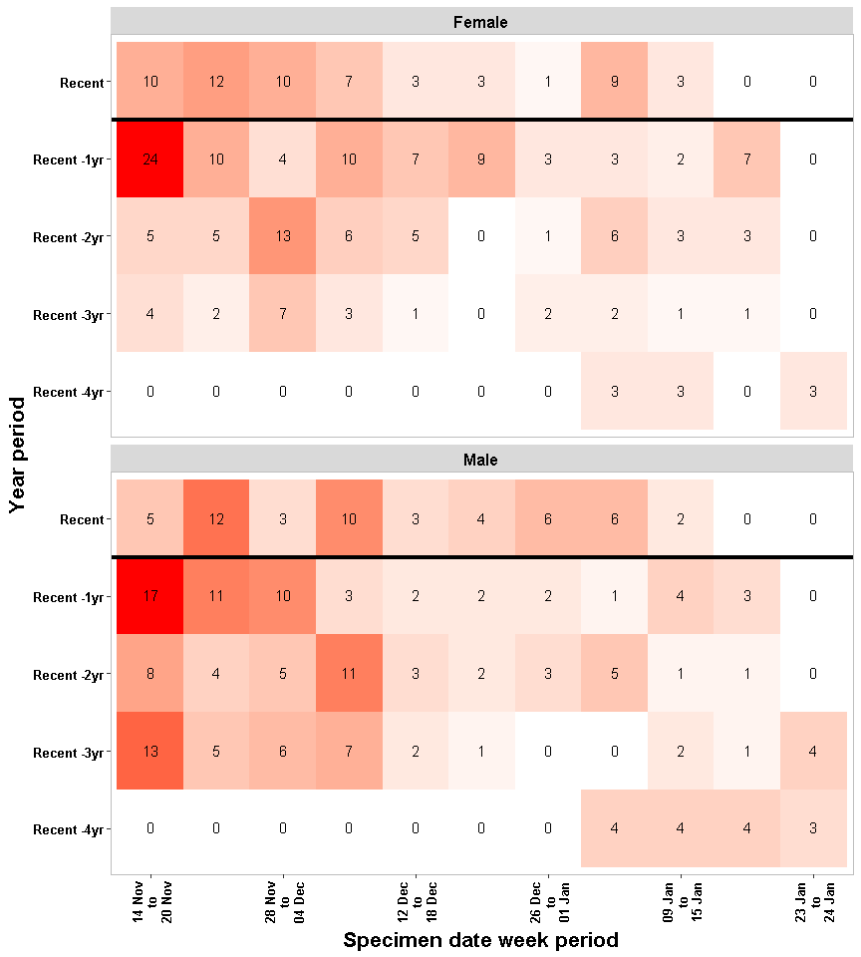

##### 

## Figure 27: Epidemic curve of cases comparing recent cases to histroic cases within 14 Nov to 24 Jan between 14/11/2012 to 24/01/2017 by age group by yearly period

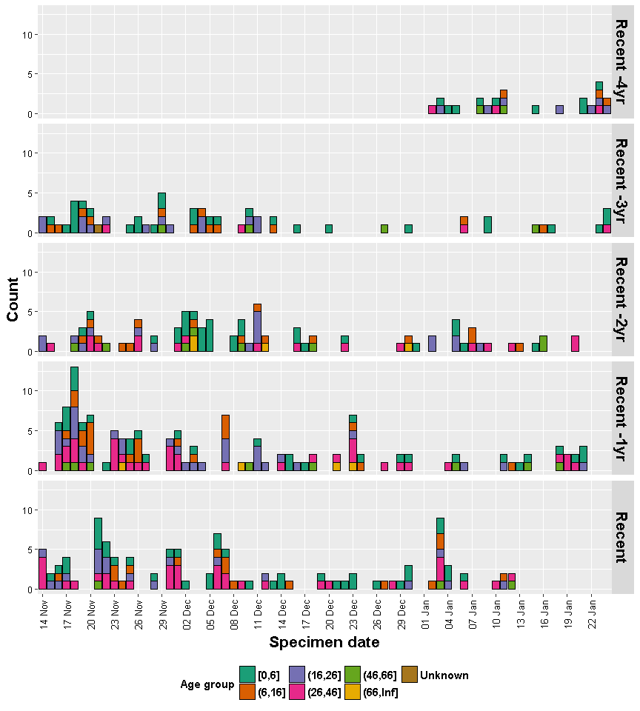

##### 

## Figure 29: Epidemic curve of cases comparing recent cases to histroic cases within 14 Nov to 24 Jan between 14/11/2012 to 24/01/2017 by age group by week by yearly period

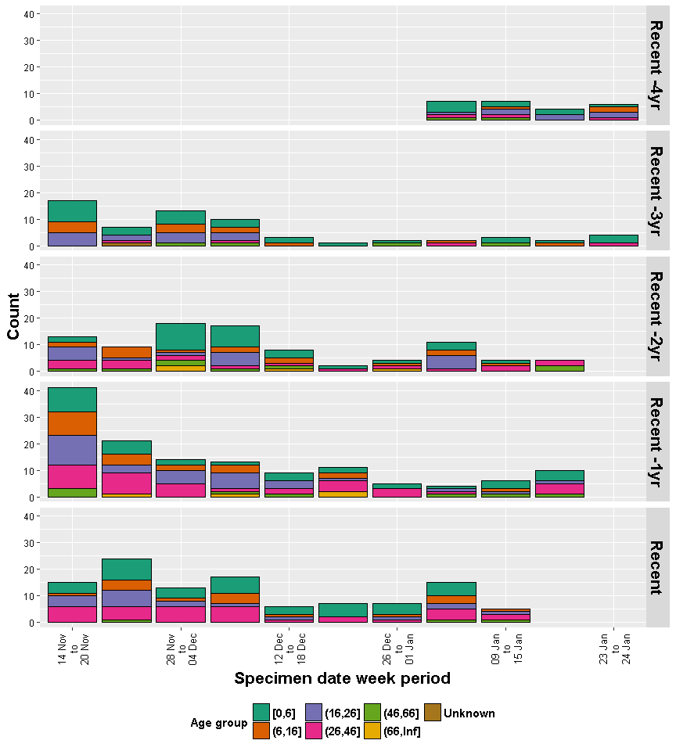

##### 

## Figure 28: Tile plot comparing recent cases to histroic cases within 14 Nov to 24 Jan between 14/11/2012 to 24/01/2017 by age group by yearly period, shading according to relative count across all within the same group

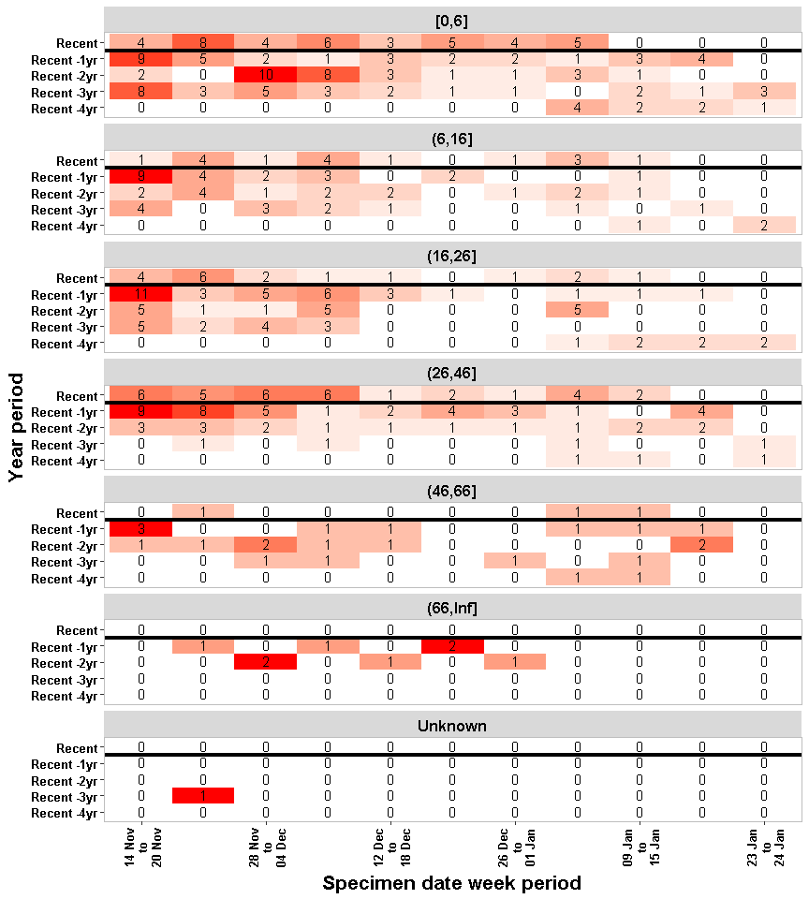

##### 

## Table 3: Table of cases comparing recent cases to histroic cases within 14 Nov to 24 Jan between 14/11/2012 to 24/01/2017 by local authority by yearly period

|  |  |  |  |  |  |  |  |  |
| --- | --- | --- | --- | --- | --- | --- | --- | --- |
| Local Authority | Recent | Historic.Avg | Recent.Vs.Historic.Avg.Diff | Historic.Total | Recent -4yr | Recent -3yr | Recent -2yr | Recent -1yr |
| CORNWALL | 25 | 12.2 | 12.8 | 49 | 7 | 14 | 12 | 16 |
| PLYMOUTH | 15 | 5.5 | 9.5 | 22 | 1 | 5 | 9 | 7 |
| WEST DORSET | 7 | 1.5 | 5.5 | 6 | 2 | 1 | 1 | 2 |
| TAUNTON DEANE | 8 | 3.5 | 4.5 | 14 | 1 | 2 | 4 | 7 |
| SOUTH SOMERSET | 6 | 1.8 | 4.2 | 7 | 1 | 2 | 2 | 2 |
| EXETER | 4 | 0.8 | 3.2 | 3 | 1 | 0 | 0 | 2 |
| CHELTENHAM | 3 | 0 | 3 | 0 | 0 | 0 | 0 | 0 |
| TORRIDGE | 3 | 0.5 | 2.5 | 2 | 1 | 0 | 0 | 1 |
| TEWKESBURY | 2 | 0 | 2 | 0 | 0 | 0 | 0 | 0 |
| WEYMOUTH AND PORTLAND | 3 | 1.2 | 1.8 | 5 | 1 | 1 | 1 | 2 |
| NORTH DORSET | 2 | 0.2 | 1.8 | 1 | 0 | 0 | 0 | 1 |
| SEDGEMOOR | 4 | 2.8 | 1.2 | 11 | 1 | 3 | 2 | 5 |
| GLOUCESTER | 1 | 0 | 1 | 0 | 0 | 0 | 0 | 0 |
| WEST SOMERSET | 1 | 0.2 | 0.8 | 1 | 0 | 0 | 0 | 1 |
| WEST DEVON | 1 | 0.5 | 0.5 | 2 | 0 | 0 | 0 | 2 |
| TEIGNBRIDGE | 2 | 1.5 | 0.5 | 6 | 0 | 1 | 3 | 2 |
| SWINDON | 1 | 0.5 | 0.5 | 2 | 1 | 1 | 0 | 0 |
| SOUTH HAMS | 2 | 1.5 | 0.5 | 6 | 0 | 4 | 2 | 0 |

##### 

## Figure 49: Bar graph of cases comparing recent cases to histroic average of cases within 14 Nov to 24 Jan between 14/11/2012 to 24/01/2017 by local authority

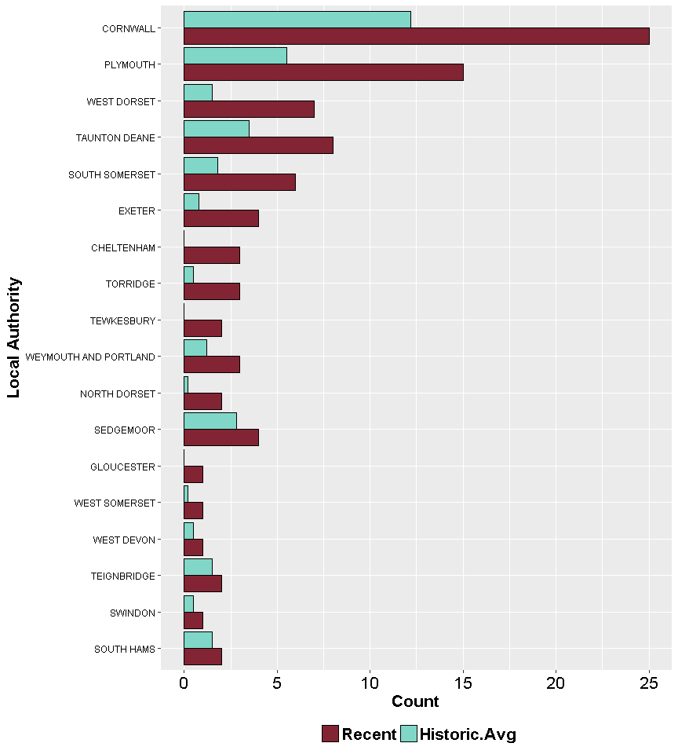

Note: only local authorities where the number of recent cases is greater than the historic avgerage are presented in the table above

##### 

## Table 4: Table of cases comparing recent cases to histroic cases within 14 Nov to 24 Jan between 14/11/2012 to 24/01/2017 by laboratory by yearly period

|  |  |  |  |  |  |  |  |  |
| --- | --- | --- | --- | --- | --- | --- | --- | --- |
| Laboratory | Recent | Historic.Avg | Recent.Vs.Historic.Avg.Diff | Historic.Total | Recent -4yr | Recent -3yr | Recent -2yr | Recent -1yr |
| TRURO MICROBIOLOGY LABORATORY | 20 | 8 | 12 | 32 | 6 | 10 | 5 | 11 |
| TAUNTON MICROBIOLOGY LABORATORY | 19 | 7 | 12 | 28 | 4 | 6 | 3 | 15 |
| DERRIFORD HOSP. (PLYMOUTH) | 21 | 10.2 | 10.8 | 41 | 2 | 14 | 16 | 9 |
| GLOUCESTERSHIRE ROYAL HOSPITAL | 17 | 10.2 | 6.8 | 41 | 1 | 14 | 6 | 20 |
| POOLE MICROBIOLOGY LABORATORY | 7 | 3 | 4 | 12 | 1 | 3 | 4 | 4 |
| EXETER MICROBIOLOGY LABORATORY | 7 | 4 | 3 | 16 | 0 | 1 | 4 | 11 |
| NORTH DEVON DISTRICT HOSPITAL (BARNSTAPLE) | 3 | 0.8 | 2.2 | 3 | 1 | 1 | 0 | 1 |
| SALISBURY MICROBIOLOGY LABORATORY | 3 | 1.8 | 1.2 | 7 | 0 | 3 | 0 | 4 |
| SEVERN PATHOLOGY | 1 | 0 | 1 | 0 | 0 | 0 | 0 | 0 |
| ROYAL BROMPTON HOSPITAL (CHELSEA; LONDON) | 1 | 0 | 1 | 0 | 0 | 0 | 0 | 0 |
| PORTSMOUTH MICROBIOLOGY LABORATORY | 1 | 0 | 1 | 0 | 0 | 0 | 0 | 0 |
| GREAT WESTERN HOSPITAL | 3 | 2 | 1 | 8 | 1 | 1 | 2 | 4 |
| BIRMINGHAM CHILDRENS HOSPITAL | 1 | 0 | 1 | 0 | 0 | 0 | 0 | 0 |
| WESTON GENERAL HOSPITAL (WESTON-SUPER-MARE) | 1 | 0.8 | 0.2 | 3 | 0 | 1 | 0 | 2 |

##### 

## Figure 50: Bar graph of cases comparing recent cases to histroic average of cases within 14 Nov to 24 Jan between 14/11/2012 to 24/01/2017 by laboratory

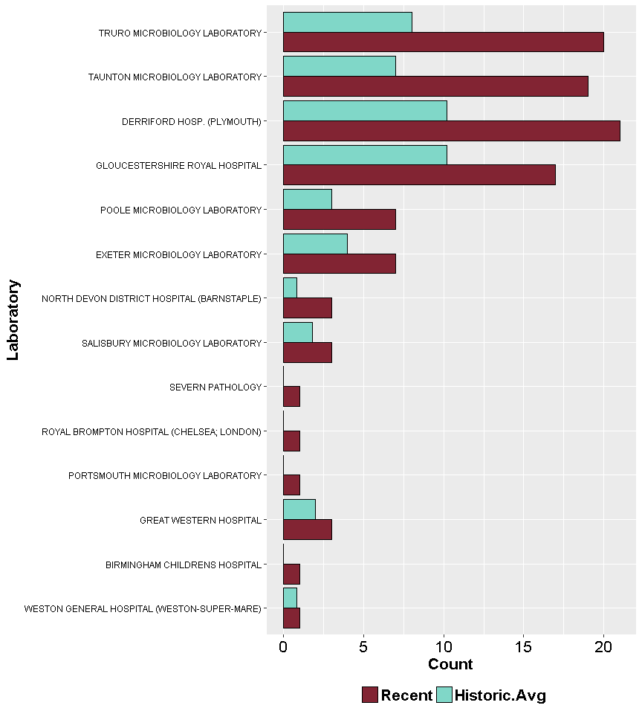

Note: only laboratories where the number of recent cases is greater than the historic avgerage are presented in the table above

##### 

## Table 4: Table of cases comparing recent cases to histroic cases within 14 Nov to 24 Jan between 14/11/2012 to 24/01/2017 by requesting organisation by yearly period

|  |  |  |  |  |  |  |  |  |
| --- | --- | --- | --- | --- | --- | --- | --- | --- |
| Requesting Organisation | Recent | Historic.Avg | Recent.Vs.Historic.Avg.Diff | Historic.Total | Recent -4yr | Recent -3yr | Recent -2yr | Recent -1yr |
| GENERAL PRACTITIONER | 77 | 58.5 | 18.5 | 234 | 22 | 45 | 56 | 111 |
| HOSPITAL INPATIENT | 18 | 5 | 13 | 20 | 1 | 3 | 5 | 11 |
| HOSPITAL OUTPATIENT | 7 | 1 | 6 | 4 | 0 | 0 | 1 | 3 |
| NOT FOUND | 3 | 1.2 | 1.8 | 5 | 0 | 0 | 1 | 4 |
| OTHER - USE 'COMMENTS' FIELD | 3 | 1.8 | 1.2 | 7 | 0 | 0 | 5 | 2 |

##### 

## Figure 50: Bar graph of cases comparing recent cases to histroic average of cases within 14 Nov to 24 Jan between 14/11/2012 to 24/01/2017 by requesting organisation

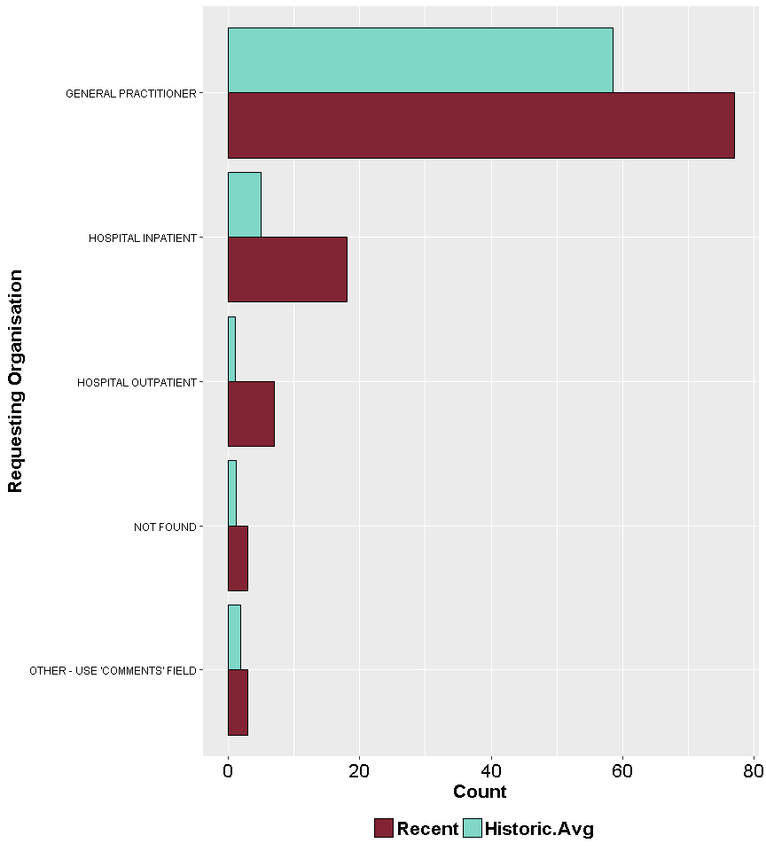

Note: only requesting organisations where the number of recent cases is greater than the historic avgerage are presented in the table above

##### 

## Table 4: Table of cases comparing recent cases to histroic cases within 14 Nov to 24 Jan between 14/11/2012 to 24/01/2017 by specimen type by yearly period

|  |  |  |  |  |  |  |  |  |
| --- | --- | --- | --- | --- | --- | --- | --- | --- |
| Specimen Type | Recent | Historic.Avg | Recent.Vs.Historic.Avg.Diff | Historic.Total | Recent -4yr | Recent -3yr | Recent -2yr | Recent -1yr |
| FAECES | 109 | 77.5 | 31.5 | 310 | 24 | 64 | 89 | 133 |

##### 

## Figure 50: Bar graph of cases comparing recent cases to histroic average of cases within 14 Nov to 24 Jan between 14/11/2012 to 24/01/2017 by specimen type

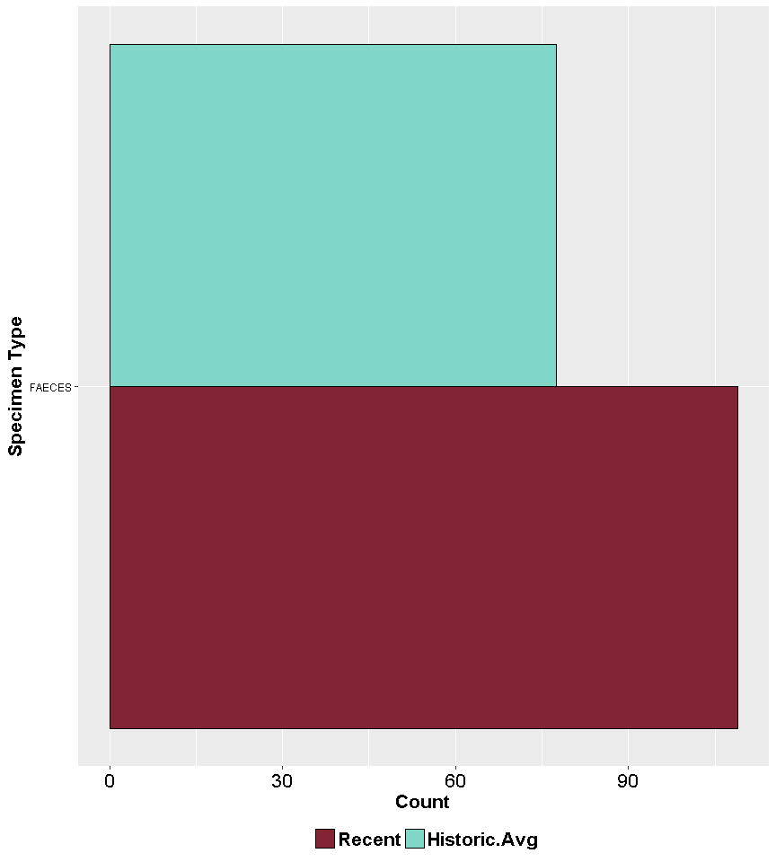

Note: only specimen types where the number of recent cases is greater than the historic avgerage are presented in the table above

## Figure 27: Epidemic curve of cases comparing recent cases to histroic cases within 14 Nov to 24 Jan between 14/11/2012 to 24/01/2017 by travel status by yearly period

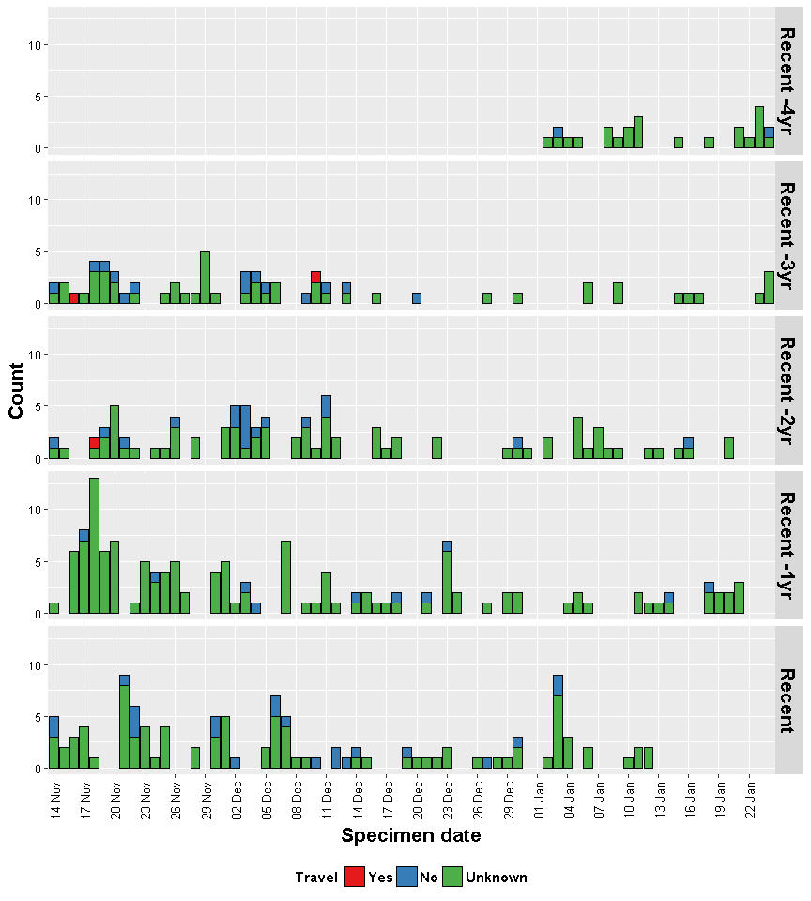

##### 

## Figure 29: Epidemic curve of cases comparing recent cases to histroic cases within 14 Nov to 24 Jan between 14/11/2012 to 24/01/2017 by travel status by week by yearly period

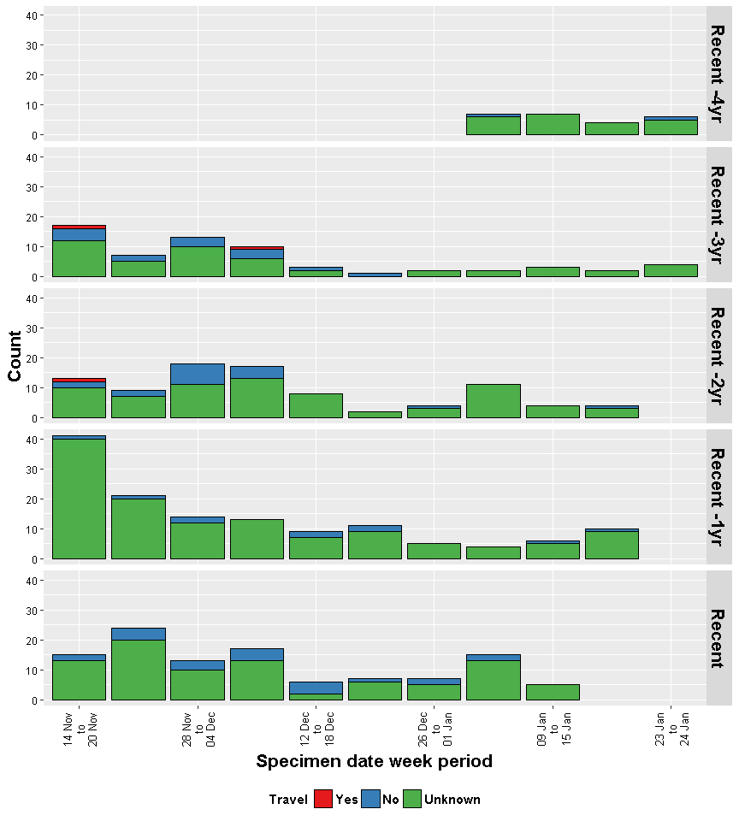

##### 

## Figure 28: Cumulative line graph of cases comparing recent cases to histroic cases within 14 Nov to 24 Jan between 14/11/2012 to 24/01/2017 by travel status by yearly period

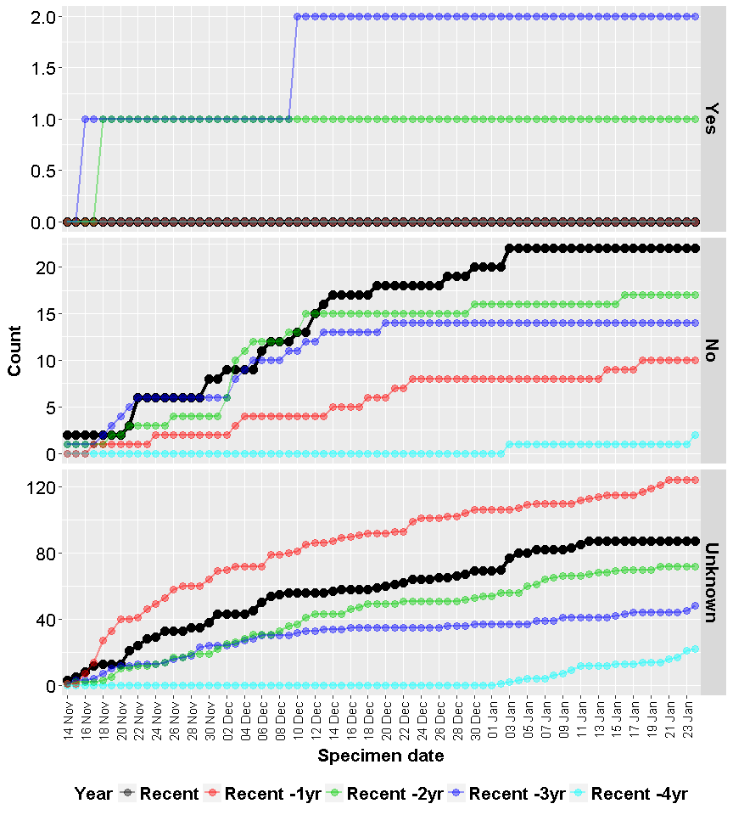

##### 

## Figure 28: Tile plot comparing recent cases to histroic cases within 14 Nov to 24 Jan between 14/11/2012 to 24/01/2017 by travel status by yearly period, shading according to relative count across all within the same group

