NOTE: Use of internet is not permitted, apart from uploading submission, calculators are permitted and your answers must include worked solutions. If you require extra sheet(s) please write your name and student number at the top of each additional sheet.
Part A
Objective
Convert decimal numbers to binary showing in detail the conversion process
- Convert the number of days in a year 365₁₀ to Base₂
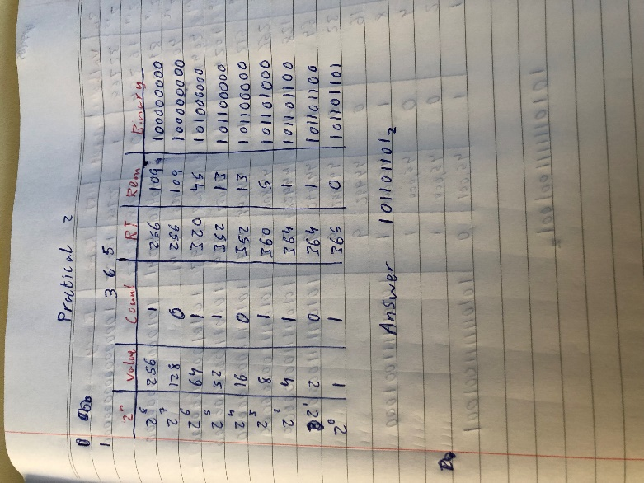

- Convert the number of available seats in the new Páirc Uí Chaoimh 45,001₁₀ to Base₂
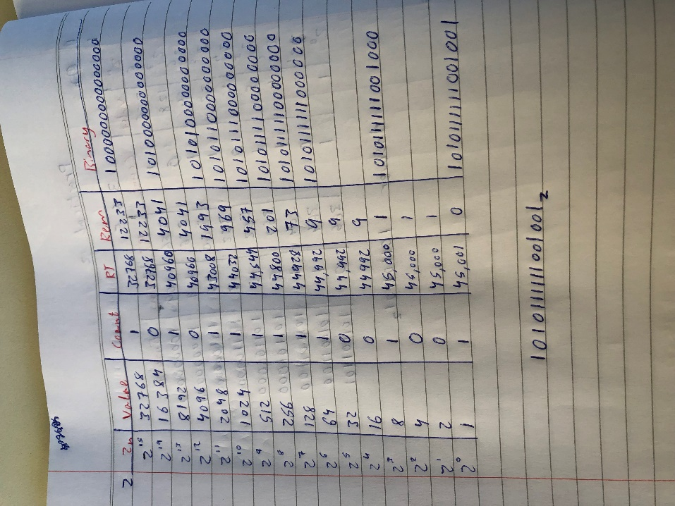

Part B
Objective
Convert numbers base₂ to Base₁₀ showing in detail the conversion process
- Convert the number 1011001001110101₂ to Base₁₀
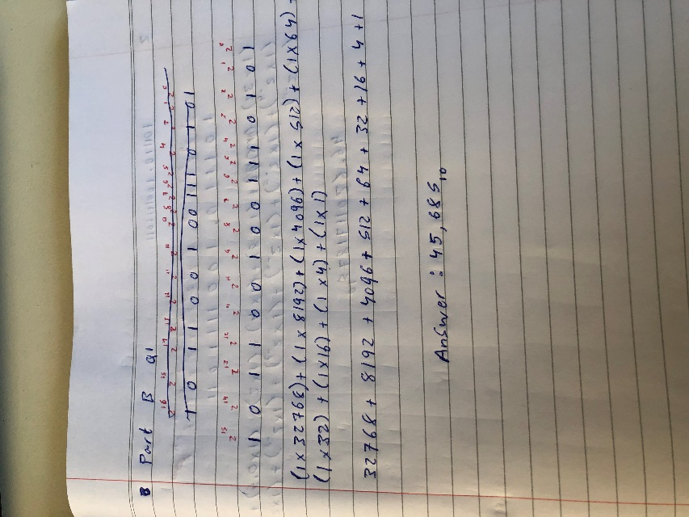

- Convert the number 101110.1001111011₂ to Base₁₀
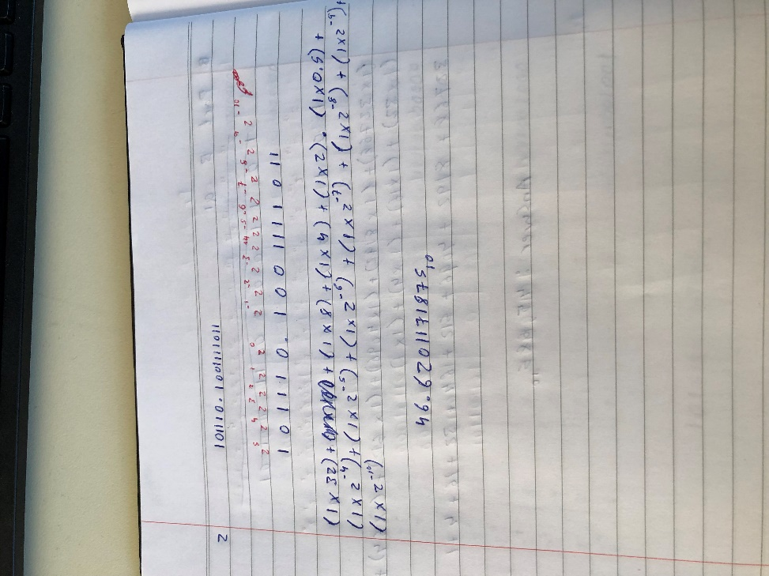

Part C
Objective
Add numbers base₂ to base₂ showing in detail the addition process
- What is the Base₂ value of addition of 1001 0111₂ + 0101 1111₂
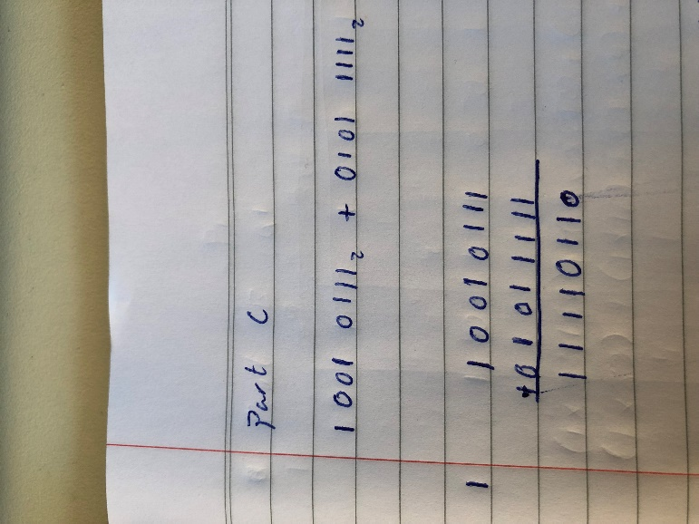

- What is the Base₂ value of addition of 1001.0101₂ + 010.1 1101₂
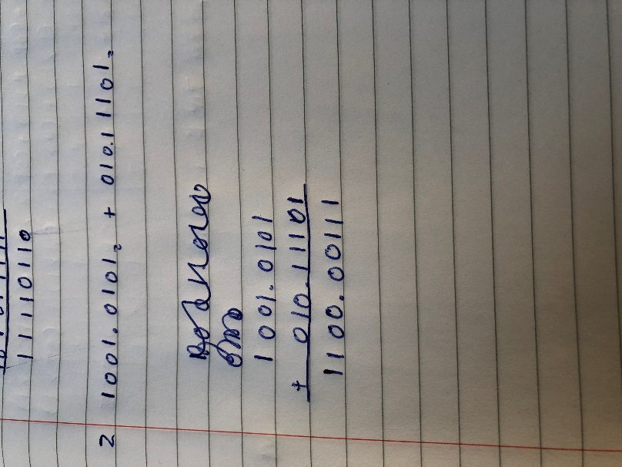

Hand up this practical report at the end of session and ensure it has been checked
Student Name | Daniel Giedraitis | Student Number | C00260331
Date | 3/11/20201 | Checked
Group | A / B

