Part A
I
A
B
C
D
E
F
G
Objective : Name and decribe each component
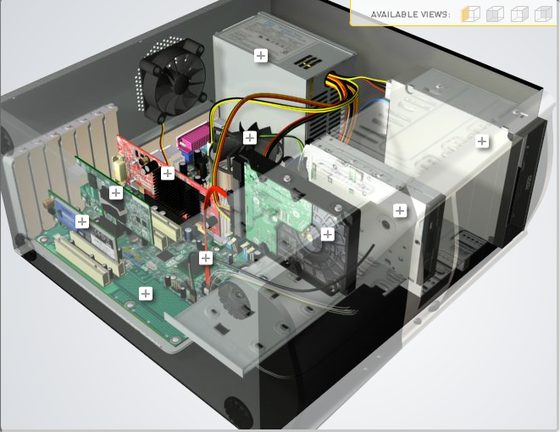
H
Download http://tinyurl.com/CW208-CAG-SIM PC Build Simulator.
Go through steps of building a PC, as you complete the simulation find and describe in detail components A to I. To run simulator first install http://www.swffileplayer.com/ and open RootMovie.swf using SWF player. Alternatively install Macromedia Flashplayer . Ideally use a simulator as listed in class.
Label | Name each component | Description
A | Ram | RAM is temporary storage that goes away when the power turns off.
B | GPU | Is a chip or electronic circuit capable of rendering graphics for display on an electronic device.
C | CPU | Is the portion of a computer that retrieves and executes instructions.
D | Power Supply | A device providing power to electronic equipment (PC)
E | Disk Drive | A device that reads and/or writes data to a disk.
F | Hard Drive | Is an electro-mechanical data storage device that stores and retrieves digital data using magnetic storage
G | SSD | Is a new generation of storage device used in computers.
H
I | Motherboard | The motherboard is a computer's central communications backbone connectivity point, through which all components and external peripherals connect

Part B
Objective
Compare a pre-assembled system and the components that could be assembled to build a comparable system. After completing this practical, you should be able to:
- Identify the components of a pre-assembled system
- Locate prices for components needed to assemble a comparable system
- Compare the cost of a pre-assembled system and a self-assembled system.
If you can’t find exact match for components, find the closest possible substitute. Use the Internet and available computer-related publications as your sources for information. Examples of websites for computer parts www.komplett.ie, www.dell.ie, www.custompc.ie www.amazon.de
MAKE SURE TO INCLUDE VALID LINKS TO WEB REFERENCES
 | Pre-Assembled Computer Package | Computer Package  Components
CPU | AMD Ryzen 3 1200 3.1GHz | AMD Ryzen 5 1600
Storage / Memory
 | 480GB | 16GB G.Skill DDR4  2TB
  RAM
  Hard Drive
  8GB DDR4 2666MHz
Input/Output
 | -Trust Gaming GXT 830-RW Avonn.(Keyboard)  -VGUARD Gaming Mouse  -Samsung LF24T350FHU - 24" 60hz  Trust GXT 608 Speakerset  RS PRO 1 Port USB 3.0 Network Adapter | 60% Mechanical Keyboard Wired  Logitech G502 Mouse  Lenovo G24-10 23.6-inch FHD WLED Gaming Monitor 144Hz  SPEAKERS LOGITECH  USB Network Adapter Syncwire USB 3.0
  Keyboard
  Pointing Device
  Monitor
  Speakers
  Network Adapter
Bundled Software  (Including Operating System) | Windows 10 Pro | Windows 10 Pro
Total Cost | €1527.5 | €1262

Part C
Objective
You have been asked by a family friend to assist them with a computer purchase. They’re unfamiliar with technology and the terms used and have presented you with two alternatives machine choices. They would like to be able to write word documents, surf internet and play Minecraft © Mojang and Half-Life © Valve Software. They are considering playing Fortnight but are not sure yet, as it depends on machine cost and if they can extract some money from their Bitcoin wallet.
Compare Personal Computer Option A and B in relation to each of the side headings and recommend a system and any alterations.

 | Personal Computer  Option A | Personal Computer  Option B
CPU | 2.2 GHz Intel Celeron 450 | 3.2 GHz Intel Core i5
Memory
  Cache
  RAM
  Hard Drive
  CD-ROM/DVD
  512 KB Cache
  4 GB RAM
  320 GB Hard Drive
  DVD+/-RW drive
  4 MB Cache
  8 GB RAM
  1 TB Hard Drive
  DVD+/-RW drive
Input/Output
  Keyboard
  Pointing Device
  Screen
  Speakers
  Network Adapter
  USB multifunction keyboard
  USB optical mouse
  20’’ HD flatscreen monitor
  Multimedia Speaker System
  Integrated 10/100/1000 Ethernet
  wireless multifunction keyboard
  wireless optical mouse
  25’’ HD flatscreen monitor
  Dolby Surround Sound Speakers
  Integrated 10/100/1000 Ethernet

Recommendations
Overall Option B is the better option because it has better parts than Option A which will make the PC perform better than Option A. Option A has a better CPU which will make the PC run faster and smoother, Option B has more Cache which means the more data can be stored closer to the CPU. Option B has more ram which means the faster the processing speed. Option B has more space in the hard drive which mean you can store more videos/apps/pictures. Option B has a wireless option with the keyboard which Option A doesn’t. Option B a bigger monitor screen than Option A. Also Option B has surround sound and Option A doesn’t.

Your Recommend System
Personal Computer
Recommendation
CPU | AMD Ryzen 7 5800X Processor
Memory

  RAM
  Hard Drive
  SSD Drive
  16GB Kingston HyperX Fury DDR4 2666MHz
  4TB Seagate Barracuda
  2TB Samsung 970
Input/Output

  Keyboard
  Pointing Device
  Screen
  Speakers
  Network Adapter
  GPU
  EVGA NVIDIA GeForce RTX 2060 6GB GDDR6
  Razer Naga Trinity
  AOC 24G2U 24" Full HD 144Hz Gaming Monitor
  AOC 24G2U 24" Full HD 144Hz Gaming Monitor
  AOC 24G2U 24" Full HD 144Hz Gaming Monitor
  EVGA NVIDIA GeForce RTX 2060 6GB GDDR6

Hand up this practical report at the end of session and ensure it has been checked
Student Name | Daniel Giedraitis | Student Number | C00260331
Date | 27/10/2021 | Checked
Group | A / B

