Objective
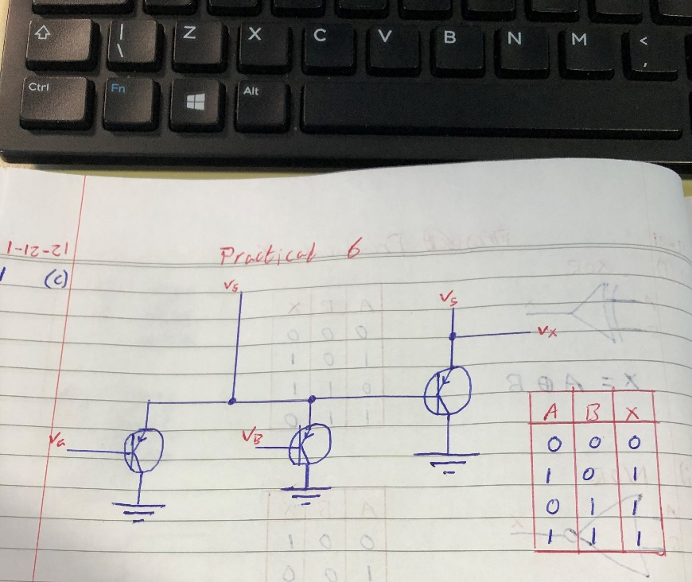
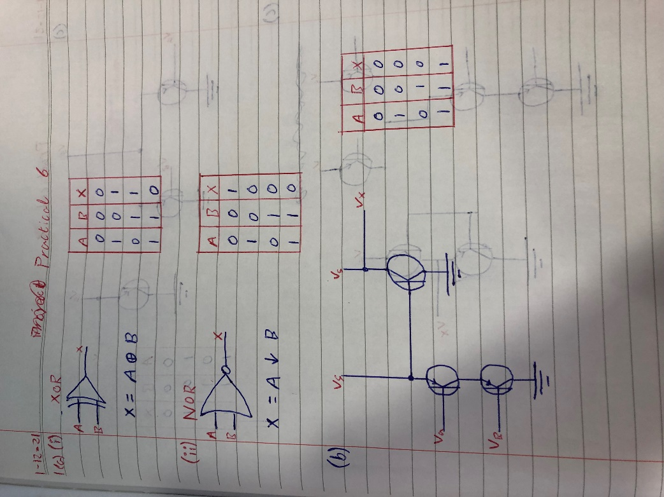
Understand various logic gates
- Complete questions below a, b, c below
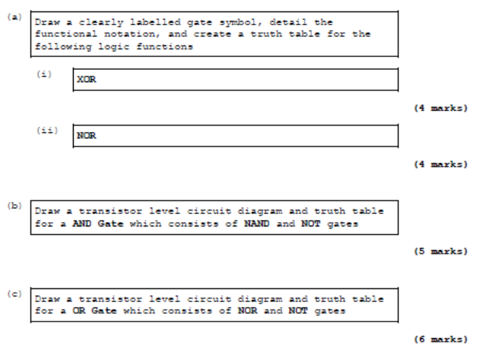

- Complete questions below
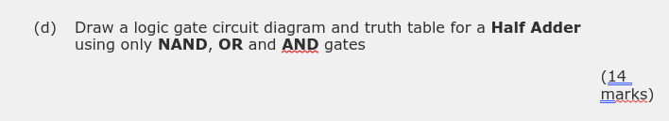

- Complete questions below
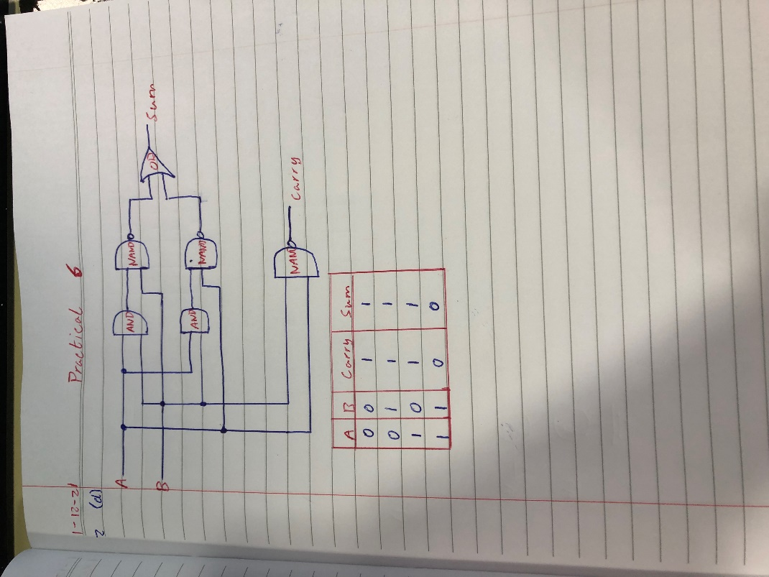
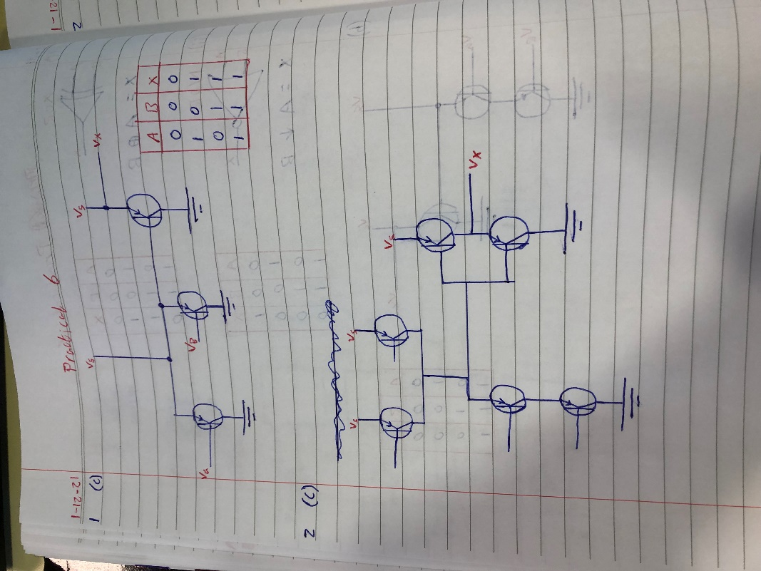

Construct the following Circuit using NAND and NOT Gates and complete Truth Tables

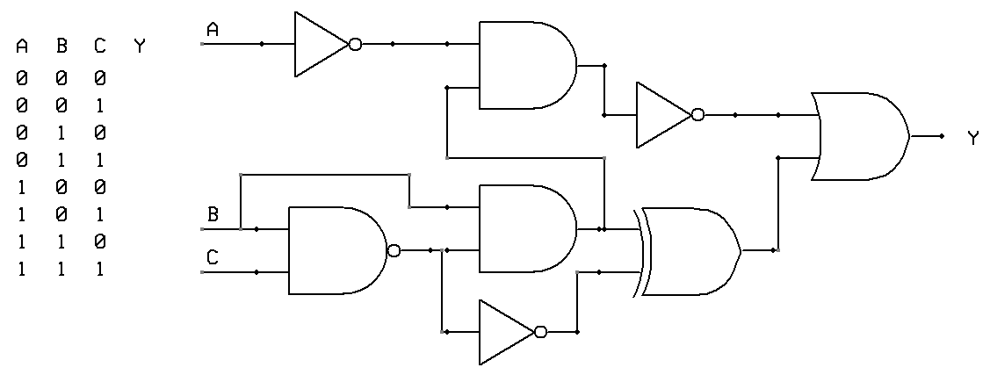

Complete Questions in Logbook
Student Name |  | Student Number
Date
Group | A / B

