Artificial Intelligence for Games
Unity Engine 2019.3.15f1
June 2020 Digital Learning Games Tallinn University

Introduction
This project implements AI with NavMeshAgents in Unity Engine.
This is made for the 'Artificial Intelligence for Games' course in Tallinn University.

Prerequisites
• Unity Engine Version 2019.3.15f1

Built With
• C#
• NavMeshAgents
Note: AI-related Behaviour is commented within the project as well.

AI Behaviour

Walking along a waypoint path, starting with the closest waypoint, or when
set up moving randomly inside a sphere radius

Chasing the player if he is inside a specific distance and can be seen without
beeing blocked by walls

Attacking the player when he is in attackrange

Losing the player when he is too far away or hidden by walls

Follow the leaderzombie, when too far away having a speedboost
to reach him faster

AI Behaviour
Waypoints

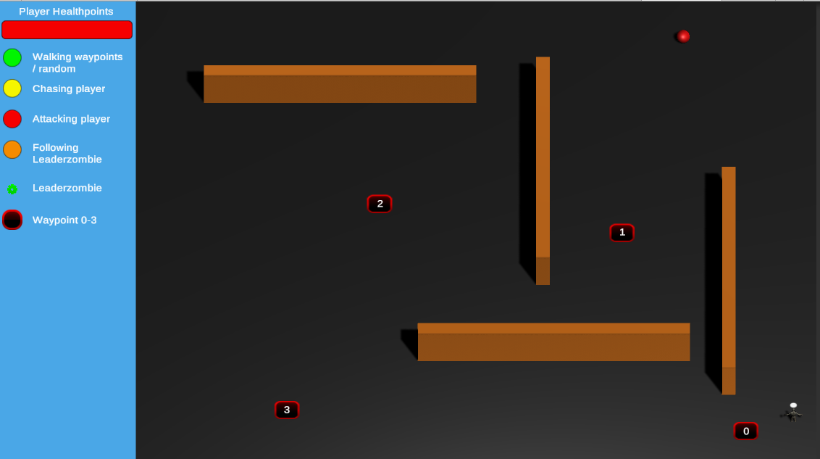

The NavMeshAgents spawn in specific spawn points.
After spawning it depends on what WanderType is active.
The random wandertype makes the AI move arround randomly inside of a sphere arround the AI object.
In our scene we used the waypoint wandertype, which holds 4 waypoints which will be passed in a specific order, starting at the closest waypoint to the AI Agent.
There are waypoint indices from 0 to 3 and are followed in order, when the last waypoint
is reached, the first one will be the next again and it starts over again.

For more specific Logic checkout the Code Documentation.

AI Behaviour
Chasing

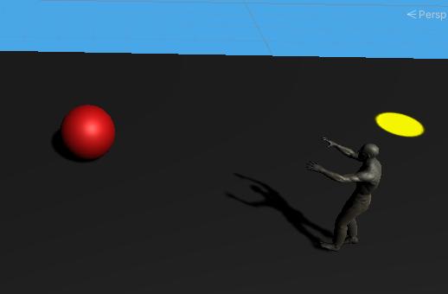

The AI will chase the player(the red ball) when he is inside a specific range and is not
covered by walls.
There is no limit on how many zombies can chase the player, but there is a limit on how many can attack the player.

For more specific Logic checkout the Code Documentation.

AI Behaviour
Attacking

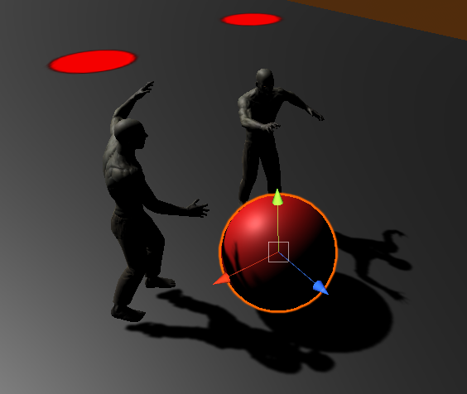

The Agents will attack the player if he is in attackrange.
They hit the player and make him loose healthpoints.
If the player has 0 healthpoints left, the player object will be set inactive instead
of beeing destroyed.
There is a maximum of 4 zombies which can attack the player at the same time.

For more specific Logic checkout the Code Documentation.

AI Behaviour
Losing the Player

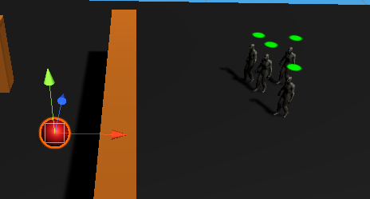

The Agents can loose the player and stop chasing him when he is out of sight by
hiding behind a wall, or by just moving far enough away from the agents.
They will switch to the idle state and continue moving along their paths again.

For more specific Logic checkout the Code Documentation.

AI Behaviour
Following the zombie leader

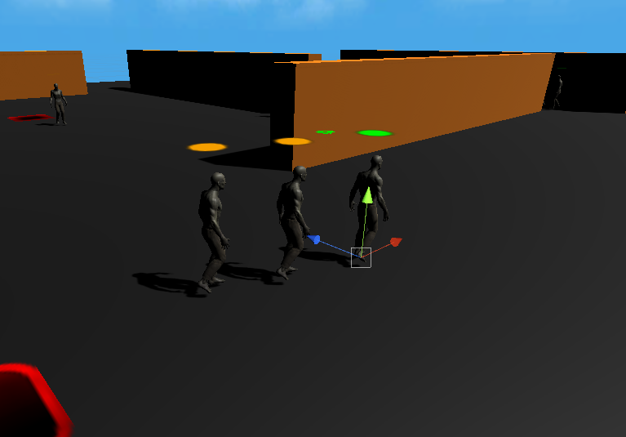
The agents will follow the leader zombie if they can see him and if he is in range.
If they are far away, they will have a speed boost and move with twice the speed until they reach a specific distance to the leader and then slow down again and move with the same speed as the leader.
When the following zombies see a player, they will stop following the leader.
If they loose the player, they start to follow the leader again if he is still close.

For more specific Logic checkout the Code Documentation.

Access to Project
The project is uploaded on GitHub.
The GitHub repository of the project can be accessed through
https://github.com/DanielGumnikow/AI_Unity

Team Members
Daniel Gumnikow
Jouke Bertus Staring
Oluwafiyikewa Aigbovbioise Alawode

Acknowledgments

Zombie AI video playlist by SRCoder (https://www.youtube.com/channel/UCYaNsGvyvIupxpecr4rZY9A)

Zombie AI video playlist by Adrian C. Chase (https://www.youtube.com/channel/UCqy5niYmcLgr4zBuc_ZAyIw)

