**Order and Delivery management system**

*Increase your profit through purchasing our “online ordering system”.*

Team #8

2014

**Project description**

Nowadays people sometimes want to have meal without leaving home. But not all cafes provide delivery service. We offer “order and delivery management system” software which helps add this feature to any catering industry. Also it makes available to control staff.

**Our goals:**

* Bring online ordering feature to any cafe
* Increase amount of clients by simplifying ordering process
* Optimize work of staff

**Actors:**

1. user who order stuff;
2. manager who will manage orders and stuff;
3. administrator who will control staff;
4. (optional)courier;

**Use-cases:**

1. users: can view catalogue, can make orders;
2. manager: can manage orders, can manage contents of site, can manage couriers;
3. administrator: same things as manager plus staff control feature;
4. (optional)courier: can view orders which was assigned to him(address and map location,price of order);

**Screens of desktop version**

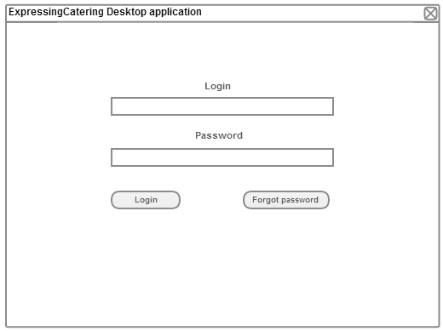

4

3

1

22

Screen 1:

This window is used as login page

1. Login of user, which is set by administrator
2. Password of user, which is also set by administrator
3. Button to login
4. Button which will open password recovery window

Made by: Amangeldiev Amantur

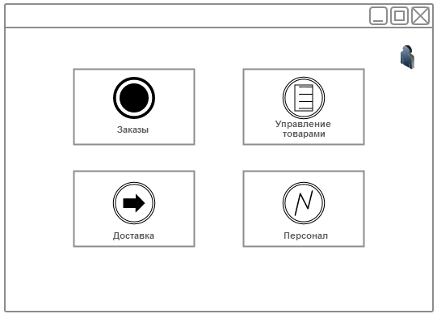

9

8

7

6

5

Screen 2:

This is a main menu.

1. Button, which will open order’s windows
2. Button, which will show delivery window
3. Button for logging out
4. Site’s content management button
5. Staff management button

Made by: Amangeldiev Amantur

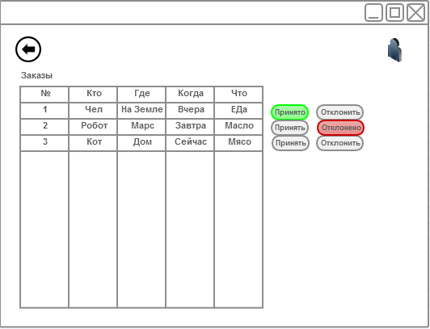

10

11

14

13

12

Screen 3:

This is order management window for manager

1. “Back” button.
2. Table, which shows all orders
3. Button to accept orders. When you choose this – button becomes green.
4. Button to decline orders. When you choose this – button becomes red.
5. Log out button

Made by: Amangeldiev Amantur

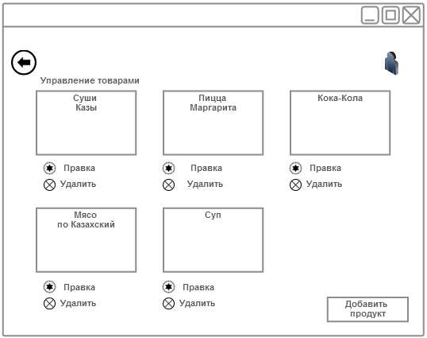

20

15

19

18

17

16

Screen 4:

This is content management

1. “Back” button.
2. Existing product’s description and photo
3. Button to edit product’s description
4. Button to delete product
5. Log out button
6. Button to add new product

Made by: Amangeldiev Amantur

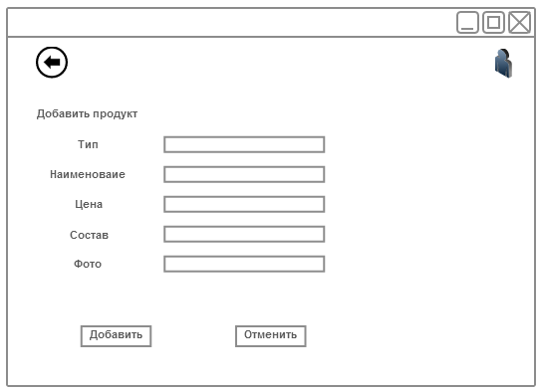

25

24

23

22

21

Screen 5:

This screen is to add new product

1. “Back” button.
2. Product’s description
3. Button to add product with its description
4. Log out button
5. Cancel button, to decline all changes

Made by: Batarayev Rassim

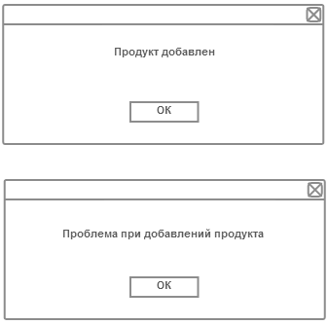

27

26

Screen 6:

Possible result of product saving operation

1. Button to close window, which says that everything ok
2. Button to close window, which says that something gone wrong

Made by: Batarayev Rassim

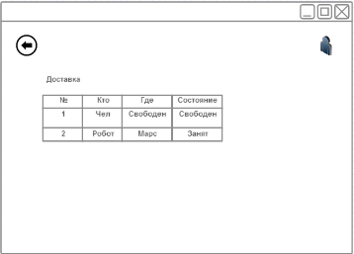

31

32

28

29

30

33

Screen 7:

This screen shows delivery window with statuses of couriers

1. “Back” button
2. Table with all couriers and their statuses
3. Log out button
4. Free space
5. Free space
6. Free space

Made by: Batarayev Rassim

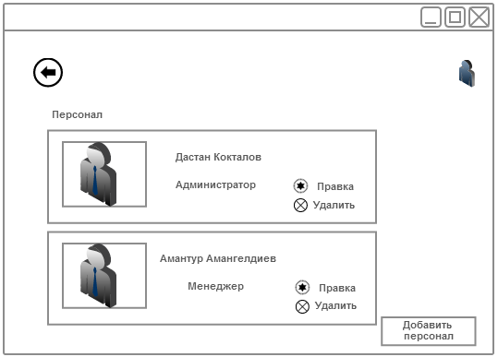

38

37

39

36

35

34

Screen 8:

Window, which shows all staff for administrator

1. “Back” button
2. User’s info
3. Log out
4. Button to edit user’s info
5. Delete user button
6. Button, which opens new window to add user

Made by: Batarayev Rassim

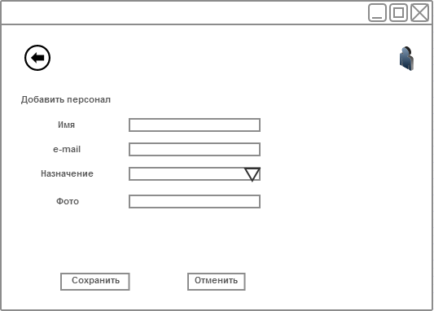

421

411

45

44

43

40

Screen 9:

This is “add personal” screen, where you can add new staff.

1. “Back” button
2. Fields, where you need to enter info about new staff
3. Button, which saves entered info
4. Log out button
5. Button, to show list of available vacancies when registering new staff
6. Cancel button

Made by: Khassanov Daniel

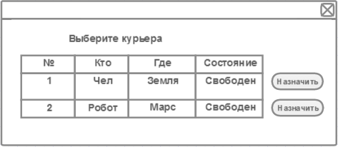

47

46

Screen 10:

This screen allows to pick available courier for delivery

1. Table of available couriers
2. Button, which sets courier to order

Made by: Khassanov Daniel

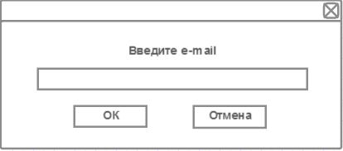

50

49

48

Screen 11:

This screen allows to recover password via e-mail

1. Field for entering e-mail
2. Button, to recover password
3. Button, to cancel recovery

Made by: Khassanov Daniel

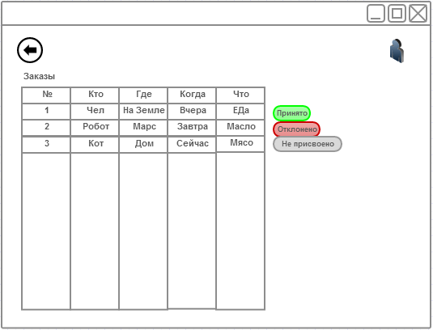

5244

51

53

54

Screen 12:

This is order managements log for administrator

1. “Back” button
2. Table shows all orders
3. This is the status of order. Shows us if manager taken order or dismissed it
4. Logout button

Made by: Khassanov Daniel

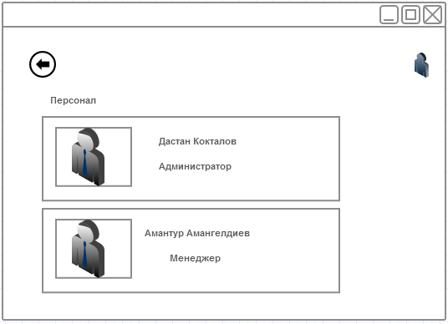

57

56

55

Screen 13:

Window, which shows all staff for manager

1. “Back” button
2. User’s info
3. Logout button

Made by: Koktalov Dastan

**Screens of web version**

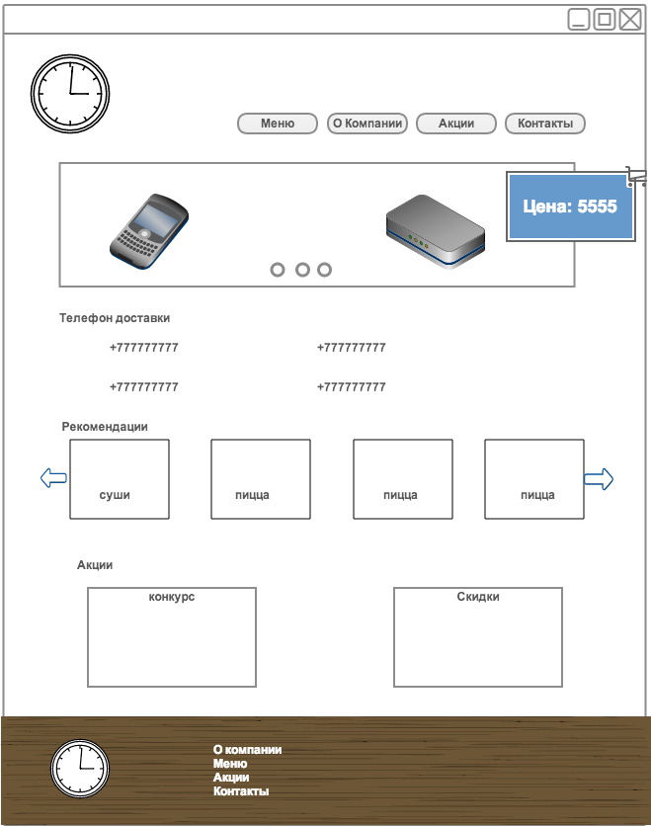

61

51

41

31

21

11

71

Screen 1:

This is the main page

1. Site navigation menu
2. News banner
3. Company’s phone numbers
4. Popular orders
5. Promotions and advertisements
6. Shopping cart
7. Site map

Made by: Koktalov Dastan

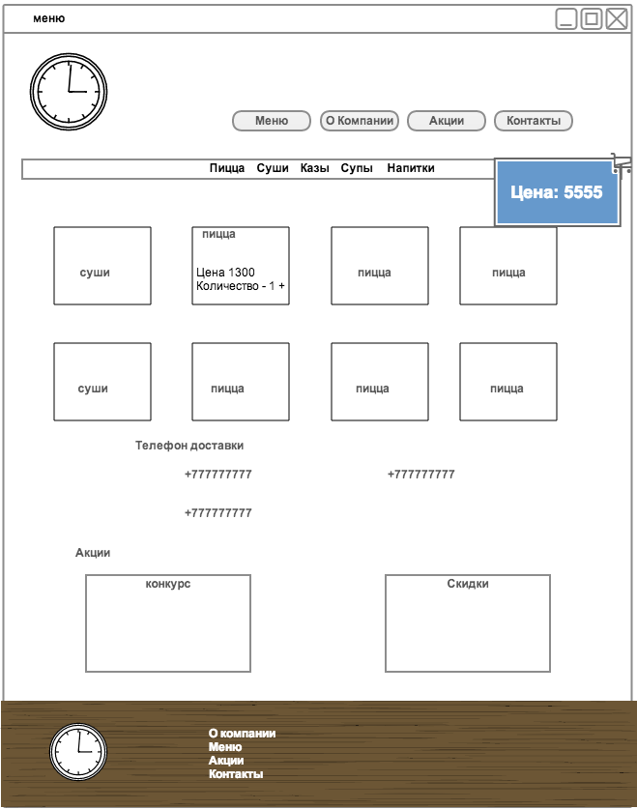

141

131

121

111

101

91

81

15

Screen 2:

This is menu page

1. Site navigation menu
2. Meal’s category selection
3. Products
4. After selecting product – there will be showed price of choosen product and you can select amount of needed products
5. Company’s phone numbers
6. Promotions and advertisements
7. Shopping cart
8. Site map

Made by: Koktalov Dastan

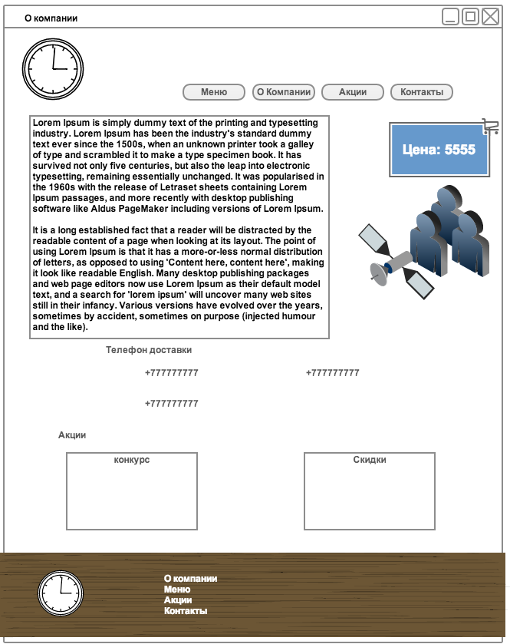

20

19

18

17

16

21

Screen 3:

Page with info about company

1. Site navigation menu
2. Info about company
3. Company’s phone numbers
4. Promotions and advertisements
5. Shopping cart
6. Site map

Made by: Koktalov Dastan

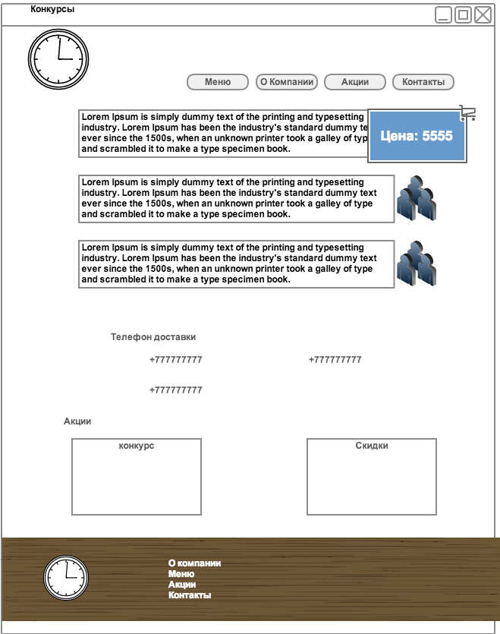

22

27

26

25

24

23

Screen 4:

Promotions and advertisements page

1. Site navigation menu
2. Info about company
3. Company’s phone numbers
4. Promotions and advertisements
5. Shopping cart
6. Site map

Made by: Mukhanov Daniyar

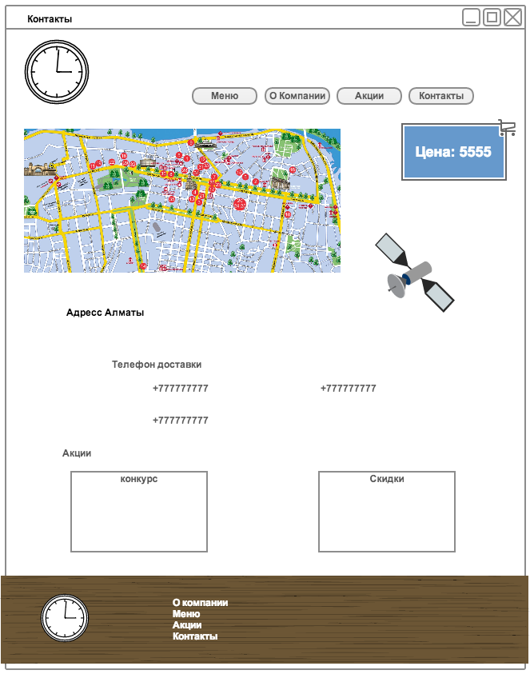

32

31

30

29

28

33

Screen 5:

Contacts

1. Site navigation menu
2. Company location on map
3. Company’s phone numbers
4. Promotions and advertisements
5. Shopping cart
6. Site map

Made by: Mukhanov Daniyar

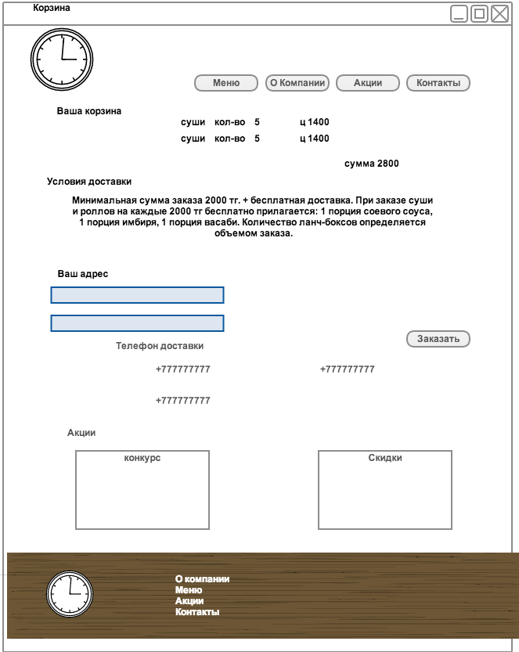

40

39

38

37

36

35

34

41

Screen 6:

Shopping cart page

1. Site navigation menu
2. Your cart’s contents
3. Terms of delivery
4. Your delivery address
5. Company’s phone numbers
6. Promotions and advertisements
7. “Order” button. Places order to DB
8. Site map

Made by: Mukhanov Daniyar

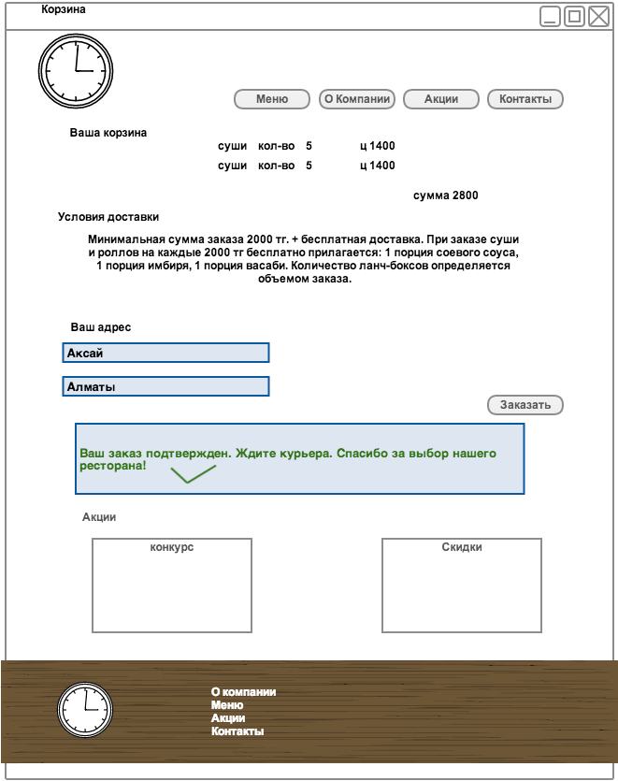

49

47

46

45

44

43

42

48

Screen 7:

Shopping cart page after successful order placement

1. Site navigation menu
2. Your cart’s contents
3. Terms of delivery
4. Your delivery address
5. Message, which shows that order was successfully created
6. Promotions and advertisements
7. Site map
8. “Order” button. Places order to DB

Made by: Mukhanov Daniyar

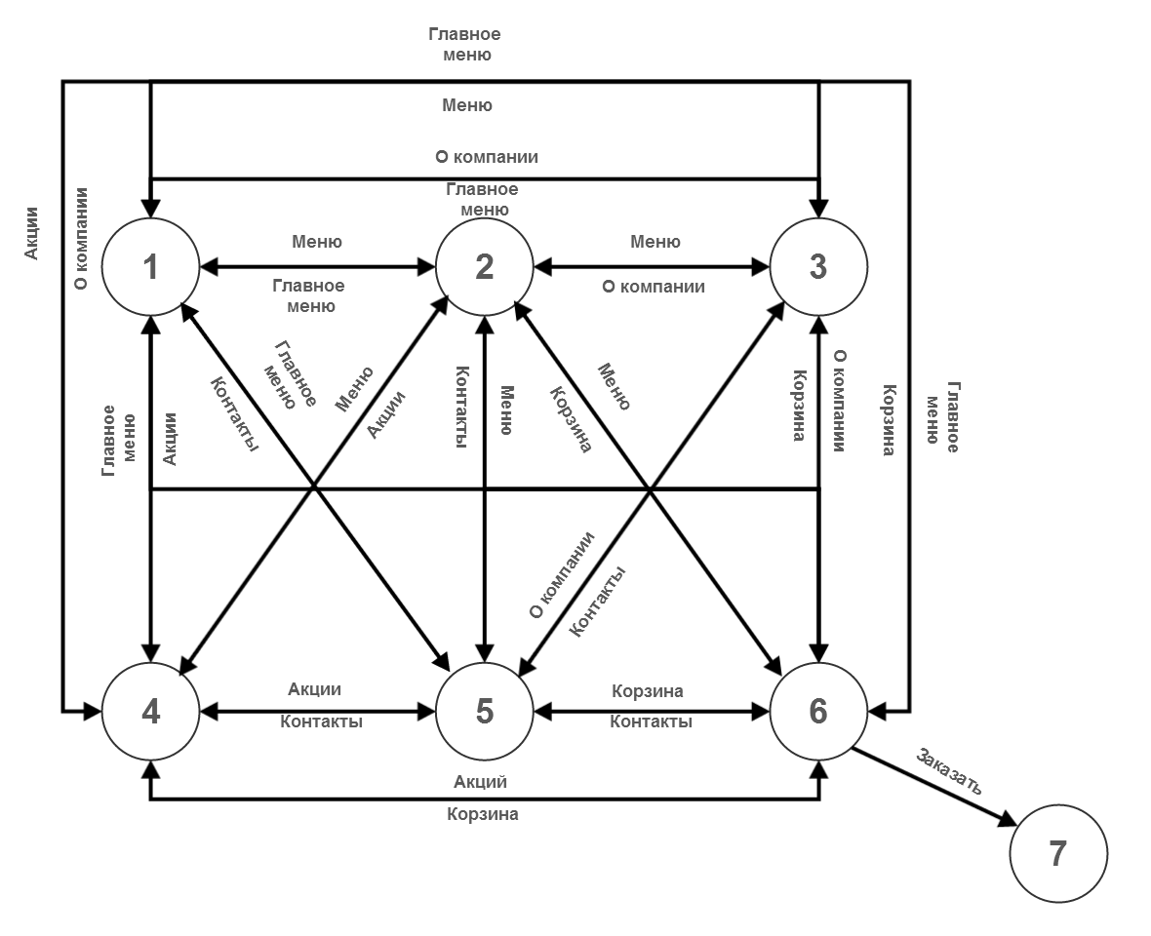

**Screen flow of web site**

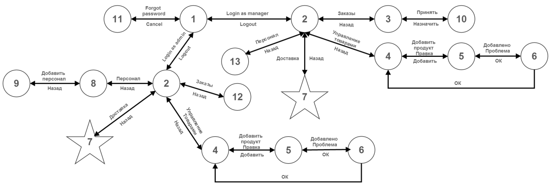

**Screen flow of desktop application**