331 ODE Assignment

# Bungy Jump

## Cord Selection

To be fully dunked, the maximum displacement needs to be greater than or equal to 43m. The SHORT50 cord falls just shy of that at roughly 42.9m. The cord that fully dunks with the least overshoot is the REG70.

## Impact Velocity

With a height of 1.8m, the head of the jumper will impact the water when the rope is extended to 41.2m. For the REG70 cord this impact velocity is approximately 8.1516m/s.

## Jumper Weighs 87kg

If the jumper weighs 87kg and the REG70 cord is used, the maximum displacement the jumper reaches will be approximately 48.731m. However, this number does not consider the increased drag that will be experienced when the jumper hits the water. At the point when the jumper hits the water, they will be travelling approximately 13.665m/s.

# Three-Body Problem

## Energy conservation in the simplified three-body problem

In this simplified version of the three-body problem the energy of the system is always conserved, with no energy being lost to any external forces. With this formulation we would never expect the three bodies to collapse and stop moving

## Small perturbations of the system

With the initial conditions as specified in the project, this is the result:

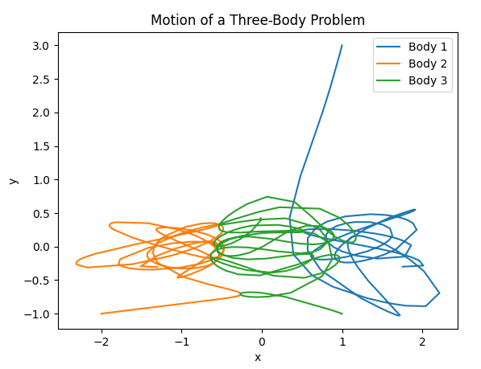

However, when the initial conditions are perturbed only slightly by increasing the mass of body 3 by 0.001, a completely different solution is observed:

## Presentation of the animation tool

The output of the animation tool may be visually misleading as it presents the data with a constant time step between frames with a default value of 100. This means there are 10 “frames”, which are consecutive time points at which the ODE is evaluated, being presented per second. When the time step is large, the bodies will seem to be moving rapidly as a time step of 0.8 for 10 frames means 8 seconds of motion will be presented in one second. With a very small time step of 0.001, one second of animation will only represent 0.01 seconds of real time motion. Given that our adaptive step size RK solver is constantly changing the step size, the speed of the bodies is constantly changing in the animation and is not representative of their actual speeds.

# Van der Pol Oscillator

## Time Steps when mu = 0

The more accurate solution is given by the smaller step size of 0.01. While the implicit forward Euler method is unconditionally stable, it is still more accurate to use a smaller step size. When , the ODE takes the form of , which has the solution . The phase graph should then show a perfect repeating circle. However, we can see that for both step sizes some damping is seen.

## Varying values of mu

We can see that as increases, the ODE gets increasingly stiff. There are regions where the rate of change is rapidly increasing and then regions where is levels off again characteristic of a stiff ODE. With higher values of this property gets more pronounced.