pRODUCT

Design

DOCUMENT

Group 4348



Company Name: Foodle

- Introduction:
Foodle is our revolutionary mobile based website dedicated to promoting sustainable cooking practices. Foodle does this by simplifying the complex negative environmental externalities of food consumption into one score for each recipe. Administrators within Exeter accommodations will act as the game keepers creating groups for each kitchen within their accommodation. Students, the player users can then join these groups through QR codes in the kitchens (printed out by administrators). This promotes group cooking which has environmental benefits (such as reduced food waste, reduced energy consumption etc.) As well as promoting the use of more environmentally friendly recipes from the Foodle website.

- Key-features:
Foodle the Game:
Convincing students (the player users) to use our website was at the forefront of many of our group meeting. This combined with the requirement of gamification led us to our solution. Foodle THE GAME. What if every day a student logged into our website instead of being greeted by some boring recipes, they were greeted by a 5-character word guessing game (based on Wordle) where all the words were names of food items like (curry, bagel, sushi, etc.) This would promote continued use and repeated revisiting of the website allowing us to attract and retain users that would otherwise have no interest in our website. A Foodle score generated based on the number of guesses it took a user to correctly guess the word would be recorded and added to the user’s profile (This score is visible on the home page).
The leaderboard page displays users with the highest Foodle scores. This will create a competitive aspect to Foodle encouraging users to compete with one another and continually use our website.
The next stage of development will include adding badges to each user’s profile based on their Foodle score (Gold badge top 20% of Foodle scores, Silver badge top 50% of users outside of Gold, Bronze badge remaining users) This will provide further incentive for students to repeatedly visit our website increasing user retention.
Recipe Ratings:
Foodle recipe ratings are based on water pollution and eutrophication. This is not a perfect estimation of the complex negative environmental impact food production, though it is heavily researched and a great starting place. Eutrophication is the process in which nutrients accumulate in a body of water, resulting in an increased growth of microorganisms and substantial environmental degradation. This is measures in grams of phosphate equivalents (PO₄eq) per kilogram of food product.
Recipes with lower environmental impact (displayed as a low Environmental Impact Ratings within the website) will be promoted while those with higher environmental impact (displayed as a high Environmental Impact Rating within the website) will be demoted and potentially removed by game keepers.
(Removing of recipes will be a restricted action and the environmental impact of a recipe not only must be substantial enough but also the recipe popular enough to warrant this action. Removing of highly environmentally impactful recipes will help to ensure Foodles aim of environmental sustainability)
When a recipe is created either by an admin or a student the recipe will be assigned an Environmental Rating based on the ingredients and quantity of these ingredients used in the recipe.
The calculation of the real negative impact a single food item bought from the local Tesco’s has on the environment is incredibly difficult to compute. There are many variables to consider and weigh.
Greenhouse gas emissions (CO₂, CH₄ etc.), water pollution and eutrophication, deforestation, soil degradation, loss of biodiversity etc.
The list is long, and the weights assigned to each of these variables is highly location specific.
Deforestation of the Amazon rain forest would be worse than most places in the world and this would need to be accounted for and weighted more heavily (for a hypothetical food item with this negative externality)
Focusing in on one of these negative externalities early will allow us to include others in future development and provide users better estimations of the real negative impact of a given food item.
Kitchen Groups:
At the beginning of every new university year administrators of Exeter accommodations (the game keepers) such as Holland Hall, Lafrowda, Mardon Hall etc. would create a group for each kitchen in their accommodation. The Administrator would then generate and print out the QR codes linked to the join group page for each of these kitchens.
Students (player users) in these accommodations would be encouraged to scan these QR codes and join their kitchen groups. Many of these students in the example accommodations given above would be first years cooking for themselves for the first time. Foodle would enable these students to learn to cook together in a more environmentally friendly way.
Meal Events and Environmental Score:
A member of a group can also make a Meal Event where a date, time and recipe are selected enabling the group members to organise and cook together. The Environmental Rating of a recipe and the number of group members for a Meal event will be used to add points to each member within the groups Environmental score. These Environmental scores in future development will be displayed much like the Foodle scores. With a separate leaderboard page for the top users with the highest Environmental scores and their own badge on each user’s profile (Gold badge top 20% of Environmental scores, Silver badge top 50% of users outside of Gold, Bronze badge remaining users)
Currently If a user is not in an Exeter accommodation kitchen group, they are restricted from creating a meal event as there is no way to track the kitchen being used for this event. This is due to the requirements of the project mandating the usage of Exeter university campus locations.
In future development (without this requirement) events like these can be accounted for. A user without a group will be able to make and receive points for a Meal Event though at a lower rate. This will encourage users to be part of one of kitchen groups when possible, still allowing Foodle to promote group cooking.

- Product Design:
Current Website Design | Current Database Design
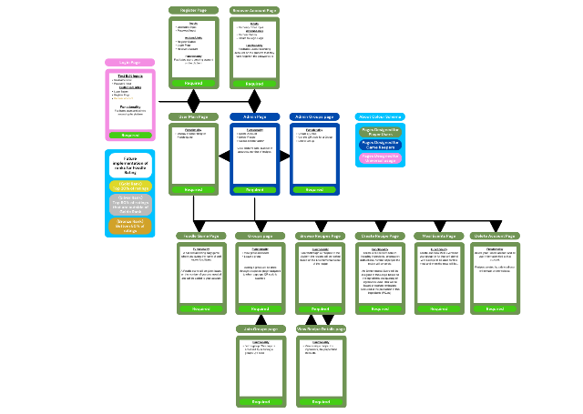 | 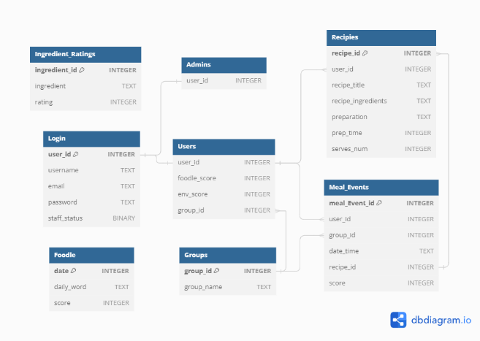

Designing a website and database with users and functionality in mind is essential for creating a seamless and user-friendly experience. Here's an overview the intended flow of users through our website and the database architecture that enables this website to function.

Our website is big with many different features that all combine to create Foodle. The functionality of the website is supported by and extensive database that enables Foodle to do all that it does. It allows for the implementation of new and exciting features into the future like being part of more than one kitchen group, selection of different Foodle games to be greeted by every day, the implementation location to get ingredient ratings specific to where you are in the world, etc. There are so many possibilities with the initial implementation of a strong database architecture.

- Feedback and Following Development:
The market strategy of Foodle involves a soft launch. This will serve as a pivotal step in the next stage of Foodles development. Allowing for the refinement and optimization of Foodle for a wider audience. By initially introducing Foodle to 2-5 accommodations, we will gain valuable insights on user preferences and engagement patterns, allowing us to identify any weaknesses or potential challenges of our platform. This form of user experience testing will help to increase customer satisfaction, retention and help to refine our strategy converting new users to the Foodle. This will ensure Foodles readiness for broader rollout.
In the soft launch each accommodation will be used as its own sperate testing ground. This will allow for the testing of new features in controlled environments on separate testing grounds, allowing for multiple tests to be run simultaneously and providing more accurate feedback on sentiment towards a final feature implementation.
Game keepers (accommodation administrators) and in website surveys will be utilized to track student sentiment towards key features within our platform helping guide decision making.

- Foodles Goal:
1. Create an intuitive, fun, and user-friendly website for discovering, sharing, and creating environmentally friendly recipes.
2. Educate users about environmentally sustainable cooking practices, ingredients, and recipes.
3. Cultivate a vibrant community around the groups in university accommodations. Containing environmentally conscious cooks who can share insights, tips, and experiences related to eco-friendly cooking.

- Conclusion:
Foodle represents a new era in sustainable cooking, where students can come together to explore, learn, and create delicious meals while making a positive impact on the planet. Foodle aims to inspire a global university movement towards more environmentally friendly consumption habits. Join us on our journey to a greener tomorrow, one recipe at a time.

