pRODUCT

DOCUMENT

Group 4348

Company Name: Foodle



- Introduction:
Foodle is our revolutionary mobile based website dedicated to promoting sustainable cooking practices. Foodle does this by simplifying the complex negative environmental externalities of food consumption into one score for each recipe. Administrators within Exeter accommodations will create groups for each kitchen within the accommodation. Students/Users can join these groups through the QR codes within their accommodation kitchens (printed out by administrators). This promotes group cooking which has environmental benefits (such as reduced food waste, reduced energy consumption etc.) As well as promoting the use of more environmentally friendly recipes from the Foodle website.

- Key-features:
Foodle the Game:
Convincing students to use our website was at the forefront of many of our group meeting. This combined with the requirement of gamification led us to our solution. Foodle THE GAME. What if every day a student logged into our website instead of being greeted by some boring recipes, they were greeted by a 5-character word guessing game (based on Wordle) where all the words are names of food items like (curry, bagel, sushi, etc.) This would promote continued use and repeated revisiting of the website allowing us to attract users that would otherwise have no interest in our website. A Foodle score generated based on the number of guesses it took a user to guess the word would be recorded and added to the user’s profile. The one hundred users with the highest Foodle scores will be displayed and a badge will be added to each user’s profile based on their Foodle score (Gold badge top 20% of Foodle scores, Silver badge top 50% of users outside of Gold, Bronze badge remaining users) This will create a competitive aspect to our website encouraging users to compete with one another and continually use our website.
Recipe Ratings:
Our group decided to focus on water pollution and eutrophication with the belief that an estimation of the negative environmental impact is better than none. Eutrophication is the process in which nutrients accumulate in a body of water, resulting in an increased growth of microorganisms and causing substantial environmental degradation. This is measures in grams of phosphate equivalents (PO₄eq) per kilogram of food product.
Recipes with lower environmental impact (displayed as a high Environmental Rating within website) will be promoted within the website while those with higher environmental impact (displayed as a low Environmental Rating) will be demoted or removed.
When a recipe is created either by an admin or a users the recipe will be assigned an Environmental Rating based on the ingredients and quantity of these ingredients used in the recipe.
The calculation of the real negative impact a single food item bought from the local Tesco’s has on the environment is incredibly difficult to compute. There are many variables to consider and weigh.
Greenhouse gas emissions, water pollution and eutrophication, deforestation, soil degradation, loss of biodiversity etc.
The list is long, and the weights assigned to each of these variables is highly location specific.
Deforestation of the Amazon rain forest would be worse than most places in the world and this would need to be accounted for and weighted more heavily (for a hypothetical food item with this negative externality)
Focusing in on one of these negative externalities early will allow us to include others later and provide users better estimations of the negative impact of a given food item.
Kitchen Groups:
At the beginning of every new university year administrators of Exeter accommodations such as Holland Hall, Lafrowda, Mardon Hall etc. would create a group for each kitchen in their accommodation. The Administrator would then print out and display the QR codes linked to a join group page for each of these kitchens.
Students in these accommodations would be encouraged to scan these QR codes and join their kitchen groups. Many of these students in the example accommodations given above would be first years cooking for themselves for the first time. Foodle would enable these students to learn to cook together in a more environmentally friendly way.
Meal Events and Environmental Score:
A member of a group can also make a Meal Event where a date, time and recipe are selected encouraging the group members to organise and cook together. The Environmental Rating of a recipe and the number of group members for a Meal event will be used to add points to each member within the groups Environmental score. These Environmental scores will be displayed much like the Foodle scores. With a separate page for the top hundred users with the highest Environmental scores and their own badge on each user’s profile (Gold badge top 20% of Environmental scores, Silver badge top 50% of users outside of Gold, Bronze badge remaining users)
If a user is not in a group, this can be accounted for, and they will still receive points for a Meal Event though at a lower rate encouraging users to be part of one of their accommodations kitchen groups.

- Product Design:
Current Website Design | Current Database Design
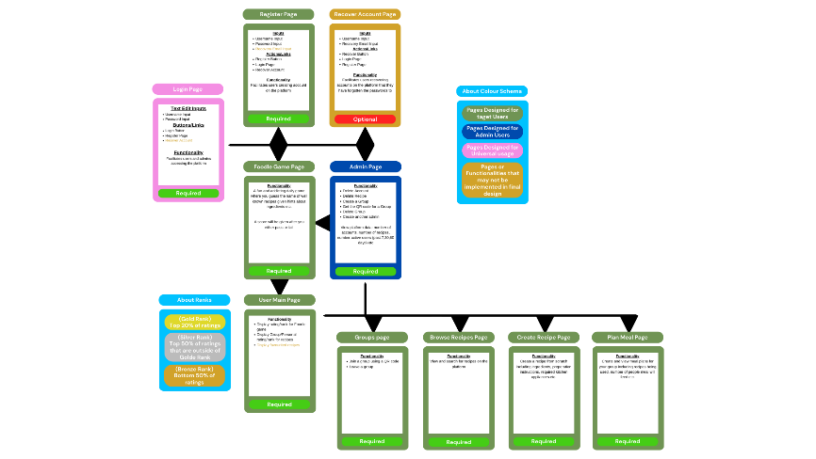 | 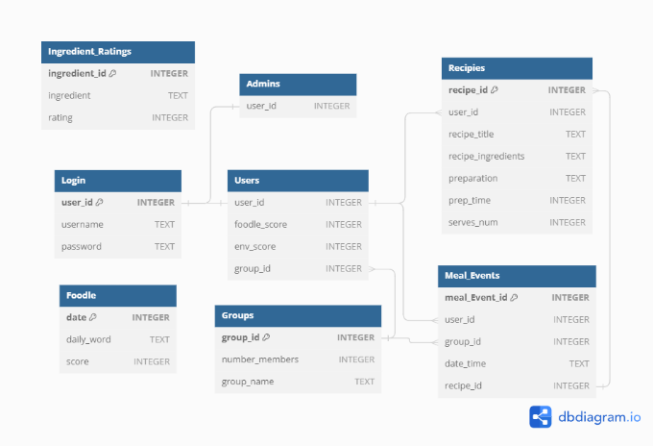

Designing a website and database with users and functionality in mind is essential for creating a seamless and user-friendly experience. Here's an overview the intended flow of users through our website and the database architecture that enables this website to function.

Our website is big with many different features that all combine to create Foodle. The functionality of the website is supported by and extensive database that enables Foodle to do all that it does. It allows for the implementation of new and exciting features into the future like being part of more than one kitchen group, selection of different Foodle games to be greeted by every day, the implementation location to get ingredient ratings specific to where you are in the world, etc. There are so many possibilities with the initial implementation of a strong database architecture.

- Foodles Goal:
1. Create an intuitive, fun, and user-friendly website for discovering, sharing, and creating environmentally friendly recipes.
2. Educate users about environmentally sustainable cooking practices, ingredients, and recipes.
3. Cultivate a vibrant community around the groups in university accommodations. Containing environmentally conscious cooks who can share insights, tips, and experiences related to eco-friendly cooking.

- Conclusion:
Foodle represents a new era in sustainable cooking, where students can come together to explore, learn, and create delicious meals while making a positive impact on the planet. Foodle aims to inspire a global university movement towards more environmentally friendly consumption habits. Join us on our journey to a greener tomorrow, one recipe at a time.

