comands

npx playwright codogen🡪 to open Chromiun Window and playwright editor

npx playwright test 🡪 to run test

npx playwright show-report 🡪 to show test report

npx playwright test uiteng –headed 🡪to watch what is happening in the screen

npx playwright test assert –debug 🡪 to open playwright inspector to debugin

PWDEBUG=console npx playwright test assert 🡪 to open dev tools

DEBUG=pw:api npx playwright test assert

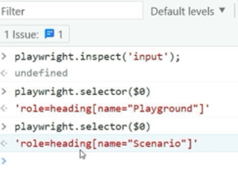

# 🡪id selector

. 🡪 class selector

A 🡪 tag selector

In console 🡪 document.querySelector(“”) document.querySelectorAll(“”)

