RF Waveform Generator

Daniel Hickl

Brian Chau

Khoi Le

Eugene Asare

**Concept of Operations**

REVISION – Draft

06 February 2024

Concept of Operations

for

RF Waveform Generator

Team <10>

Approved by:

_____________________________

Project Leader Date

_____________________________

Prof. Kalafatis Date

_____________________________

T/A Date

**Change Record**

| **Rev.** | **Date** | **Originator** | **Approvals** | **Description** |
| --- | --- | --- | --- | --- |
| **-** | 2/6/2024 | Sandia National Labs |  | Draft Release |
| **1** | 2/24/2024 | RF Waveform Generator |  | Revision 1 |
| **2** | 4/27/2024 | RF Waveform Generator |  | Final Report |

**Table of Contents**

**Table of Contents III**

**List of Tables IV**

**No table of figures entries found. IV**

**List of Figures V**

Figure 1. Example RF Frequency Synthesis Block Diagram 7

Figure 2. RF Waveform Generator Block Diagram 8

Figure 3. RF Frequency Output 10

Figure 4. Subsystem Block Diagram 11

**1.** **Executive Summary 6**

**2.** **Introduction 6**

2.1. Background 6

2.2. Overview 6

2.3. Referenced Documents and Standards 7

**3.** **Operating Concept 8**

3.1. Scope 8

3.2. Operational Description and Constraints 8

3.3. System Description 8

3.4. Modes of Operations 9

3.5. Users 9

3.6. Support 10

**4.** **Scenario(s) 11**

4.1. Research and Development 11

**5.** **Analysis 11**

5.1. Summary of Proposed Improvements 11

5.2. Disadvantages and Limitations 11

5.3. Alternatives 11

5.4. Impact 12

**List of Tables**

No table of figures entries found.

**List of Figures**

Figure 1. Example RF Frequency Synthesis Block Diagram

Figure 2. RF Waveform Generator Block Diagram

Figure 3. RF Frequency Output

Figure 4. Subsystem Block Diagram

# Executive Summary

One of the fundamental pillars that make up the field of RF communications and designs is frequency synthesis and modulation. To transmit radio signals and implement them in various applications, an RF signal must first be generated, preferably at a low cost and complexity. Therefore, Sandia National Labs has requested an RF waveform generator design focusing on low SWAP-C (minimal size, weight, power, and cost). This generator will produce a sawtooth waveform from 1.6-3.2GHz and should be robust to an increasing chirp rate without significant waveform degradation. While this is entirely exploratory research and development with no direct application in mind, this project aims to help reduce the cost and resources as much as possible to optimize the mass production of frequency synthesis.

# Introduction

Frequency synthesis is the process of producing radio frequency signals with varying frequencies. It allows communication systems to tune to different frequencies quickly and precisely, thus forming the building blocks for RF communication and circuit designs. Practically anything that requires a stable RF source uses frequency synthesis, hence its wide variety of applications from Bluetooth transmitters to Wi-Fi routers and mobile phones. With such a pivotal role in RF communication, simpler and more economical designs of frequency synthesis would allow RF applications to be manufactured quickly and optimally.

## Background

RF waveform generators, more generally recognized as RF frequency synthesizers, are the most essential part of any RF device. They directly generate a wide range of high frequencies from a single, lower reference frequency and are responsible for generating signals in the RF domain. Therefore, they are used in a variety of wireless applications, from Bluetooth transmitters/ receivers to Wi-Fi routers and communication systems. Generally, any device that transmits signals that require a stable RF source has some form of a frequency synthesizer.

Figure 1 below is an example block diagram for a frequency synthesizer. It contains a Voltage-Controlled oscillator which transforms a signal into an RF signal, with some components around it that keep the phase fixed to the reference signal known as a Phase-Locked Loop. For the scope of this project, the Phase-Locked Loop is not required as mentioned by our sponsor, just the reference signal and VCO.

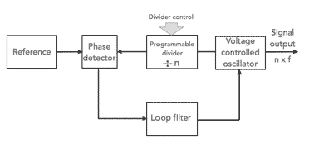

*Figure 1. Example RF Frequency Synthesizer Block Diagram*

Despite its wide use in the RF industry, most RF synthesis devices are costly, ranging well above $2,000 per device which drives production costs in manufacturing. Therefore, this project is exploratory research and development, which aims to create an RF waveform generator in low SWAP-C (Size, weight, power, and cost). By minimizing costs and complexity, mass production would be easier to realize while still meeting the same specifications as the current ones used in the industry. For this project, our primary focus will be minimizing SWAP-C. While the original concept was to generate a higher waveform from 6-8GHz, due to the limited testing equipment provided as well as the budget of the project, a compromise was made to lower the frequency range to 1.6 to 3.2 GHz to fit all of our project constraints.

## Overview

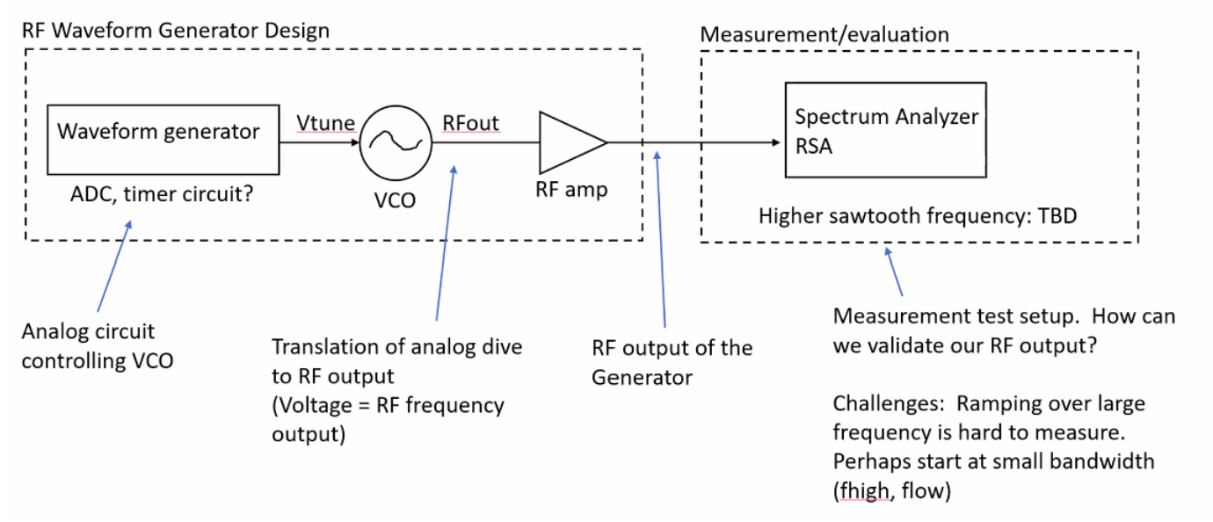

*Figure 2. RF Waveform Generator Block Diagram*

Drawing from the block diagram above, a waveform generator will produce the tuning voltage. A digital-to-analog converter (DAC) will be implemented to produce a periodic, tuning voltage. This tuning voltage acts like a dial for the Voltage Controlled Oscillator (VC), which produces an RF waveform. Changing the tuning voltage changes the frequency of the RF signal. The RF output would then be amplified to a magnitude that can be seen by an oscilloscope or spectrum analyzer for testing.

## Referenced Documents and Standards

1. For the article "Synthesizer Types - Introduction" from Electronics Notes:  
   [1] Author(s), "Synthesizer Types - Introduction," Electronics Notes, Available: [Online]. URL:<https://www.electronics-notes.com/articles/radio/frequency-synthesizer/synthesizer-types-introduction.php>. [Accessed: Feb 10, 2024].
2. For the article "The Basics of Voltage Controlled Oscillators (VCOs)" from Digi-Key:  
   [2] Author(s), "The Basics of Voltage Controlled Oscillators (VCOs)," Digi-Key, Available: [Online]. URL:<https://www.digikey.com/en/articles/the-basics-of-voltage-controlled-oscillators-vcos>. [Accessed: Feb 10, 2024].
3. For the Surface Mount (SMT) Voltage Controlled Oscillator (VCO) product page from Pasternack:  
   [5] Author(s), "Surface Mount (SMT) Voltage Controlled Oscillator (VCO) 3.2 GHz," Pasternack, Available: [Online]. URL:<https://www.pasternack.com/surface-mount-smt-voltage-controlled-oscillator-vco-3.2-ghz-pe1v14003-p.aspx>. [Accessed: Feb 13, 2024].
4. For the product page of TQL9093 from Qorvo:  
   [6] Author(s), "TQL9093," Qorvo, Available: [Online]. URL:<https://www.qorvo.com/products/p/TQL9093>. [Accessed: Feb 28, 2024].

# Operating Concept

## Scope

The RF waveform generator will be used for research and development purposes. The end goal is to demonstrate the function of the design on an evaluation board or PCB. This will provide a proof of concept for the design and demonstrate the capability of a low SWAP-C (Size, Weight, Power, and Cost) waveform generator. This project will determine the minimum size, complexity, and cost of this type of RF waveform generator.

## Operational Description and Constraints

The RF generator described in this document will be used to investigate the capabilities of a low SWAP-C waveform generator. Our team is trying to push the boundaries by producing a product that is low in size, weight, power, and cost. This waveform generator will be designed to operate with the following specifications:

* Frequency range from 1.6GHz-3.2GHz
* Output power of +20dBm
* Small size and weight - 2x2 inch PCB board
* Low power consumption only using 2 AA batteries

The design will be oriented towards expanding what one can do with RF waveform generation. This means that as the project progresses, our team and Sandia National Labs might find it fit to change the specifications of this system to explore other areas of interest.

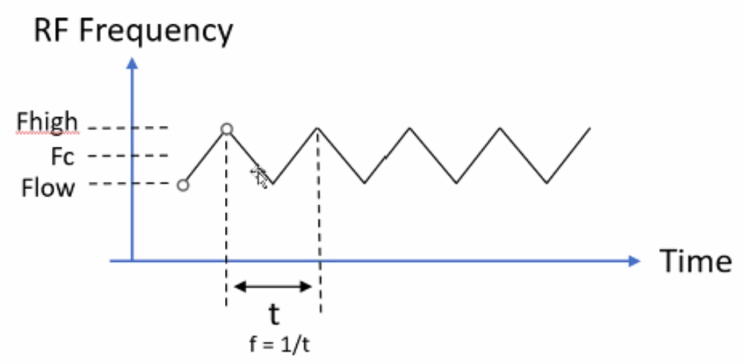

*Figure 3. RF Frequency Output*

One constraint of this waveform generator is maintaining stability and robustness despite a constantly changing frequency. To do so, the tuning voltage must be a periodic sawtooth wave function, in turn causing the frequency to oscillate and increasing the chirp rate.

## System Description

The RF waveform generator will consist of several components that will be integrated into a single PCB board. These components are broken up into 4 different subsystems: Power Regulation, Analog Drive, VCO & RF Amplifier, and Design Implementation. These systems are described below:

*Figure 4. Subsystem Block Diagram*

**Power Regulation Subsystem:** Power is a very important system of the waveform generator. It is necessary to regulate the power of each component to decrease the overall noise of the output. This means that our system must have a stable and reliable power supply. Our team has chosen to use two double A batteries to comply with the low SWAP-C goal. To provide the necessary voltage to the other parts of the system we will use a DC-DC boost converter. To regulate the power these batteries provide, our team will implement a linear voltage regulator. This will provide a constant voltage to each part while also decreasing the noise that will be generated from the DC-DC boost which will help keep the waveform generation stable.

**Analog Drive:** The analog drive subsystem is what controls the waveform generation of the device. This portion of the waveform generator is controlled by a microcontroller that will be programmed to control the output of digital to analog converter (DAC). This DAC will be used to control the voltage-controlled oscillator (VCO) and in turn, produce the RF output signal. This subsystem is integral to the success of the waveform generator because it acts as the brains of the design. It will be responsible for controlling the modulation of the waveform and providing the different modes of operation. It is important to note that the microcontroller will control a voltage from the battery supply which will be amplified to match the tuning voltage range of the VCO. To meet our requirements of producing a frequency range from 1.6GHz to 3.2GHz, this subsystem must be able to produce voltages equivalent to these frequency ranges.

**VCO/ RF Amplifier:** Once the DAC and Microcontroller drive a tuning voltage, the Voltage Controlled Oscillator will take that as an input to create a waveform in the RF domain. The magnitude of the tuning voltage will directly affect the frequency of the RF signal produced. As previously mentioned, the signal frequency will oscillate from 1.6 to 3.2GHz, and the goal is to prevent any waveform degradation from the changing frequency (also known as chirp rate). From there, an RF amplifier with an intended output power of 20 dBm will increase the voltage of the signal for adequate testing. To satisfy the specifications, our current decision is to use a PE1V14003 chip as the VCO, and TQL9093 as the RF amplifier.

**GUI/ User Interface:** To test the system for functionality, a set of voltage/ current sensors will be placed on the DAC and LDOs. Those sensors will ensure the power distribution supplies each component with the voltage/current to their respective specifications. Moreover, one additional sensor will measure the tuning voltage since it is the most critical component for the VCO to produce that RF output. Not only will this user interface show the tuning voltage/ projected frequency of the RF signal, but also play a critical role in testing/debugging the system towards the later stages of the project.

## Modes of Operations

The RF waveform generator is designed to be simple and robust. This means that the operation modes will be limited to 3 different types. The first will be off, the second will be on, and the third will be in modulation mode. These will provide an adequate range of operations for the user.

Once the user turns the generator on, the RF waveform Generator will begin to produce a waveform of constant frequency. The user will be able to choose the frequency at which the system generates. This will be in the form of a sawtooth waveform and will continue to output this waveform until the user changes the frequency.

The final mode will be a modulation mode. This will allow the user to modulate the frequency output of the RF generator from 1.6GHz to 3.2GHz. This output will also be in the form of a sawtooth waveform and will continue to output this waveform until the user switches modes. your proposed system.

## Users

Due to the research and development nature of the project, the RF waveform generator itself will not be used by end-users. However, this project will be useful to Sandia National Labs in providing knowledge about the capabilities of a low SWAP-C RF waveform generator design. With this knowledge, one can implement this design into many practical systems such as communications.

The user of this device will require minimal training. It will be simple to use as there are only 3 modes of operation.

## Support

Operational assistance will be provided through the use of documentation and user manuals. This will include the details of how to navigate the different modes of operation and operate the system. Troubleshooting information will also be provided in the documentation.

# Scenario(s)

## Research and Development

The design will determine what minimum size, complexity, and cost of this type of RF waveform generation because of designing for SWaP-C (Size, Weight, Power, and Cost). Our miniaturized and battery-operated RF waveform generators will be an achievement of compact designs, minimizing power consumption, and promising construction to space-constrained installations. Furthermore, the RF generator demonstrates its function on a path forward on size reduction into a single small PCB.

## Mass Production

Mass production is effective for many goods due to standardized processes, technology, and supply chain optimization. Since designing for SWAP-C, one of the features of our RF waveform generator is to fit on a 2 in. x 2 in. circuit board. With these benefits of minimal space and power consumption leading to low costs, this waveform generator can be implemented in practically any RF device and application potentially becoming the standard waveform generator when mass-producing RF devices.

# Analysis

## Summary of Proposed Improvements

* Since we are designing for SWAP-C the design would take up minimal space and power with the low cost. This would make mass production easier, resulting in further cost reductions in quantity.
* The design will have a minimal amount of parts to meet the proposed size of a 2x2 in board.
* The waveform generator will operate on 2 AA batteries.

## Disadvantages and Limitations

The RF Waveform Generator will have some limitations which would include:

* The sawtooth will only be for a range of 1.6 to 3.2 GHz.
* The sawtooth signal produced will be transmitted over only a short distance or short periods due to the low power.
* Due to budget constraints, the quality of the RF parts will be limited.

## Alternatives

Since the RF waveform generator that we are designing is focused more on research and development to find the most optimal design to maximize SWAP-C there are a few other ways to complete the design.

* One way to help tune the voltage of the VCO is to use a timer circuit instead of a DAC to reduce the complexity of the current-voltage drive system.
* Since size is also a factor, some alternative, smaller parts for DC Regulation could also be implemented but the trade-off could be costs, so in this case cost has a higher priority than size.

One additional note on this project is that there may be limitations on lab equipment in measuring the RF waveform. The school currently has a Spectrum Analyzer that could go up to 3GHz, the capabilities of producing a spectrogram/ waterfall plot of that high frequency are unknown. Therefore, in the case that it doesn’t, either the project sponsors will provide adequate lab equipment.

## Impact

* Since we are generating an RF waveform the general concerns that come from radio waves apply here.
* Exposure to very high RF intensities can result in the heating of biological tissue and an increase in body temperature.
* At relatively low levels of exposure to RF radiation, the effects have been referred to as “non-thermal” effects. Research into this needs to be conducted to determine the generality of such effects and their possible relevance, if any, to human health.