RF Waveform Generator

Brian Chau

Daniel Hickl

Eugene Asare

Khoi Le

**Interface Control Document**

Interface Control Document

for

RF Waveform Generator

Prepared by:

_____________________________

Author Date

Approved by:

_____________________________

Project Leader Date

_____________________________

John Lusher II, P.E. Date

_____________________________

T/A Date

**Change Record**

| **Rev.** | **Date** | **Originator** | **Approvals** | **Description** |
| --- | --- | --- | --- | --- |
| **-** | 02/23/2024 | RF Waveform Generator |  | Draft Release |
| **1** | 04/27/2024 | RF Waveform Generator |  | Final Report - ECEN 403 |
| **2** | 11/24/2024 | RF Waveform Generator |  | Final Report - ECEN 404 |

**Table of Contents**

[**Table of Contents III**](https://docs.google.com/document/d/1mWBIA_Oa1ZBRBI4hyHL5FGaYiQXWECAY/edit#heading=h.30j0zll)

[**List of Tables IV**](https://docs.google.com/document/d/1mWBIA_Oa1ZBRBI4hyHL5FGaYiQXWECAY/edit#heading=h.3znysh7)

Table 1. User Interface Reference 7

Table 2. Items for Interface 8

Table 3. DIP Switch Pins Chart 10

Table 4. Microcontroller Pins Chart 11

[**List of Figures V**](https://docs.google.com/document/d/1mWBIA_Oa1ZBRBI4hyHL5FGaYiQXWECAY/edit#heading=h.tyjcwt)

[Figure 1. User Interface Block Diagram](https://docs.google.com/document/d/1C9GXhG9sJ0_4vOoZsvajsr1RVehu7ySU/edit#heading=h.1t3h5sf) 6

**1. Overview** **6**

**2. References and Definitions** **7**

2.1. References 7

2.2. Definitions 7

**3. Physical Interface** **8**

3.1. Weight 8

3.2. Dimensions 8

3.3. Mounting Locations 8

3.4. Thermal Interface 8

**4. Electrical Interface** **9**

4.1. Primary Input Power 9

4.2. Signal Interfaces 9

4.3. DIP Switch Interface 9

4.4. Microcontroller Pin Interface 10

**List of Tables**

**Table 1. User Interface References 7**

**Table 2. Items for Interface 8**

**Table 3. DIP Switch Pins Chart 11**

**Table 4. Microcontroller Pins Chart 12**

**List of Figures**

# Figure 1. User Interface Block Diagram 6 **Figure 2: Voltage Level Schematic** **9**

# Overview

The document describes the interface between the DIP Switch, microcontroller, and the LEDs in our RF waveform generator. The DIP Switch and the LED’s are what the user will interact with on our board. A user interface for a microcontroller involves using binary configuration on the switch that allows users to interact with the microcontroller's functionalities such as changing the mode of operations or changing the frequency generated by the microcontroller. The LEDs are used to show the user what state the machine is in and verify that the board is powered on. Below is a block diagram of the user interface system.



**Figure 1. User Interface Block Diagram**

# References and Definitions

## References

| Document Name | Revision/Release Date/Version | Publisher |
| --- | --- | --- |
| MPLab IDE User's Manual | 2021 | Microchip |

**Table 1. User Interface References**

## Definitions

DIP: Short for Dual In-line Package, consisting of a small block of switches mounted on a dual in-line package. Each switch corresponds to a specific binary digit. Using the switch on PCB provides flexibility in configuration.

# Physical Interface

| Component | Dimension (cm) | Weight (g) |
| --- | --- | --- |
| DIP Switch | 2.2 | 3 |
| PCB | 5 x 5 | 100 |
| LEDs | 0.13 | 1 |

**Table #2 : Items for Interface**

## Weight

The device shall have the ability to be powered and controlled through a DIP switch, without the computer GUI connected.

The microcontroller and PCB board will weigh no more than 200g.

## Dimensions

The dimensions of the RF generator PCB shall be no more than 5cm x 5cm. This is important for our goal of having a low SWAP-C for the system. If possible, we shall decrease the dimensions of this board even further.

## Mounting Locations

The interface is based on the hardware interface with the microcontroller functioning as the hardware control of the system. We will not have mounting locations as the end goal of this project is to be used for research and development purposes. This end does not require any mounting or connections because it will be a standalone device.

* 1. ***Thermal Interface***

Although this generator is low power due to the small size of our project there might be some issues with heating in the VCO and power components. If heating becomes an issue we can use top mounted heat sinks on these components to dissipate the heat in our system. This is an acceptable solution because it does not require additional space on the PCB itself but instead is placed on top keeping it within our desired size.

# Electrical Interface

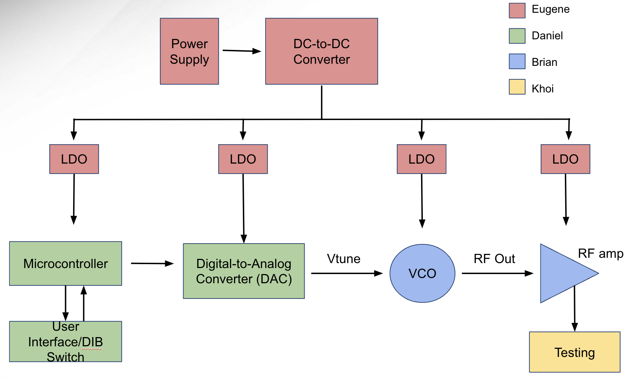

**Figure 2. Voltage Level Schematic**

## Primary Input Power

The RF waveform generator will be powered through the use of two AA batteries. This will be amplified using a DC-DC converter to multiple different rails to provide power to each component of the system. The use of low dropout regulators will be used to provide a stable input and supply voltage to the system. This is important as noise may have a dramatic effect on RF signals. The mitigation of this noise will be paramount to our success.

## Signal Interfaces

Using the microcontroller, a sawtooth voltage signal will be made digitally and then converted from digital to analog (DAC). While it isn’t possible to directly measure the RF signal without external lab equipment, the tuning voltage could be measured and display the projected frequency of the generator on the oscilloscope and spectrum analyzer.

## DIP Switch Interface

A user interface will be placed on the PCB of the RF waveform generator. A DIP switch will be provided to allow the user to manually adjust the state of the system from a direct hardware connection. This DIP switch will also be used to control which user interface to use. The functionality of the switch is described in the table below.

| **Switches** | **Binary Inputs** | **Function** |
| --- | --- | --- |
| Pin 1: Constant Mode | Pin1 = 1 (Other Pins = 0) | 4V Tuning Voltage |
| Pin 2: Constant Mode | Pin2 = 1 (Other Pins = 0) | 7V Tuning Voltage |
| Pin 3: Constant Mode | Pin3 = 1 (Other Pins = 0) | 10V Tuning Voltage |
| Pin 4: Constant Mode | Pin4 = 1 (Other Pins = 0) | 20V Tuning Voltage |
| Pin 5: Modulation Mode | Pin5 = 1 (Other Pins = 0) | 0-20V at 1kHz Tuning Voltage |
| Pin 6: Modulation Mode | Pin6 = 1 (Other Pins = 0) | 0-20V at 5kHz Tuning Voltage |
| Pin 7: Modulation Mode | Pin7 = 1 (Other Pins = 0) | 0-20V at 10kHz Tuning Voltage |
| Default Mode | Other Pin Configurations | 0V Tuning Voltage |

**Table 3. DIP Switch Pins Chart**

If the user switches any inputs that are not listed in this table, the state will be set to the default state of a 0V Tuning voltage. If the user selects any two or more pins at the same time, apart from Pin8, the state will be set to the default state.

## Microcontroller Pin Interface

The microcontroller will be used to control the RF waveform generator once the system is powered on and the user has selected its state. To do this, the chip will connect to peripherals inside and outside the chip to provide the correct functionality of the system. The pin connections of the microcontroller unit are listed in the table below.

| **Pins** | **Functionality** |
| --- | --- |
| 1- 2, 9-10 | UART Connection |
| 4 | Reset Button |
| 6, 22, 26, 43 | Vdd: Power |
| 5, 21, 29, 42 | Vss: Ground |
| 4, 13, 14 | Programming Pins |
| 11, 18, 31, 32, 34 | I2C Connection |
| 15 | AVDD: Analog Power |
| 16 | AVSS: Analog Ground |
| 23 | DAC: Output to VCO |
| 27, 28, 33, 35, 38, 39, 40, 41 | DIP Switch Inputs |
| 36, 37, 44, 45, 46, 47 | LED Outputs |

**Table 4. Microcontroller Pins Chart**