RF Waveform Generator

Brian Chau

Daniel Hickl

Eugene Asare

Khoi Le

**Execution Plan and Validation Plan**

Execution Plan (403)

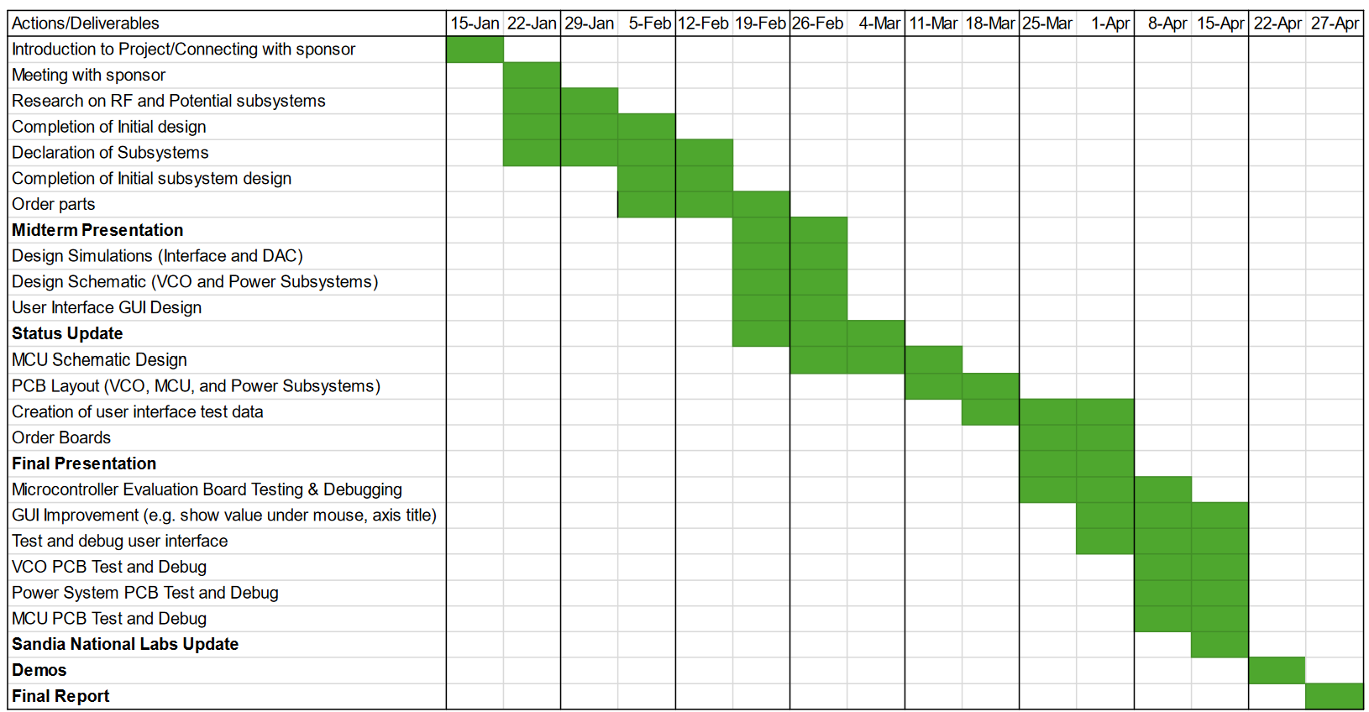

Execution Plan (404)

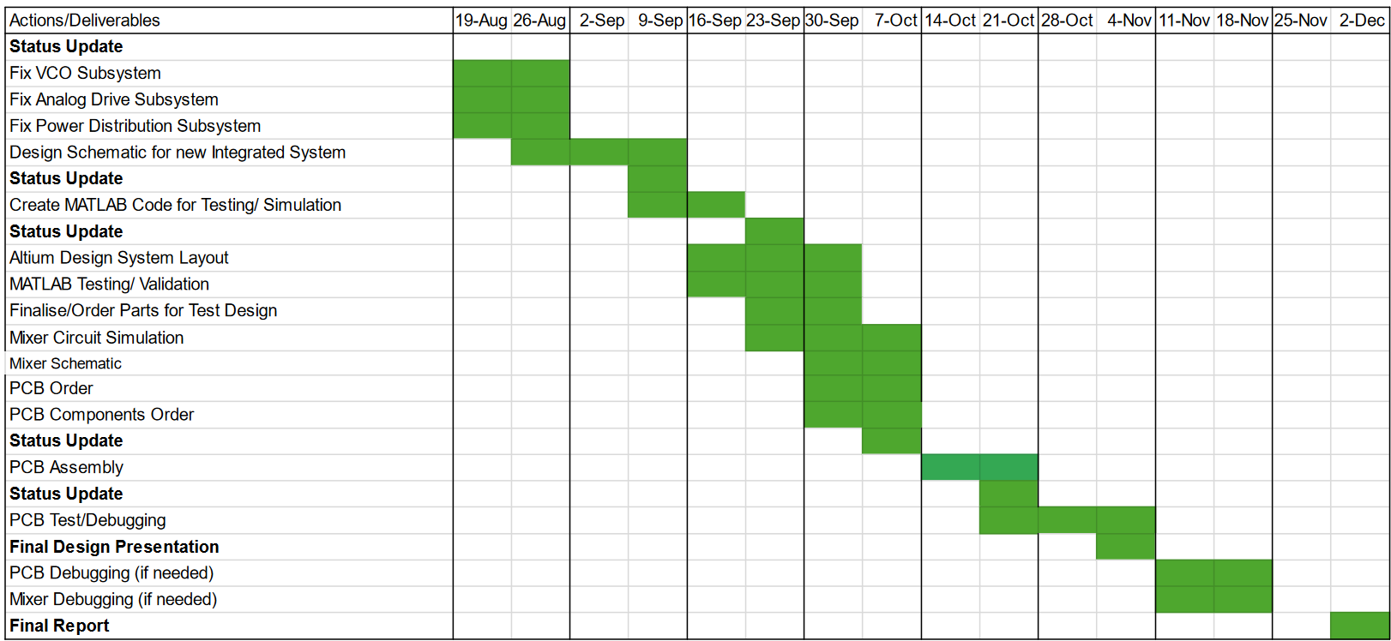

Validation Plan (403/404)