Syllabus management portal

# Project structure and progress

|  |  |  |
| --- | --- | --- |
| **Part** | **Responsible** | **State** |
| Database   * Table structure * Optimising | Daniel | Done (09.11)  Open |
| HTML - Page   * Layout * Login * Skeletal structure * Apply Bootstrap | Milan | Done (13.11.)  Done (12.11.)  Done (13.11.)  Open |
| Admin part   * User * Modules * User-module rights * Assessment Types * MQF Skills * Learning and Teaching activities * Mode of delivery   CRUD functions for all mentioned entities. | Milan | Done (18.11)  In progress  In progress  Open  Open  ?  ? |
| Syllabus Management   * Different Revisions * Different Versions * Functionality * Styling | Daniel | In progress Done(15.11)  Done(15.11)  Done(15.11)  In progress |
| Syllabus Print View   * HTML View as similar as possible to the Word document | Daniel | In progress |
| Approval process (To be defined)  Function that the Module owner gets an E-Mail when syllabus is ready to approve?  Is the syllabus locked for edit after the approval? | tbd |  |
| User manual | tbd |  |

# Session Variables

userId -> Id of the current logged in user (Milan can u add this for my or how can I get the current user?)

syllabus -> Array with the Row Data of the current Syllabus

syllabusId -> Active SyllabusId

moduleId -> Active ModuleId

wizStep -> Active Step in the Syllabus Wizzard

user -> current logged user (array with following attributes)

* userId
* fullName (name + surname)
* username
* isAdmin (true/false)

# Database

main tables

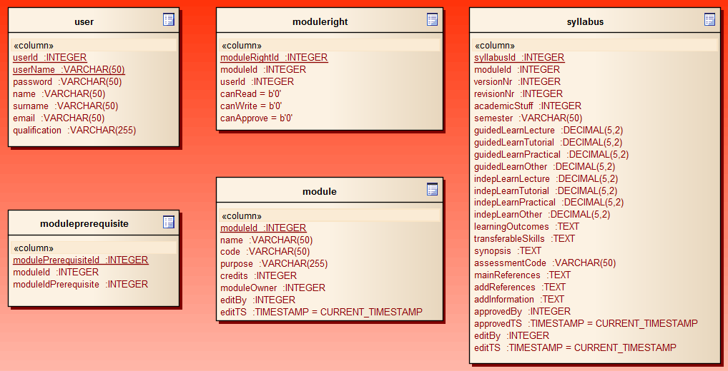

Basic data

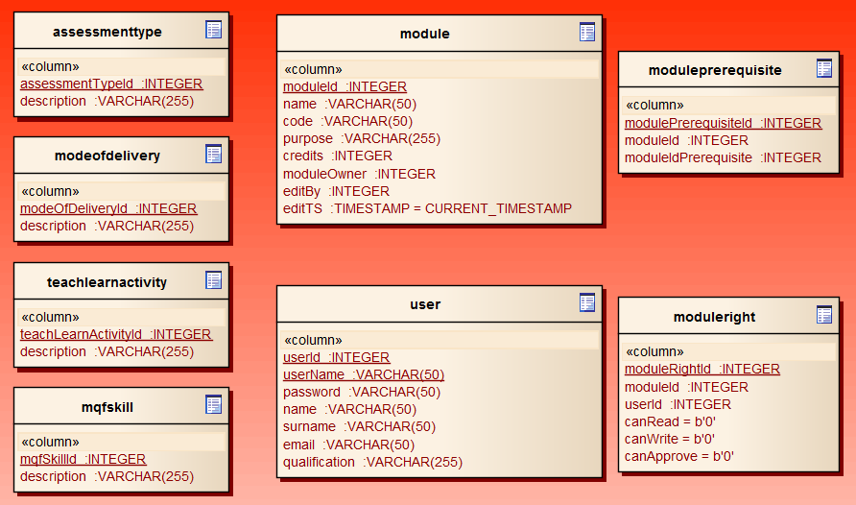

Syllabus related data

