Syllabus management portal

# Project structure and progress

|  |  |  |
| --- | --- | --- |
| **Part** | **Responsible** | **State** |
| Database   * Table structure * Optimising | Daniel | Done (09.11)  Done (09.11) |
| HTML - Page   * Layout * Login * Skeletal structure * Apply Bootstrap | Milan | Done (13.11.)  Done (12.11.)  Done (13.11.)  Done (19.11.) |
| Admin part   * User * Modules * User-module rights * Assessment Types * MQF Skills * Learning and Teaching activities * Mode of delivery   CRUD functions for all mentioned entities. | Milan | Done (17.11.)  Done (18.11.)  Done (18.11.)  Done (19.11.)  Done (19.11.)  Done (19.11.)  Done (19.11.) |
| Syllabus Management   * Different Revisions * Different Versions * Functionality * Styling | Daniel | Done  Done(15.11)  Done(15.11)  Done(15.11)  Done(29.11) |
| Syllabus Print View   * HTML View as similar as possible to the Word document | Daniel | Done (29.11) |

# Installation Instruction

Database

There are two mysql scripts:

* dbInit.sql -> DDL Tasks to create the Database. The Database name can be adjusted on the first lines of the script.
* demoData.sql -> Some initial Data to get started with the application.

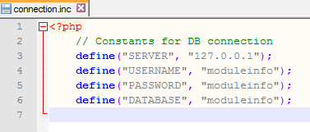Connection Details

The Connection parameters for the Web application can be configured in the app/db folder the file connection.inc. This File is containing 4 constants to define the connection details.

Login

The default root user is admin with the password admin. After the first login, the password can be changed in the User settings.

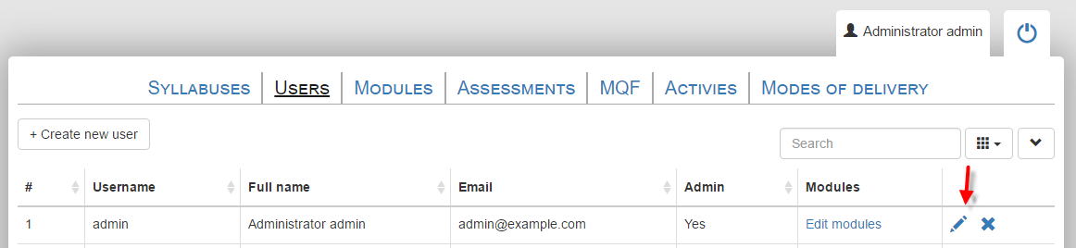

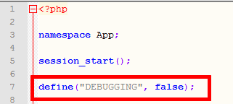Debug modus

To show Debug messages, the debug modus can be switched on. This is done in the index.php file.

To add a Debug output, following method can be used:



# Database

main tables

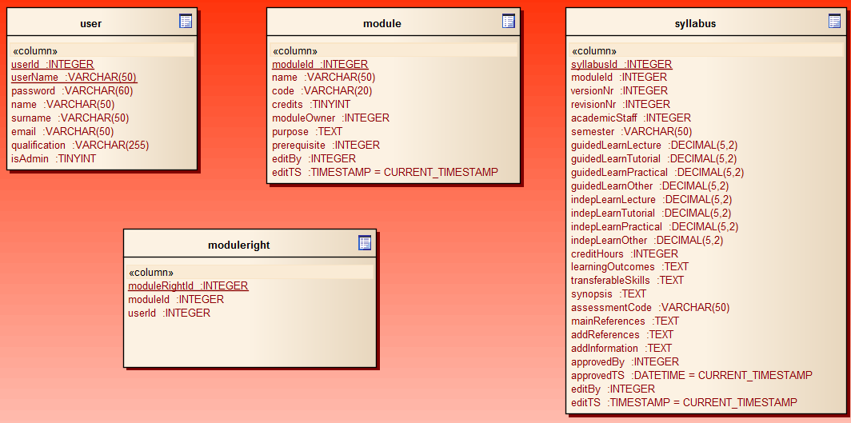

Basic data

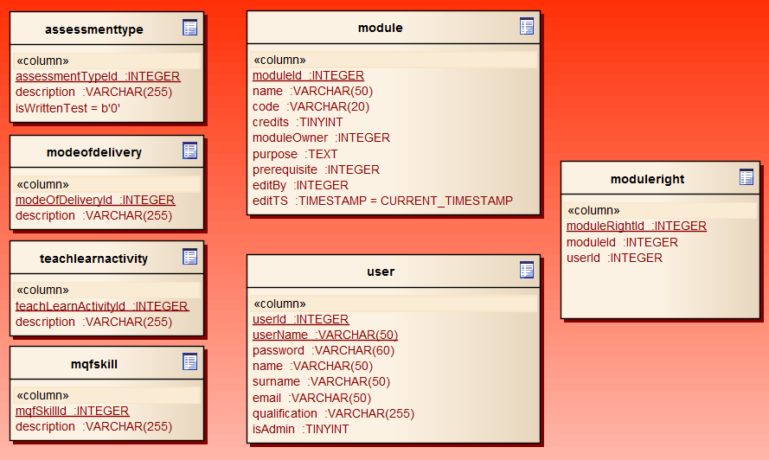

Syllabus related data

