MSPL |  | Week 2 |  | 何柏昇
Denoise
 | Mean Filter
平滑降噪，原理主要是計算該點周圍的平均值，來達到降低雜訊，但也會使圖片模糊化。 |  |  | 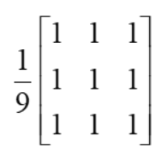
Median Filter
取其與周圍的鄰近，找出中位數並以其取代該點，其優點在於不會使圖片過度模糊化。 |  |  | 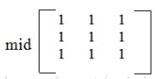
Gaussian Filter
減少圖像雜訊以及降低細節層次，其視覺效果就像是經過一個半透明屏幕在觀察圖像。少了很多顆粒感，但也變模糊了。 |  |  | 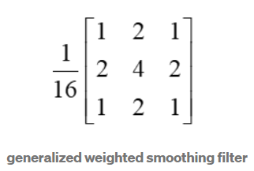
$$G\left(x,y\right)=\frac{1}{2πσ^{2}}e^{-\frac{x^{2}+y^{2}}{2σ^{2}}}$$

// Denoise: Mean, Median, Gaussian
#include <stdio.h>
#include <ctime>
#include <cmath>
#include "opencv2/opencv.hpp"

using namespace std;
using namespace cv;

//Mean Filter
void meanFilter(Mat &src, Mat &dst, int kernel)
{
if (!src.data) return;

//At pixel of image
for (int y = 0; y < src.rows; y++)
{
for (int x = 0; x < src.cols; x++)
{
int sum;
if ((y-kernel >= 0)&&(x-kernel >= 0)&&(y+kernel < src.rows)&&(x+kernel < src.cols))
{
// Sum pixels in the kernel size
for (int k1 = 0; k1 < (2*kernel+1); k1++)
for (int k2 = 0; k2 < (2*kernel+1); k2++)
sum += src.at<uchar>(y-kernel+k1, x-kernel+k2);
// Calculate the mean value
sum /= ((2*kernel+1)*(2*kernel+1));
dst.at<uchar>(y,x)=sum;
}
}
}
}

//Median Filter
void medianFilter(Mat &src, Mat &dst, int kernel)
{
if (!src.data) return;

//At pixel of image
for (int y = 0; y < src.rows; y++)
{
for (int x = 0; x < src.cols; x++)
{
int tmp[(2*kernel+1)*(2*kernel+1)];
if ((y-kernel >= 0)&&(x-kernel >= 0)&&(y+kernel < src.rows)&&(x+kernel < src.cols))
{
// List pixels in the kernel size
for (int k1 = 0; k1 < (2*kernel+1); k1++)
for (int k2 = 0; k2 < (2*kernel+1); k2++)
tmp[k1 * (2*kernel+1) + k2] = src.at<uchar>(y-kernel+k1, x-kernel+k2);
// Finde the median value
sort(tmp,tmp+((2*kernel+1)*(2*kernel+1)));
dst.at<uchar>(y, x)=tmp[((2*kernel+1)*(2*kernel+1)-1)/2];
}
}
}
}

// Gaussian Filter

void gaussianFilter(Mat &src, Mat &dst, int kernel, double sigma= 0.84089642)
{
// Initialise values
double GKernel[2*kernel+1][2*kernel+1];
double r, s=2.0 * sigma * sigma;
double sum=0.0;

// Generate the gaussian kernel
for (int y = 0; y < (2*kernel+1); y++)
{
for (int x = 0; x < (2*kernel+1); x++)
{
r = ((x-kernel)*(x-kernel)+(y-kernel)*(y-kernel));
GKernel[y][x] = (exp(-r/s)) / (M_PI * s);
sum += GKernel[y][x];
}
}

// Normalize the kernel
for (int y = 0; y < (2*kernel+1); y++)
for (int x = 0; x < (2*kernel+1); x++)
{GKernel[y][x] /= sum;
//cout << GKernel[y][x]<<endl;
}

// Convolution image with GKernel
for (int y = 0; y < src.rows; y++)
{
for (int x = 0; x < src.cols; x++)
{
if ((y-kernel >= 0)&&(x-kernel >= 0)&&(y+kernel < src.rows)&&(x+kernel < src.cols))
{
// Convolution
double sum = 0;
for (int k1 = 0; k1 < (2*kernel+1); k1++)
for (int k2 = 0; k2 < (2*kernel+1); k2++)
sum += (double)src.at<uchar>(y-kernel+k1, x-kernel+k2)*GKernel[k1][k2];
dst.at<uchar>(y,x)=sum;
}
}
}

}

// Salt the image
void salt(Mat &image, int num)
{
if (!image.data) return;
int x, y;
srand(time(NULL));
for (int i = 0; i < num; i++)
{
x = rand() % image.rows;
y = rand() % image.cols;
image.at<uchar>(y,x) = 255;
}
}

int main(int argc, char** argv)
{
// Read the image
Mat image = imread("../images/lena.png",0);

// Add the salt noise to image
Mat saltImage = image.clone();
salt(saltImage, 5000);

// Setting the kernel size
if ( argc != 2 || (atoi(argv[1])%2) == 0 || atoi(argv[1]) > image.rows || atoi(argv[1]) > image.cols)
{
printf("usage: ./denoise <kernel size(3 ,5 ,7, ..., 2N+1)>\n");
return -1;
}
int kernel;
kernel = (atoi(argv[1])-1)/2;

// Mean Filter
Mat meanImage = image.clone();
meanFilter(saltImage, meanImage, kernel);

// Median Filter
Mat medianImage = image.clone();
medianFilter(saltImage, medianImage, kernel);

// Gaussian Filter
Mat gaussianImage = image.clone();
gaussianFilter(saltImage, gaussianImage, kernel);

// Show images
imshow("Original",image);
imshow("Salt",saltImage);
imshow("Mean",meanImage);
imshow("Median",medianImage);
imshow("Gaussian",gaussianImage);
waitKey();

// Save images
imwrite("../images/salt.png", saltImage);
imwrite("../images/mean.png", meanImage);
imwrite("../images/median.png", medianImage);
imwrite("../images/gaussian.png", gaussianImage);

return 0;
}

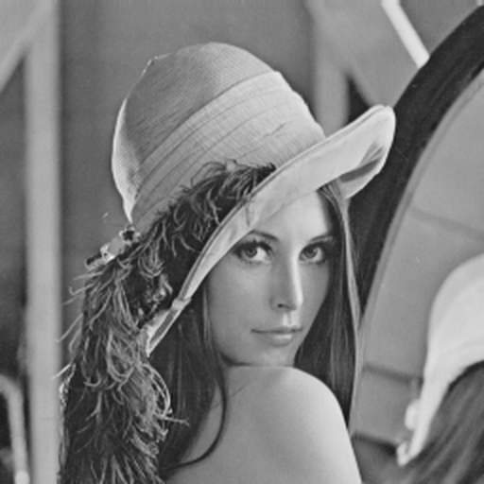
Original
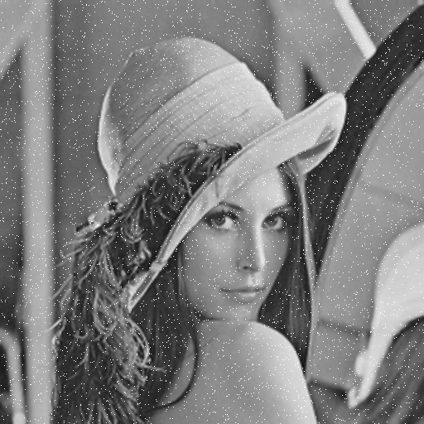 | 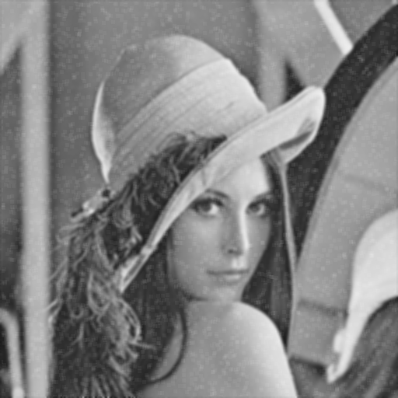
Salt | Mean
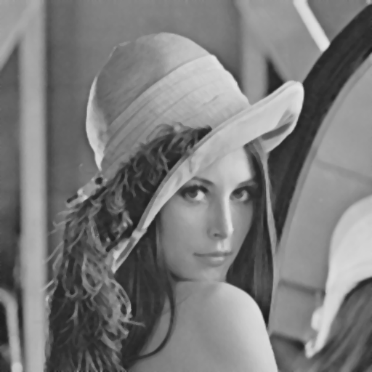 | 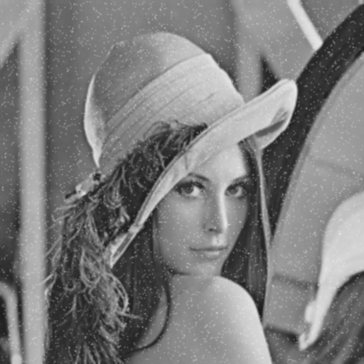
Median | Gaussian

Edge Detection
 | Sobel
分別計算：  - 偏x方向的$G_{x}$  - 偏y方向的 $G_{y}$  - 求絕對值，壓縮到[0, 255]區間  $$G\left(x,y\right)=G_{x}+G_{y}$$ |  | 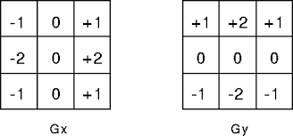
 | Laplacian
一階差分：  $$f^{'}\left(x\right)=f\left(x\right)-f\left(x-1\right)$$  二階差分：  $$f^{'}\left(x\right)=\left(f\left(x+1\right)-f\left(x\right)\right)-(f(x)-f\left(x-1\right)$$  $$=f\left(x-1\right)-2f\left(x\right)+f(x+1)$$  二維:  $$f^{'}\left(x,y\right)=-4f\left(x,y\right)+f\left(x-1,y\right)+f\left(x+1,y\right)+f\left(x,y-1\right)+f\left(x,y+1\right)$$ |  | 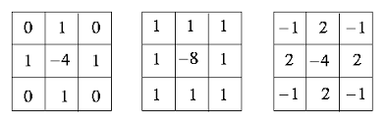    
 | Canny
1.高斯濾波器平滑圖像。
2.一階差分偏導計算梯度值和方向Sobel。
3.對梯度值不是極大值的地方進行抑制。
4.用雙閾值連接圖上的聯通點。

// Edge Detect: Sobel, Laplacian
#include <stdio.h>
#include <cmath>
#include "opencv2/opencv.hpp"

using namespace std;
using namespace cv;

void sobelKernel(Mat &src, Mat &dst, int kernel, int sita)
{
// Initialise values
int size= 2 * kernel + 1;
double Gx[size][size], Gy[size][size], G[size][size];

// Generate sobel kernel
for (int y = 0; y < size; y++)
{
for (int x = 0; x < size; x++)
{
if (y != kernel || x != kernel)
{
// Gx f(x,y) dot (1,0)
Gx[y][x] = (double)(x-kernel) / (double)((x-kernel)*(x-kernel) + (y-kernel)*(y-kernel));
// Gy f(x,y) dot (0,1)
Gy[y][x] = (double)(y-kernel) / (double)((x-kernel)*(x-kernel) + (y-kernel)*(y-kernel));
}
else
Gx[y][x]=Gy[y][x]=0;
// G = (Gx*cosa + Gy*sina)/2
G[y][x] = (Gx[y][x] * cos(sita) + Gy[y][x] * sin(sita));
}
}

// Convolution image with soble kernel
for (int y = 0; y < src.rows; y++)
{
for (int x = 0; x < src.cols; x++)
{
if ((y-kernel >= 0)&&(x-kernel >= 0)&&(y+kernel < src.rows)&&(x+kernel < src.cols))
{
// Convolution
double sum = 0;
for (int k1 = 0; k1 < size; k1++)
for (int k2 = 0; k2 < size; k2++)
sum += src.at<uchar>(y-kernel+k1, x-kernel+k2) * G[k1][k2];
dst.at<uchar>(y,x)=abs(sum);
}
else
dst.at<uchar>(y,x)=0;
}
}
}

// Combine two images to one
void addImage(Mat &src1, Mat &src2,Mat &dst)
{
for (int y = 0; y < dst.rows; y++)
for (int x = 0; x < dst.cols; x++)
dst.at<uchar>(y,x)=sqrt(pow(src1.at<uchar>(y,x),2) + pow(src2.at<uchar>(y,x),2));
}

// Laplacian Filter
void laplacianFilter(Mat &src, Mat &dst, int kernel,double sigma = 84089642)
{
// Initialise values
int size = 2 * kernel + 1;
double LKernel[size][size];

// Generate sobel kernel
for (int y = 0; y < size; y++)
{
for (int x = 0; x < size; x++)
{
if (y != kernel || x != kernel)
LKernel[y][x] = -1;
else
LKernel[y][x] = size * size - 1;
}
}

// Convolution image with GKernel
for (int y = 0; y < src.rows; y++)
{
for (int x = 0; x < src.cols; x++)
{
if ((y-kernel >= 0)&&(x-kernel >= 0)&&(y+kernel < src.rows)&&(x+kernel < src.cols))
{
// Convolution
double sum = 0;
for (int k1 = 0; k1 < size; k1++)
for (int k2 = 0; k2 < size; k2++)
sum += (double)src.at<uchar>(y-kernel+k1, x-kernel+k2)*LKernel[k1][k2];
dst.at<uchar>(y,x)=abs(sum);
}
else
dst.at<uchar>(y,x) = 0;
}
}
}

int main(int argc, char** argv)
{

// Read the image
Mat image = imread("../images/lena.png",0);

// Setting the kernel size
if ( argc != 2 || (atoi(argv[1])%2) == 0 || atoi(argv[1]) > image.rows || atoi(argv[1]) > image.cols)
{
printf("usage: ./edgeDetect <kernel size(3 ,5 ,7, ..., 2N+1)>\n");
return -1;
}
int kernel;
kernel = (atoi(argv[1])-1)/2;

// Sobel
Mat sobelImageX = image.clone(), sobelImageY = image.clone(), sobelImage = image.clone();
sobelKernel(image, sobelImageX, kernel, (0*M_PI/180));
sobelKernel(image, sobelImageY, kernel, (90*M_PI/180));
addImage(sobelImageX, sobelImageY, sobelImage);

// Laplacian of Gaussian
Mat LaplacianImage = image.clone();
laplacianFilter(image,LaplacianImage,kernel);

// Show images
imshow("Original",image);
imshow("Sobel",sobelImage);
imshow("Laplacian", LaplacianImage);

waitKey();

// Save images
imwrite("../images/sobel.png", sobelImage);
imwrite("../images/sobelX.png", sobelImageX);
imwrite("../images/sobelY.png", sobelImageY);
imwrite("../images/laplacian.png", LaplacianImage);

}


Original
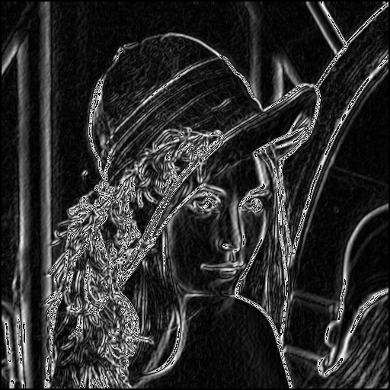
Sobel
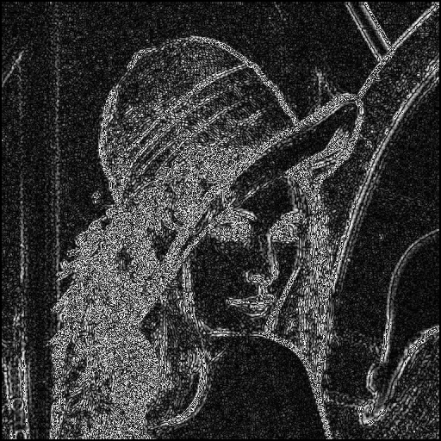
Laplacian

/* Edge Detect: Canny
* Step 1: Apply a Gaussian blur
* Step 2: Find edge gradient strength and direction
* Step 3: Trace along the edges
* Step 4: Suppress non-maximum edges
*/
#include <stdio.h>
#include <ctime>
#include <cmath>
#include "opencv2/opencv.hpp"

using namespace std;
using namespace cv;

// Gaussian Filter

void gaussianFilter(Mat &src, Mat &dst, int kernel, double sigma= 0.84089642)
{
// Initialise values
int size = 2 * kernel + 1;
double GKernel[size][size];
double r, s=2.0 * sigma * sigma;
double sum=0.0;

// Generate the gaussian kernel
for (int y = 0; y < (size); y++)
{
for (int x = 0; x < (size); x++)
{
r = ((x-kernel)*(x-kernel)+(y-kernel)*(y-kernel));
GKernel[y][x] = (exp(-r/s)) / (M_PI * s);
sum += GKernel[y][x];
}
}

// Normalize the kernel
for (int y = 0; y < size; y++)
for (int x = 0; x < size; x++)
{GKernel[y][x] /= sum;
//cout << GKernel[y][x]<<endl;
}

// Convolution image with GKernel
for (int y = 0; y < src.rows; y++)
{
for (int x = 0; x < src.cols; x++)
{
if ((y-kernel >= 0)&&(x-kernel >= 0)&&(y+kernel < src.rows)&&(x+kernel < src.cols))
{
// Convolution
double sum = 0;
for (int k1 = 0; k1 < (size); k1++)
for (int k2 = 0; k2 < (size); k2++)
sum += (double)src.at<uchar>(y-kernel+k1, x-kernel+k2)*GKernel[k1][k2];
dst.at<uchar>(y,x)=sum;
}
}
}
}

// Sobel Filter
void sobelKernel(Mat &src, Mat &dst, Mat &dst2, int kernel)
{
// Initialise values
int size= 2 * kernel + 1;
double Gx[size][size], Gy[size][size];
int edgeDir[src.rows][src.cols];

// Generate sobel kernel
for (int y = 0; y < size; y++)
{
for (int x = 0; x < size; x++)
{
if (y != kernel || x != kernel)
{
// Gx f(x,y) dot (1,0)
Gx[y][x] = (double)(x-kernel) / (double)((x-kernel)*(x-kernel) + (y-kernel)*(y-kernel));
// Gy f(x,y) dot (0,1)
Gy[y][x] = (double)(y-kernel) / (double)((x-kernel)*(x-kernel) + (y-kernel)*(y-kernel));
}
else
Gx[y][x]=Gy[y][x]=0;
}
}

// Convolution image with soble kernel
for (int y = 0; y < src.rows; y++)
{
for (int x = 0; x < src.cols; x++)
{
double sumx = 0, sumy = 0;
double angle = 0;
if ((y-kernel >= 0)&&(x-kernel >= 0)&&(y+kernel < src.rows)&&(x+kernel < src.cols))
{
// Convolution
for (int k1 = 0; k1 < size; k1++)
{
for (int k2 = 0; k2 < size; k2++)
{
sumx += src.at<uchar>(y-kernel+k1, x-kernel+k2) * Gx[k1][k2];
sumy += src.at<uchar>(y-kernel+k1, x-kernel+k2) * Gy[k1][k2];
}
}
dst2.at<uchar>(y,x) = dst.at<uchar>(y,x) = (int)sqrt(pow(sumx,2) + pow(sumy,2));
angle = (atan2(sumx,sumy) / M_PI) * 180.0;
}
else
{
dst2.at<uchar>(y,x) = dst.at<uchar>(y,x)=0;
angle = 0;
}

/* Convert actual edge direction to approximate value */
if ( ( (angle < 22.5) && (angle > -22.5) ) || (angle > 157.5) || (angle < -157.5) )
edgeDir[y][x] = 0;
if ( ( (angle > 22.5) && (angle < 67.5) ) || ( (angle < -112.5) && (angle > -157.5) ) )
edgeDir[y][x] = 45;
if ( ( (angle > 67.5) && (angle < 112.5) ) || ( (angle < -67.5) && (angle > -112.5) ) )
edgeDir[y][x] = 90;
if ( ( (angle > 112.5) && (angle < 157.5) ) || ( (angle < -22.5) && (angle > -67.5) ) )
edgeDir[y][x] = 135;
}
}

// Non-maximum suppression
for (int y = 0; y < src.rows; y++)
{
for (int x = 0; x < src.cols; x++)
{
if ((y-kernel >= 0)&&(x-kernel >= 0)&&(y+kernel < src.rows)&&(x+kernel < src.cols))
switch (edgeDir[y][x])
{
case 0:
if ((dst.at<uchar>(y,x) < dst.at<uchar>(y,x-1))||(dst.at<uchar>(y,x) < dst.at<uchar>(y,x+1)))
dst2.at<uchar>(y,x)=0;
break;

case 45:
if ((dst.at<uchar>(y,x) < dst.at<uchar>(y+1,x-1))||(dst.at<uchar>(y,x) < dst.at<uchar>(y-1,x+1)))
dst2.at<uchar>(y,x)=0;
break;

case 90:
if ((dst.at<uchar>(y,x) < dst.at<uchar>(y-1,x))||(dst.at<uchar>(y,x) < dst.at<uchar>(y+1,x)))
dst2.at<uchar>(y,x)=0;
break;

case 135:
if ((dst.at<uchar>(y,x) < dst.at<uchar>(y-1,x-1))||(dst.at<uchar>(y,x) < dst.at<uchar>(y+1,x+1)))
dst2.at<uchar>(y,x)=0;
break;
}
}

}

}

// double thershold
void db_thershold(Mat &src, Mat &dst, int kernel,int low, int high)
{
int G[src.rows][src.cols];
int size = 2 * kernel + 1;
for (int y = 0; y < src.rows; y++)
{
for (int x = 0; x < src.cols; x++)
{
if ((y-kernel >= 0)&&(x-kernel >= 0)&&(y+kernel < src.rows)&&(x+kernel < src.cols))
{
if (src.at<uchar>(y,x)<low) G[y][x] = 0;
else if ((src.at<uchar>(y,x)>low) && (src.at<uchar>(y,x)<high))
{
bool edge = false;
for (int k1 = 0; k1 < (size); k1++)
{
for (int k2 = 0; k2 < (size); k2++)
{
if (src.at<uchar>(y-kernel+k1, x-kernel+k2)>high)
{
edge = true;
break;
}
}
}
if (!edge) G[y][x] = 0;
}
dst.at<uchar>(y,x)=dst.at<uchar>(y,x-1)=dst.at<uchar>(y,x+1)=G[y][x];
}
}
}
}

int main(int argc, char** argv)
{
// Read the image
Mat image = imread("../images/lena.png",0);

// Gaussian
int kernel;
printf("Enter kernel size of gaussian filter(3 ,5 ,7, ..., 2N+1): ");
scanf("%d",&kernel);
if ((kernel%2) == 0 || kernel > image.rows || kernel > image.cols || kernel == 1)
{
printf("Error value!!\n");
return -1;
}
kernel = (kernel-1)/2;
Mat gaussianImage = image.clone();
gaussianFilter(image, gaussianImage, kernel);

// Sobel
printf("Enter kernel size of sobel filter(3 ,5 ,7, ..., 2N+1): ");
scanf("%d",&kernel);
if ((kernel%2) == 0 || kernel > image.rows || kernel > image.cols || kernel == 1)
{
printf("Error value!!\n");
return -1;
}
kernel = (kernel-1)/2;
Mat sobelImage = image.clone();
Mat suppressionImage = image.clone();
sobelKernel(gaussianImage, sobelImage, suppressionImage, kernel);

// Double thershold
printf("Enter kernel size of double thershold(3 ,5 ,7, ..., 2N+1): ");
scanf("%d",&kernel);
if ((kernel%2) == 0 || kernel > image.rows || kernel > image.cols || kernel == 1)
{
printf("Error value!!\n");
return -1;
}
kernel = (kernel-1)/2;
Mat dbImage = suppressionImage.clone();
int low=0, high=0;
printf("Enter low and high value for double thershold: ");
scanf("%d %d",&low, &high);
if (low > high || high > 254 || low < 0)
{
printf("Error value!!%d %d\n",low ,high);
return -1;
}
db_thershold(suppressionImage, dbImage, kernel, low, high);

// Show images
imshow("Original",image);
imshow("Gaussian", gaussianImage);
imshow("Sobel", sobelImage);
imshow("Suppression", suppressionImage);
imshow("Double thershold", dbImage);
waitKey();

// Save images
imwrite("../images/1-gaussian.png", gaussianImage);
imwrite("../images/2-sobel.png", sobelImage);
imwrite("../images/3-suppression.png", suppressionImage);
imwrite("../images/4-dbThershold.png", dbImage);
}

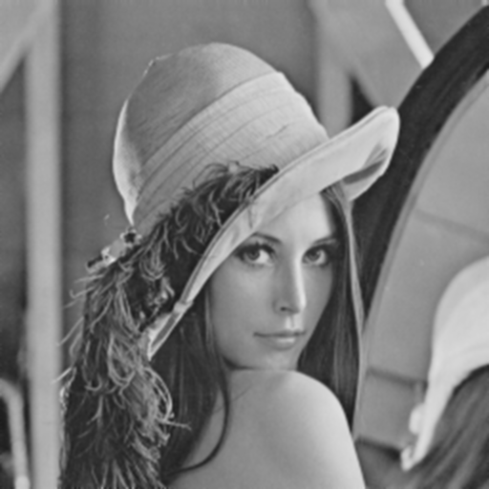 | 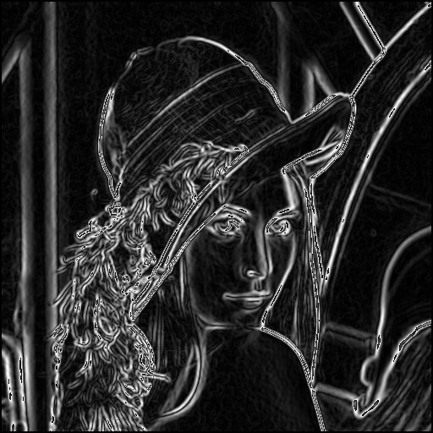
1-Gaussian | 2-Sobel
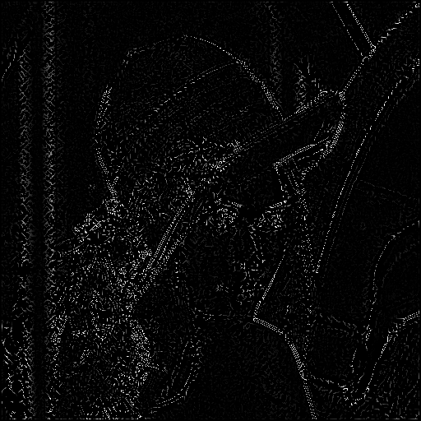 | 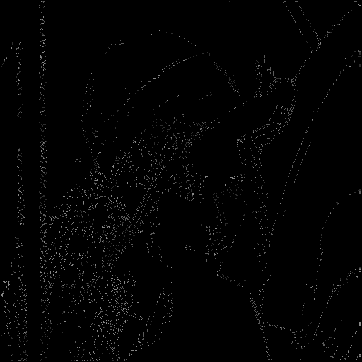
3-Supperssion | 4-Double thershold

Github
MSPL/ week2

