MSPL | Week 1 | 何柏昇
Binary Fixed & Otsu
Fixed
Let RGB image mapping to gray-level, then segmentation of each pixel by threshold(T).From 8-bit to 1-bit.
$$g\left(x,y\right)=\left\{\begin{aligned}0, f\left(x,y\right)≥T \\ 1(or 255), x<T\end{aligned}\right.$$
Otsu
Otsu’s algorithm is a simple and popular thresholding method for image segmentation, which falls into the clustering category.
The algorithm divides the image histogram into two classes, by using a threshold such as the in-class variability is very small. This way, each class will be as compact as possible.The algorithm tries to minimize the weighted within-class variance $σ_{w}^{2}\left(t\right)$.
$$σ_{w}^{2}\left(t\right)=q_{1}\left(t\right)σ_{1}^{2}\left(t\right)+q_{2}(t)σ_{2}^{2}\left(t\right)$$
$$q_{1}\left(t\right)=\sum_{i=1}^{t}{P(i)} q_{2}\left(t\right)=\sum_{i=t+1}^{I}{P(i)}$$
$$μ_{1}\left(t\right)=\sum_{i=1}^{t}{\frac{iP(i)}{q_{1}\left(t\right)}} μ_{2}\left(t\right)=\sum_{i=t+1}^{I}{\frac{iP(i)}{q_{2}\left(t\right)}}$$
$$σ_{1}^{2}\left(t\right)=\sum_{i=1}^{t}{{[i-μ_{1}\left(t\right)]}^{2}\frac{P(i)}{q_{1}\left(t\right)}}$$
$$σ_{2}^{2}\left(t\right)=\sum_{i=t+1}^{I}{{[i-μ_{2}\left(t\right)]}^{2}\frac{P(i)}{q_{2}\left(t\right)}}$$
The total variance can be defined, as the sum of the within class $σ_{w}^{2}(t)$ and the between-class variance $σ_{b}^{2}(t)$. The value $σ^{2}$ is constant, as it does not depend on the threshold (the variance of an image is always a constant value), meaning that the algorithm must focus on minimizing $σ_{w}^{2}\left(t\right)$, or maximizing $σ_{b}^{2}\left(t\right)$.
$${σ^{2}= σ}_{w}^{2}\left(t\right)+σ_{b}^{2}\left(t\right), where σ_{b}^{2}\left(t\right)=q_{1}\left(t\right)q_{2}\left(t\right){[μ_{1}\left(t\right)-μ_{2}\left(t\right)]}^{2}.$$
// Binary Fixed & Otsu
#include <stdio.h>
#include <opencv2/opencv.hpp>

using namespace std;
using namespace cv;

int main(int argc, char** argv)
{
//Read the image
Mat image, fixedImage, otsuImage;
image = imread("images/lena.png", 0);
fixedImage = image.clone();
otsuImage = image.clone();
long double N = image.rows * image.cols;

//Initialize variables
long double threshold = -1, var_max = 0,
sum = 0, sumB = 0, q1 = 0, q2 = 0,
u1 = 0, u2 = 0, vb =0;
long double max_intensity = 255;
long double histogram[255];
for (int i = 0; i < max_intensity; i++)
histogram[i] = 0;

// Compute the image histogram
for (int y = 0; y < image.rows; y++)
for (int x = 0; x < image.cols; x++)
histogram[(int)image.at<uchar>(y,x)]++;

// Auxiliary value for computing µ2
for (int i = 0; i < max_intensity; i++)
sum += i * histogram[i];

// Update qi(t)
for (int t = 0; t < max_intensity; t++)
{
q1 += histogram[t];
if (q1 == 0)
continue;
q2 = N - q1;

// Update µi(t)
sumB += t * histogram[t];
u1 = sumB / q1;
u2 = (sum - sumB) / q2;

// Update the between-class variance
vb = q1 * q2 * (u1 - u2) * (u1 - u2);

// Update the threshold
if (vb > var_max)
{
threshold = t;
var_max = vb;
}
}

// Build the binary-fit image
if ( argc != 2 )
{
printf("usage: ./binary <binary_fit>\n");
return -1;
}
int fit;
fit = atoi(argv[1]);

for (int y = 0; y < fixedImage.rows; y++)
{
for (int x = 0; x < fixedImage.cols; x++)
{
if (fixedImage.at<uchar>(y,x) > fit)
fixedImage.at<uchar>(y,x) = 255;
else
fixedImage.at<uchar>(y,x) = 0;
}
}

// Build the binary-otsu image
for (int y = 0; y < otsuImage.rows; y++)
{
for (int x = 0; x < otsuImage.cols; x++)
{
if (otsuImage.at<uchar>(y,x) > threshold)
otsuImage.at<uchar>(y,x) = 255;
else
otsuImage.at<uchar>(y,x) = 0;
}
}

// Show images
namedWindow("Image", WINDOW_AUTOSIZE );
imshow("Image", image);

namedWindow("fixedImage", WINDOW_AUTOSIZE );
imshow("fixedImage", fixedImage);

namedWindow("Otsu", WINDOW_AUTOSIZE );
imshow("Otsu", otsuImage);
waitKey(0);

// Save images
imwrite("images/fixed.png", fixedImage);
imwrite("images/otsu.png", otsuImage);

return 0;
}

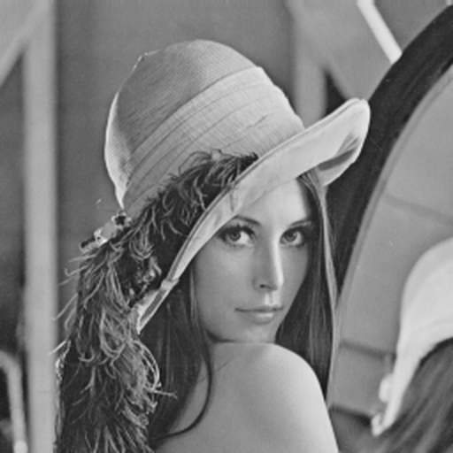 | 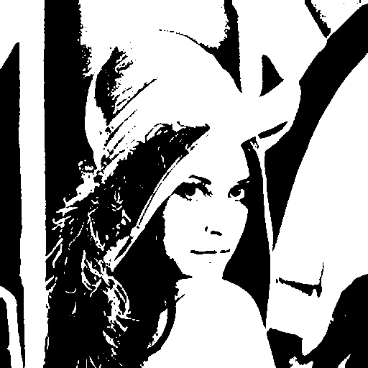
Original | Otsu
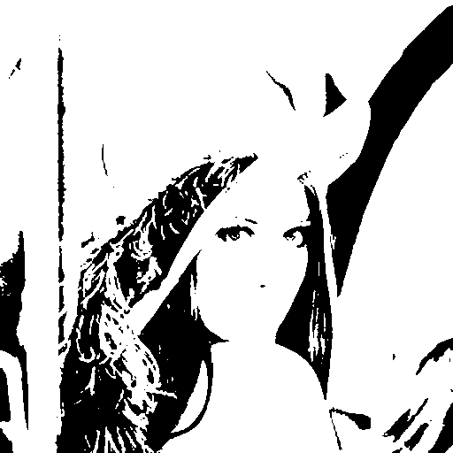 | 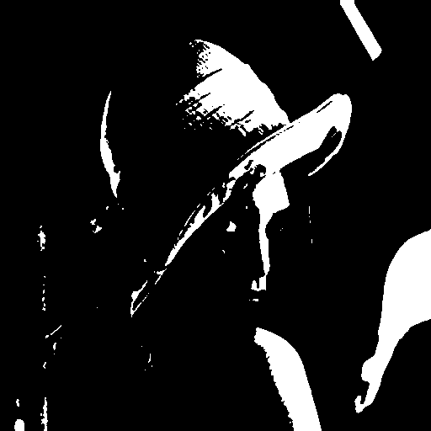
fixed_80 | fixed_180

Histogram Equalization
Following is the algorithm to do histogram equalization in C language.
- Convert the input image into a grayscale image
- Find frequency of occurrence for each pixel value i.e. histogram of an image (values lie in the range [0, 255] for any grayscale image)
- Calculate Cumulative frequency of all pixel values
- Divide the cumulative frequencies by total number of pixels and multiply them by maximum gray count (pixel value) in the image

// Histogram Equalization
#include <stdio.h>
#include <cmath>
#include <opencv2/opencv.hpp>

using namespace std;
using namespace cv;

int main(int argc, char** argv)
{
// Read the image
Mat image, newImage;
image = imread("images/lena.png", 0);
newImage = image.clone();
// Initialize variables
int max_intensity = 255;
long double histogram[255];
long double new_histogram[255];
for (int i = 0; i < max_intensity; i++)
{
histogram[i] = 0;
new_histogram[i] = 0;
}

// Compute the image histogram
for (int y = 0; y < image.rows; y++)
for (int x = 0; x < image.cols; x++)
histogram[(int)image.at<uchar>(y,x)]++;

// calculating total number of pixels
long double total = image.rows * image.cols;
long double curr =0;

for (int i = 0; i < max_intensity; i++)
{
curr += histogram[i];
new_histogram[i]=round((((float)curr) * 255) / total);
}
// Performing histogram equalization by mapping new gray levels
// Compute the image histogram
for (int y = 0; y < newImage.rows; y++)
for (int x = 0; x < newImage.cols; x++)
newImage.at<uchar>(y,x)= new_histogram[newImage.at<uchar>(y,x)];

// Show images
namedWindow("Image", WINDOW_AUTOSIZE );
imshow("Image", image);

namedWindow("Histogram Equalization", WINDOW_AUTOSIZE );
imshow("Histogram Equalization", newImage);
waitKey(0);

// Save image
imwrite("images/hq.png", newImage);

return 0;
}

 | 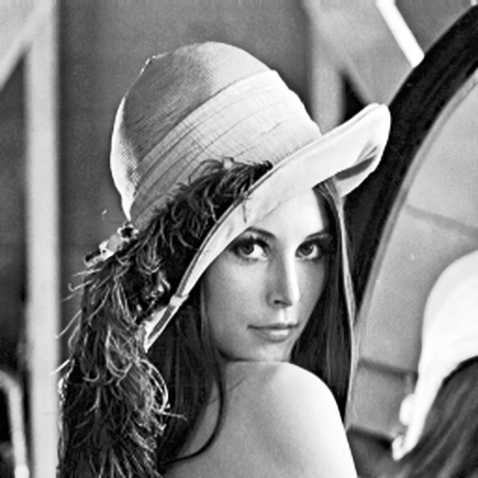
Original | HQ
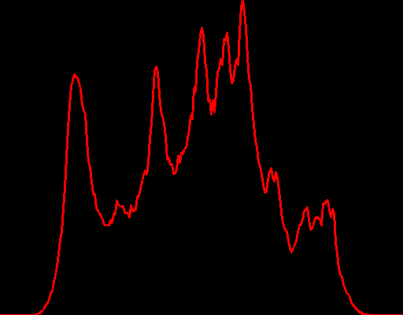 | 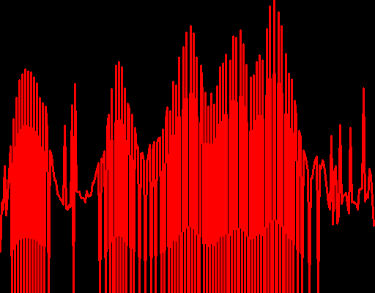
Original | HQ

Morphology
Erosion
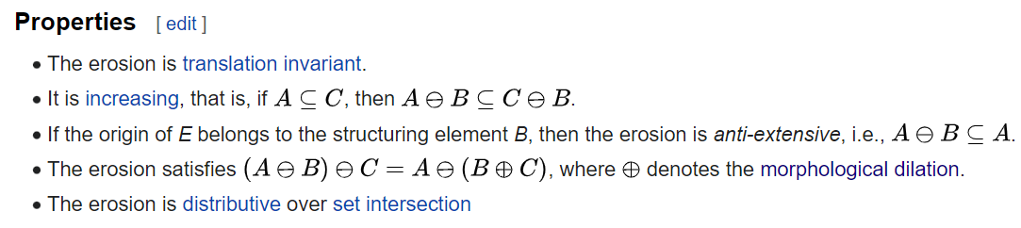
Dilation
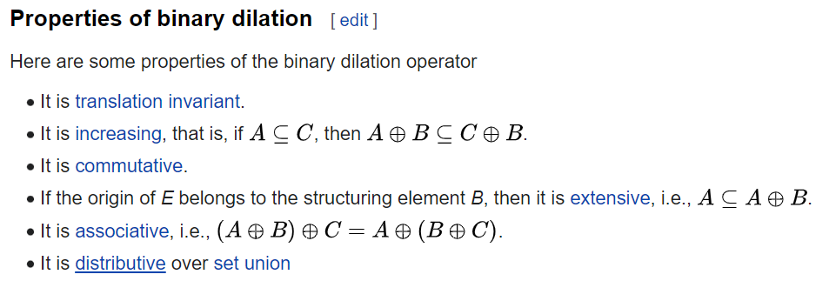
Opening
Closing

// Morphology : Erosion, Dilation, Opening, Closing
#include <stdio.h>
#include <opencv2/opencv.hpp>

using namespace std;
using namespace cv;

int main(int argc, char** argv)
{
// Read the image
Mat image;
image = imread("images/lena.png", IMREAD_GRAYSCALE);

// Build the binary-fit image
if ( argc != 2 || (atoi(argv[1])%2) == 0 || atoi(argv[1]) > image.rows || atoi(argv[1]) > image.cols)
{
printf("usage: ./morphology <kernel size(3 ,5 ,7, ..., 2N+1)>\n");
return -1;
}
int kernel;
kernel = atoi(argv[1])/2;

// Dilated and Eroded
Mat dilatedImage, erodedImage;
dilatedImage = image.clone();
erodedImage = image.clone();
// find the maximum and minimum pixel intensity of image
for (int i = 0; i < image.rows; i++)
{
for (int j = 0; j < image.cols; j++)
{
uchar maxV = 0;
uchar minV = 255;
for (int y = i-kernel; y <= i+kernel; y++)
{
for (int x = j-kernel; x <= j+kernel; x++)
{
if (x < 0 || x >= image.cols || y < 0 || y >= image.rows)
continue;
// Dilated
maxV = max<uchar>(maxV, image.at<uchar>(y,x));
// Eroded
minV = min<uchar>(minV, image.at<uchar>(y,x));
}
}
dilatedImage.at<uchar>(i,j) = maxV;
erodedImage.at<uchar>(i,j) = minV;
}
}

// Opening and Closing
Mat openImage, closeImage;
openImage = image.clone();
closeImage = image.clone();
// find the maximum and minimum pixel intensity of image
for (int i = 0; i < image.rows; i++)
{
for (int j = 0; j < image.cols; j++)
{
uchar maxV = 0;
uchar minV = 255;

for (int y = i-kernel; y <= i+kernel; y++)
{
for (int x = j-kernel; x <= j+kernel; x++)
{
if (x < 0 || x >= image.cols || y < 0 || y >= image.rows)
continue;
// Opening = Dilated(Eroded())
maxV = max<uchar>(maxV, erodedImage.at<uchar>(y,x));
// Close = Eroded(Dilated())
minV = min<uchar>(minV, dilatedImage.at<uchar>(y,x));
}
}
openImage.at<uchar>(i,j) = maxV;
closeImage.at<uchar>(i,j) = minV;
}
}

// Show image
namedWindow("Image", WINDOW_AUTOSIZE );
imshow("Image", image);

namedWindow("Dilated", WINDOW_AUTOSIZE );
imshow("Dilated", dilatedImage);

namedWindow("Eroded", WINDOW_AUTOSIZE );
imshow("Eroded", erodedImage);

namedWindow("Opening", WINDOW_AUTOSIZE );
imshow("Opening", openImage);

namedWindow("Closing", WINDOW_AUTOSIZE );
imshow("Closing", closeImage);
waitKey(0);

// Save image
imwrite("images/dilatedImage.png", dilatedImage);
imwrite("images/erodedImage.png", erodedImage);
imwrite("images/openImage.png", openImage);
imwrite("images/closeImage.png", closeImage);

return 0;

}

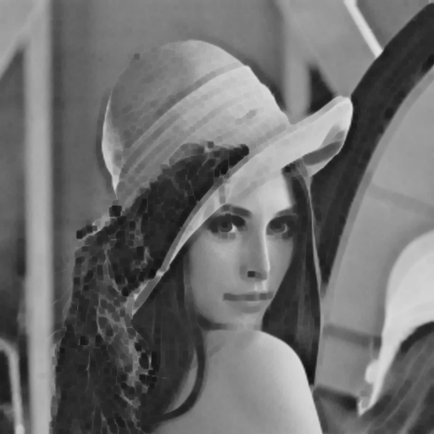 | 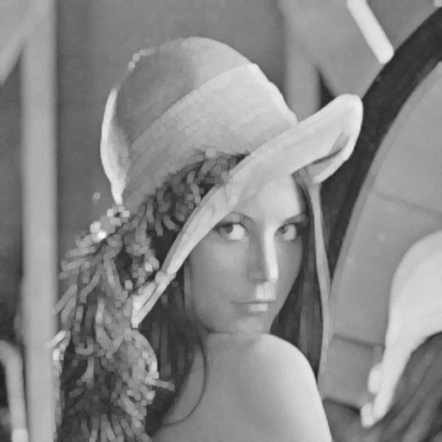
Erosion | Dilation
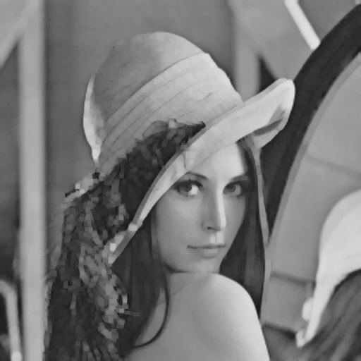 | 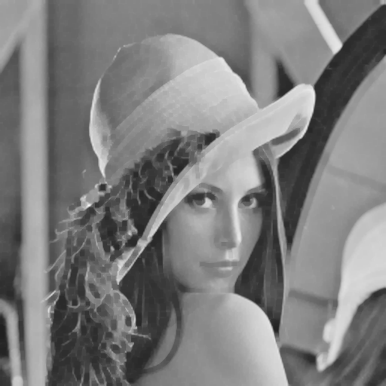
Opening | Closing

Reference
- https://www.ipol.im/pub/art/2016/158/article_lr.pdf
- https://hbyacademic.medium.com/otsu-thresholding-4337710dc519
- https://learnopencv.com/otsu-thresholding-with-opencv
- https://jason-chen-1992.weebly.com/home/-histogram-equalization
- https://www.geeksforgeeks.org/histogram-equalisation-in-c-image-processing/
- https://docs.opencv.org/3.4/db/df6/tutorial_erosion_dilatation.html
- https://docs.opencv.org/3.4/d3/dbe/tutorial_opening_closing_hats.html
- https://blog.51cto.com/u_15414551/4399694
- http://www.scu.edu.tw/math/Chieping/n.5-dimension/image_processing.html
- https://homepages.inf.ed.ac.uk/rbf/BOOKS/PHILLIPS/cips2ed.pdf
- https://docs.opencv.org/3.4.0/db/df5/tutorial_linux_gcc_cmake.html
Github
MSPL/ week1

