Design Documentation

Interactive House Project (Device Subgroup)

Revision History

Date | Version | Description | Author
2026-02-19 | 1.0 | Initial design document | Patrick Nordahl

Design item List
Requirement Name | Priority
D1. High-Level Architecture (Device → Gateway → Server → UI) | Essential
D2. Arduino Device Component Design (Controller, State, Sensors, Actuators) | Essential
D3. Serial Communication Protocol (Message types + structured format) | Essential
D4. Interaction Flow (Sequence: UI Command → Device Actuation → ACK/State Update) | Essential
D5. Fault Handling & Safe State Behavior (Communication failure strategy) | Essential

Design Item Descriptions

D1 High Level Architecture (Device -> Gateway -> Server -> UI)
Description:
The system follows a layered architecture where devices do not communicate directly with user interfaces. Instead, communication is routed through via a gateway (middleman) component, which maintains communication with the server.

The architecture is divided into four logical layers:

- Device Layer (Arduino) – Handles sensor readings, sensor control, and maintains local device state.
- Gateway Layer (Laptop/Raspberry Pi) – Reads and writes serial messages, validates data and forwards observations to/from the server.
- Server Layer – Maintains system state and distributes commands to connected clients.
- User Interface Layer – Allows users to observe and control device states.

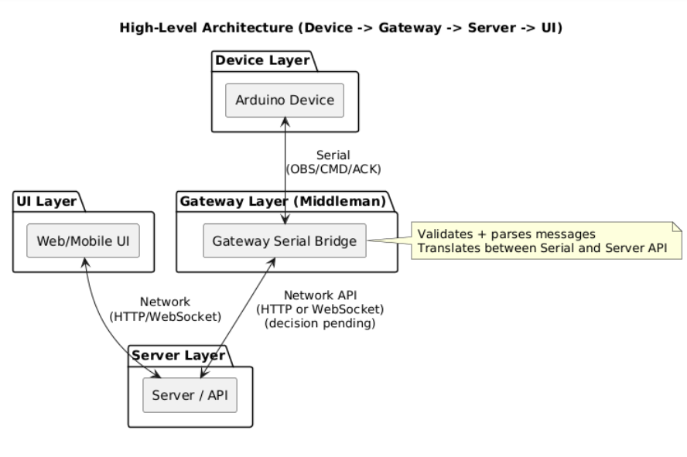
Figure 1. Architecture/Component Diagram (D1)

This design ensures separation of concerns and supports interoperability through the middleman architecture.

D2 Arduino Device Component Design
Description:
The Arduino device is structured into logical components to maintain modularity and separation of responsibilities.

The following conceptual components are defined:
- DeviceController – Main coordination loop (loop execution, responsible for updates).
- SensorManager – Reads sensors values and normalizes data.
- ActuatorManager – Applies state changes to physical hardware.
- DeviceState / HouseState – Stores the current device state.
- SerialProtocol Module – Encodes outgoing messages and decodes incoming commands.

This modular structure improves maintainability and reduces coupling between sensors, state management and communication.

D3. Serial Communication Protocol
Description:
Structured Serial communication is used between the Arduino device and the gateway to ensure reliable data exchange.

Three conceptual message types are defined:
- OBS (Observation) – Sent from device to gateway (sensor values + state).
- CMD (Command) – Sent from gateway to device (state change request).
- ACK (Acknowledgement) – Sent from device to confirm applied command.

Example key-value format:
- obs;gas=312;motion=1;light=0
- cmd;light=1
- ack;light=1
Final message format (JSON or key-value) remains an open design decision.
Structured messaging reduces integration risks and supports validation.

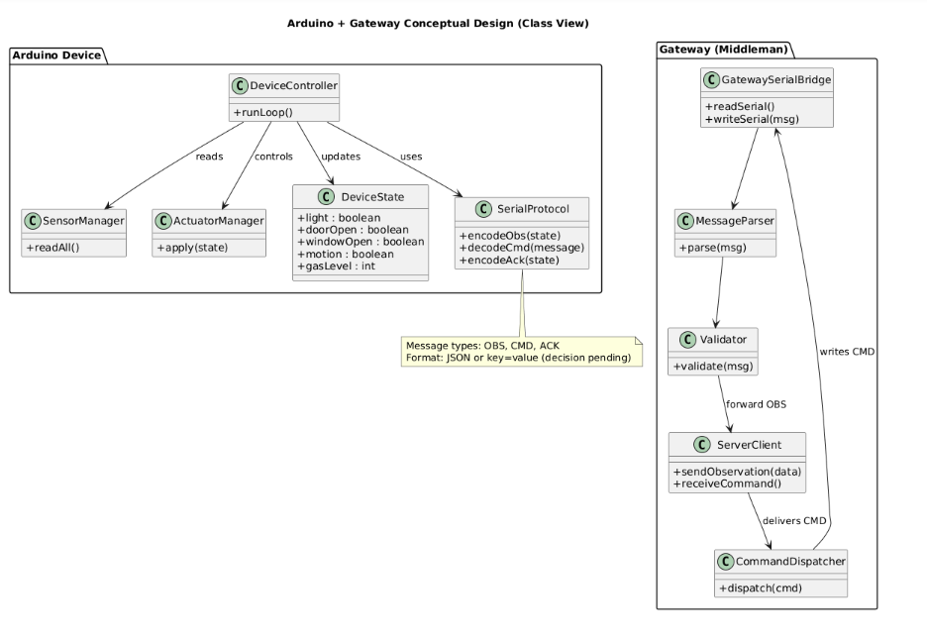
Figure 2. Class diagram (D2+D3)

D4 Interaction Flow – UI Command to Device
Description:
The following interactions sequence describes how a user command goes through the system.

Scenario: User toggles light from UI
- UI sends command to server.
- Server forwards command to gateway.
- Gateway writes CMD message via serial
- Arduino decodes CMD message.
- DeviceController updates DeviceState.
- ActuatorManager applies physical change.
- Arduino sends ACK + updated state back via Serial.

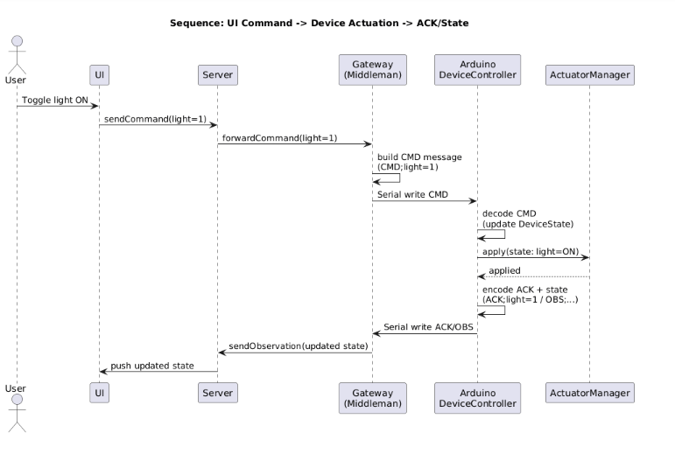
Figure 3. Sequence Diagram (D4)

This flow ensures end-to-end synchronization between UI, server and device.

D5 Fault Handling & Safe Behaviour
Description:
To improve reliability, the device must handle communication failures gracefully.
If Serial communication is interrupted or corrupted:
- The Arduino continues operating in its last known safe state.
- Incoming commands must be validated before actuation.
- Invalid messages is ignored.
- The gateway is responsible for dropping corrupted data and logging errors.

This design reduces the impact of communication instability and addresses identified integration and reliability risks.

