Design Documentation
Interactive House - AI Smart Control System

Revision History

Date | Version | Description | Author
2026-02-24 | 1.0 | Initial AI design including safety and sensors (D1, D2) | Anitta Antony
2026-02-24 | 1.0 | Initial AI design including safety and sensors (D3, D4) | Md Abu Taher
2026-02-28 | 1.0 | Smart Home code | Daniel Marcarini
2026-02-28 | 1.0 | Speech Recognition Initial Design D5 | Daniel Holderik
2026-03-15 | 1,0 | Floating Speech control and revission | Daniel Holderik
2026 -03-16 | 1.1 | Modify D1-D4 for Web | Anitta Antony  Md Abu Taher
2026-03-16 | 1.1 | Testing | Daniel Marcarini
2026-04-24 | 1.2 | Initial Speech Recognition for web (D5) | Daniel Holderik
2026-05-08 | 1.3 | Added final design updates and emergency button feature | Anitta Antony  Md Abu Taher
2026-05-08 | 1.3 | Updated D6 with implemented Jest automated testing and Istanbul coverage for web authentication and Firebase configuration | Daniel Marcarini

Design item List
Requirement Name | Priority | Progress
D1. AI Architecture Overview & Component Design | Essential | Done
D2. Intent Output Format + Prompting Rules(Firebase AI) | Essential | Done
D3. AI chat UI Design (Mobile+Web) + API Contract | Essential | Done
D4. Error Handling, Reliability & State/Context Handling | Desirable | Done
D5. Speech Recognition Integration and Voice Navigation Design | Essential
D6. Web application testing strategy for device-control integration | Desirable | Partially done
D7. Emergency Button and Emergency Assistance Flow Design | Essential | Done

Contents
D1 - AI Architecture Overview & Component Design 2
D2 - Intent Output Format + Prompting Rules (Firebase AI) 3
D3 - Mobile AI Chat UI Design (AiScreen.tsx) + API Contract 4
D4 - Error Handling and Frontend State Management 5
Description 5
Reliability Rules 5
Error Handling 5
State Management 5
D5 – Speech Recognition Integration and Voice Navigation Design 6
D7 – Emergency Button and Emergency Assistance Flow Design 11
Description 11
Design Overview 12
D1 – Embedded System Architecture & Hardware Integration 14
D2 – Sensor Monitoring and State Machine Design 14
D3 – Actuator Control and Alarm Management System 15
D4 – LCD Display and User Interaction Handling 16
D5 – Non-Blocking Timing and Concurrent Operation Design 16

Design Item Descriptions

D1 - AI Architecture Overview & Component Design
The AI feature is implemented for both web (Next.js) and mobile (React Native) using a shared Firebase configuration.
User messages are sent from the chat interface to Firebase AI, which generates responses and returns them to the UI.
The web client sends messages using direct AI requests, while the mobile client maintains a chat session for continuous conversation.
The UI displays the response and keeps chat history visible.
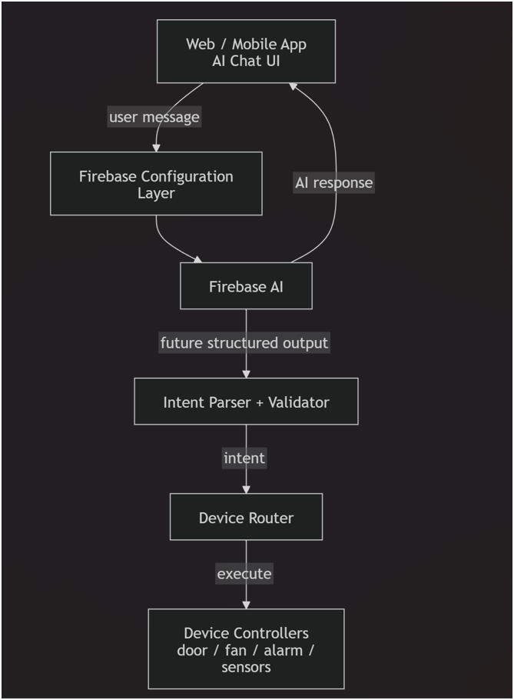
Figure 1:AI Architecture using Firebase AI for Web and Mobile Applications

D2 - Intent Output Format + Prompting Rules (Firebase AI)
The AI system generates human-readable responses for the chat interface. Responses are used mainly for conversation, but the design also supports structured output for future smart-home commands.
Example intent JSON
{
"action": "open",
"device": "door",
"location": "main",
}
Using Firebase AI allows flexible responses while keeping the system ready for command interpretation.
Figure – Design Class Diagram (AI intent pipeline)

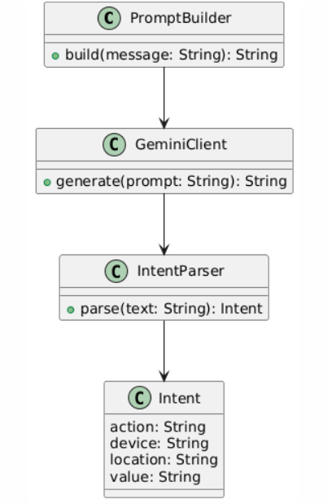
D3 - Mobile AI Chat UI Design (AiScreen.tsx) + API Contract
The AI what interface is implemented in both the web and mobile applications. The UI keeps message history, allows user input, shows loading state, and displays AI responses.Web version uses generateContent() for each message.Mobile version uses a chat session to keep conversation context.Both versions use the same Firebase configuration.
This provides consistent behaviour across platforms

Figure – Sequence Diagram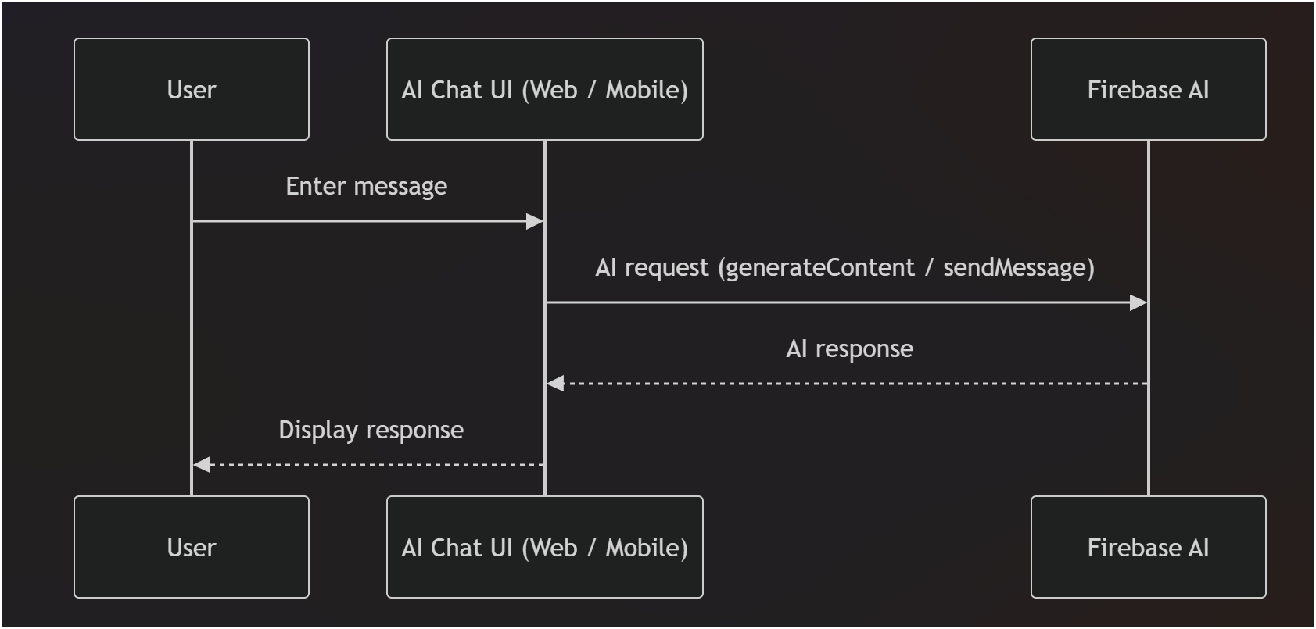

D4 - Error Handling and Frontend State Management

Description
This design item explains how the frontend ensures reliability and safe interaction with the AI backend.

Reliability Rules
- Prevent empty message submission
- Prevent duplicate requests while loading
- Display configuration error if Firebase configuration is missing
- Show fallback message if AI request fails

Error Handling
- Missing backend configuration: Display setup warning
- Network Error: Show network error message
- Invalid JSON response: Handle safely without crashing
- Non-200 response: Display returned error message

State Management
The frontend manages request states using a loading flag:
- Idle
- Sending
- Success
- Failure
This allows the AI system to correctly interpret context-dependent commands such as “Turn it off” by identifying which device is being referenced.

Maintaining device states ensures consistent behavior and improves the intelligence and usability of the AI system.

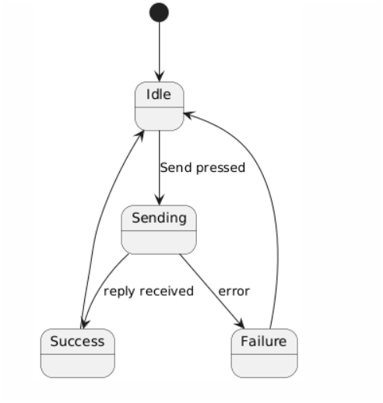
Figure – State Diagram

D5 – Speech Recognition Integration and Voice Navigation Design

- Description
This design item describes the integration of speech recognition into the mobile application using Expo and an external speech recognition library. The feature allows users to control the Interactive House system using spoken commands instead of manual text input.
- Technology and Build Configuration
The speech recognition functionality requires native device capabilities that are not available in the standard Expo Go environment. Therefore, a custom Expo development build was created to support the external speech recognition library and enable microphone access and real-time voice processing.
- Architecture Integration
The speech recognition module is implemented as a dedicated screen (tab) within the mobile application. The module interacts with the existing navigation and AI chat system.

The interaction flow is:
1. The user opens the Speech Recognition tab.
2. The user activates the microphone using the UI control.
3. Spoken input is captured and converted into text using the speech recognition library.
4. The recognized text is displayed and forwarded to the backend AI API. (Future feature)
5. The backend processes the command and returns a response.(Future feature)
The application navigates to the relevant screen or updates the system state based on the interpreted command.
- Navigation Integration
Speech recognition can trigger navigation between different screens in the application. This allows users to move between system features using voice commands, improving accessibility and interaction efficiency.
- Global floating voice control interface
The speech system was fully redesigned and the dedicated speech screen was removed and replaced with a persistent floating voice control component.
The floating voice control icon stays attached across all screens and follows the user interface during navigation and scrolling. This makes sure that voice interaction is always available without requiring the user to manually open a specific feature tab.

- Implementation
The floating component is implemented at the application root level so that it remains active regardless of the currently displayed screen. The icon maintains a fixed overlay position above the main interface while allowing the user to continue interacting with the rest of the application.

- Interaction Flow
1. The user activates the floating microphone icon.
2. The application captures spoken input using the speech recognition module.
3. The speech input is converted into text commands.
4. The system interprets the command and triggers the corresponding UI interaction.

- UI Control Integration
The speech recognition system is connected to existing interface controls including:
• Door control buttons
• Window control buttons
• Ventilation and device toggles
• Sliders and adjustable controls
Voice commands trigger the same underlying functions used by the UI controls. This ensures consistent behavior between manual interaction and speech-based interaction.

D6 – Web application testing strategy for device-control integration
This design item describes how the web application will be verified during the current sprint. The testing focus is the interaction path between the web user interface, Firebase Authentication, Firestore, and the device state representation used by the project.
The verification strategy includes:
- manual testing of login and signup validation
- manual testing of navigation and guest access
- verification of Firestore-backed device toggles
- verification of real-time synchronization through snapshot updates
- defect logging and retesting after fixes
This strategy supports reliable integration between subgroup components and reduces the risk of hidden faults in the device-control workflow.
Web Speech API Integration and Global State Management
The speech recognition system was updated to use the browser based Web API. This allows speech processing to be handled directly within the web environment without requiring a custom development build.
- Technology Change

The Web Speech API provides real time speech to text functionality within supported browsers. This removes the dependency on native modules and simplifies deployment for web based environments.
- Global State Integration
Speech recognition is integrated with the application’s global state management system. This enables voice commands to be processed and executed consistently across all screens without requiring local component level handling.
The global state acts as a central controller for voice input, allowing commands to trigger UI actions regardless of the current screen or component.
- Interaction Flow (Updated)
1. The user activates the floating voice control icon.
2. The Web Speech API captures and processes spoken input.
3. The recognized text is stored in global state.
4. The application interprets the command and triggers the corresponding UI action.
5. UI components react to state changes and execute actions such as button presses or slider updates.

Advantages

• No dependency on native speech libraries
• Simplified deployment for web platforms
• Centralized voice control through global state
• Improved consistency across multi-screen interaction

Implemented Automated Testing Setup

The web application now includes an automated testing setup using Jest and React Testing Library. The test environment is configured for the Next.js frontend and uses jsdom to simulate browser behavior during test execution.

The automated tests are designed to verify frontend behavior without using the real Firebase backend. Firebase Authentication and Firestore functions are mocked during testing, which makes the tests repeatable, safe, and independent from external database state.

The current automated implementation covers the authentication part of the web application and the Firebase configuration layer. The login page tests verify rendering, empty input validation, successful login behavior, redirection to the hub page, and friendly handling of Firebase login errors. The signup page tests verify rendering, form validation, successful account creation flow, profile update, Firestore user document creation, and handling of already registered email errors.

The Firebase configuration tests verify that the application exports the Auth and Firestore instances correctly. This gives basic confidence that the shared Firebase configuration used by the web application is available to the frontend modules.

Coverage reporting is generated through Istanbul using Jest coverage. The report is available as an HTML page and shows which files and branches are covered by the current automated tests.

Current automated testing status:
- 4 test suites passing
- 14 tests passing
- Login screen tested
- Signup screen tested
- Firebase Auth configuration tested
- Firebase Firestore configuration tested
- Istanbul coverage report generated

The next design/testing step is to extend automated coverage to the hub page, device toggles, Firestore snapshot synchronization, emergency page, music page, and AI page.

D7 – Emergency Button and Emergency Assistance Flow Design

Description
This design item describes the emergency assistance feature in the Interactive House application. The purpose of the feature is to provide users with quick access to an emergency action from the user interface. This is especially important for elderly or vulnerable users who may need immediate assistance during an unsafe situation.

Design Overview
The emergency button is designed as a visible and easily accessible interface element. When the user activates the emergency button, the application opens an emergency assistance flow. Since the project does not integrate with real emergency services, the feature is implemented as a simulated emergency call or alert flow for demonstration purposes.
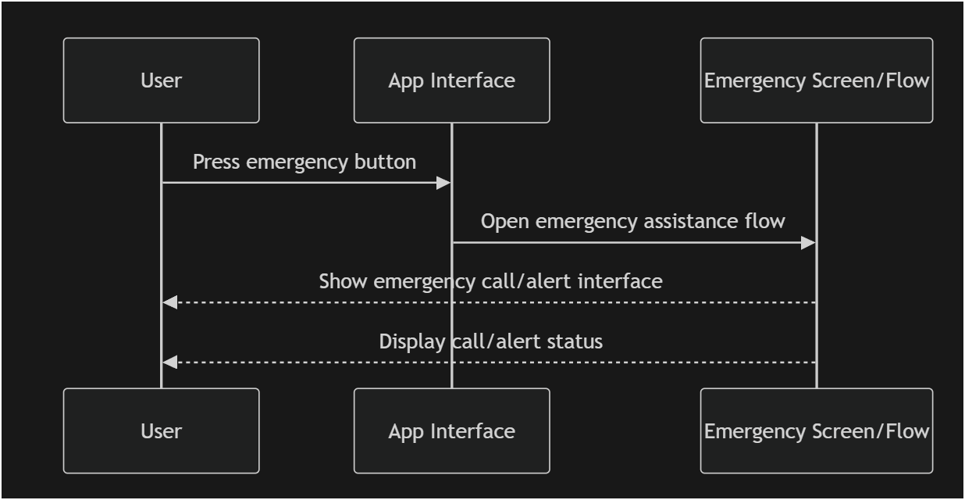
This diagram shows that:
- The user presses the emergency button
- The application interface opens the emergency flow
- The emergency screen appears
- The user sees a simulated emergency call or alert status

Daniel Marcarini - Smart Home code

Requirement Name | Priority
D1. Embedded system architecture and hardware integration | Essential
D2. Sensor monitoring and state machine design | Essential
D3. Actuator control and alarm management system | Essential
D4. LCD display and user interaction handling | Essential
D5. Non-blocking timing and concurrent operation design | Essential

D1 – Embedded System Architecture & Hardware Integration
This design item defines the overall architecture of the embedded Smart Home system and the integration of hardware components.
The system is built around the Arduino Uno microcontroller, which serves as the central processing unit. All sensors, actuators, and interface components are connected directly to the microcontroller.
The architecture separates system functionality into three logical layers:
● Input Layer (gas sensor, temperature sensor, LDR, push buttons, Bluetooth)
● Processing Layer (state management and decision logic)
● Output Layer (servo motors, buzzer, LEDs, LCD display)
This layered design improves clarity and modularity while maintaining simplicity suitable for embedded systems.

D2 – Sensor Monitoring and State Machine Design
This design item specifies how environmental data is processed and how system states are managed.
The system continuously monitors:
● Gas levels
● Temperature
● Ambient light
Gas detection is implemented using a threshold-based comparison combined with a staged state machine. The state machine ensures that safety actions are executed in a controlled sequence rather than simultaneously.
Internal state variables maintain:
● Window open/closed state
● Door open/closed state
● Alarm activation status
● Gas detection transition state
This prevents repeated triggering and ensures stable system behavior.

D3 – Actuator Control and Alarm Management System
This design item describes how mechanical and alarm components are controlled.
The system controls:
● Window servo motor
● Door servo motor
● Buzzer (multiple modes)
● LED indicators
Buzzer behavior is centralized using defined operational modes (e.g., off, solid alarm, siren mode). This prevents conflicting sound activation from different subsystems.
During emergency events:
● The buzzer is activated
● The window may open automatically
● Visual indicators reflect hazard status
Safety-related actions override normal user interaction.

D4 – LCD Display and User Interaction Handling
This design item defines how the system provides feedback and processes user input.
The LCD module displays:
● Environmental readings
● Alarm notifications
● Device status information
Display updates are controlled to prevent flickering and unnecessary refresh operations.
User interaction is implemented using:
● Push buttons with edge-detection logic
● Bluetooth communication for remote commands
Button presses are detected through state comparison to ensure reliable toggling behavior.

D5 – Non-Blocking Timing and Concurrent Operation Design
This design item explains how the system maintains real-time responsiveness.
The system uses non-blocking timing mechanisms based on internal timers instead of delay-based blocking. This allows:
● Continuous sensor monitoring
● Immediate emergency response
● Simultaneous user interaction handling
● Stable LCD updates
This design ensures that no subsystem prevents another from executing, maintaining reliable concurrent behavior within the embedded environment.

