Test Plan Documentation

[GitHub]: https://github.com/DanielJ0131/interactive-house/tree/main/SG3_Devices/SG3_Artifacts
Subgroup 3: Devices

Revision History 1
Test Plan 2
Task Delegation 2
Figures 3

Revision History

Date | Version | Description | Author
08/May/26 | 1.0 | Updated file to contain Table of content and figures. | Mustafa Al-Bayati, Sergej Macut, Tony Nguyen, Ryad Hazin
08/May/26 | 1.1 | Initial draft of the test plan, defining unit testing and documentation scope for the ARDUINO_REFACTOR project. | Mustafa Al-Bayati, Sergej Macut, Tony Nguyen, Ryad Hazin
08/May/26 | 1.2 | Added PlatformIO native unit testing setup and Unity framework configuration. | Sergej Macut  Ryad Hazin  Tony Nguyen
08/May/26 | 1.3 | Added device unit tests for BuzzerDevice, Fan, DoorDevice, and WindowDevice. | Mustafa Al-Bayati

Test Plan

Task Delegation

Here is a balanced breakdown of the unit testing and documentation workload, divided by the folders and files shown in your src directory:

- Ryad will be responsible for the core logic, configuration, and system safety. This includes writing unit tests and documentation for the core/ folder (CommandHandler.cpp, CommandHandler.h, Observer.h, Subject.h), the config/ folder (config.cpp, config.h), and the safety/ folder (GasSafety.cpp, GasSafety.h) Figure[3].

- Mustafa will handle the hardware device representations. Due to the size of the folder, Mustafa will focus entirely on the devices/ folder, covering tests and documentation for BuzzerDevice, Devices (base/manager), DoorDevice, Fan, and WindowDevice Figure[4] and [5].

- Sergej will take charge of the system inputs and safety mechanisms. This involves unit testing and documenting the sensors/ folder (sensors.cpp, sensors.h, SteamSensor.cpp, SteamSensor.h), the music/ folder (MusicEngine.cpp, MusicEngine.h), and the entry point file (main.cpp) Figure[2].

- Tony will manage the outputs, media, and the main execution loop. Tony will write tests and documentation for the display/ folder (LCDManager.cpp, LCDManager.h), and the gateway.js file.

Figures

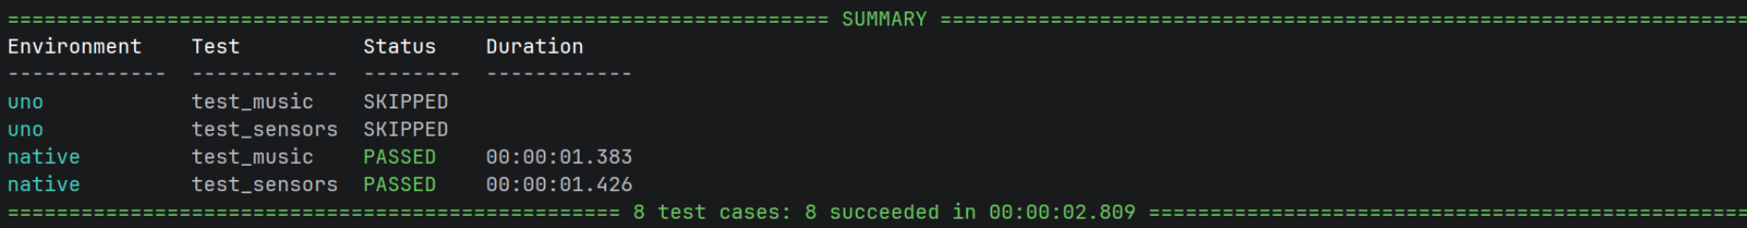
Figure 2: Music and Sensors tests

Figure 3; Config, Core and Safety tests

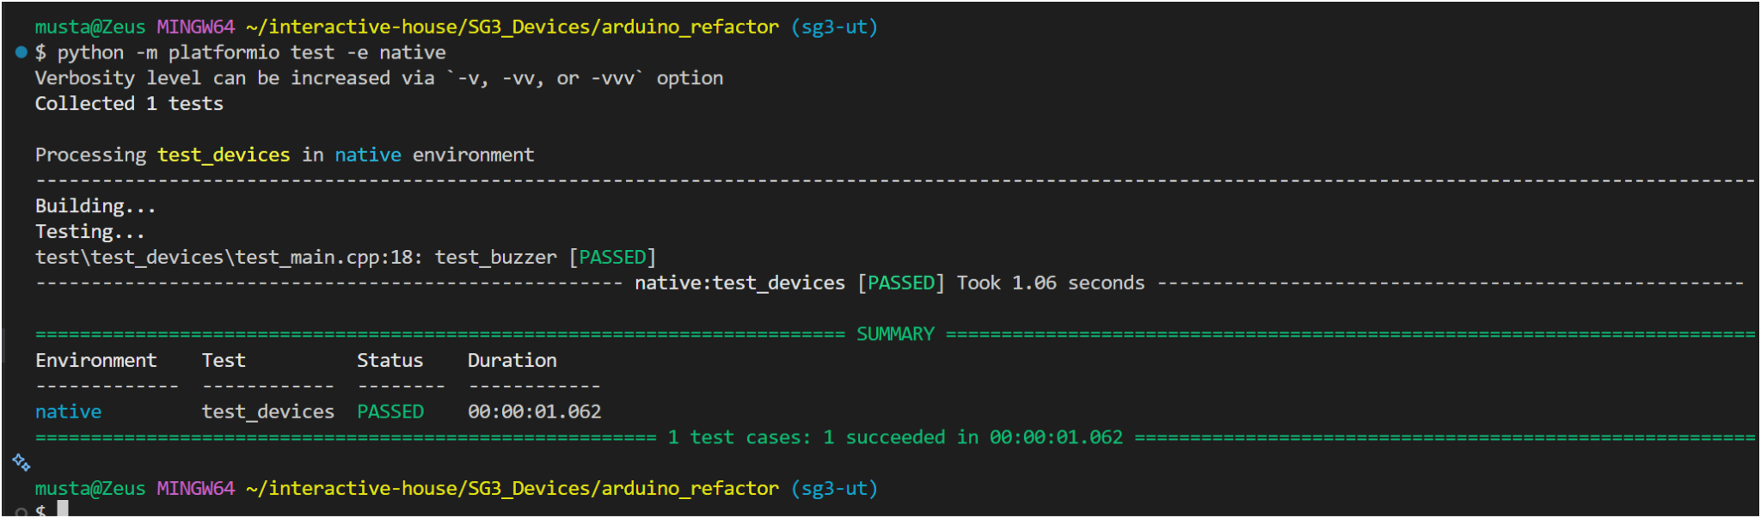
Figure 4; Devices testing

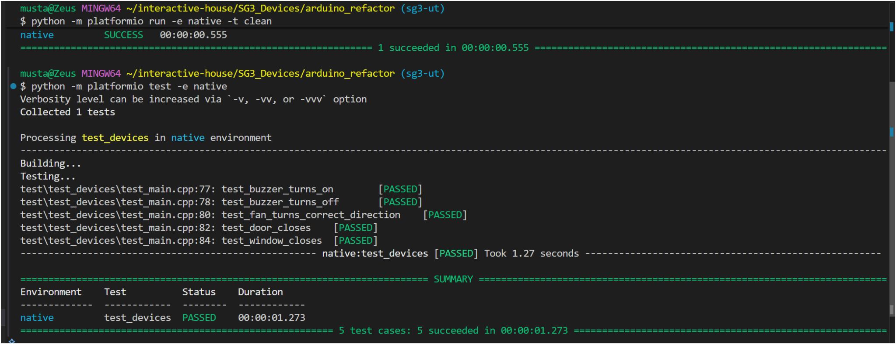
Figure 5; Buzzer, Door, Fan and Window
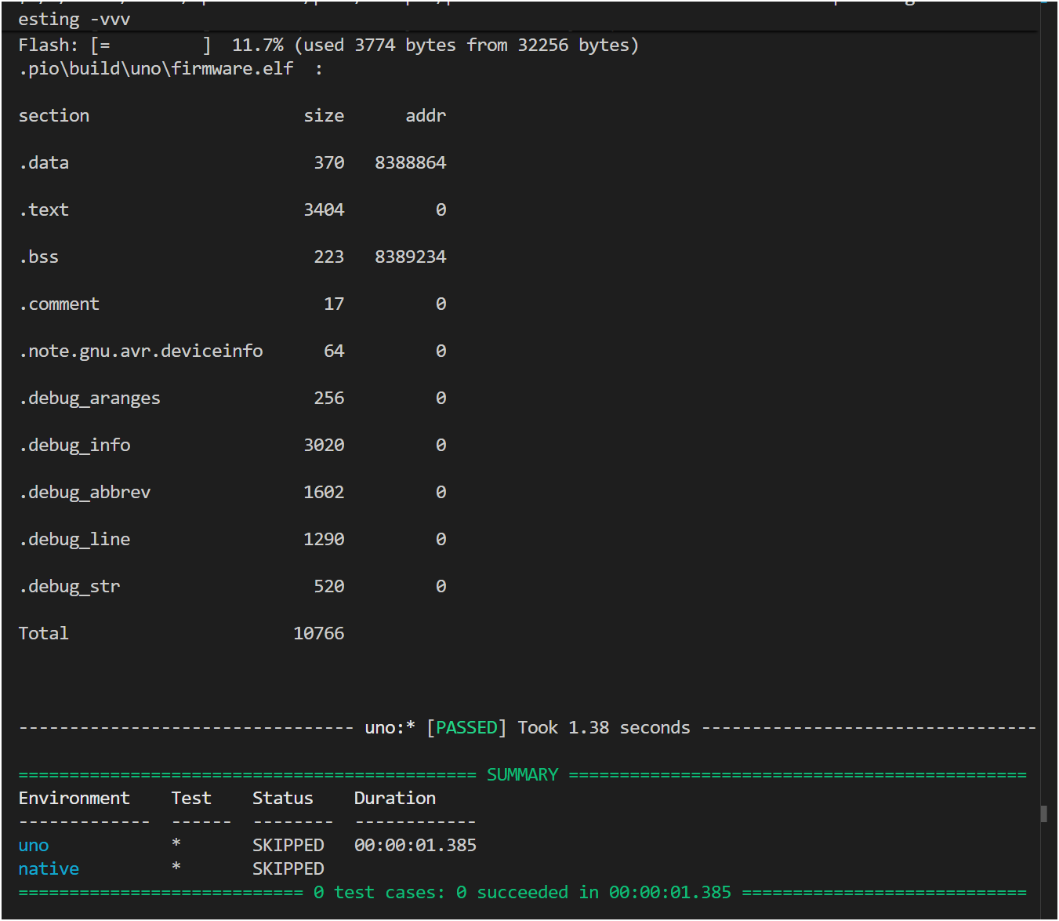

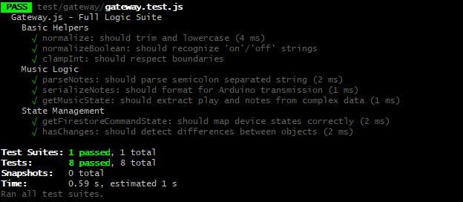
Figure 7. Gateway test

