Design Documentation

Smart House

Revision History

Date | Version | Description | Author
01/03/2026 | 1.0 | Initial design item descriptions focusing on requirements document | Katerina Arvay, Dario Ostojic, Andre Sandblom

Design item List
Requirement Name | Priority
D1. Use case diagram | Essential
D2. Entity and class diagram | Essential
D3. Interaction sequence diagram | Essential
D4. State diagram | Essential

Design Item Descriptions

D1. Use case diagram

The user can perform several key actions: registering a new account, logging in to authenticate themselves and logging out to terminate their session.

Once authenticated, the user can control various devices in the house. These include opening or closing the door and window, turning lights on or off, activating or deactivating the fan, and controlling the buzzer. Each of these actions corresponds to a specific use case from the system.

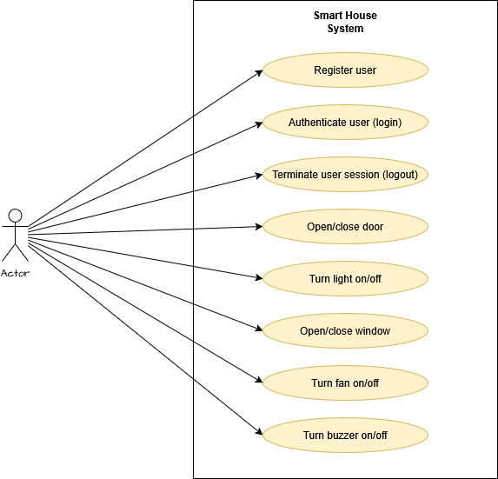

D2. Entity and class diagram

The User entity includes two attributes: Username, which uniquely identifies the user, and HashedPassword, which stores the user’s encrypted password for secure authentication.

The Device entity represents smart home devices and contains four attributes: Name to identify the device, State to indicate its status (such as on/off or open/closed), Value to hold any additional relevant data and Pin which corresponds to the hardware control pin.

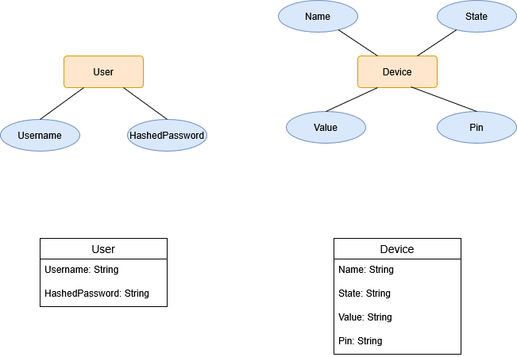

D3. Interaction sequence diagram

The sequence diagram shows how the user interacts with the Smart House system through a Web or Mobile application. When a new user registers, the application sends the username and password to the backend API. The server checks whether the user already exists, hashes the password and stores the user information in the users collection in Firestore. No devices are created during registration because all devices are stored in a separate, shared collection named devices.

When a user logs in, the application sends the credentials to the backend. The server verifies the password and, if it is correct, generates a JWT token. This token is required for all protected operations.

For actions such as turning a light on or off, opening or closing the door or window, activating the fan or buzzer, updating the password, or retrieving device status, the request must include the JWT token. The backend first validates the token and then performs the requested operation. Device states are updated or retrieved from the shared devices collection, while authentication data remains in the users collection.

Logout is handled on the client side by deleting the stored JWT token. After logout, the user must log in again to perform authenticated actions.

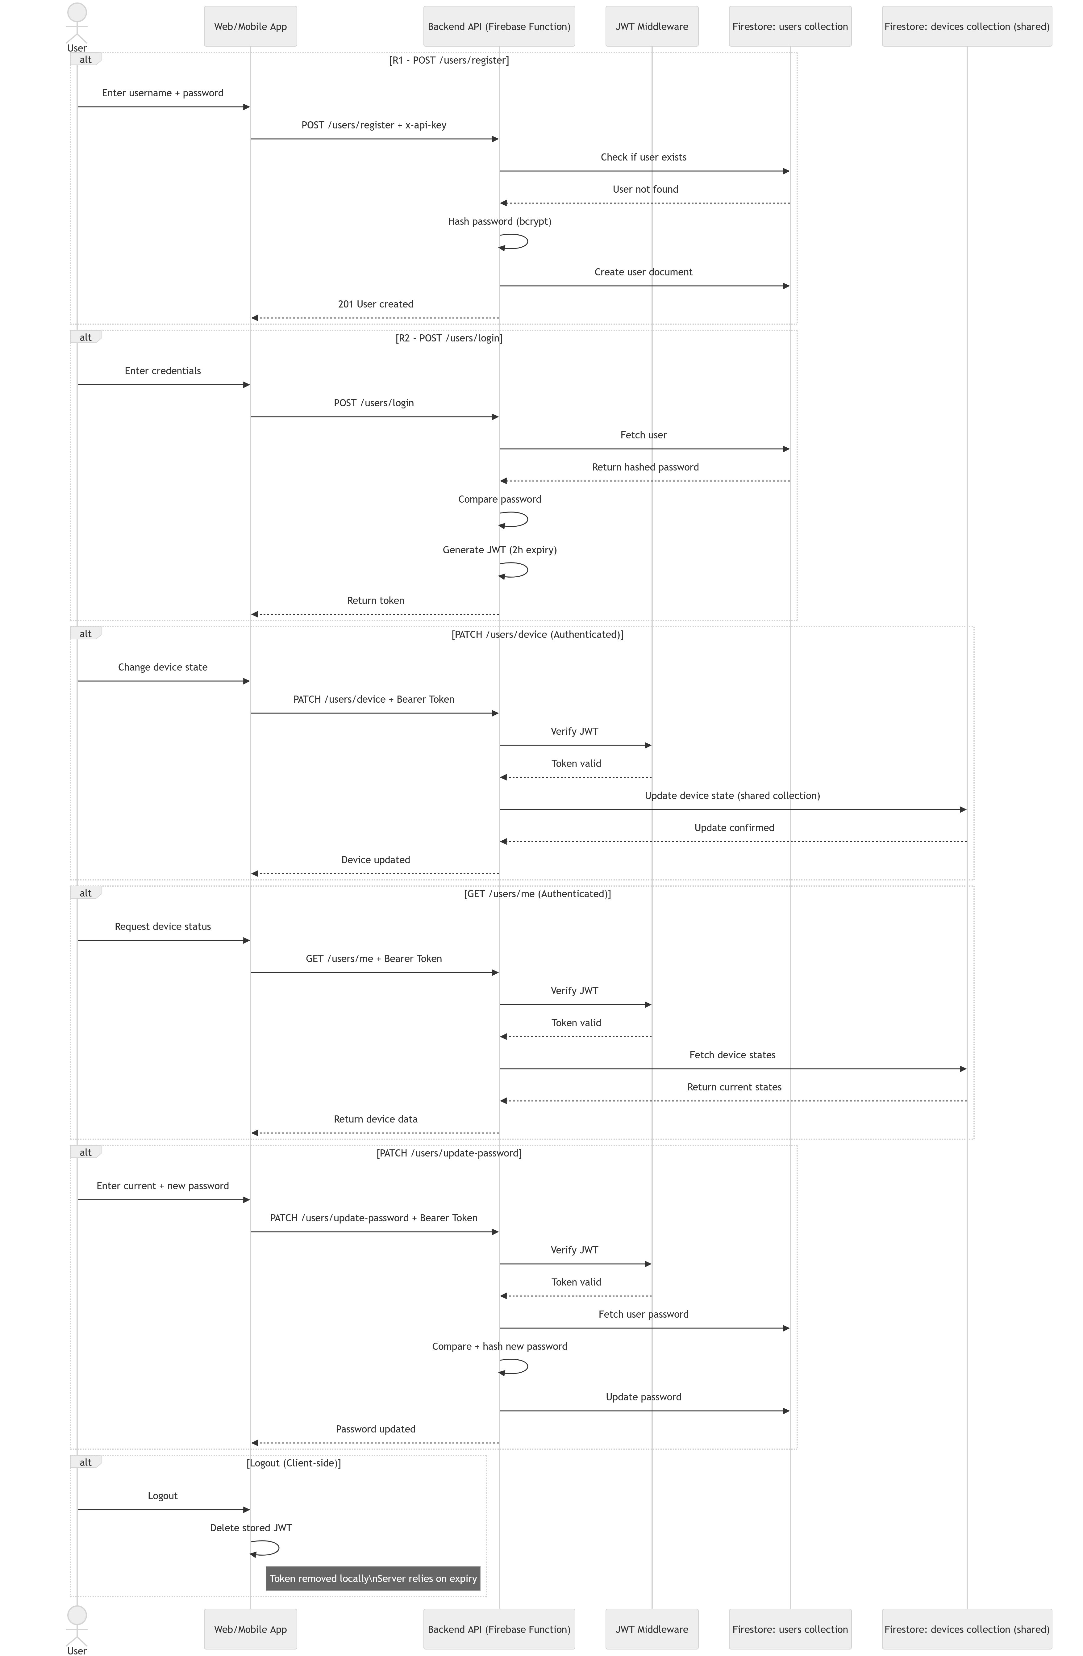

D4. State diagram

Devices such as lights, fans and the buzzer follow the same On/Off behavior, while the door and window follow an Open/Closed behavior.

