C1. Data Analysis

a) Plots for 2013

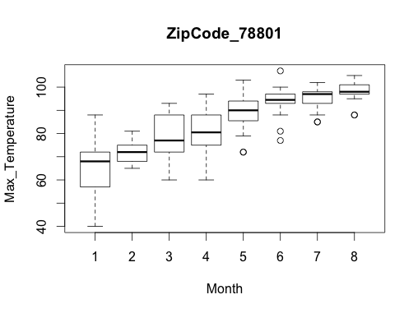
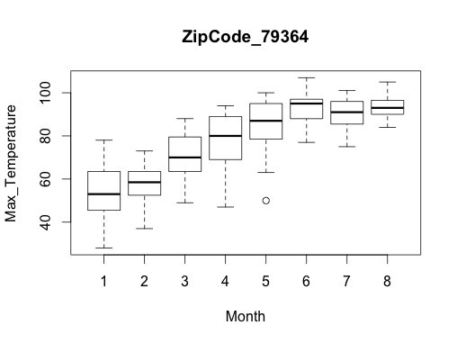
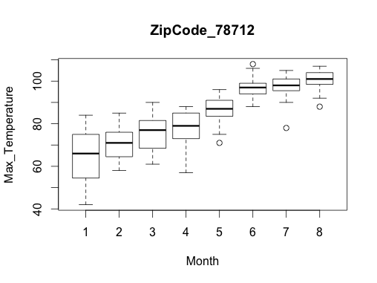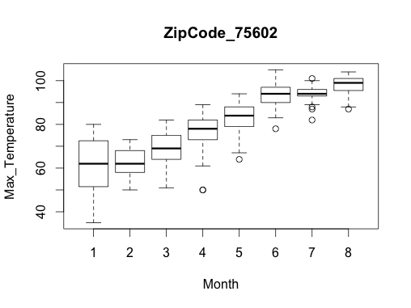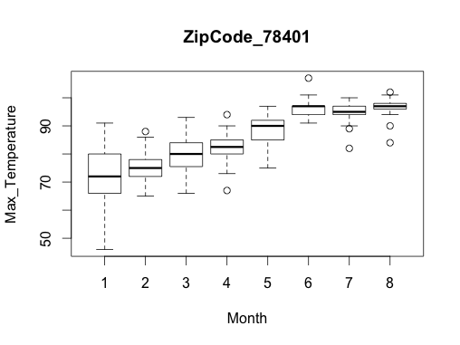

i.) -- Data is linear, makes sense. Cooler months from January progressing through till August. The variation in temperatures decreases over time which is interesting (although there are more outliers as a consequence). 78401 has more outliers, less variation though.
In July 2013, NE Texas(78401) got a cold front which is seen in via the increased number of outliers.
The outliers are mostly colder temperatures and outside of the box plot, we considered these as outside the normal range. For example, during the summer there are mainly temperatures of 90-100 degrees Farenheit and temperature of 70 is considered an outlier. The outliers are more than 1.5 times outside of the IQR.
ii.) --Data doesn’t seem too crazy. Some of the data in the containers aren’t consistent. Uses strings or floats to represent something.
iii.) -- In May 79364 there was a cooler than normal event but there are no extreme outliers in this dataset.

Max Temp v Month for 2011:
b)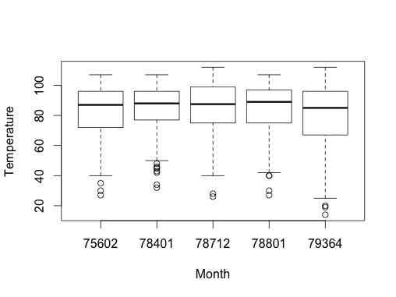
i. Describe your analysis from observations.
--Mean temperatures seem to be about the same even though the spread is varied across regions.
Outliers in the central texas area in 2011, less variation meaning more outliers. Mostly 75-100 degree weather throughout the year. NE got cold for a short period in Feb 2011.
Overall, The state had little variation in Max Temperatures.

ii. Did you find any “unusual” data? What did you do to “deal with it”, if any?
Nope. Everything is happiness and sunshine.
iii. Did you find any outliers? If you did, why did you consider them as outlier?
--75602 has a bunch of “outliers” but not extreme and still within the range of the plot that other regions have. No extreme outliers.

c.

MaxTemperature V. Month Time series
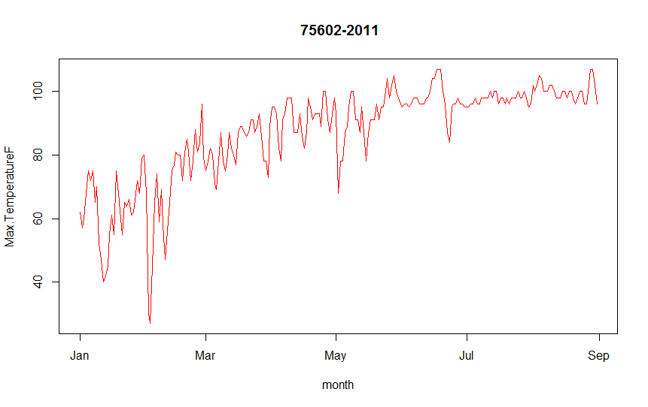
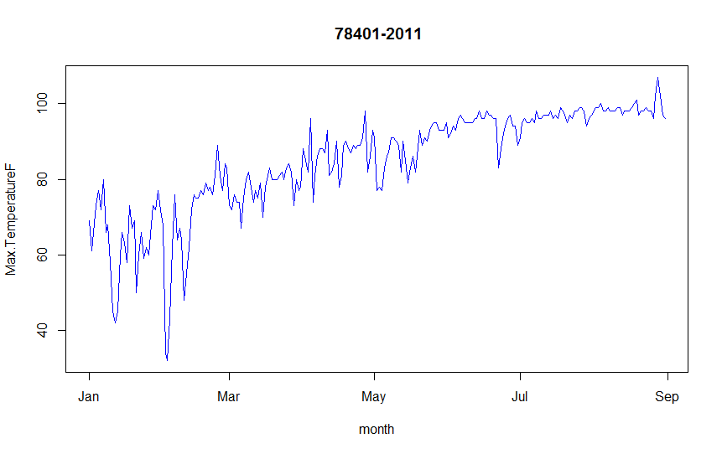

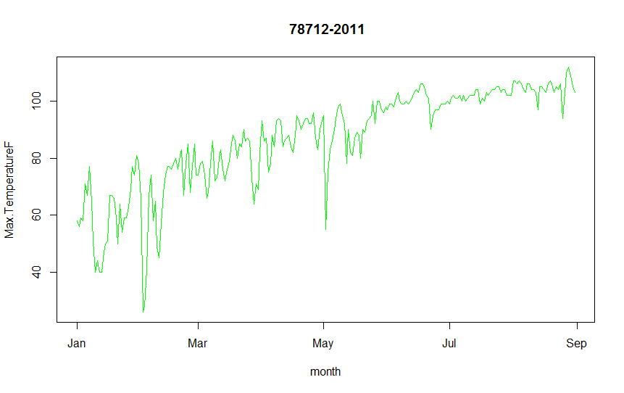

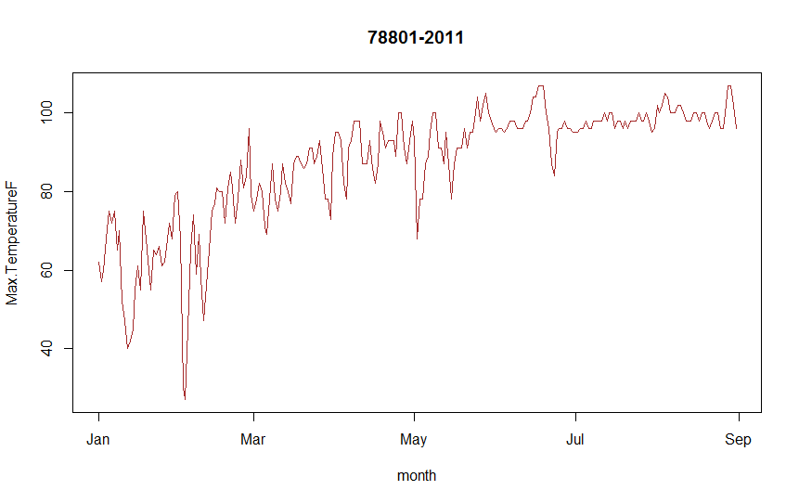
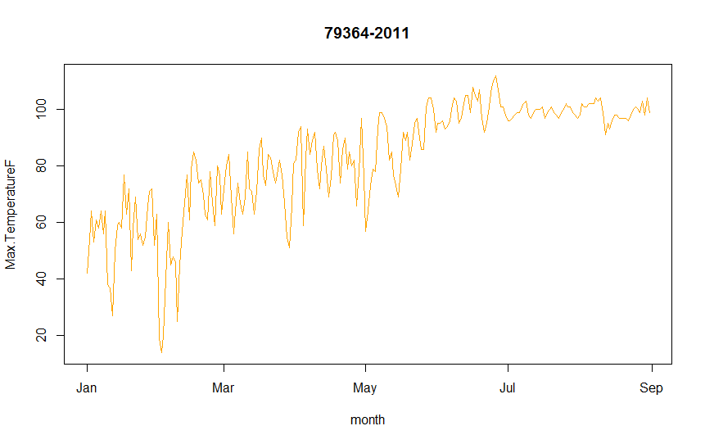
i. Describe your analysis from observations.
-- February had cold days across Texas against the positive linear trend of the graph.
Plot is a good representation of a time series. Data seems similar across regions.
ii. Did you find any “unusual” data? What did you do to “deal with it”, if any?
--No.

d.

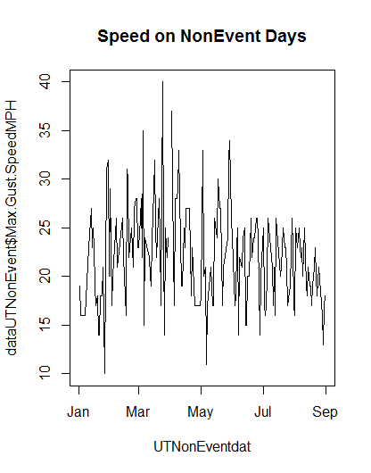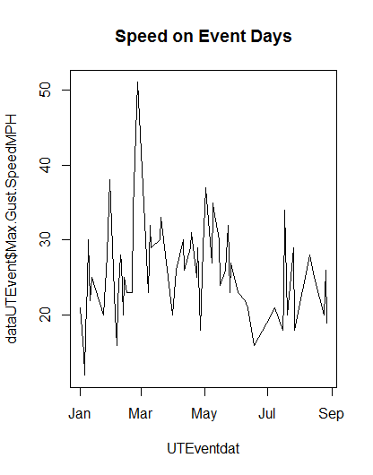

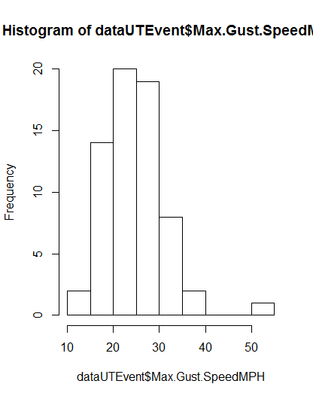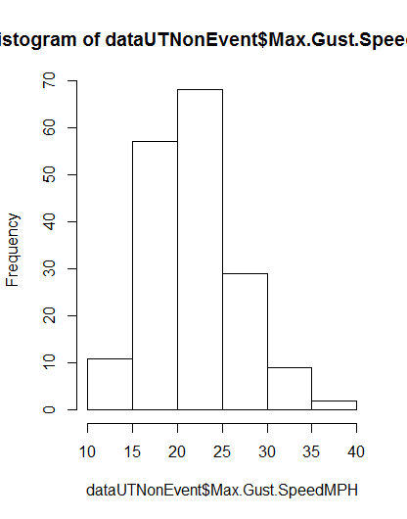

Gust speed -> Event Days
There were 66 Event days in 2013 in the 78712 zip code vs 177 NonEvent days.
Using both the Histograms and and line plots, you can see that the Event days had a higher proportion of Gust Wind Speeds in excess of 30MPH. The max overall reaches 50MPH for Event days was only 40 on NonEvent days. Although both types of days had a big proportion of max gust winds in the 15-25 mph range, the event days saw a higher percentage of speeds above that range.

e. Temp Density for 78712

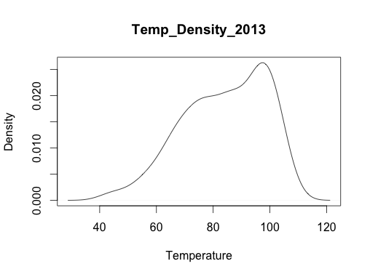
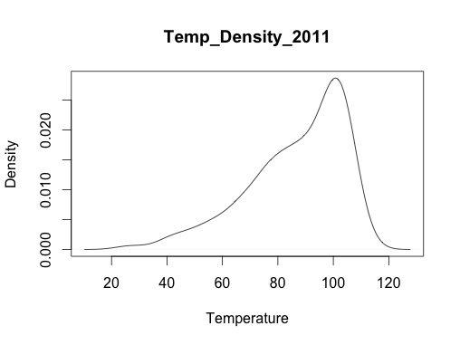

i. Describe your analysis from observations.
--2013 looks more normal.
ii. Did you find any “unusual” data? What did you do to “deal with it”, if any?
--Nope.
iii. Is there any skew?
--2011 is more skewed. Hotter summer than 2013.

f.
2013 max hum v max gust for UT zipcode. Events are red, else black.
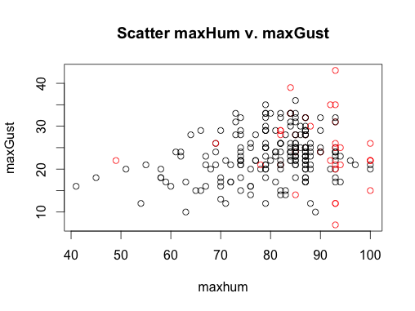
i. Describe your analysis from observations.
--Higher humidity and gust speed are weakly correlated with there being an event.
ii. Did you find any outliers? If you did,
1. Why did you consider them as outlier?
2. Did you use any other plotting mechanism to verify?
--Hard to tell from the data if the spread is an accurate representation of the truth. Scatter looks more or less random, small positive correlation.

g.

2013 scatterplot Maxhum versus min sea level pressure in for UT zipcode. Events are red, else black.
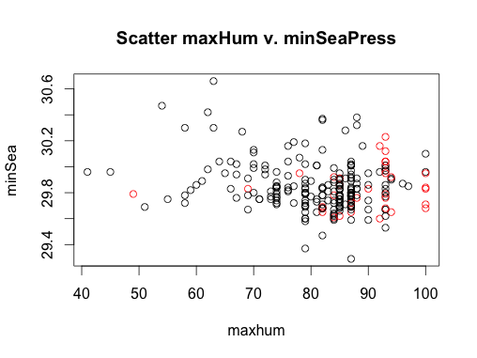

i. Describe your analysis from observations.
--low pressure and high humidity seem to correlate with an event.

ii. Did you find any outliers? If you did,
1. Why did you consider them as outlier?
2. Did you use any other plotting mechanism to verify?
--There are a few fringe cases, I don’t see a reason to omit them.

