- List all threads implemented in your system and briefly describe their responsibilities.

- There are 7 threads:
Engine: For simulating the engine, updating RPM and Temperature
Motion: For simulating speed
Fuel: For simulating fuel
Ecu: For simulating the ECU, noticing the change in RPM, Fuel, and Temp
Hybrid: For simulating the Hybrid system with the battery
event_logger: For logging all the events: mode change, low battery, low fuel, …
dashboard: For updating the dashboard
- Describe how your system state is organized. Did you use a single struct? Multiple structs? Global variables? Nested structures? Explain your reasoning.
- We use one big global struct for global state of all the measurements: like fuel, rpm, speed, ..
- We also use a smaller struct for events that contain message and time
3. Explain how you ensured that:
(a) Simulation logic is not mixed with dashboard printing.
The dashboard printing just prints whatever is in the current global states, and the all the simulation logic threads are all updating the global states
(b) The ECU does not simulate physical quantities.
Because the ECU threads does not update any of the states, except for the zone variables. It just read the value of the states
(c) The dashboard does not enforce system rules.
The dashboard thread just reads and prints. It does not change the global states
4. Describe how information flows in your system.
(a) How does RPM move from Engine − > ECU − > Dashboard?
All 3 threads use a shared RPM global state. Only the Engine thread updates the shared RPM global states. The ECU change the zone variables (RPM_zone, Temp_zone). The Dashboard thread only read and print out the current states.
(b) How does fuel consumption affect what is displayed?
It would change the Mode and Low fuel. The Event Logger thread would picks up on that and update the event array. The Dashboard would print out the 4 latest events
5. Attach a screenshot of your dashboard output. Why did you choose this layout? Did you prioritize, realism, minimalism, compactness, or visual appeal?
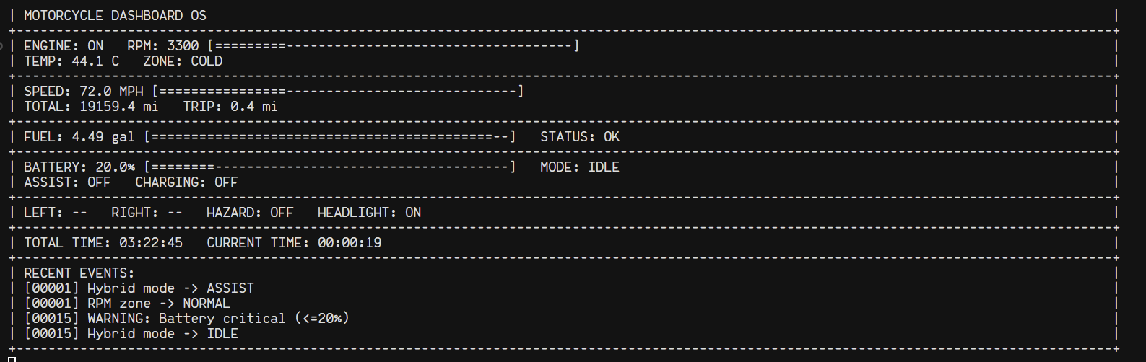
We prioritized the readability, and minimalism
6. Explain how you represented the following: RPM, Fuel level, Speed, Engine state. Why did you choose numeric values, bars, symbols, or a hybrid approach?
RPM: number and bar because it is easier to read and visualize at a glance
Fuel: number and bar because it is easier to read and visualize at a glance
Speed: number and bar because it is easier to read and visualize at a glance
Engine state: words because that would make it more clear
7. Describe at least two relationships between subsystems, note that the relationship logic will be implemented in future phases.
All the simulation logic will update the global states. The Dashboard subsystems will print out the current global state/
8. What responsibilities does your ECU handle in Phase 1?
ECU read the current state variable (RPM, Engine Temp), and then update the Zone
Accordingly

9. Even though synchronization is not implemented in Phase 1: Identify at least two shared variables that could cause race conditions in your program. Explain why concurrent access might be problematic.
There are subsystems that try to update that variables, while there are other subsystems that try to read the variables. This could potentially cause a mismatch between threads that try to read that variables.
10. What is one design weakness in your system that you would improve in the next phase?
Because we have 7 different threads running concurrently, and only one big shared global state struct. Maybe this could cause a big issue when we have more complex logic or have priority order.

