QA Bug Report Sheet
Title: Windows 11 Pro – Travel Policies – Link on the travel policies page give an error message
1. Environment Details
- OS: Windows 11 Pro
- Browser: Google
- Screen Resolution: 1920 x1200 at 150 percent scale
- Website link: https://ece.ufl.edu/
2. Classification
- Severity: [ Critical | High | Medium | Low ]
- Priority: [ High | Medium | Low ]
- Bug Type: [ Functional | Visual | Content | Performance | Crash ]
- Reproducibility: [ Always | Often | Sometimes | Rarely | Once ]
4. Steps to Reproduce
- Go to “https://ece.ufl.edu/”
- Scroll down to footer
- Click on the “Travel Policies” Link
- Scroll down to the “Updated UF Guidance on Travel” section
- Click the “TripSource website”

5. Results
- Expected Result:
Should send user to the trip source website.
- Actual Result:
The link gives an error message saying “No URL found for this tracker ID.”
6. Evidence & Attachments
- Screenshots:
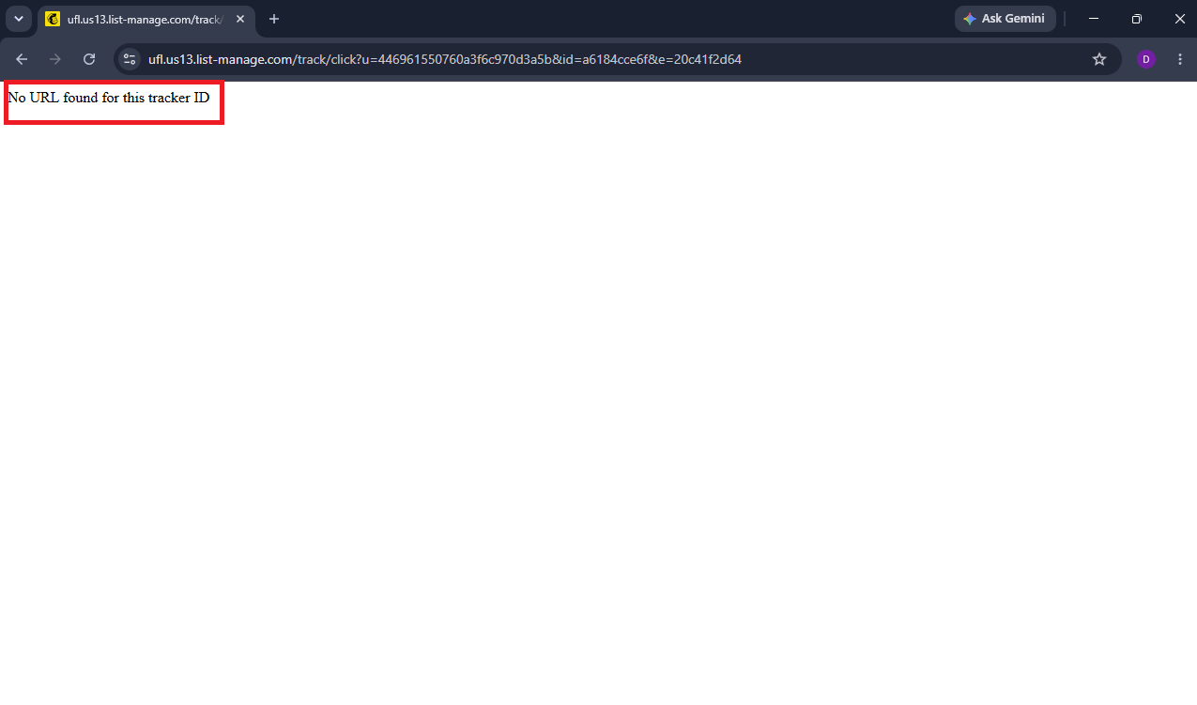
- Screen Recording:
In BugReporting Folder

