QA Bug Report Sheet
Title: Windows 11 Pro – News feed – Menu links are not displayed
1. Environment Details
- OS: Windows 11 Pro
- Browser: Google
- Screen Resolution: 1920 x1200 at 150 percent scale
- Website link: https://ece.ufl.edu/
2. Classification
- Severity: [ Critical | High | Medium | Low ]
- Priority: [ High | Medium | Low ]
- Bug Type: [ Functional | Visual | Content | Performance | Crash ]
- Reproducibility: [ Always | Often | Sometimes | Rarely | Once ]
4. Steps to Reproduce
- Go to “https://ece.ufl.edu/”
- Scroll down to footer
- Click on the “News feed” icon
- Click on the “Menu” button in the top right corner

5. Results
- Expected Result:
The user should see all the menu links available to them so they can navigate to another page.
- Actual Result:
No links are shown when clicking on the menu button.
6. Evidence & Attachments
- Screenshots:
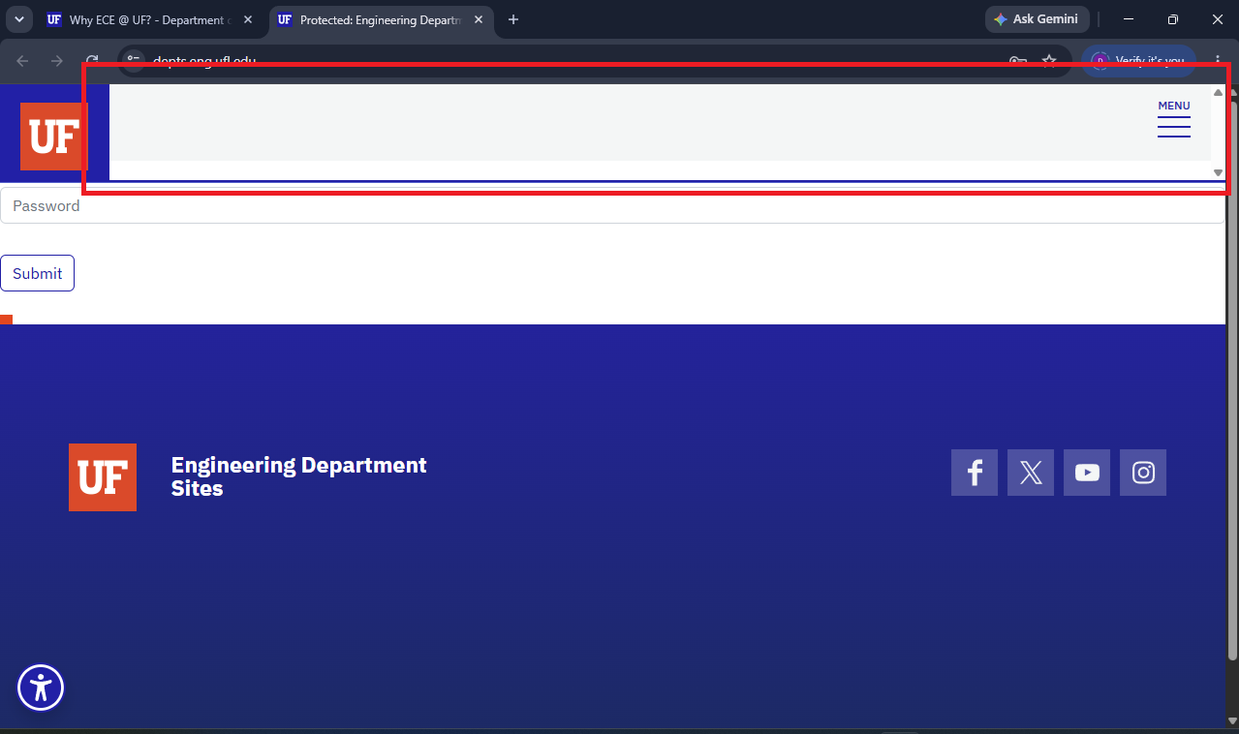
- Screen Recording:
In BugReporting Folder

