QA Bug Report Sheet
Title: Windows 11 Pro – Navbar – Resource and News links don’t navigate to anywhere
1. Environment Details
- OS: Windows 11 Pro
- Browser: Google
- Screen Resolution: 1920 x1200 at 150 percent scale
- Website link: https://ece.ufl.edu/
2. Classification
- Severity: [ Critical | High | Medium | Low ]
- Priority: [ High | Medium | Low ]
- Bug Type: [ Functional | Visual | Content | Performance | Crash ]
- Reproducibility: [ Always | Often | Sometimes | Rarely | Once ]
4. Steps to Reproduce
- Go to “https://ece.ufl.edu/”
- Click “Menu” in top right corner
- Click on the “Resources” Link or the “News, Honors & Awards” Link
5. Results
- Expected Result:
Should send user to a page about Resources or not have a link for it.
- Actual Result:
The link doesn’t send you anywhere and keeps the user on the current page.
6. Evidence & Attachments
- Screenshots: 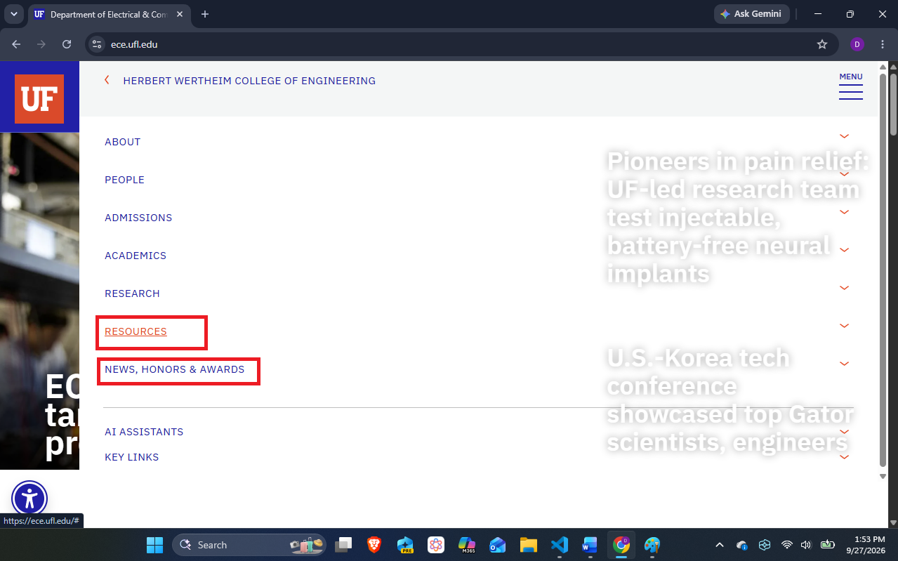
- Screen Recording:
In BugReporting Folder

