Report

Team 20

Contains introduction, requirements and designs

2020

# Introduction

Out task is to create an operation scheduler for health professionals to manage and organize their patient appointments. The software must contain the ability to add, delete, undo and edit appointments. The diary must be saved to and from a file, it must have an option to display all of a health professional’s appointments. A timed search feature – this will record how fast the search is completed. This piece of software might contain a graphical user interface so that it is easier to navigate.

|  |
| --- |
|  |
|  |

# Requirements:

R1: The program shall store data of professionals. This data should include: Name, profession and their work location/office.

R2: The user shall be able to add, delete and or alter the data that has been stored.

R3: Program shall have contain a diary for each health professional – this will store their patient’s appointments (multiple doctors might be booked for the same appointment with the same patient).

R3.1: The data for each appointment shall be stored in the diary. This would include, date, and start time, end time and the treatment (e.g. operation, consolation).

R4: The user shall be able display the list of diary entries for each health professional.

R5: The program shall be able to save the diary entries to a file and then read from that file.

R7.0: The program shall have a search function. This will include searching from a start date to an end date.

R7.1: The program shall show all the available appointments with all the doctors available also.

R7.2: The program shall enable the user to schedule an appointment between the times that were just searched.

R7.3 The program shall allow to invite health professionals to be involved in the appointment.

R7.4: It shall then display the times for the potential slots identified.

R7.5: The user shall be able to select their desired slot (a slot for their appointment)

R7.6: The program shall place this appointment in the diaries of all the doctors involved.

R8: The program shall be able to record the time taken for the search to complete. This time can stored as seconds, milliseconds etc.

R9: The program shall have an “Undo” feature. This will allow for the undoing of the last entry to the diary.

R10: The program shall be made using java.

R10.1: The program shall use data structures developed from the first principles or data structures from the java collection class library.

# Optional requirements:

R11: The program might have a graphical user interface that will allow for easier navigation.

R12: The program might be able to display the data in a different format e.g. calendar view, and agenda view, display only the next few days etc.

R13: The program might allow for recurring appointments e.g. allow repeated treatments (weekly, monthly, yearly etc.), every Friday @9am etc.

R14: The program might have a task list for the health professionals. This apart from the diary will allow them to add, delete, edit or view a list of tasks.

R14.1: Each task should have a description and a priority level (high, medium or low)

R15: Program might include a list of resources available to be booked for a patient appointment. E.g. MRI scanners, operation rooms etc.

**All of the requirements will be attempted.**

# Pseudo Code

**Int recordTime()**

A while loop that loops while found is false.

A thread that will wait a certain amount of items between incrementing a value. This will be in a try catch statement.

e.g. Thread.sleep(1000); searchTimer++; //increments every second

After the try catch, if found is true then return searchTimer. Else if searchTimer is too long then maybe end program and say it was not found.

End while loop.

**Undo()**

Every time an appointment is added to the tree/diary, its ID will be added to a stack. Then whenever the undo feature is selected it will delete the appointment that has their ID on top of the stack.

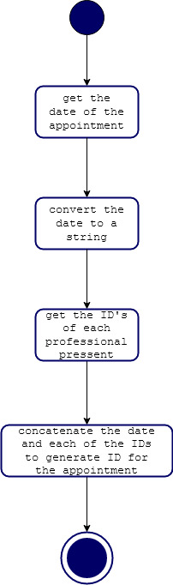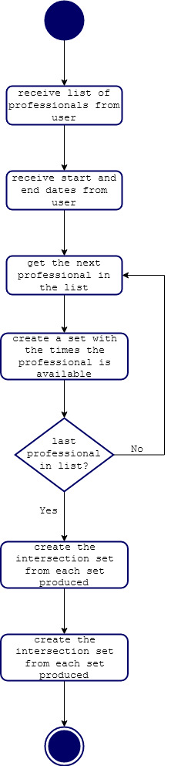

# Class diagram

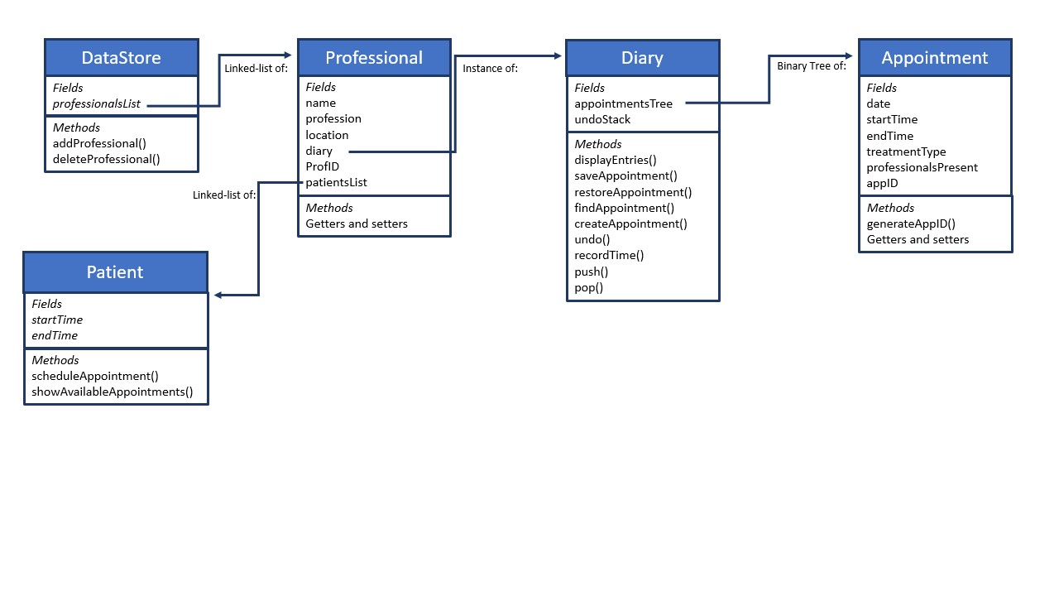

# Interface

## Main Menu

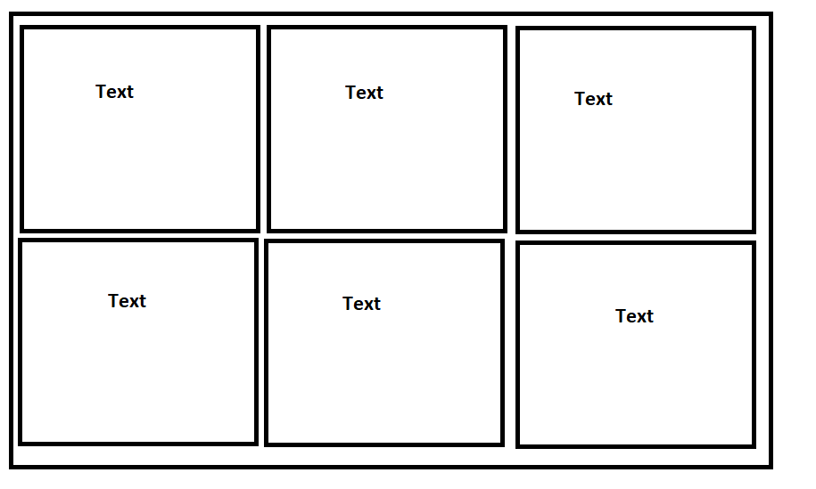

## General calendar

