Instructions

1. Download and install anaconda3 from given link(ignore step 1,3 if you already done )

- link : <https://www.filehorse.com/download-anaconda-64/download/>

- At the stage given in the image below check first three checkboxes

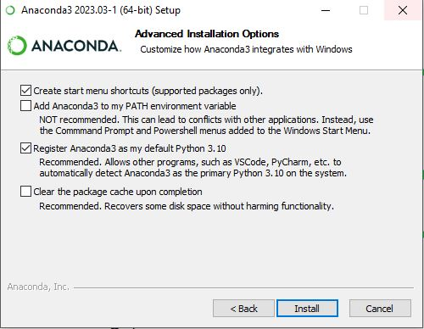

1. Extract “NAVEEN_MS_UK.rar” file in a folder
2. Extract “ stockenv.rar” file to location C->users->user(it may be vary based on your system)->anaconda3->envs
3. Open anaconda prompt
4. In prompt(cd) Navigate to ‘NAVEEN_MS_UK’ folder
5. Run command : activate stockenv
6. Run command : python gui.py