Toward f: A General Factor of Human Flourishing
Measurement, Prediction, and Mechanism
Daniel Ketterer
2026

The Question
“Human good turns out to be activity of soul in accordance with virtue, and if there are more than one virtue, in accordance with the best and most complete.” - Aristotle
Here is a pattern that has puzzled psychologists for decades. When you measure different aspects of how well a person’s life is going - their sense of purpose, the quality of their relationships, their feeling of competence and control, their self-regard - these measures almost always correlate positively. People who score high on one dimension of wellbeing tend to score high on all of them. People who are struggling in one area tend to be struggling across the board.
This is called the positive manifold, and it is one of the most robust findings in wellbeing science. It appears in every major dataset, across cultures, across age groups, across socioeconomic levels. The question is: why?
Intelligence research faced an identical puzzle a century ago. Charles Spearman noticed that cognitive abilities - verbal, spatial, numerical, memory - all correlated positively, and proposed that a single general factor, g, explained the pattern. The g-factor became one of the most productive constructs in all of psychology. It predicted life outcomes better than any individual ability measure. It transformed how we think about human cognitive architecture.
This project asks: does the same structure exist for human flourishing? Is there a general factor - call it f - that captures what all the dimensions of wellbeing share? And if so, can it predict outcomes that matter - not just other wellbeing scores, but employment, income, and economic participation years into the future?
This paper proceeds in four stages. First, we establish f as a psychometrically coherent construct, using both single-instrument and multi-instrumental bifactor models on individual-level data. Second, we test whether f predicts economic outcomes across a nine-year lag, and whether it carries predictive information beyond what standard pathology measures provide. Third, we apply a capabilities-adjusted framework that prevents compensatory averaging from masking domain-specific deprivation. Fourth, we introduce a dynamical systems interpretation - the mutualism model - not as an established mechanism, but as a theoretical framework that generates the specific, testable predictions motivating a planned three-paper dissertation.

Part I: Establishing f - The Measurement Case

The Positive Manifold
The empirical case begins with the most basic observation. The MIDUS 2 study (ICPSR 4652) - one of the flagship longitudinal health studies in the United States - administered Ryff’s Psychological Wellbeing Scale to 4,963 respondents, yielding 4,026 complete cases across all six subscales: Autonomy, Environmental Mastery, Personal Growth, Positive Relations with Others, Purpose in Life, and Self-Acceptance.
The correlation matrix across these six subscales shows universally positive correlations, with a mean inter-subscale correlation of r = 0.397. All 15 pairwise correlations are positive. The strongest pairings - Self-Acceptance with Environmental Mastery (r = 0.58), Self-Acceptance with Positive Relations (r = 0.54), Personal Growth with Positive Relations (r = 0.48) - suggest that self-regard, competence, and social bonds form a particularly tight cluster. Autonomy is the most distinct subscale (weakest pair: Purpose in Life with Autonomy, r = 0.22), consistent with published MIDUS psychometric benchmarks.
This positive manifold is not an artifact of a single instrument. When the analysis extends to 17 indicators from six independently designed instrument families spanning four theoretical traditions - Ryff’s six eudaimonic subscales, Keyes’s five social wellbeing subscales, Watson’s Positive Affect, Diener’s Life Satisfaction, Rosenberg’s Self-Esteem, Pearlin and Lachman’s Sense of Control, Scheier and Carver’s Optimism, and McAdams and de St. Aubin’s Generativity - all 136 unique pairwise correlations remain positive (mean r = 0.406, range [0.126, 0.761]). Within-group correlations are higher than between-group correlations (eudaimonic within: 0.578; social within: 0.370; hedonic within: 0.493; agentic within: 0.363), but even the weakest between-group mean (hedonic-social: 0.284) remains solidly positive.

Extracting f: Principal Component Analysis
Principal Component Analysis confirms that a single dominant component - our f proxy - explains 50.4% of the total variance across the six Ryff subscales. The first eigenvalue is 3.027, well above the Kaiser criterion of 1.0, and the scree plot shows a clear elbow after the first component. The remaining five components each explain between 6.6% and 13.6%, with none approaching the dominance of PC1.
The factor loadings on PC1 are relatively uniform across all six subscales, ranging from 0.323 (Purpose in Life) to 0.452 (Self-Acceptance), with bootstrap confidence intervals (1,000 resamples) confirming the stability of these estimates. This means f is not being driven by one or two dominant items - it indexes covariance shared across all dimensions. Self-Acceptance (0.452), Environmental Mastery (0.447), and Personal Growth (0.441) load most strongly; Purpose in Life (0.323) and Autonomy (0.334) load somewhat lower but still substantially.
Across the full 17-indicator set, PC1 explains 45.6% of total variance, with a PC1/PC2 eigenvalue ratio of 5.44 - indicating strong dominance of the first component.

Within-Instrument Confirmation: Bifactor CFA
PCA is exploratory - it identifies the dominant axis of variation but does not test whether f is a coherent construct separable from domain-specific variance. The bifactor confirmatory factor analysis does exactly this. It simultaneously estimates a general factor (f) that loads on all items and domain-specific factors that capture what is unique to subgroups of items.
With six Ryff PWB subscales grouped into three specific factors (hedonic: Environmental Mastery and Self-Acceptance; eudaimonic: Personal Growth and Purpose in Life; social-agentic: Autonomy and Positive Relations), the bifactor model yields omega hierarchical = 0.789 and ECV = 0.758. These values indicate that the general factor f captures the dominant share of common variance across all six subscales. The model converged successfully (df = 3, chi-squared = 106.66, RMSEA = 0.093).
The general factor loadings range from 0.427 (Purpose in Life) to 0.731 (Self-Acceptance), with all six subscales loading substantially. Self-Acceptance (0.731), Positive Relations (0.713), Environmental Mastery (0.698), and Personal Growth (0.683) form a cluster of high-loading indicators. The specific factor loadings reveal meaningful domain-level structure beneath the general factor: Purpose in Life retains the strongest specific loading (0.577 on the eudaimonic factor), while Positive Relations has a near-zero specific loading (-0.146), indicating that nearly all of its reliable variance is captured by f itself.
This establishes that f is a statistically prominent general factor at the individual level - not merely an artifact of ecological aggregation. But a skeptic can raise a sharper objection: perhaps the high omega_h reflects the fact that all six subscales were designed by the same researcher, within the same theoretical framework, using similar item formats. If so, f would be an instrument artifact.

The Decisive Test: Multi-Instrumental Bifactor
The decisive test is to add indicators from independently designed instruments. If f is a Ryff artifact, adding scales built by different research teams with different theoretical commitments should fracture the general factor into instrument-specific clusters. If f reflects something real, the general factor should persist - and the instrument-specific factors should be negligible.
The results are striking. A bifactor CFA with one general factor f loading on all 17 indicators and four orthogonal group factors (eudaimonic, social, hedonic, agentic) yields: CFI = 0.903, RMSEA = 0.093, SRMR = 0.052. The bifactor model is a substantial improvement over the unidimensional model (delta-chi-squared = 2,132 on 17 fewer df).
Omega hierarchical rises from 0.789 (Ryff-only) to 0.893 across the 17-indicator model. The general factor got stronger, not weaker, when independently designed instruments were added. This is the opposite of what an instrument-artifact account predicts. The Explained Common Variance is 0.738, confirming that f captures the dominant share of common variance across all six instrument families. The Factor Determinacy Coefficient (FDC = 0.973, computed as the square root of lambda_f-prime times Sigma-inverse times lambda_f) exceeds the 0.90 threshold for individually meaningful scores.
The group factor omega_hs values are revealing: eudaimonic = 0.004, hedonic = 0.008, agentic = 0.003, social = 0.034. All four instrument-family-specific factors capture effectively zero reliable variance beyond what f already explains. The instruments are not measuring different things - they are measuring the same thing from different angles.
The general factor loadings span all six instrument families: Self-Acceptance (0.892), Env Mastery (0.852), Self-Esteem (0.820), Sense of Control (0.784), Purpose in Life (0.773), Personal Growth (0.759), Positive Relations (0.725), Optimism (0.616), Life Satisfaction (0.608), Positive Affect (0.570). Positive Affect is the one indicator where the group factor (0.821) dominates the general factor - momentary positive mood is partly about flourishing but mostly about something else, likely temperamental reactivity. Everything else is predominantly f.
Factor scores are extracted via Bartlett’s method using the full bifactor loading structure and residual-variance weighting (Theta-inverse), which properly separates f from group factor contamination. Bartlett and Thurstone regression scores correlate at r = 0.996, confirming scoring robustness.

f Is Not Just the Absence of Pathology
A critical test: is f simply the inverse of psychopathology? If so, the entire construct collapses into something we already measure. The dual continua model, proposed by Corey Keyes, predicts that flourishing and psychopathology are related but distinct dimensions - that it is possible to flourish despite symptoms, and to languish without meeting any diagnostic threshold.
Using the multi-instrumental f (17 indicators, Bartlett scoring), the correlation with negative affect is r = -0.439 - meaningful but moderate. They share only 19.3% of their variance. The remaining 80.7% is independent. The correlation with depression is r = -0.323 (10.4% shared variance), and with anxiety r = -0.213 (4.5% shared variance). This supports the view that flourishing indexes something about human experience that pathology measures alone do not capture.
The Big Five personality traits explain 47.3% of f variance, leaving 52.7% independent - f is related to personality but clearly not reducible to it. Clinical discrimination is strong: individuals with a depression diagnosis score nearly a full standard deviation lower on f than those without (Cohen’s d = 0.978), and the GAD effect is even larger (d = 1.503). These are large, clinically meaningful separations from a construct defined entirely by positive indicators.
The multi-instrumental result transforms the measurement case. Within one instrument, f could be dismissed as a test construction artifact. Across six independently designed instruments, that dismissal fails. What remains is a general factor of flourishing that emerges wherever wellbeing is measured - regardless of who designed the instrument, what theoretical tradition motivated it, or what item format it uses.

Part II: What f Predicts - Economic Validation
The measurement case establishes that f exists and is coherent. But a construct earns its place in policy by predicting outcomes that matter - not just other wellbeing scores, but the things economists and policymakers care about: income, employment, and economic participation. This section tests whether f, measured at one point in time, predicts these outcomes nearly a decade later.

Design
The MIDUS panel links respondents across waves: Wave 2 (2004-2006, N = 4,963) and Wave 3 (2013-2014, N = 3,294). After merging on respondent ID and requiring complete Ryff data at Wave 2, the analysis sample is N = 2,894 (with outcome-specific N varying due to item nonresponse). f is computed as PC1 of the six Ryff subscales at Wave 2, standardized to mean zero and unit variance.
The key design features are temporal precedence (Wave 2 f predicting Wave 3 outcomes across a roughly nine-year lag), control for the baseline level of the outcome variable (eliminating the possibility that f merely proxies for initial economic status), control for age, sex, and education, and an incremental validity test asking whether f predicts beyond negative affect. All models use HC1 robust standard errors.
This is not a causal design. Omitted variables, reverse causality via stable traits, and panel attrition all limit interpretation. The claim is predictive, not causal: f carries information about future economic outcomes that is not captured by demographics, baseline economic status, or standard pathology proxies.

f Predicts Future Income
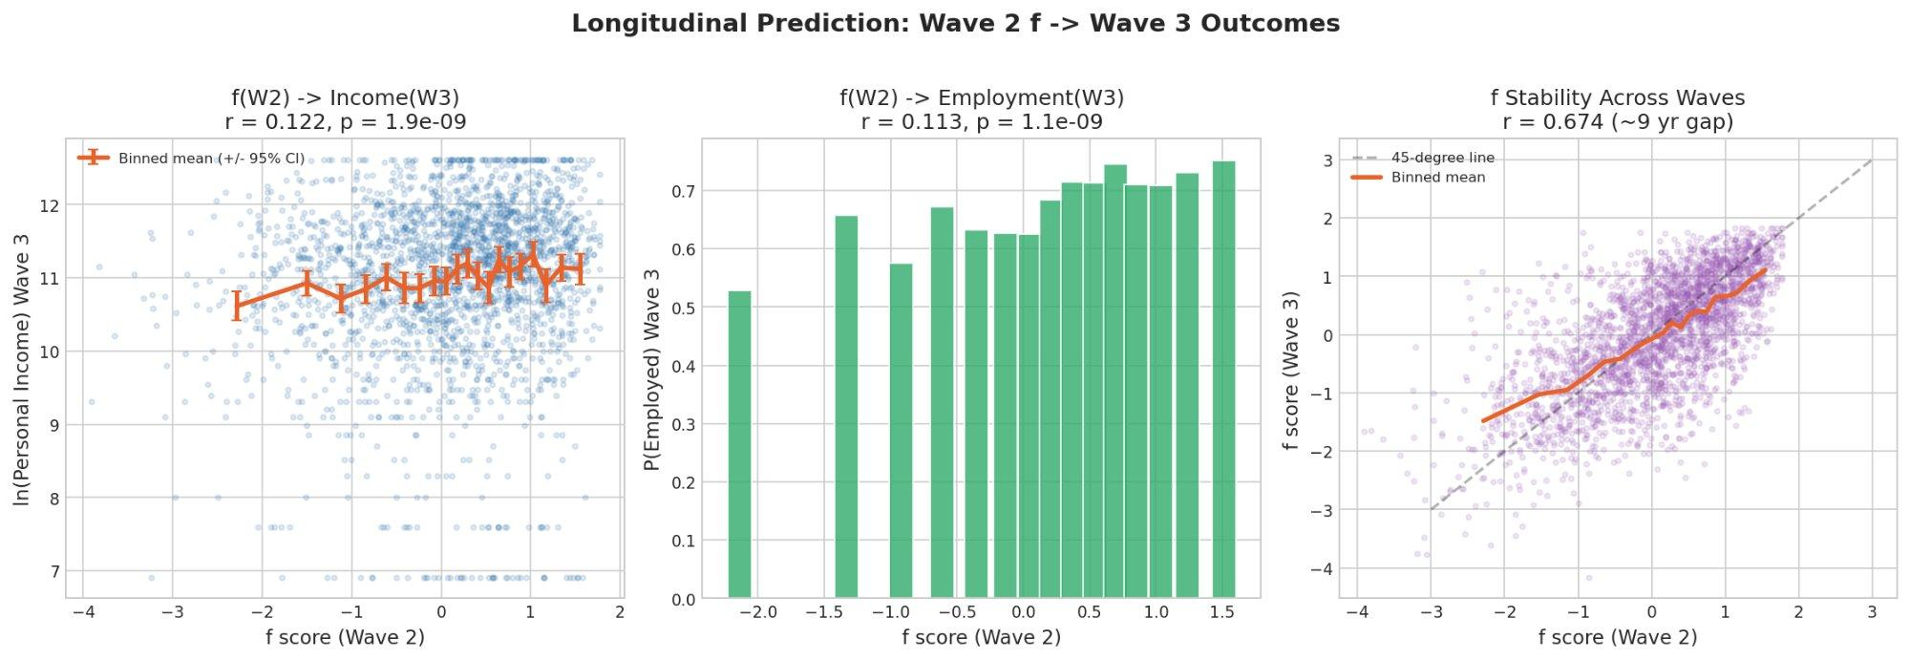
Longitudinal prediction: Wave 2 f predicts Wave 3 outcomes
Figure 1. Longitudinal prediction: Wave 2 f scores predict Wave 3 income (r = 0.122, p < 0.001), employment probability (r = 0.113, p < 0.001), and show strong test-retest stability across ~9 years (r = 0.674).
In the income model, Wave 2 f significantly predicts Wave 3 log income (beta = 0.083, t = 4.36, p < 0.001), controlling for Wave 2 log income, age, sex, and education. Adj. R-squared = 0.355, N = 2,318. The coefficient means that a one-standard-deviation increase in f at Wave 2 is associated with an 8.3% increase in income nine years later, holding initial income constant.
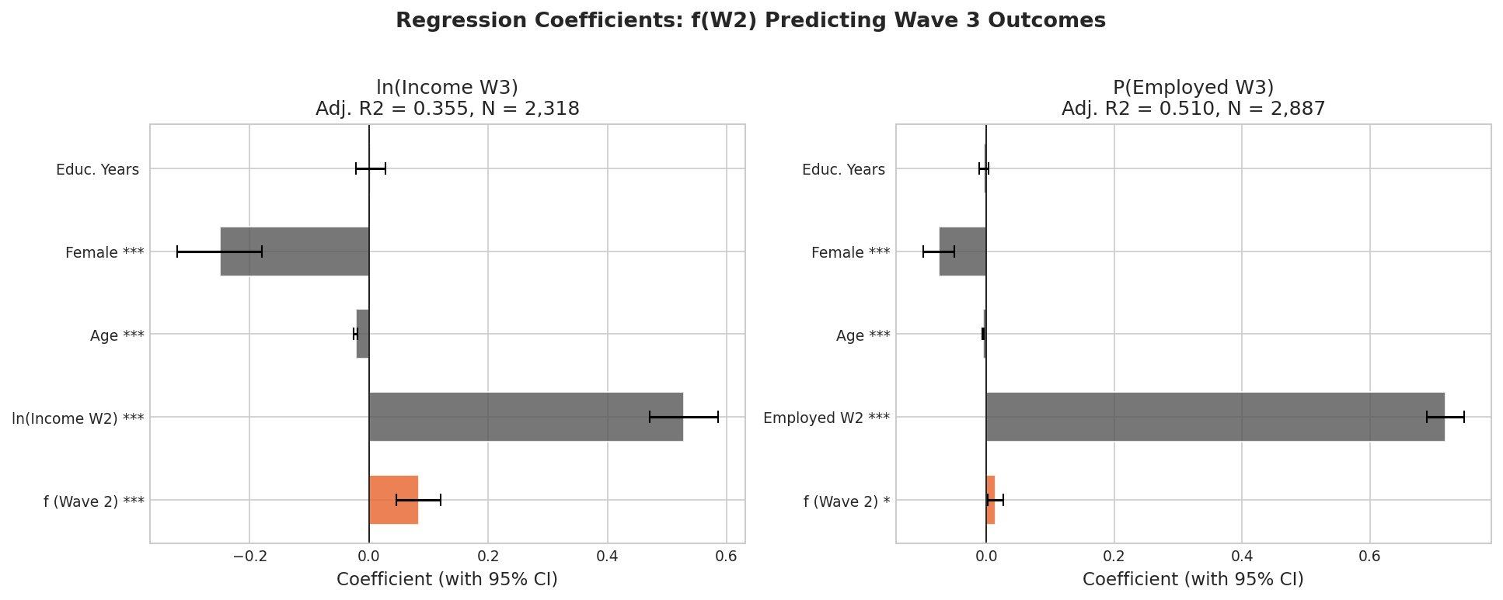
Regression coefficients
Figure 2. Regression coefficients: f (Wave 2) predicting Wave 3 income and employment, with 95% confidence intervals. f contributes significant predictive information beyond demographics and baseline economic status.

Incremental Validity Beyond Negative Affect
The policy-relevant question is not just whether f predicts economic outcomes, but whether it predicts beyond what standard pathology measures already capture. If f merely recapitulates negative affect in positive language, it adds nothing new.
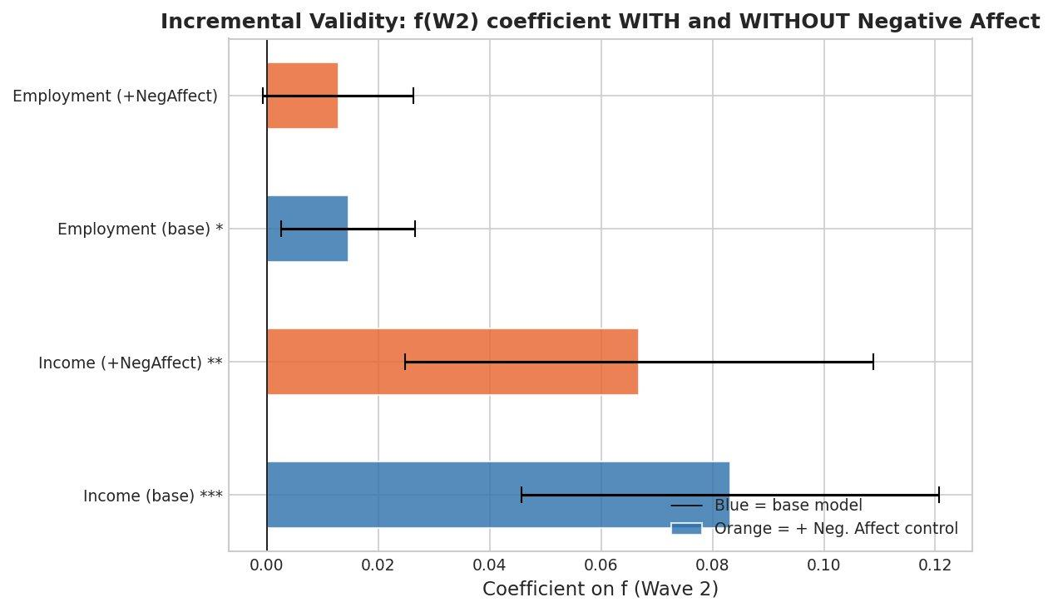
Incremental validity
Figure 3. Incremental validity: f coefficient with and without negative affect as a covariate. For income, f remains significant (p = 0.002) even after controlling for negative affect. The attenuation is modest - f carries predictive information that pathology measures miss.
When negative affect is added as a covariate alongside f, the f coefficient for income drops from 0.083 to 0.067 but remains significant (t = 3.11, p = 0.002). Negative affect itself is not significant in this model (beta = -0.060, p = 0.097). This is a clean incremental validity result: f predicts future income beyond what negative affect captures, while negative affect does not predict beyond f. The flourishing dimension carries information about economic trajectory that the pathology dimension misses.

f Predicts Employment
Wave 2 f also predicts Wave 3 employment status (beta = 0.015, t = 2.37, p = 0.018) in a linear probability model controlling for Wave 2 employment, age, sex, and education. Adj. R-squared = 0.510, N = 2,887. The effect is smaller than for income but statistically significant: higher flourishing at Wave 2 predicts a higher probability of being employed nine years later.
When negative affect is added, the f coefficient attenuates to 0.013 (p = 0.064) - marginal significance. This is consistent with f and negative affect sharing some predictive content for employment but not being fully redundant.
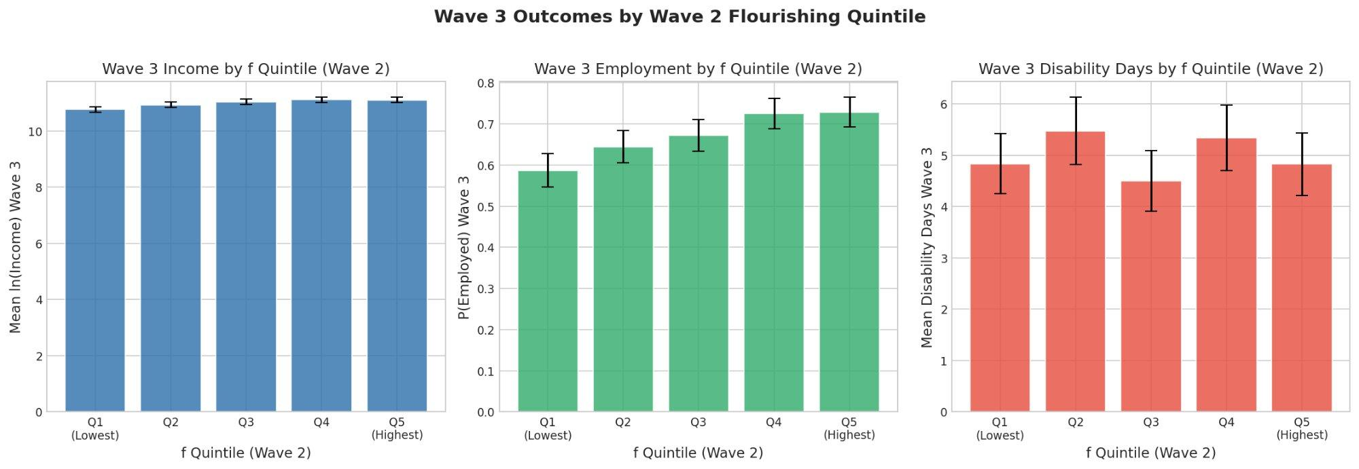
Quintile outcomes
Figure 4. Wave 3 outcomes by Wave 2 f quintile. Income and employment show clear positive gradients across f quintiles. Disability days show no clear pattern.

Disability Days: A Null Result
f does not significantly predict Wave 3 disability days (beta = -0.088, t = -0.85, p = 0.398). This is an honest null. Disability days in this sample have a highly skewed distribution (mean = 5.0, SD = 7.4), and the measure may be too coarse or too dominated by physical health conditions to detect the kind of functional variation f captures. Alternatively, f may genuinely not predict this particular outcome once baseline disability is controlled. Both possibilities should be noted.

f Stability Across Waves
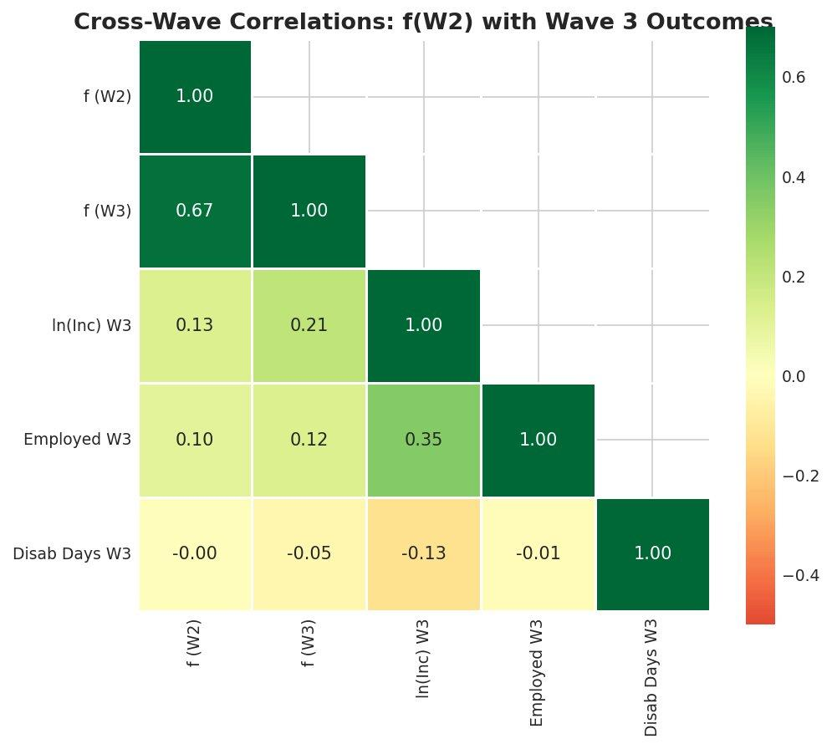
Cross-wave correlations
Figure 5. Cross-wave correlations. f shows strong test-retest stability (r = 0.674) across the ~9-year gap between Waves 2 and 3, consistent with a dispositional-timescale construct.
The test-retest correlation of f across the roughly nine-year gap between Waves 2 and 3 is r = 0.674. This is high enough to confirm that f captures something stable and dispositional - not merely reflecting transient mood - while leaving room for meaningful change over time. For comparison, Big Five personality traits typically show test-retest correlations of 0.60-0.80 over similar intervals. f behaves like a trait-level construct.

Summary of Economic Validation
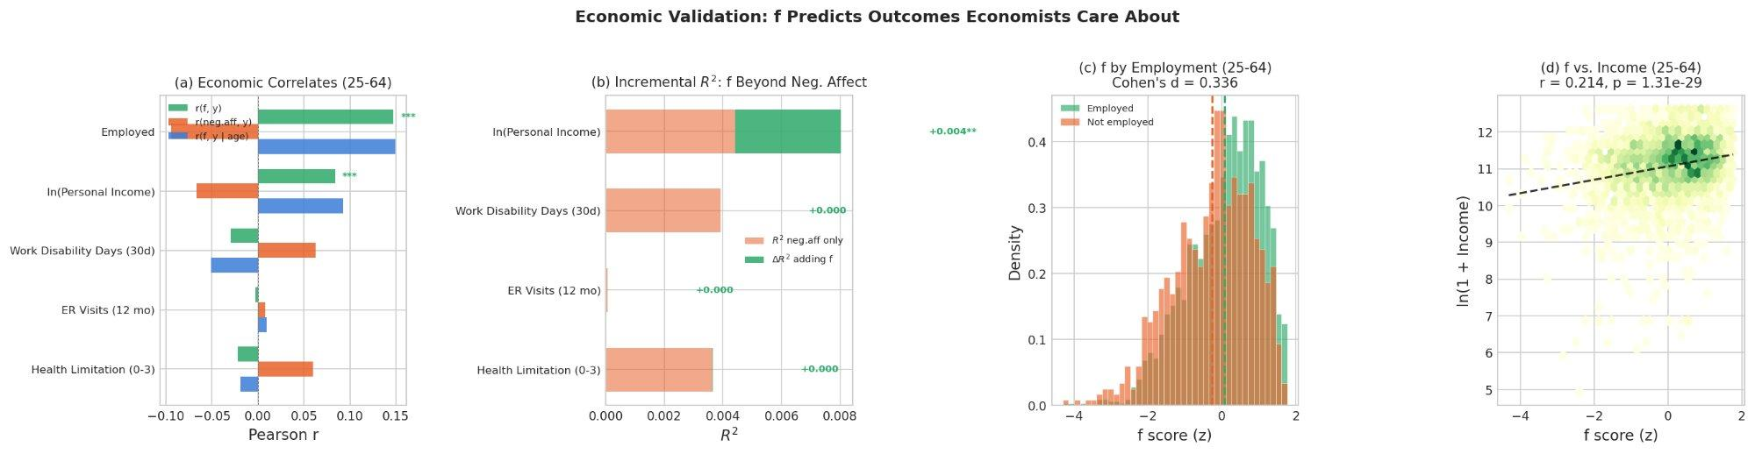
Economic validation overview
Figure 6. Economic validation summary: (a) f and negative affect correlations with economic outcomes for working-age adults, (b) incremental R-squared from adding f beyond negative affect, (c) f distributions by employment status (Cohen’s d = 0.336), (d) f vs. income scatter with trend line (r = 0.214, p < 0.001).
The economic validation establishes that f is not merely an internal consistency exercise. It predicts real-world outcomes that economists care about, across a substantial time lag, beyond what demographics and baseline economic status explain, and - for income - beyond what standard pathology measures capture. This is the empirical foundation for treating f as a policy-relevant construct: flourishing, measured properly, carries information about economic trajectory that symptom counts miss.

Part III: Beyond Averages - Capabilities-Adjusted Flourishing
A standard f score is compensatory: high scores on some domains can offset low scores on others. But this masks a crucial ethical and practical concern. A person with excellent social bonds and strong purpose indicators but no sense of autonomy is not flourishing in the sense the capabilities approach requires - they are deprived of a basic capability, regardless of what the average says.
The capabilities-adjusted measure, f_cap, addresses this using ideas from Martha Nussbaum’s capabilities approach and the Alkire-Foster multidimensional poverty methodology. A threshold is set for each domain (here at the 25th percentile of each Ryff subscale). Any individual falling below the threshold in any dimension receives a downward penalty.
Using MIDUS 2 data (N = 4,026), only 41.5% of individuals pass all six thresholds; the remaining 58.5% fall below at least one. The adjusted deprivation index M_0 = 0.184, with a headcount H = 0.348 and an average intensity A = 0.527 (meaning deprived individuals fall below threshold on roughly half their domains).
The critical diagnostic is the divergence between compensatory f and non-compensatory f_cap. Their correlation is r = 0.725 - substantially lower than perfect, confirming that the threshold corrections matter. The people flagged only by f_cap but not by f are precisely those most at risk of being missed by standard screening: individuals whose overall average looks acceptable but who are deprived in specific domains.
The per-dimension deprivation rates reveal which capabilities most often fail: Autonomy is the most frequently depressed domain (24.6% of individuals fall below threshold), followed by Purpose in Life (21.3%), Positive Relations (15.5%), Self-Acceptance (15.1%), Environmental Mastery (13.5%), and Personal Growth (10.0%). For clinical and policy targeting, this suggests that Autonomy and Purpose in Life are the domains most frequently falling below threshold across the sample.

Part IV: The Mechanism Question - What Generates f?
“The whole is not just more than the sum of its parts. The whole is what makes the parts possible.” - Adapted from systems thinking
The measurement of f raises a deeper question: what generates the positive manifold? This section introduces a theoretical framework - the mutualism model - not as an established mechanism, but as a formal account that (a) can produce the observed structure without positing a latent cause, and (b) generates specific, falsifiable predictions that motivate the planned dissertation work.
An important caveat must be stated upfront: cross-sectional data alone cannot distinguish between a latent-cause account and the mutualism alternative. Both can produce a positive manifold and a dominant first component. The contribution of this section is to show that an alternative mechanism exists, to calibrate it against real data, and to derive the predictions that would distinguish the two accounts.

Two Competing Accounts
The standard interpretation of a dominant first factor is that there exists a latent variable - a real thing - that causally drives all the observed domains. This is how g works in intelligence theory (at least under some interpretations): a single cognitive resource that enables all abilities.
The alternative is the mutualism model, originally proposed for intelligence by Han van der Maas. The idea is that the domains are not driven by a common cause. Instead, they boost each other directly. Positive relationships improve your sense of purpose. A strong sense of purpose improves your engagement with challenges. Engagement builds competence. Competence builds self-acceptance. Self-acceptance makes relationships easier. Under this account, the positive manifold - and the apparent general factor - emerge from this web of mutual reinforcement, with no latent variable required.

A Proof of Concept: The Mutualism Dynamical System
The implementation formalizes this as a system of coupled generalized Lotka-Volterra (GLV) differential equations. Each wellbeing domain has an intrinsic growth rate and is subject to self-limitation and mutual coupling with every other domain. The calibration uses Lyapunov matrix inversion (J = -(1/2) Sigma-inverse), which is exact: the GLV Jacobian at the observed mean vector reproduces the observed covariance matrix by construction. This is calibrated from individual-level data (N = 4,026).
The Jacobian is stable (all eigenvalues negative), the equilibrium matches observed means to machine precision, and all 30 off-diagonal coupling terms are positive - confirming that the model describes a fully mutualistic system with no inhibitory interactions.
The asymmetric coupling analysis reveals that Self-Acceptance is the most coupling-dependent domain (99% of its equilibrium level sustained by inputs from other domains, particularly Environmental Mastery and Positive Relations), while Autonomy is the most self-sustaining (47% of its equilibrium from intrinsic growth). This asymmetry generates a testable prediction: disruptions to domains that are “coupling hubs” (Environmental Mastery, Positive Relations) should have larger system-wide effects than disruptions to relatively independent domains (Autonomy).
The perturbation decomposition confirms that the Jacobian is nearly symmetric (asymmetry index = 0.049), meaning the system is well-approximated by a symmetric Ornstein-Uhlenbeck process for small perturbations. The alignment chain shows that the dominant eigenvector of the Jacobian aligns almost perfectly with PC1 of the observed covariance (cosine = 0.9997).
A calibration gap remains. The simulated PC1 variance (84.0%) exceeds the observed (50.4%), and the model’s eigenvalue dominance ratio substantially exceeds the observed ratio. This is expected: the calibrated dynamical system generates tighter correlations than the heterogeneous, noisy process that produces real human data. The coherence checks confirm directional alignment; closing the magnitude gap requires richer noise models or heterogeneous coupling.

Stability and Resilience: Model Predictions
If the mutualism model is approximately correct, Lyapunov stability analysis characterizes the predicted stability properties. The dominant eigenvalue lambda_1 = -0.1225 gives a model-predicted return time of tau = 8.16 time units. The basin of attraction has a radius of approximately 0.495, and the composite resilience R(x*) = 0.246.
Within the model, individual-level f and model-predicted resilience correlate at r = 0.958 - but this is an internal consistency check, not an independent validation, because model-predicted resilience is computed from the same model fitted to the same data. True validation would require observing that individuals the model predicts to be resilient actually recover faster from documented adverse life events.
A coupling sweep across different values of coupling strength reveals a tradeoff: stronger coupling buys higher mutual benefit at the cost of fragility. Composite resilience peaks at low coupling and declines as coupling increases, while equilibrium wellbeing levels and f dominance rise. The stability boundary sits at approximately 1.33 times the observed coupling strength - suggesting meaningful but not unlimited margin. The coupling-resilience signature - how recovery time, variance, and success rate jointly vary as a function of coupling and shock magnitude - provides a directly testable prediction for longitudinal data.

What the Model Predicts for Policy
The mutualism framework, if approximately correct, generates a specific class of policy predictions. Because Medicaid expansion operates through multiple domains simultaneously (health access, financial stress, care avoidance), it should strengthen cross-domain couplings and produce outsized effects on f relative to any single symptom measure. More specifically: if Medicaid expansion increases the correlations among wellbeing domains for treated individuals - not just the levels - then that is direct evidence for the mutualism channel. If it only raises one domain without changing the coupling structure, the model predicts the gains will be shallow and revert faster.
These predictions are conditional on the model being approximately correct. Testing them is the work of the planned dissertation.

What Comes Next: A Dissertation in Three Papers
This paper establishes that f is psychometrically coherent, economically predictive, and theoretically generative. The remaining questions - whether f is causally useful, whether policy can move it, and whether the mutualism mechanism holds - define a planned three paper dissertation .
Paper 1: Can f earn the right to be a policy outcome variable? Building on the longitudinal analysis in Part II, this paper would use the full MIDUS panel (Waves 1, 2, and 3) to test whether changes in f predict changes in labor force participation, earnings, healthcare utilization, and disability claims above and beyond what standard psychopathology measures predict. The incremental validity result here -f predicts income beyond negative affect - is the preliminary evidence. The dissertation version would use panel fixed effects to strip out time-invariant confounders and test within-person change.
Paper 2: Do changes in policy lead to changes in f? Medicaid expansion provides the natural experiment. Staggered adoption across states gives identification. Using BRFSS data and Callaway-Sant’Anna estimators designed for staggered difference-in-differences, this paper would estimate the causal effect of expansion on a flourishing proxy, and test whether that effect exceeds what you would predict from the pathology channel alone.
Paper 3: Did the structure change, or just the score? Most policy evaluation asks if the outcome moved. This paper asks if the structure changed. If Medicaid expansion increases the correlations among wellbeing domains for treated individuals and not just the levels, that is direct evidence for the mutualism channel. If it only raises one domain without changing the coupling structure, the dynamical model predicts the gains will be shallow and revert faster. This paper connects the systems theory to a testable empirical prediction and, if confirmed, offers a new design criterion: prioritize policies that strengthen couplings, not just those that shift means.

Technical Summary
Data. MIDUS 2 (ICPSR 4652): Ryff PWB 6-subscale composites, N = 4,026 complete cases. Multi-instrumental: 17 indicators from 6 instrument families, N = 3,922. Longitudinal panel: MIDUS Waves 2-3, merged N = 2,894.
Bifactor CFA (Ryff-only). General factor f plus three specific factors (hedonic, eudaimonic, social-agentic). omega_h = 0.789, ECV = 0.758. df = 3, chi-squared = 106.66, RMSEA = 0.093. General loadings: 0.427-0.731.
Multi-Instrumental Bifactor (17 indicators). General factor f plus four orthogonal group factors. omega_h = 0.893, ECV = 0.738, FDC = 0.973. chi-squared = 3,557.4, df = 102, CFI = 0.903, RMSEA = 0.093, SRMR = 0.052. Group factor omega_hs: eudaimonic = 0.004, social = 0.034, hedonic = 0.008, agentic = 0.003. Bartlett factor scoring.
Dual continua. r(f_17, Negative Affect) = -0.439, R-squared = 0.193. r(f_17, Depression) = -0.323. r(f_17, Anxiety) = -0.213. Big Five R-squared = 0.473. Clinical: Cohen’s d = 0.978 (depression), 1.503 (GAD).
Longitudinal economic prediction (W2 f -> W3 outcomes, ~9-year lag). Income: beta = 0.083 (p < 0.001), Adj. R-squared = 0.355, N = 2,318. Income with negative affect: beta = 0.067 (p = 0.002). Employment: beta = 0.015 (p = 0.018), Adj. R-squared = 0.510, N = 2,887. Disability days: beta = -0.088 (p = 0.398, n.s.). f stability: r(W2, W3) = 0.674.
Alkire-Foster capabilities. 25th-percentile thresholds. M_0 = 0.184, H = 0.348, A = 0.527. Pass all: 41.5%. f vs. f_cap: r = 0.725. Weakest domain: Autonomy (24.6% below threshold).
GLV dynamical system. Lyapunov inversion calibration (J = -(1/2) Sigma-inverse). Jacobian stable, equilibrium exact. Asymmetry index = 0.049. Simulated PC1 = 84.0% (vs 50.4% observed). Return time tau = 8.16. Basin radius = 0.495. R(x*) = 0.246. f-resilience r = 0.958 (internal consistency check).
Implementation. ~3,000 lines of Python (NumPy, SciPy, scikit-learn, semopy, matplotlib). Code: github.com/DanielKetterer/Flourishing.

