Toward f
A General Factor of Human Flourishing
What the work is, how it works, and why it matters

Daniel Ketterer
2026
Computational implementation & empirical analysis

The Question
"The good life is not a single thing. It is many things, woven together." — Adapted from Aristotle
Here is a pattern that has puzzled psychologists for decades. When you measure different aspects of how well a person’s life is going — their sense of purpose, the quality of their relationships, their feeling of competence and control, their self-regard — these measures almost always correlate positively. People who score high on one dimension of wellbeing tend to score high on all of them. People who are struggling in one area tend to be struggling across the board.
This is called the positive manifold, and it is one of the most robust findings in wellbeing science. It appears in every major dataset, across cultures, across age groups, across socioeconomic levels. The question is: why?
Intelligence research faced an identical puzzle a century ago. Charles Spearman noticed that cognitive abilities — verbal, spatial, numerical, memory — all correlated positively, and proposed that a single general factor, g, explained the pattern. The g-factor became one of the most productive constructs in all of psychology. It predicted life outcomes better than any individual ability measure. It transformed how we think about human cognitive architecture.
This project asks: does the same structure exist for human flourishing? Is there a general factor — call it f — that captures what all the dimensions of wellbeing share? And if so, what generates it? Is f a real thing in the mind, a latent cause that drives all the domains upward or downward together? Or does it emerge from something more interesting — the domains bootstrapping each other?
These are not just academic questions. If f exists, and if its structure is generated by inter-domain coupling rather than a single latent cause, then policy design may need to change. Instead of targeting anxiety in isolation, or loneliness in isolation, or unemployment in isolation, we would ask: what interventions strengthen the couplings between domains? What moves people along the f dimension — toward a state where everything lifts together?

The Evidence: Finding f in Real Data
The empirical work proceeds in two stages. First, a country-level ecological analysis using international wellbeing indicators mapped to the PERMA+H framework (Positive Emotion, Engagement, Relationships, Meaning, Accomplishment, and Health) across 140 countries. Second — and more decisively — an individual-level analysis using Ryff’s Psychological Wellbeing Scale from the MIDUS 2 study (ICPSR 4652), one of the flagship longitudinal health studies in the United States, with 4,026 complete cases out of 4,963 respondents.
The individual-level analysis is the more important test. Country-level correlations can arise from confounds: wealthy nations score high on everything because wealth causes everything. The individual-level question is different and sharper: within a single national context, does a person who reports strong relationships also tend to report strong purpose, strong self-acceptance, strong personal growth? The answer, decisively, is yes.

The Positive Manifold
The correlation matrix across the six Ryff PWB subscales shows universally positive correlations, with a mean inter-subscale correlation of r = 0.397. All 15 pairwise correlations are positive. The strongest pairings — Self-Acceptance with Environmental Mastery (r = 0.58), Self-Acceptance with Positive Relations (r = 0.54), Personal Growth with Positive Relations (r = 0.48) — suggest that self-regard, competence, and social bonds form a particularly tight cluster. Autonomy is the most distinct subscale (weakest pair: Purpose in Life with Autonomy, r = 0.22), consistent with published MIDUS psychometric benchmarks.
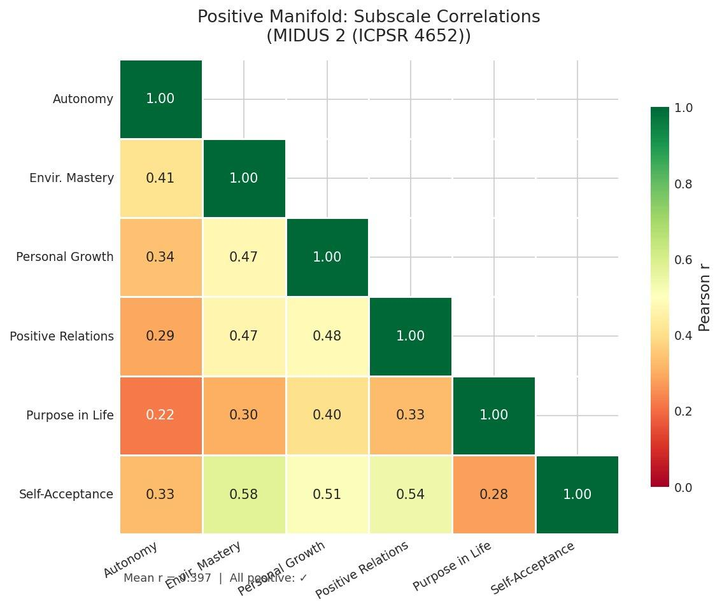
Figure 1. Positive manifold: all six Ryff PWB subscales correlate positively (MIDUS 2, N = 4,026).

Extracting f: Principal Component Analysis
Principal Component Analysis confirms that a single dominant component — our f proxy — explains 50.4% of the total variance across all six subscales. The first eigenvalue is 3.027, well above the Kaiser criterion of 1.0, and the scree plot shows a clear elbow after the first component. The remaining five components each explain between 6.6% and 13.6%, with none approaching the dominance of PC1. Three components are needed to reach 77% cumulative variance, and four to reach 85%.
Critically, the factor loadings on PC1 are relatively uniform across all six subscales, ranging from 0.323 (Purpose in Life) to 0.452 (Self-Acceptance). This means f is not being driven by one or two dominant items — it indexes covariance shared across all dimensions. (PCA is descriptive and model-free; it identifies the dominant axis of variation but does not by itself establish what generates it.) The bootstrap confidence intervals (1,000 resamples) are tight, confirming the stability of these estimates. Self-Acceptance (0.452), Environmental Mastery (0.447), and Personal Growth (0.441) load most strongly; Purpose in Life (0.323) and Autonomy (0.334) load somewhat lower but still substantially.

What f Looks Like in the Population
The distribution of individual f scores is negatively skewed — most people cluster toward the high end of flourishing, with a long left tail of individuals experiencing low wellbeing across multiple domains simultaneously. This is not a normal distribution (Shapiro-Wilk W = 0.970, p < 0.0001), and the skewness matters: those in the left tail tend to score low across multiple domains at once, not on just one in isolation.
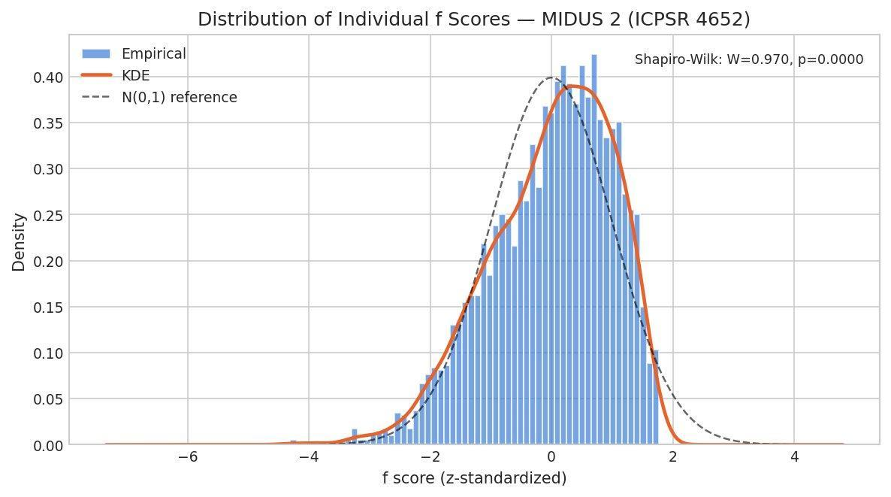
Figure 2. Distribution of individual f scores. The left skew reveals a vulnerable subpopulation experiencing multi-domain wellbeing deficits (MIDUS 2).

f Across Demographic Groups
The demographic analysis reveals that f is remarkably stable across sex (Cohen’s d = 0.002, p = 0.942 — effectively zero difference between men and women) and shows nuanced variation by age and education. The education gradient is notable: while the median f score is similar across education levels, the lower tail extends further for those with less education, suggesting that low education is a risk factor not for lower average flourishing, but for greater dispersion into the low-f tail — simultaneously low scores across multiple domains.
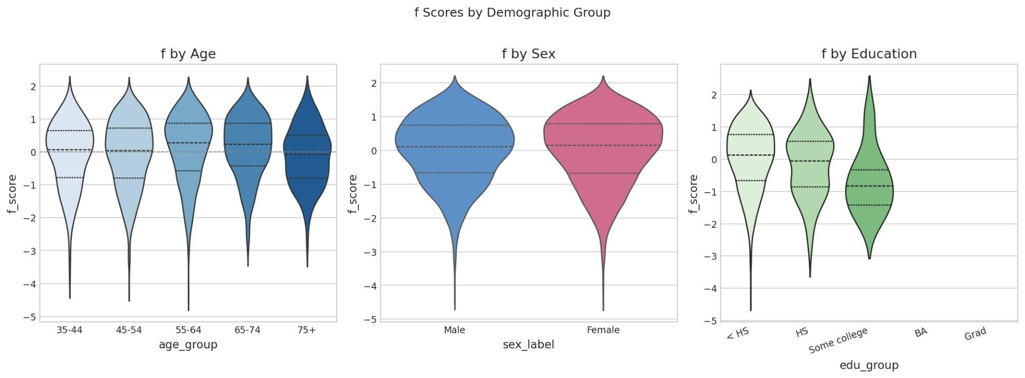
Figure 3. f scores by age, sex, and education. The story is in the tails, not the means (MIDUS 2).

Confirming f: Bifactor Analysis and the Dual Continua
PCA is exploratory — it finds the dominant axis of variation but does not test whether f is a coherent construct. Two additional analyses probe this question from different angles.

Bifactor Confirmatory Factor Analysis
A bifactor CFA simultaneously estimates a general factor (f) that loads on all items and domain-specific factors that capture what is unique to subgroups of items. The key diagnostics are the Explained Common Variance (ECV) — what fraction of the shared variance is attributable to f versus the domain-specific factors — and omega hierarchical (ω_h), which estimates the proportion of total score variance attributable to the general factor.
Individual-level results (MIDUS 2, N = 4,026). This is the confirmatory test. With six Ryff PWB subscales grouped into three specific factors (hedonic: Environmental Mastery and Self-Acceptance; eudaimonic: Personal Growth and Purpose in Life; social-agentic: Autonomy and Positive Relations), the bifactor model has positive degrees of freedom (df = 3) and can be evaluated as a testable claim. The results are strong: ω_h = 0.789 and ECV = 0.758. These values indicate that the general factor f captures the dominant share of common variance across all six subscales. The model converged successfully, with χ² = 106.66 (df = 3) and RMSEA = 0.093 — the chi-square is significant (expected with N = 4,026), and RMSEA falls in the marginal range, reflecting modest remaining misfit in a model with only three degrees of freedom.
The general factor loadings range from 0.427 (Purpose in Life) to 0.731 (Self-Acceptance), with all six subscales loading substantially. Self-Acceptance (0.731), Positive Relations (0.713), Environmental Mastery (0.698), and Personal Growth (0.683) form a cluster of high-loading indicators. The specific factor loadings reveal meaningful domain-level structure beneath the general factor: Purpose in Life retains the strongest specific loading (0.577 on the eudaimonic factor), consistent with its lower general loading — it contributes to f but also captures something distinct about goal-directedness and meaning. Autonomy shows a substantial specific loading (0.486 on the social-agentic factor), while Positive Relations has a near-zero specific loading (−0.146), indicating that nearly all of its reliable variance is captured by f itself.
This is an important finding. It tells us that f is a statistically prominent general factor at the individual level — not merely an artifact of ecological aggregation. The ω_h of 0.789 means that roughly 79% of the reliable variance in total Ryff scores is attributable to the general factor. At the same time, the specific factors are not negligible: Purpose in Life and Autonomy, in particular, retain meaningful domain-specific content. The general factor is statistically dominant at the individual level, but it coexists with meaningful domain specificity. This is consistent with the mutualism interpretation developed below: domains that mutually reinforce each other will share variance (generating f) while also retaining their own dynamics (generating domain-specific factors). (A note on model fit: the RMSEA of 0.093 falls in the marginal-to-poor range by conventional cutoffs. With only df = 3, fit indices are difficult to interpret cleanly; additional indices such as CFI, TLI, and SRMR would strengthen the assessment in future work.)
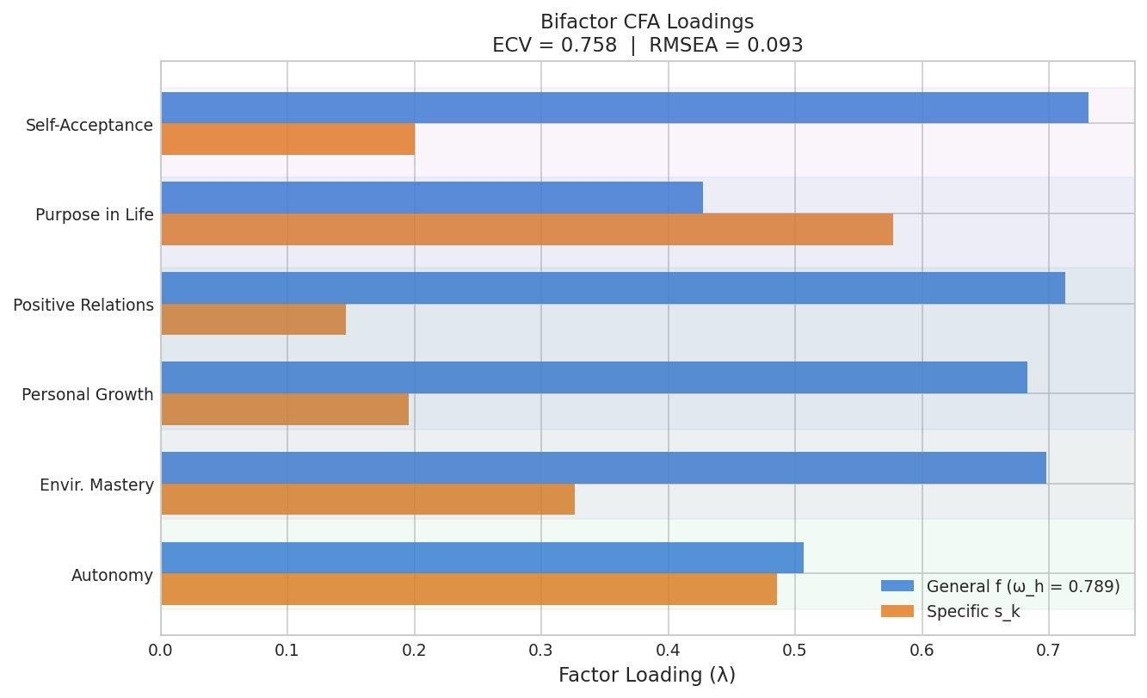
Figure 4. Bifactor CFA loadings: f captures the dominant share of common variance (ω_h = 0.789, ECV = 0.758), while domain-specific factors retain meaningful residual structure (MIDUS 2).

Flourishing Is Not Just the Absence of Pathology
A critical test: is f simply the inverse of psychopathology? If so, the entire construct collapses into something we already measure — depression, anxiety, negative affect. The dual continua model, proposed by Corey Keyes, predicts that flourishing and psychopathology are related but distinct dimensions — that it is possible to flourish despite symptoms, and to languish without meeting any diagnostic threshold.
The data are consistent with this. The correlation between f and negative affect (the MIDUS B1SNEGAF composite, a coarse mood-level proxy rather than a clinical p-factor measure) is r = −0.379 — meaningful but moderate. They share only 14.4% of their variance. The remaining 85.6% is independent. This supports the view that flourishing indexes something about human experience that pathology measures alone do not capture.
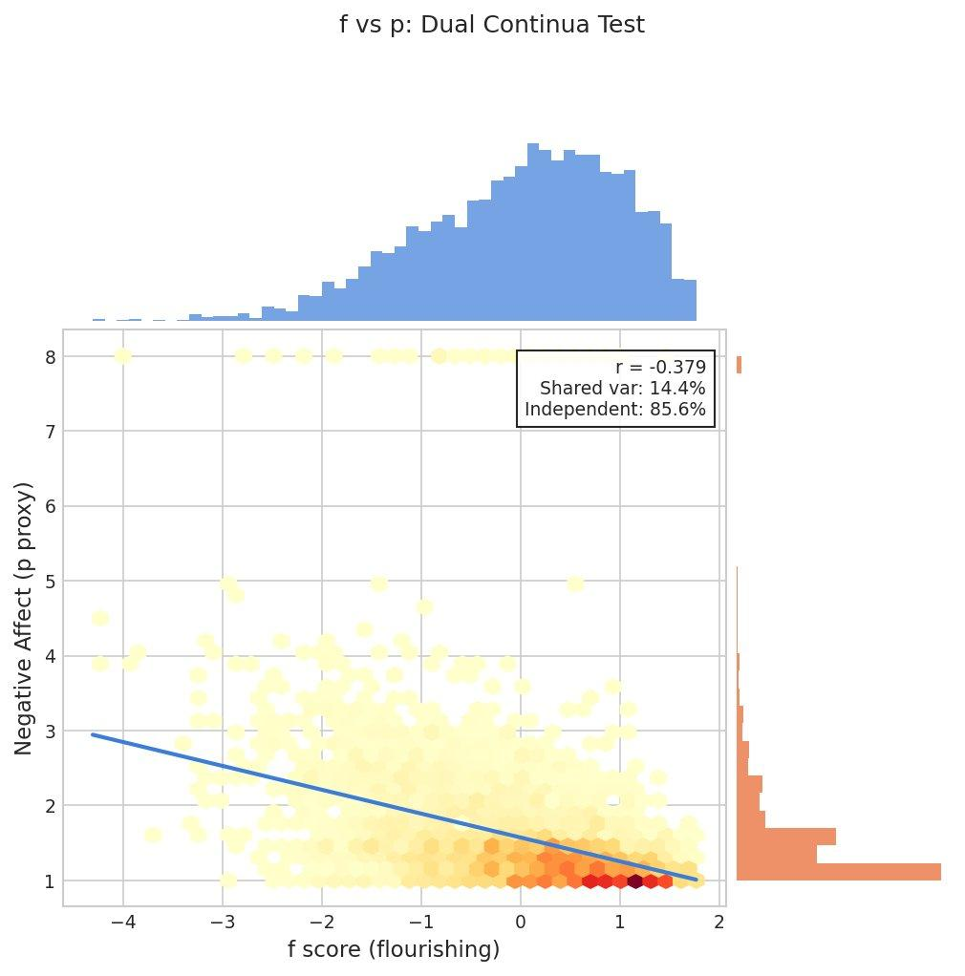
Figure 5. f vs. p: related but distinct dimensions. 85.6% of variance is independent — flourishing is not just the absence of suffering (MIDUS 2).

The Mechanism: Where Does f Come From?
"The whole is not just more than the sum of its parts. The whole is what makes the parts possible." — Adapted from systems thinking
The measurement of f raises a deeper question: what generates the positive manifold? Two competing accounts exist. The standard interpretation of a dominant first factor is that there exists a latent variable — a real thing — that causally drives all the observed domains. This is how g works in intelligence theory (at least under some interpretations): a single cognitive resource that enables all abilities. An important caveat must be stated upfront: cross-sectional data alone cannot distinguish between this latent-cause account and the alternative developed below. Both can produce a positive manifold and a dominant first component. The contribution of this section is to show that an alternative mechanism can generate the observed structure, and to derive predictions that would distinguish the two accounts — predictions specified in the coupling–resilience signature section.
The alternative is the mutualism model, originally proposed for intelligence by Han van der Maas. The idea is that the domains are not driven by a common cause. Instead, they boost each other directly. Positive relationships improve your sense of purpose. A strong sense of purpose improves your engagement with challenges. Engagement builds competence. Competence builds self-acceptance. Self-acceptance makes relationships easier. Under this account, the positive manifold — and the apparent general factor — emerge from this web of mutual reinforcement, with no latent variable required.

The Mutualism Dynamical System
The implementation formalizes this as a system of coupled logistic differential equations. Each wellbeing domain grows according to its own intrinsic rate and carrying capacity, but is boosted by every other domain through a coupling matrix M. The calibration uses individual-level between-person partial correlations from MIDUS (N = 4,026), which avoids the ecological fallacy inherent in country-level calibration but remains a between-person cross-sectional estimate — not the within-person temporal coupling that the dynamical model ideally requires. The individual-level carrying capacities range from C = 3.783 (Purpose in Life) to C = 4.007 (Personal Growth), and the resulting mean coupling strength is M̄ = 0.161.
The key proof-of-concept result: even with no latent variable in the model — no f driving anything — the simulated population of 200 individuals exhibits a dominant first principal component explaining 91.1% of variance. The simulated positive manifold shows uniformly positive correlations with a mean of r = 0.893. Within the model, the positive manifold arises entirely from mutualism, with no latent variable required. Furthermore, the equilibrium that the system converges to lies above every domain’s individual carrying capacity — the ratio x*/C ranges from 4.64 to 6.47 across domains. In the model, mutualism doesn’t just correlate the domains; it lifts them all above where they would be in isolation. (These are properties of the specified ODE system. Whether the actual generative process in human wellbeing is mutualistic remains an open empirical question requiring longitudinal data.)
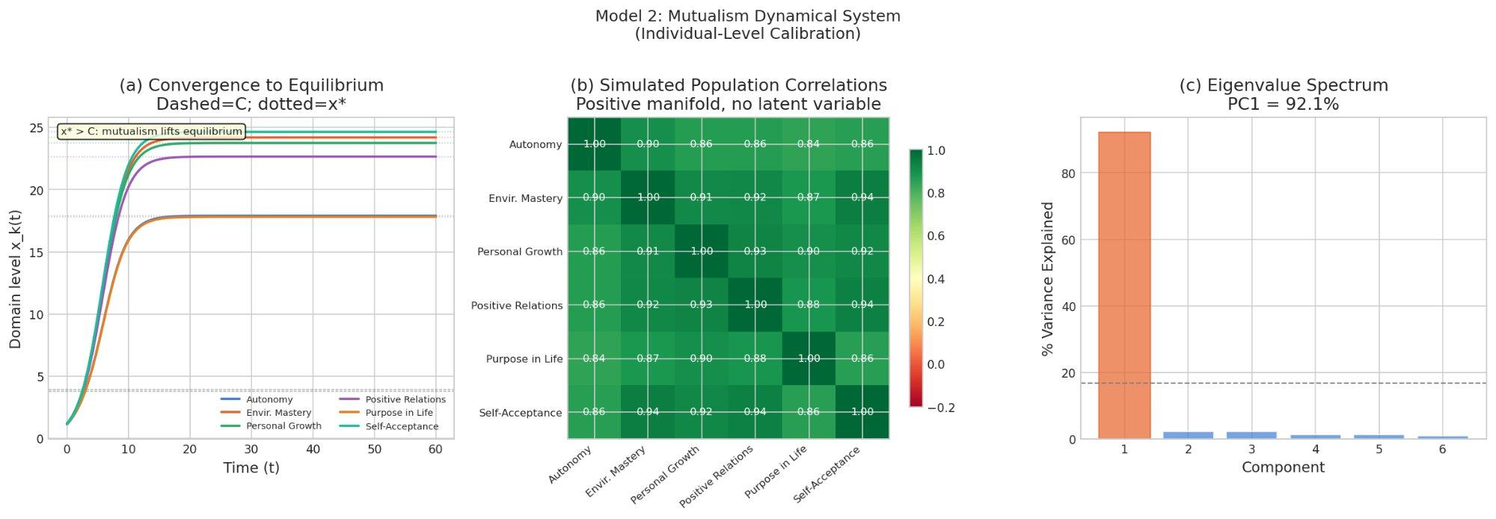
Figure 6. The mutualism model: (a) convergence to equilibrium above carrying capacity, (b) emergent positive manifold, (c) PC1 captures 91.1% of variance — no latent variable needed (individual-level calibration).
The representation coherence checks confirm that the dynamical model’s structure aligns with the observed data. The weak coherence test (cosine similarity between the leading eigenvectors of observed and model-implied covariance matrices) yields 0.993. The medium coherence test (alignment of the PC1 direction with the Jacobian’s dominant mode) yields 0.9999. Sign discipline passes: the mutualism model preserves the direction of all loadings. Cross-structure discipline (r = 0.988) confirms the overall pattern match. These checks establish that the mutualism model reproduces the directional and structural features of the observed covariance pattern — a necessary condition for the model to be correct, though not a sufficient one, since other generative models (including a latent common cause) could pass the same checks.
A calibration gap remains. The model’s eigenvalue dominance ratio (λ₁/λ₂ = 36.55) substantially exceeds the observed ratio (3.70), and the simulated PC1 variance of 91.1% overshoots the observed 50.4%. This is expected: the logistic mutualism system with uniform coupling generates tighter correlations than the heterogeneous, noisy process that produces real human data. The coherence checks confirm directional alignment; closing the magnitude gap requires richer noise models or heterogeneous coupling, which is a target for future work.

Stability, Resilience, and the Basin of Attraction
If flourishing is a dynamical equilibrium maintained by mutual reinforcement, then a natural question follows: how stable is it? What happens when something goes wrong — a health crisis, a relationship breakdown, a loss of purpose?
If the mutualism model is approximately correct, Lyapunov stability analysis characterizes the predicted stability properties. The Jacobian matrix at the model’s equilibrium has all eigenvalues with negative real parts (ranging from −0.500 to −4.260), confirming that the equilibrium is asymptotically stable within the specified system. The dominant eigenvalue λ₁ = −0.500 determines the slowest recovery mode, giving a model-predicted return time τ ≈ 2.0 time units. The basin of attraction — the set of states from which the system will return to equilibrium — has a radius of approximately 0.996. The composite resilience measure R(x*), defined as the geometric mean of recovery speed and basin radius, is 0.706 — indicating that the flourishing equilibrium is robust.
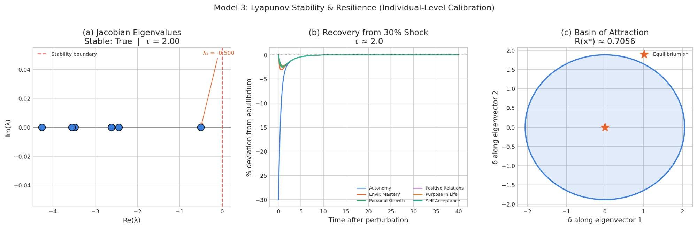
Figure 7. Lyapunov analysis: (a) all eigenvalues stable, (b) rapid recovery from a 30% shock, (c) basin of attraction with R(x*) ≈ 0.706 (individual-level calibration).
The perturbation analysis illustrates a key model prediction. When a domain is shocked by 30%, all domains are briefly disturbed — but the mutual reinforcement pulls everything back. The recovery is not domain-by-domain; it is systemic. This is the mutualism model’s central prediction: the couplings that create vulnerability to cascading decline also provide the mechanism for coordinated recovery.
Within the model, the distance from bifurcation (λ₁ = −0.500, well below zero) suggests the system is far from the critical threshold where recovery would slow dramatically. This reflects the signature of critical slowing down in dynamical systems: as λ₁ approaches zero, return time τ diverges to infinity. The model predicts substantial margin — whether this margin exists in real human wellbeing systems is an empirical question.
At the individual level, f and model-predicted resilience correlate at r = 0.434 (p = 3.4 × 10⁻¹⁶⁹), showing internal consistency between flourishing level and the model’s predicted recovery capacity. An important caveat: model-predicted resilience is computed from the same model fitted to the same data, so this correlation is an internal consistency check, not an independent validation. True validation would require observing that individuals the model predicts to be resilient actually recover faster from documented adverse life events — a longitudinal, prospective test. With that caveat, the relationship is nonlinear: individuals at the high end of f cluster near the resilience ceiling, while those at the low end show dramatically wider variance in recovery capacity. This is the pattern the coupling model predicts — high-f individuals have strong mutual reinforcement sustaining their equilibrium, while low-f individuals occupy a regime where small differences in coupling produce large differences in resilience.
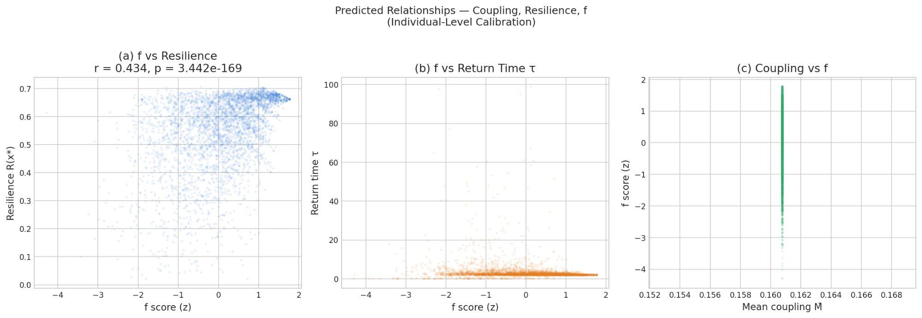
Figure 8. Individual-level relationships: (a) f vs. resilience (r = 0.434), (b) f vs. return time τ, (c) coupling proxy vs. f (individual-level calibration, N = 4,026).

The Optimal Regime: Not Too Loose, Not Too Tight
A coupling sweep across different values of the mean coupling strength M̄ reveals a striking prediction: there exists an optimal regime where flourishing and resilience interact in non-trivial ways. At low coupling, the domains are nearly independent — the positive manifold is weak, mutual benefit is limited, but the system is inherently stable because perturbations in one domain cannot propagate. At moderate coupling, the system benefits from mutual reinforcement: equilibrium levels rise above carrying capacity and f dominance strengthens. At extreme coupling, the system becomes fragile — the domains are so tightly linked that a shock to any one propagates through all of them, and the basin of attraction collapses.
The sweep reveals that composite resilience peaks at very low coupling (M̄ ≈ 0.01) and declines sharply as coupling increases. By M̄ ≈ 0.20, the basin radius drops to near zero — the system is technically stable but has almost no tolerance for perturbation. Meanwhile, PC1 variance climbs steeply with coupling, and equilibrium wellbeing levels peak around M̄ ≈ 0.15–0.20. The implication is that there is a genuine tradeoff: stronger coupling buys higher mutual benefit at the cost of fragility.
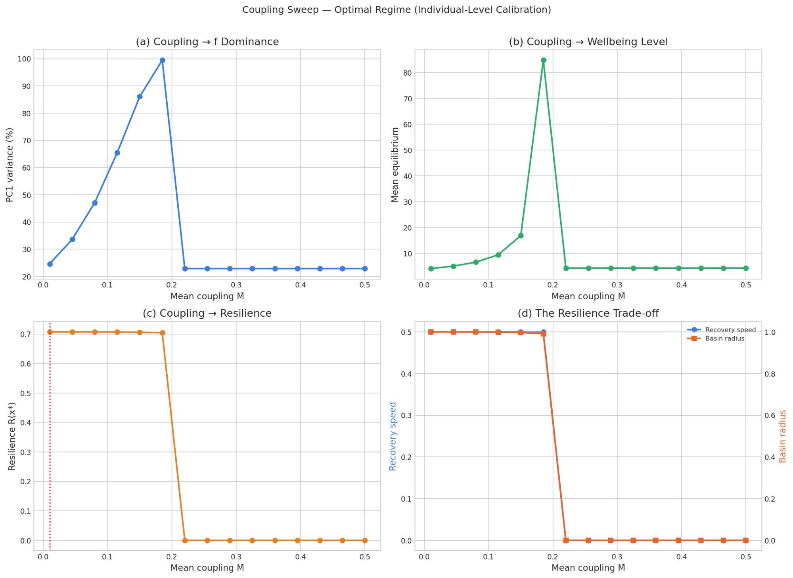
Figure 9. The coupling sweep: resilience trades off against wellbeing level and f dominance as coupling increases (individual-level calibration).
This is a non-trivial theoretical result with potential policy implications. If the mutualism model is approximately correct, it predicts that the goal of intervention is not to maximize coupling between wellbeing domains at all costs, but to operate in a regime that balances mutual benefit against systemic fragility. In practice, this would mean building robust but not brittle connections between life domains — strong enough to produce upward spirals, flexible enough to contain downward cascades. Whether this tradeoff governs real human wellbeing systems remains to be tested empirically.

The Coupling–Resilience Signature
To make the resilience tradeoff empirically testable, the model generates a coupling–resilience signature: a prediction about how mean recovery time, recovery variance, and recovery success rate should jointly vary as a function of coupling strength and shock magnitude. The simulation crosses five shock sizes (5%, 10%, 20%, 35%, 50%) with coupling values ranging from 0.05 to 0.45.
The results reveal a sharp phase boundary. At low and moderate coupling, the system recovers successfully from all but the largest shocks, with low variance in recovery time. As coupling crosses the critical threshold (around M̄ ≈ 0.20), the 50% shock recovery rate drops to zero — the system is pushed outside its basin of attraction and fails to return. Recovery variance peaks just before the transition, the classic signature of critical slowing down. Smaller shocks (5–20%) remain recoverable even at high coupling, but with increasing fragility.
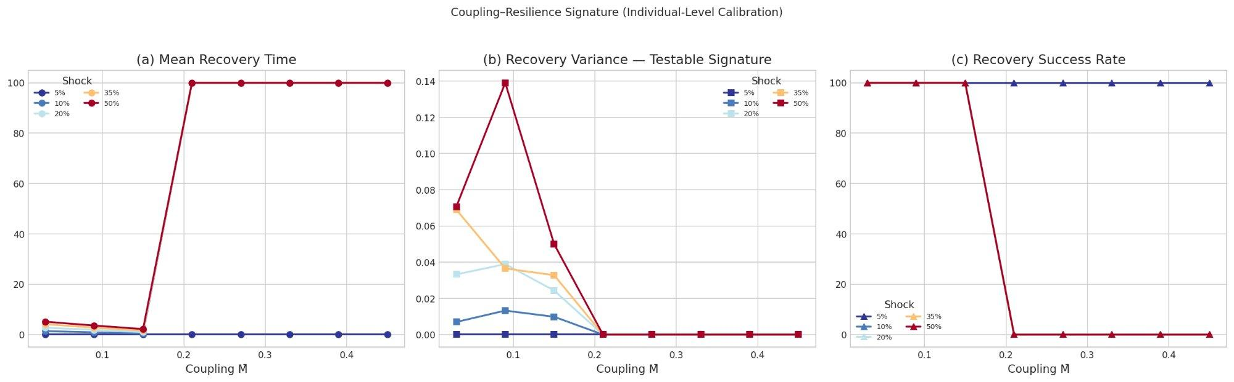
Figure 10. Coupling–resilience signature: recovery time, variance, and success rate as a function of coupling strength and shock magnitude. The phase boundary near M̄ ≈ 0.20 marks the onset of systemic fragility.
This signature is directly testable with longitudinal data. If two populations differ in estimated coupling strength, the model predicts specific, quantitative differences in how they recover from adverse life events — not just whether they recover, but the variance and speed of recovery. This derives falsifiable predictions from the mutualism framework — the empirical test has not yet been conducted.

Beyond Averages: Capabilities-Adjusted Flourishing
A standard f score is compensatory: high scores on some domains can offset low scores on others. But this masks a crucial ethical and practical concern. We now extend the measurement framework with a normative commitment drawn from the capabilities tradition: no domain is fully substitutable. A person with excellent social bonds and strong purpose indicators but no sense of autonomy is not flourishing in the sense the capabilities approach requires — they are deprived of a basic capability, regardless of what the average says. This is a philosophical and policy choice, not something forced by the data, but it is a well-motivated one.
The capabilities-adjusted measure, f_cap, addresses this using ideas from Martha Nussbaum’s capabilities approach and the Alkire-Foster multidimensional poverty methodology. A threshold is set for each domain (here at the 25th percentile). Any individual falling below the threshold in any dimension receives a downward penalty.

Individual-Level Capabilities: Where Policy Meets the Person
Using MIDUS 2 data, we set capability thresholds at the 25th percentile of each Ryff subscale and applied the Alkire-Foster framework to 4,026 individuals. The results sharpen the policy case. Only 41.5% of individuals pass all six thresholds; the remaining 58.5% fall below at least one. The adjusted deprivation index M₀ = 0.184, with a headcount H = 0.348 and an average intensity A = 0.527 (meaning deprived individuals fall below threshold on roughly half their domains).
The critical diagnostic is the divergence between compensatory f and non-compensatory f_cap. Their correlation is r = 0.725 — substantially lower than a hypothetical perfect correlation, confirming that the threshold corrections matter. The people flagged only by f_cap but not by f are precisely those most at risk of being missed by standard screening: individuals whose overall average looks acceptable but who are deprived in specific domains that matter.
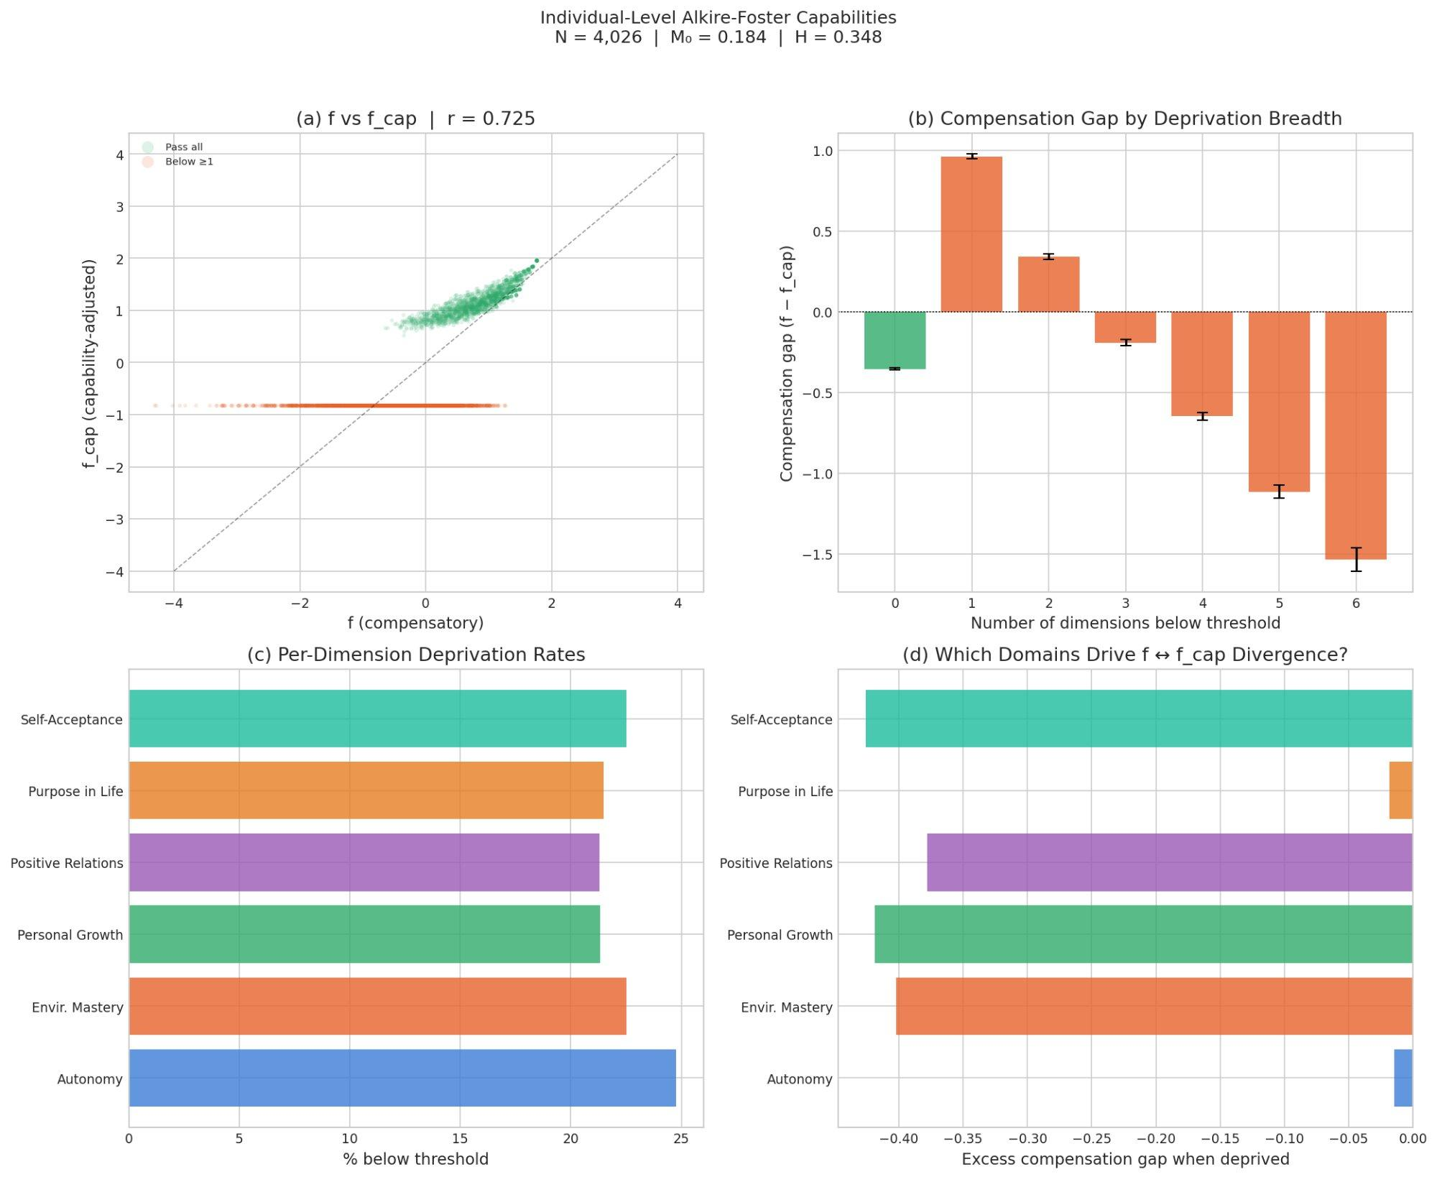
Figure 11. Individual-level Alkire-Foster capabilities: (a) f vs. f_cap divergence, (b) compensation gap by deprivation breadth, (c) per-dimension deprivation rates, (d) which domains drive f ↔ f_cap divergence (MIDUS 2, N = 4,026).
The per-dimension deprivation rates reveal which capabilities most often fail: Autonomy is the most frequently depressed domain (24.6% of individuals fall below threshold), followed by Purpose in Life (21.3%), Positive Relations (15.5%), Self-Acceptance (15.1%), Environmental Mastery (13.5%), and Personal Growth (10.0%). For clinical targeting, this suggests that Autonomy and Purpose in Life are the most frequently deprived domains — the capabilities most often falling below threshold across the sample.

Individual-Level Coupling: A Proxy and Its Limits
The mutualism model predicts that inter-domain coupling strength should relate to both resilience and vulnerability. To begin probing this at the individual level, we computed a cross-sectional coupling proxy based on profile flatness (1 minus the normalized coefficient of variation across a person’s six Ryff subscale scores). Higher values indicate tighter coupling — the person’s domains move more in lockstep.
The median coupling proxy is 0.775 (mean = 0.752, SD = 0.127), indicating that most MIDUS respondents have fairly flat profiles. The coupling proxy shows a small but highly significant negative correlation with the compensation gap (r = −0.077, p = 1.0 × 10⁻⁶), consistent with the model’s prediction: tighter coupling may coexist with narrow deprivation, because when all domains are locked together, a deficit in one domain is more visible against an otherwise uniform profile.
An important caveat: this coupling proxy is cross-sectional and measures profile flatness, not the true within-person temporal covariance that the mutualism model requires. The proper estimate of individual coupling demands longitudinal data — tracking each person’s domain scores across MIDUS waves 1, 2, and 3, and computing per-person inter-domain correlations over time. This remains a priority for future work and represents the most direct empirical test of the mutualism framework at the level where policy interventions actually operate.

Why This Matters
"The question is not whether mental health is important. The question is whether we have the right model — and therefore the right interventions."
This work matters because it changes the frame. Currently, mental health policy is organized around pathology: diagnose a disorder, treat the disorder, measure the disorder’s reduction. This is necessary but radically incomplete. The dual continua finding (f and p share only 14.4% of variance) supports the view that reducing pathology is not the same as building flourishing. They are related but distinct goals, and a system that addresses only one leaves the other untouched.
The mutualism model generates a further hypothesis. If flourishing emerges from the mutual reinforcement of wellbeing domains, then the most effective interventions would be those that strengthen cross-domain couplings. A mental health treatment that also improves social functioning and sense of purpose would not just be treating three things — it would be strengthening the system that keeps everything elevated. Conversely, an intervention that treats symptoms in isolation, without addressing the person’s relationships or their sense of meaning, might achieve temporary relief without moving the underlying f. This remains a model-derived prediction, not an established empirical result.
The stability analysis makes the stakes concrete — within the model. The model’s flourishing equilibrium has a basin of attraction, and the model predicts that people can be pushed outside it. Cascading decline is a mathematical prediction of the mutualism model: a job loss reduces competence, which strains relationships, which erodes self-acceptance, which undermines purpose. Each step weakens the couplings that would otherwise pull the system back. If this model is approximately correct, it offers a candidate mechanism for languishing — and it predicts that early, multi-domain intervention before the cascade completes would be far more effective than single-domain treatment after it does.
The capabilities-adjusted measure adds an equity dimension. Aggregate flourishing scores can mask deprivation in specific domains. A policy that raises average wellbeing while leaving autonomy untouched has not solved the problem — it has averaged over it. The individual-level Alkire-Foster analysis makes this concrete: 58.5% of MIDUS respondents fall below threshold on at least one domain, and the compensatory f score overestimates their wellbeing. Autonomy and Purpose in Life are the most frequently deprived domains, suggesting that interventions targeting self-determination and meaning-making deserve particular attention. The Alkire-Foster framework forces attention to where the thresholds are being violated, and for whom.
The bifactor results add methodological confidence. At the individual level using the Ryff PWB subscales, f captures the dominant share of common variance (ω_h = 0.789, ECV = 0.758). This is not an artifact of ecological aggregation — it holds within a single national sample at the level of individual persons. At the same time, domain-specific factors retain meaningful content, particularly for Purpose in Life and Autonomy. The implication for policy is that individual-level interventions should work within a systems framework and remain attentive to domain-specific needs.
Taken together, this body of work provides: a rigorous measurement framework for general flourishing (f) validated at both ecological and individual levels; a plausible mechanistic model that can generate the observed structure (mutualism); a stability analysis deriving predictions about recovery and vulnerability (Lyapunov); a testable coupling–resilience signature that derives falsifiable predictions from the framework; an equity-sensitive adjustment that prevents compensatory averaging (capabilities); individual-level diagnostics identifying which domains most frequently fail and for whom; and a set of model-derived implications for mental health and social policy design. The measurement results are established. The mechanistic model is a proof of concept. The policy implications are conditional on the model being approximately correct — and that awaits the longitudinal tests the paper specifies.
The hypothesis this work defends: flourishing may be better modeled as a dynamical system than as a scorecard — and if so, designing policy for systems requires different tools than designing policy for symptoms.

Technical Summary
Data. Individual level: MIDUS 2 (ICPSR 4652), Ryff PWB 6-subscale composites, N = 4,026 complete cases (4,963 respondents total). Country level: PERMA+H indicators from international wellbeing datasets, N = 140 countries.
Model 1 — Bifactor CFA. Individual level (MIDUS 2, N = 4,026): General factor f plus three specific factors (hedonic: Environmental Mastery, Self-Acceptance; eudaimonic: Personal Growth, Purpose in Life; social-agentic: Autonomy, Positive Relations). ω_h = 0.789, ECV = 0.758. df = 3, χ² = 106.66, RMSEA = 0.093. General loadings range 0.427–0.731. Strongest specific loading: Purpose in Life (0.577 on eudaimonic). Positive Relations shows near-zero specific loading (−0.146), indicating near-total capture by f.
Model 2 — Mutualism dynamical system. Coupled logistic ODEs with coupling matrix calibrated from individual-level between-person partial correlations (M̄ = 0.161; note: these are cross-sectional between-person estimates, not within-person temporal couplings). Carrying capacities C = [3.86, 3.91, 4.01, 3.92, 3.78, 3.81]. Equilibrium x* = [17.9, 24.2, 23.8, 22.7, 17.8, 24.6]; x*/C ratios range 4.64–6.47. Simulated population (N = 200): PC1 = 91.1%, mean r = 0.893, all correlations positive. Representation coherence: weak = 0.993, medium = 0.9999, sign discipline = pass, CS discipline r = 0.988. Eigenvalue dominance gap: model λ₁/λ₂ = 36.55 vs. observed 3.70.
Model 3 — Lyapunov stability & resilience. Jacobian analysis at equilibrium: all eigenvalues have negative real parts (λ₁ = −0.500 to λ₆ = −4.260). Return time τ ≈ 2.0. Basin radius = 0.996. Composite resilience R(x*) = 0.706. Recovery speed |Re(λ₁)| = 0.500. Individual-level f ↔ resilience correlation: r = 0.434 (p = 3.4 × 10⁻¹⁶⁹). Perturbation recovery is systemic, not domain-specific.
Model 4 — Individual-level capabilities (MIDUS 2). Alkire-Foster scoring on Ryff subscales (25th percentile thresholds). M₀ = 0.184, H = 0.348, A = 0.527. Threshold compliance: 1,669/4,026 (41.5%) pass all; 2,357 below ≥1. f ↔ f_cap correlation: r = 0.725. Weakest domain: Autonomy (24.6% of individuals below threshold), followed by Purpose in Life (21.3%).
Individual-level coupling proxy. Cross-sectional proxy (1 − normalized CV). Mean = 0.752, median = 0.775, SD = 0.127. Coupling ↔ compensation gap: r = −0.077 (p = 1.0 × 10⁻⁶). Proper within-person longitudinal coupling requires MIDUS panel waves.
Dual continua validation. Individual f vs. negative affect (MIDUS B1SNEGAF, a composite mood measure used as a coarse psychopathology proxy): r = −0.379, shared variance = 14.4%. Consistent with the dual-continua view that flourishing and psychopathology are meaningfully distinct dimensions.
Coupling sweep. Parametric sweep over mean coupling strength M̄. Peak resilience at M̄ ≈ 0.01 (R = 0.707, PC1 = 24.7%). Equilibrium levels and f dominance rise steeply with coupling. Basin radius collapses near M̄ ≈ 0.20. Coupling–resilience signature shows a sharp phase boundary: 50% shocks irrecoverable above the critical coupling threshold.
Implementation. ~2,400 lines of Python (NumPy, SciPy, scikit-learn, semopy, matplotlib). Full pipeline from raw data to scored output with 10 publication-quality figures. Code available at github.com/DanielKetterer/Flourishing.

