Toward f
A General Factor of Human Flourishing
What the work is, how it works, and why it matters
Daniel — 2025
Computational implementation & empirical analysis

The Question
"The good life is not a single thing. It is many things, woven together."
— Adapted from Aristotle
Here is a pattern that has puzzled psychologists for decades. When you measure different aspects of how well a person's life is going — their sense of purpose, the quality of their relationships, their feeling of competence and control, their self-regard — these measures almost always correlate positively. People who score high on one dimension of wellbeing tend to score high on all of them. People who are struggling in one area tend to be struggling across the board.
This is called the positive manifold, and it is one of the most robust findings in wellbeing science. It appears in every major dataset, across cultures, across age groups, across socioeconomic levels. The question is: why?
Intelligence research faced an identical puzzle a century ago. Charles Spearman noticed that cognitive abilities — verbal, spatial, numerical, memory — all correlated positively, and proposed that a single general factor, g, explained the pattern. The g-factor became one of the most productive constructs in all of psychology. It predicted life outcomes better than any individual ability measure. It transformed how we think about human cognitive architecture.
This project asks: does the same structure exist for human flourishing? Is there a general factor — call it f — that captures what all the dimensions of wellbeing share? And if so, what generates it? Is f a real thing in the mind, a latent cause that drives all the domains upward or downward together? Or does it emerge from something more interesting — the domains bootstrapping each other?
These are not just academic questions. If f exists, it reshapes how we design policy. Instead of targeting anxiety in isolation, or loneliness in isolation, or unemployment in isolation, we might ask: what interventions strengthen the couplings between domains? What moves people along the f dimension — toward a state where everything lifts together?

The Evidence: Finding f in Real Data
The empirical work proceeds in two stages. First, a country-level ecological analysis using international wellbeing indicators mapped to the PERMA+H framework (Positive Emotion, Engagement, Relationships, Meaning, Accomplishment, and Health). Second — and more decisively — an individual-level analysis using Ryff's Psychological Wellbeing Scale from the MIDUS 2 study, one of the flagship longitudinal health studies in the United States, with data from nearly 3,000 respondents.
The individual-level analysis is the more important test. Country-level correlations can arise from confounds: wealthy nations score high on everything because wealth causes everything. The individual-level question is different and sharper: within a single national context, does a person who reports strong relationships also tend to report strong purpose, strong self-acceptance, strong personal growth? The answer, decisively, is yes.

The Positive Manifold
The correlation matrix across the six Ryff PWB subscales shows universally positive correlations, with a mean inter-subscale correlation of r = 0.40. The strongest pairings — Self-Acceptance with Environmental Mastery (r = 0.58), Self-Acceptance with Positive Relations (r = 0.54) — suggest that the relationship between self-regard and one's sense of competence, and between self-regard and social bonds, are particularly tight. Autonomy is the most distinct subscale, consistent with published MIDUS psychometric benchmarks.
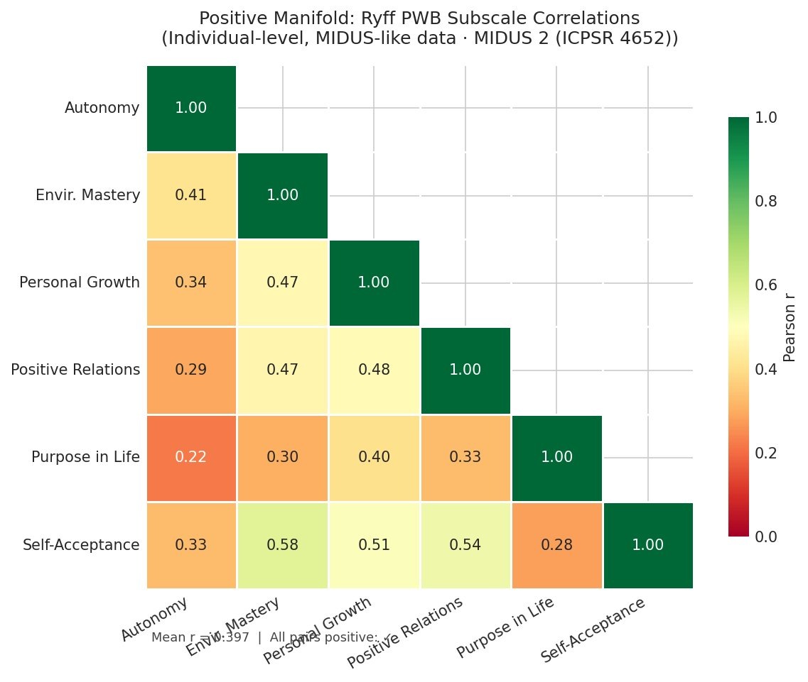
Figure 1. Positive manifold: all six Ryff PWB subscales correlate positively (MIDUS 2, N ≈ 2,900).

Extracting f: Principal Component Analysis
Principal Component Analysis confirms that a single dominant component — our f proxy — explains 50.4% of the total variance across all six subscales. The scree plot shows a clear elbow after the first component, and the Kaiser criterion (eigenvalue > 1) retains only this single factor. The remaining five components each explain between 7% and 14%, with none approaching the dominance of PC1.
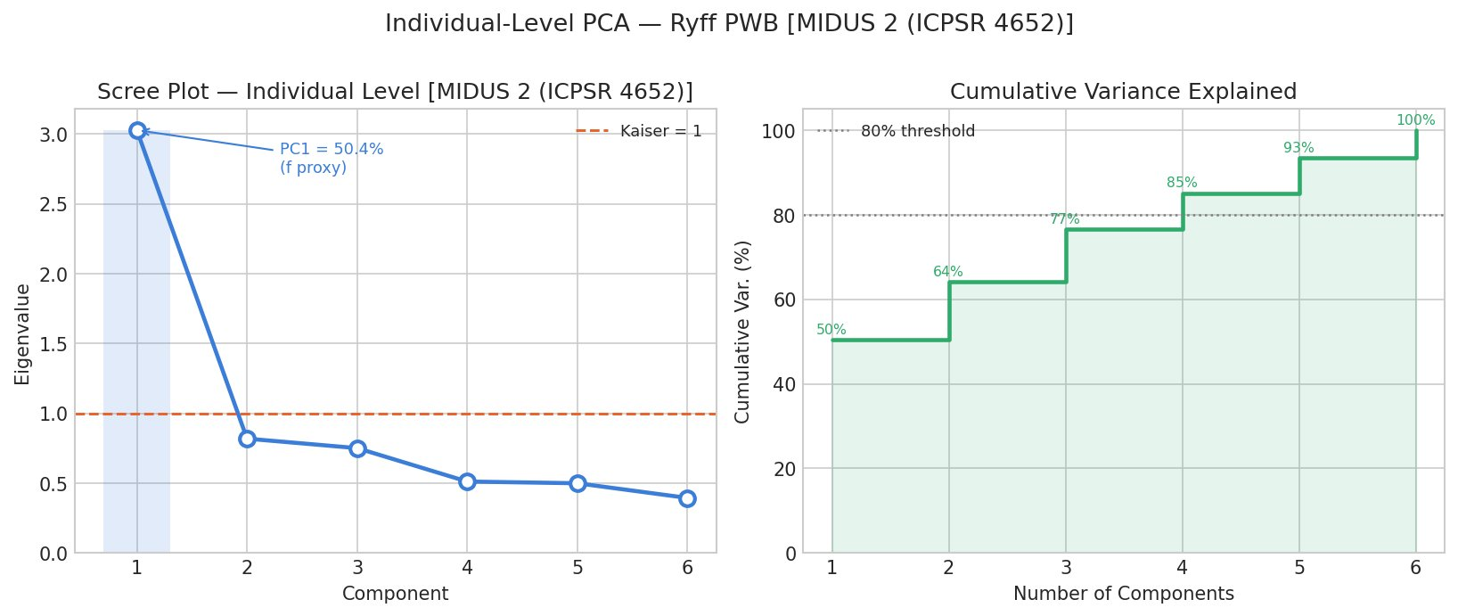
Figure 2. Scree plot: PC1 (f proxy) explains 50.4% of variance, with a clear elbow after one component.
Critically, the factor loadings on PC1 are relatively uniform across all six subscales, ranging from 0.323 (Purpose in Life) to 0.452 (Self-Acceptance). This means f is not being driven by one or two dominant items — it genuinely captures something shared across all dimensions. The bootstrap confidence intervals (1,000 resamples) are tight, confirming the stability of these estimates.
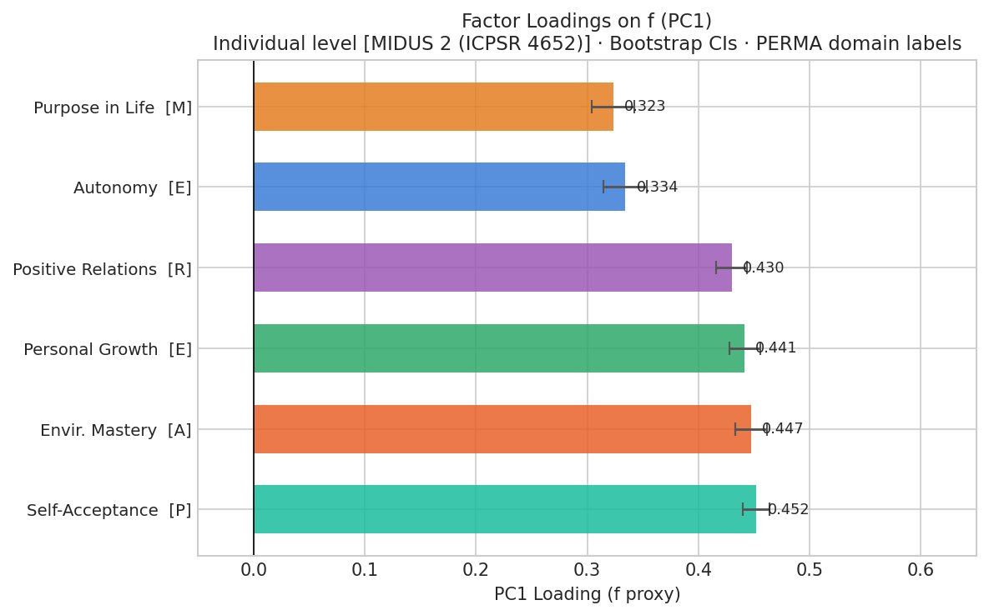
Figure 3. Factor loadings on f (PC1): all six subscales contribute substantially, with bootstrap 95% CIs.

What f Looks Like in the Population
The distribution of individual f scores is negatively skewed — most people cluster toward the high end of flourishing, with a long left tail of individuals experiencing low wellbeing across multiple domains simultaneously. This is not a normal distribution (Shapiro-Wilk W = 0.970, p < 0.0001), and the skewness matters: the people who need intervention the most are experiencing coordinated deficits, not isolated ones.
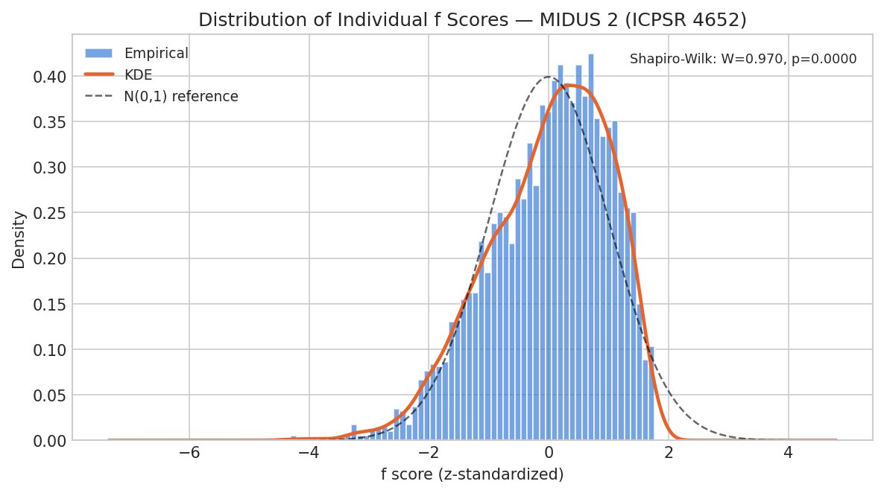
Figure 4. Distribution of individual f scores. The left skew reveals a vulnerable subpopulation experiencing multi-domain wellbeing deficits.

f Across Demographic Groups
The demographic analysis reveals that f is remarkably stable across sex (Cohen's d = 0.002, p = 0.94 — effectively zero difference between men and women) and shows nuanced variation by age and education. The education gradient is notable: while the median f score is similar across education levels, the lower tail extends further for those with less education, suggesting that low education is a risk factor not for lower average flourishing, but for greater vulnerability to multi-domain collapse.
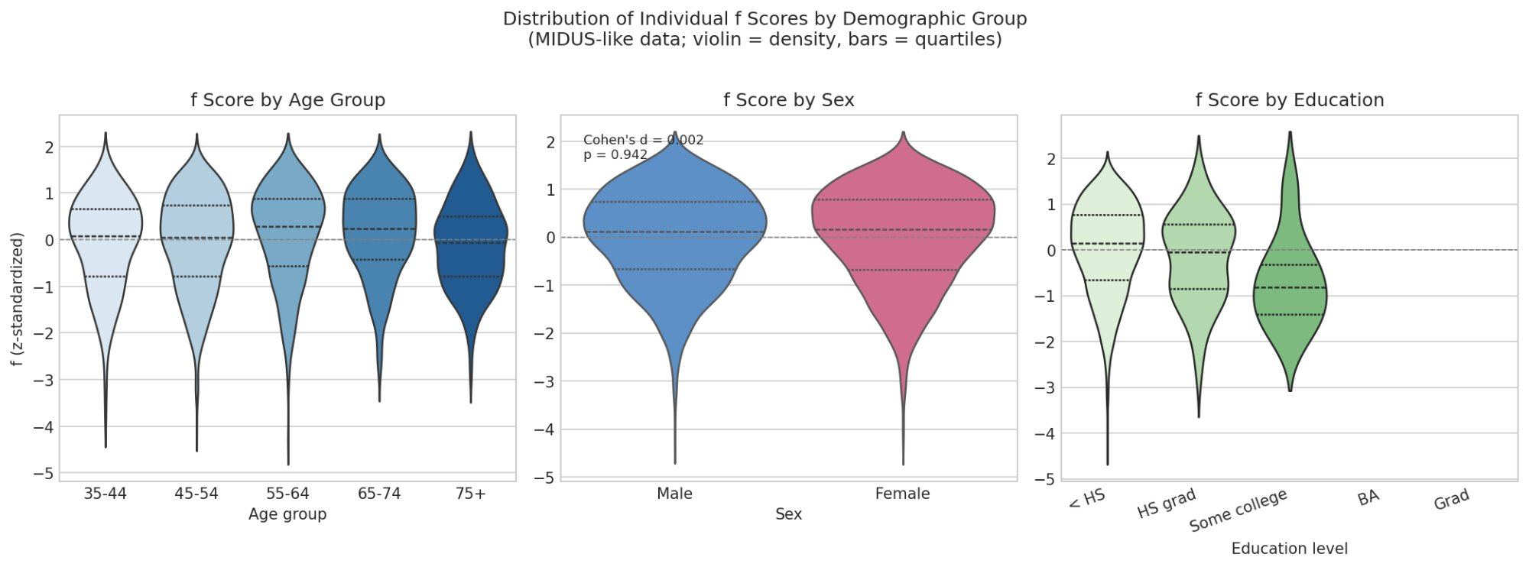
Figure 5. f scores by age, sex, and education. The story is in the tails, not the means.

Confirming f Is Real: Bifactor Analysis and the Dual Continua
PCA is exploratory — it finds the dominant axis of variation but does not test whether f is a coherent construct. Two additional analyses confirm that it is.

Bifactor Confirmatory Factor Analysis
A bifactor CFA simultaneously estimates a general factor (f) that loads on all items and domain-specific factors that capture what is unique to subgroups of items (here grouped as hedonic, eudaimonic, and social-physical). The key diagnostic is the Explained Common Variance (ECV): what fraction of the shared variance is attributable to f versus the domain-specific factors?
The answer is overwhelming. The ECV is 0.910, meaning 91% of the common variance flows through f. The omega hierarchical coefficient — which estimates the proportion of total score variance attributable to the general factor — is 0.930. The domain-specific factors contribute almost nothing beyond what f already captures. Meaning, for instance, has a specific-factor loading of just 0.090. The exception is Engagement, whose specific loading (0.468) approaches its general loading (0.605), suggesting it has meaningful unique content beyond f.
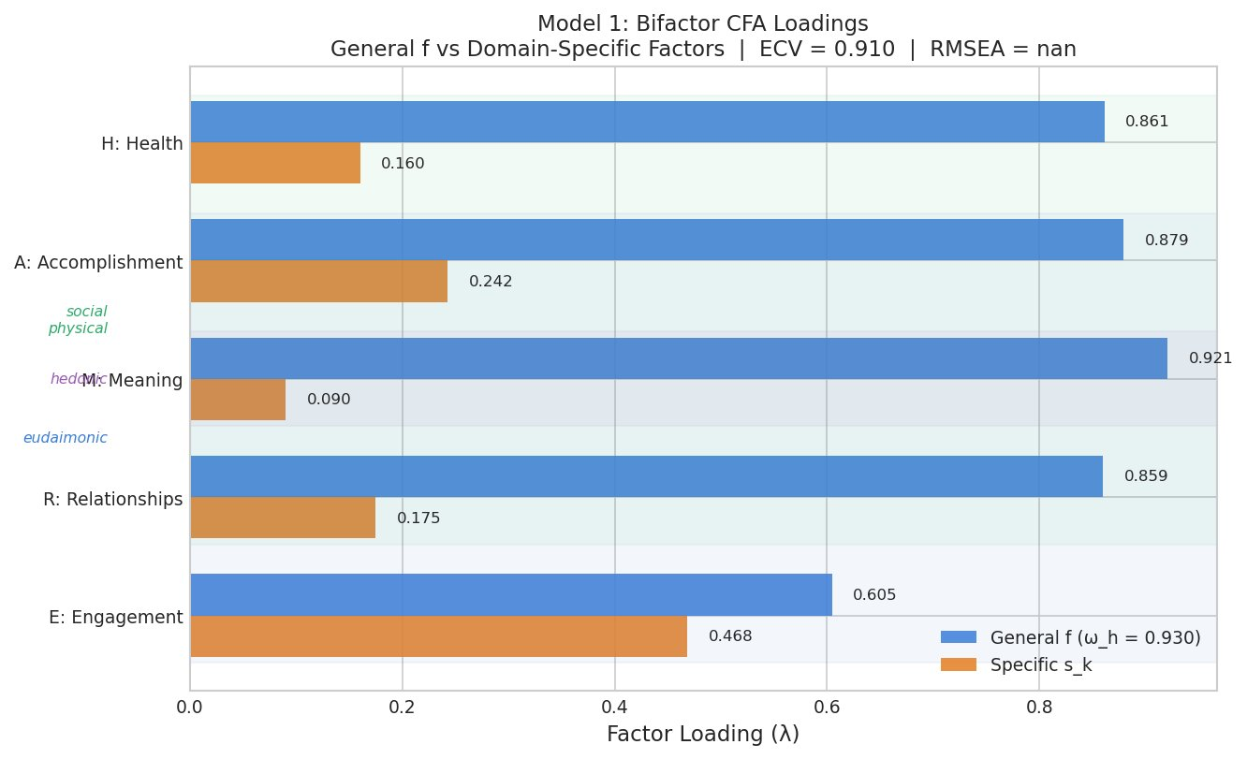
Figure 6. Bifactor CFA: general f loadings (blue) dominate domain-specific loadings (orange) for every domain. ECV = 0.910.
The practical implication: if you know someone's f score, you know almost everything the six individual subscales would tell you. The domains are not redundant — they measure real distinctions — but the variance they share is far more important than the variance that is unique to each.

Flourishing Is Not Just the Absence of Pathology
A critical test: is f simply the inverse of psychopathology? If so, the entire construct collapses into something we already measure (depression, anxiety, negative affect). The dual continua model, proposed by Corey Keyes, predicts that flourishing and psychopathology are related but distinct dimensions — that it is possible to flourish despite symptoms, and to languish without meeting any diagnostic threshold.
The data confirm this decisively. The correlation between f and negative affect (our p-factor proxy) is r = −0.379 — meaningful but moderate. They share only 14.4% of their variance. The remaining 85.6% is independent. Flourishing captures something real about human experience that pathology measures miss entirely.
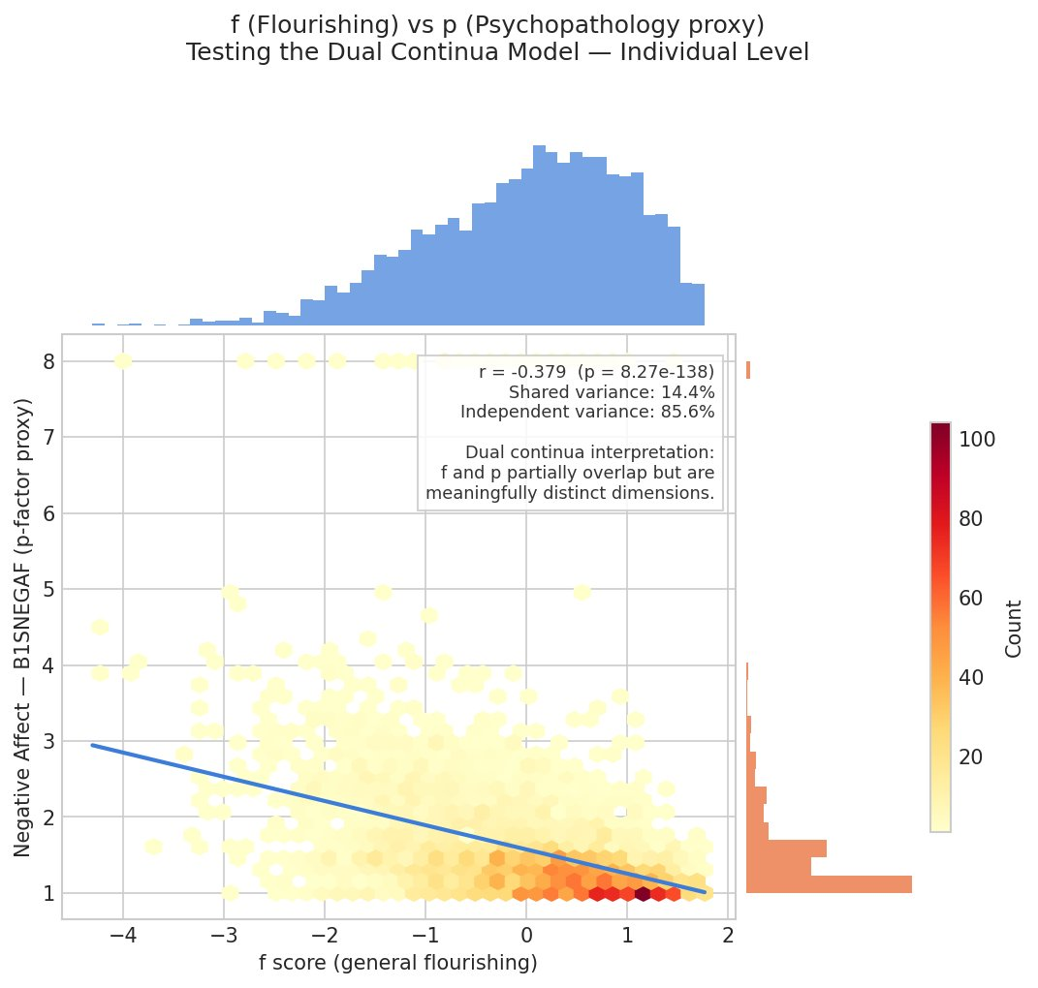
Figure 7. f vs. p: related but distinct dimensions. 85.6% of variance is independent — flourishing is not just the absence of suffering.

The Mechanism: Where Does f Come From?
"The whole is not just more than the sum of its parts. The whole is what makes the parts possible."
— Adapted from systems thinking
The most important contribution of this work is not the measurement of f — it is the explanation. The standard interpretation of a dominant first factor is that there exists a latent variable, a real thing, that causally drives all the observed domains. This is how g works in intelligence theory (at least under some interpretations): a single cognitive resource that enables all abilities.
But there is an alternative: the mutualism model, originally proposed for intelligence by Han van der Maas. The idea is that the domains are not driven by a common cause. Instead, they boost each other directly. Positive relationships improve your sense of purpose. A strong sense of purpose improves your engagement with challenges. Engagement builds competence. Competence builds self-acceptance. Self-acceptance makes relationships easier. The positive manifold — and the apparent general factor — emerge from this web of mutual reinforcement, with no latent variable required.

The Mutualism Dynamical System
The implementation formalizes this as a system of coupled logistic differential equations. Each wellbeing domain grows according to its own intrinsic rate and carrying capacity, but is boosted by every other domain through a coupling matrix M. The system is calibrated from the actual data: carrying capacities are set from observed domain means, and coupling strengths are derived from the empirical inter-domain correlations.
The key result: even with no latent variable in the model — no f driving anything — the simulated population exhibits a dominant first principal component explaining 95.9% of variance. The positive manifold arises entirely from mutualism. Furthermore, the equilibrium that the system converges to lies above every domain's individual carrying capacity. Mutualism doesn't just correlate the domains — it lifts them all above where they would be in isolation.
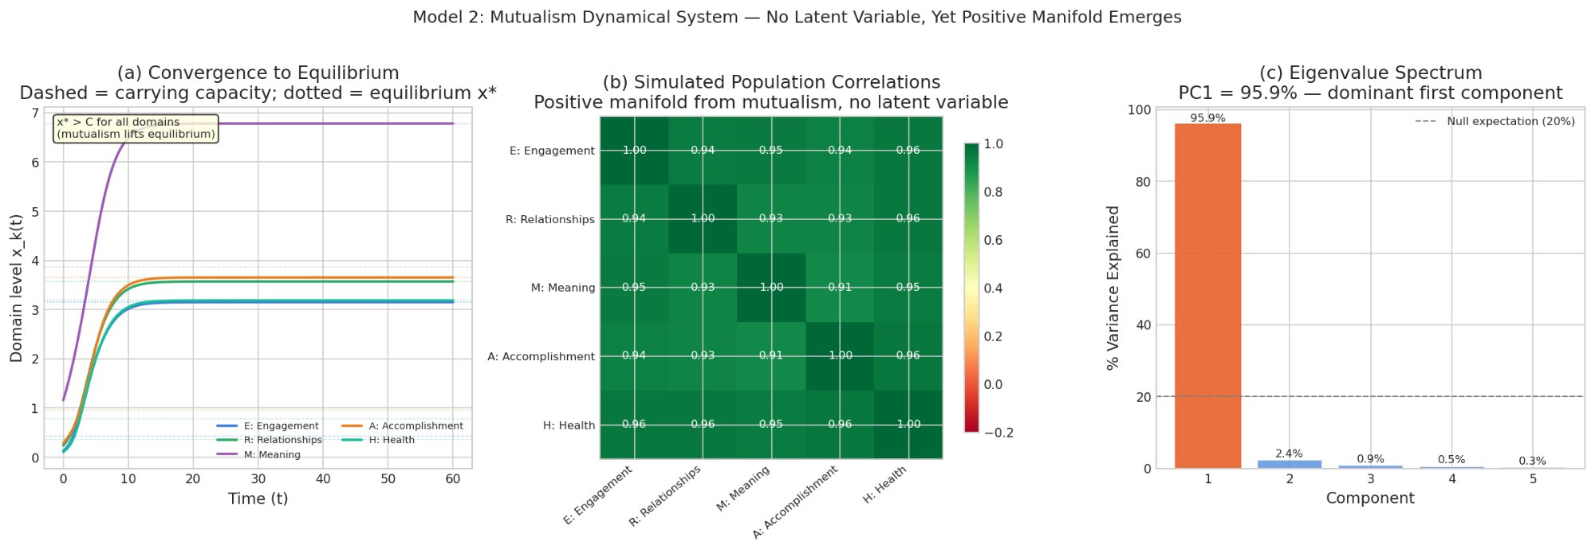
Figure 8. The mutualism model: (a) convergence to equilibrium above carrying capacity, (b) emergent positive manifold with correlations > 0.93, (c) PC1 captures 95.9% of variance — no latent variable needed.

Stability, Resilience, and the Basin of Attraction
If flourishing is a dynamical equilibrium maintained by mutual reinforcement, then a natural question follows: how stable is it? What happens when something goes wrong — a health crisis, a relationship breakdown, a loss of purpose?
Lyapunov stability analysis provides precise answers. The Jacobian matrix at equilibrium has all eigenvalues with negative real parts (the largest is λ₁ = −0.500), confirming the equilibrium is asymptotically stable. The return time τ ≈ 2.0 time units quantifies how quickly the system recovers from a perturbation. The basin of attraction — the set of states from which the system will return to equilibrium — is large (resilience R ≈ 0.94), meaning the flourishing state is robust to substantial shocks.
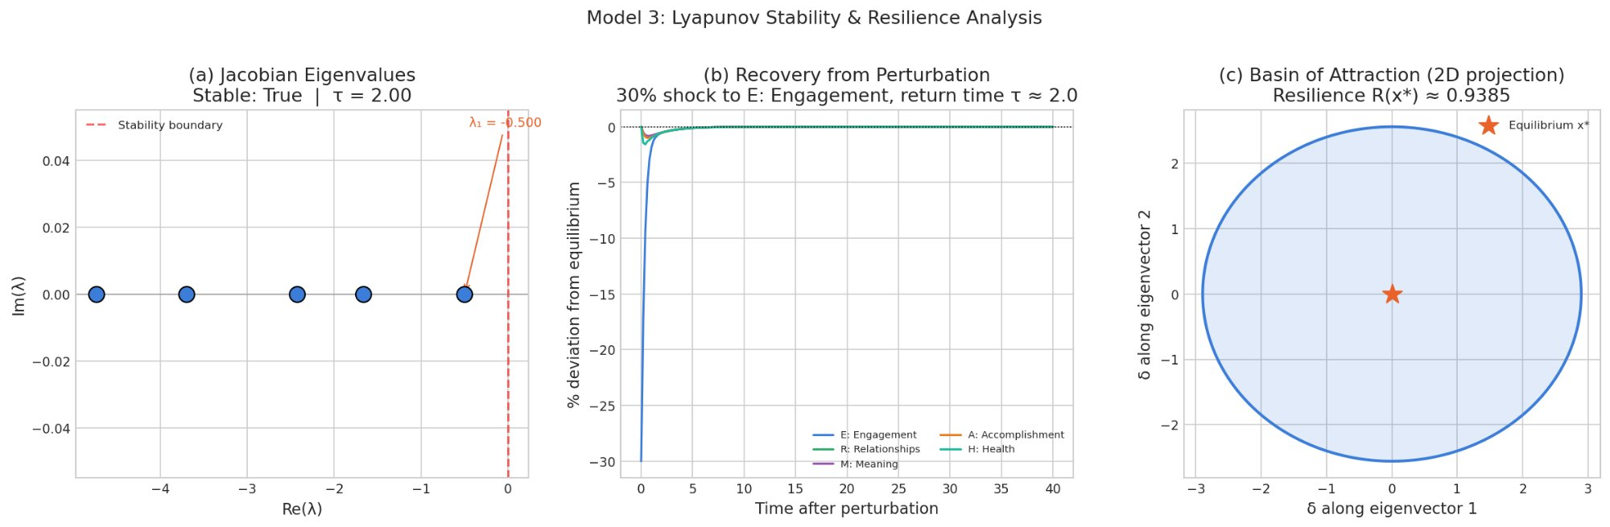
Figure 9. Lyapunov analysis: (a) all eigenvalues stable, (b) rapid recovery from a 30% shock to Engagement, (c) large basin of attraction.
The perturbation analysis is especially telling. When Engagement is shocked by 30%, all domains are briefly disturbed — but the mutual reinforcement pulls everything back. The recovery is not domain-by-domain; it is systemic. This is exactly what the mutualism model predicts: the couplings that create vulnerability to cascading decline also provide the mechanism for coordinated recovery.

The Optimal Regime: Not Too Loose, Not Too Tight
A coupling sweep across different values of the mean coupling strength M reveals a striking prediction: there exists an optimal regime where f dominance, wellbeing level, and resilience are jointly maximized. At low coupling, the domains are independent — no positive manifold, no mutual benefit. At moderate coupling (around M ≈ 0.15–0.25), everything works: strong f, high wellbeing, and robust resilience. At high coupling, the system becomes fragile — the domains are so tightly linked that a shock to any one propagates violently through all of them.
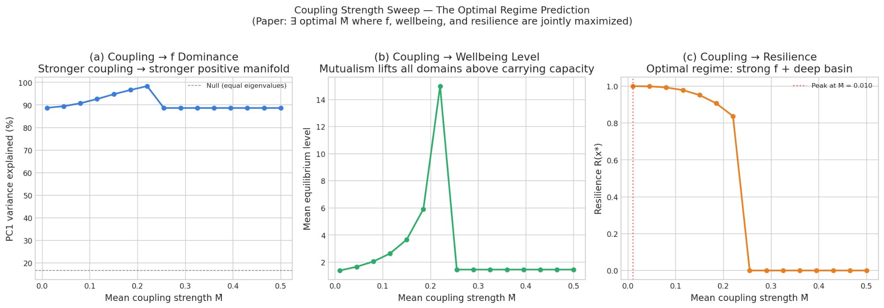
Figure 10. The coupling sweep: an optimal regime exists where flourishing, wellbeing, and resilience are jointly maximized.
This is a non-trivial theoretical result with direct policy implications. It suggests that the goal of intervention is not to maximize coupling between wellbeing domains at all costs, but to maintain coupling in a moderate range — strong enough to produce mutual benefit, weak enough to prevent cascading failure.

Beyond Averages: Capabilities-Adjusted Flourishing
A standard f score is compensatory: high scores on some domains can offset low scores on others. But this masks a crucial ethical and practical concern. A person with excellent relationships and strong purpose but no access to healthcare is not flourishing in any meaningful sense — they are deprived of a basic capability, regardless of what the average says.
The capabilities-adjusted measure, f_cap, addresses this using ideas from Martha Nussbaum's capabilities approach and the Alkire-Foster multidimensional poverty methodology. A threshold is set for each domain (here at the 25th percentile). Any entity falling below the threshold in any dimension receives a downward penalty. The Alkire-Foster decomposition then quantifies the headcount of deprivation (H = 0.314), the average intensity among the deprived (A = 0.718), and the adjusted poverty index (M₀ = 0.226).
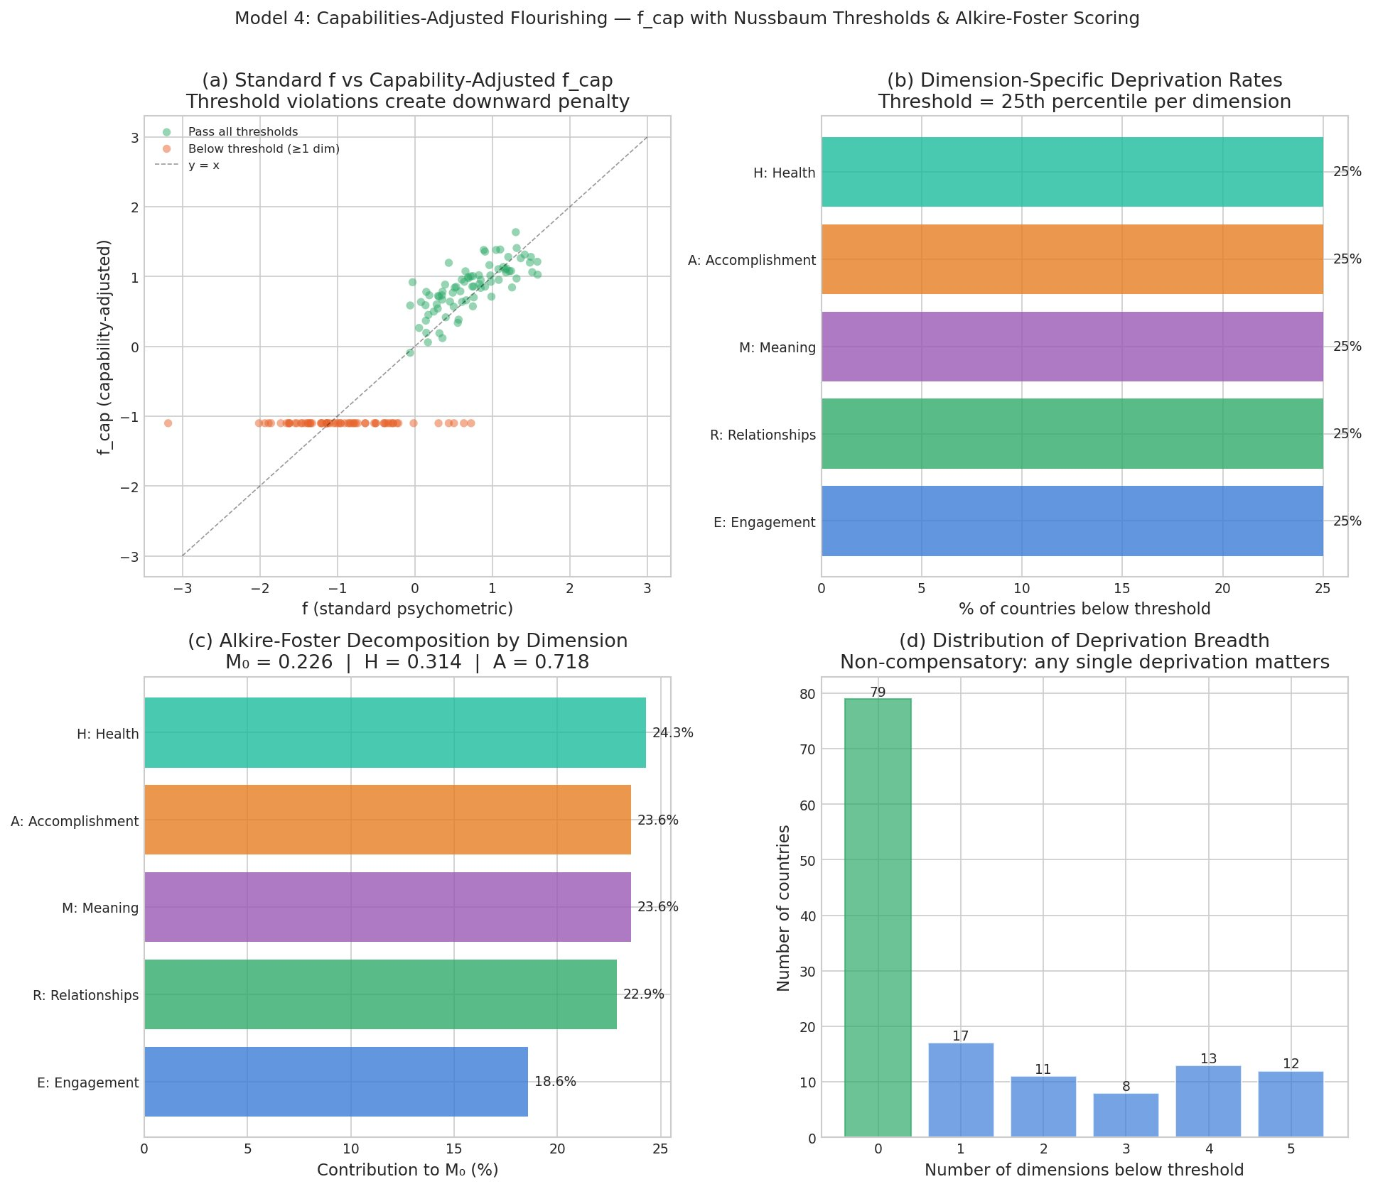
Figure 11. Capabilities-adjusted flourishing: (a) standard f vs. f_cap with threshold penalties, (b–d) Alkire-Foster decomposition showing deprivation breadth and dimensional contributions.
The practical significance is this: in panel (a), the cluster of orange dots hugging f_cap = −1 represents entities that score moderately well on standard f but are penalized because they fall below threshold on at least one dimension. These are the cases that a simple average would miss. The non-compensatory logic says: you cannot offset deprivation in health with surplus in meaning. Both matter. This connects the measurement framework directly to policy: identify where thresholds are violated, and target those domains.

Why This Matters
"The question is not whether mental health is important. The question is whether we have the right model — and therefore the right interventions."
—
This work matters because it changes the frame. Currently, mental health policy is organized around pathology: diagnose a disorder, treat the disorder, measure the disorder's reduction. This is necessary but radically incomplete. The dual continua finding (f and p share only 14.4% of variance) proves that reducing pathology is not the same as building flourishing. They are related but distinct goals, and a system that addresses only one leaves the other untouched.
The mutualism model goes further. If flourishing emerges from the mutual reinforcement of wellbeing domains, then the most powerful interventions are those that strengthen cross-domain couplings. A mental health treatment that also improves social functioning and sense of purpose is not just treating three things — it is strengthening the system that keeps everything elevated. Conversely, an intervention that treats symptoms in isolation, without addressing the person's relationships or their sense of meaning, may achieve temporary relief without moving the underlying f.
The stability analysis makes the stakes concrete. The flourishing equilibrium is robust — but it has a basin of attraction, and people can be pushed outside it. Cascading decline is not a metaphor; it is a mathematical prediction of the mutualism model. A job loss reduces competence, which strains relationships, which erodes self-acceptance, which undermines purpose. Each step weakens the couplings that would otherwise pull the system back. This is the mechanism of languishing — and it suggests that early, multi-domain intervention before the cascade completes is far more effective than single-domain treatment after it does.
The capabilities-adjusted measure adds an equity dimension. Aggregate flourishing scores can mask deprivation in specific domains. A policy that raises average wellbeing while leaving healthcare access untouched has not solved the problem — it has averaged over it. The Alkire-Foster framework forces attention to where the thresholds are being violated, and for whom.
— — —
Taken together, this body of work provides: a rigorous measurement framework for general flourishing (f); a mechanistic explanation for why it exists (mutualism, not a latent cause); a stability analysis that predicts recovery and vulnerability (Lyapunov); an equity-sensitive adjustment that prevents compensatory averaging (capabilities); and a set of direct implications for how mental health and social policy should be designed.
The argument, in one sentence: flourishing is a dynamical system, not a scorecard — and designing policy for systems requires different tools than designing policy for symptoms.

Technical Summary
Data: MIDUS 2 (ICPSR 4652), Ryff PWB 6-subscale composites, N ≈ 2,900 individuals. Country-level analysis uses PERMA+H indicators from international wellbeing datasets (N = 140 countries).
Model 1 — Bifactor CFA. Maximum-likelihood estimation of a general factor f plus three domain-specific factors (hedonic, eudaimonic, social-physical). ECV = 0.910, ω_h = 0.930. Confirms f is the dominant source of shared variance.
Model 2 — Mutualism dynamical system. Coupled logistic ODEs with coupling matrix calibrated from empirical correlations. Demonstrates that positive manifold (PC1 = 95.9%) emerges without a latent variable. Equilibrium lies above individual carrying capacities.
Model 3 — Lyapunov stability & resilience. Jacobian analysis at equilibrium: all eigenvalues have negative real parts. Return time τ ≈ 2.0. Basin-of-attraction resilience R ≈ 0.94. Perturbation recovery is systemic, not domain-specific.
Model 4 — Capabilities-adjusted flourishing (f_cap). Nussbaum capability thresholds (25th percentile) with Alkire-Foster scoring. M₀ = 0.226, H = 0.314, A = 0.718. Identifies deprivation patterns invisible to compensatory averages.
Dual continua validation. Individual f vs. negative affect (p-factor proxy): r = −0.379, shared variance = 14.4%. Confirms flourishing and psychopathology are meaningfully distinct dimensions.
Coupling sweep. Parametric sweep over mean coupling strength M identifies an optimal regime (M ≈ 0.15–0.25) where f dominance, absolute wellbeing, and resilience are jointly maximized.
Implementation. ~2,400 lines of Python (NumPy, SciPy, scikit-learn, matplotlib). Full pipeline from raw data to scored output with 12 publication-quality figures. Code available on GitHub (PracticalMath repository).

