**Optimization Tool Sets**

1. **WECA**

* <https://researchcommons.waikato.ac.nz/bitstream/handle/10289/1040/uow-cs-wp-1999-11.pdf?sequence=1&isAllowed=y>

1. **OAT (Optimization Algorithm ToolKit)**

* <http://optalgtoolkit.sourceforge.net/index.php>

1. **Dlib-ml: A Machine Learning Toolkit**

* <http://www.jmlr.org/papers/volume10/king09a/king09a.pdf>

**Papers about GA-PSO or Solution Spaces**

* **PSO-GSA (Particle Swarm Optimization, Gravitational Search Algorithm Hybrid**
  + [**https://ieeexplore.ieee.org/abstract/document/6141614**](https://ieeexplore.ieee.org/abstract/document/6141614)
  + Has some good benchmark functions ^
* **Gene selection in cancer classification using PSO/SVM and GA/SVM hybrid algorithms**
  + [**https://ieeexplore.ieee.org/abstract/document/4424483**](https://ieeexplore.ieee.org/abstract/document/4424483)
* **GA and a novel PSO-GA-based hybrid algorithm**
  + [**https://www.sciencedirect.com/science/article/pii/S0020019004003254**](https://www.sciencedirect.com/science/article/pii/S0020019004003254)
* **Variable-Length Particle Swarm Optimization for Feature Selection on High-Dimensional Classification**
  + <https://ieeexplore.ieee.org/document/8458226>

**Benchmark Optimization Functions**

* Ackley's function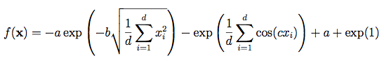
* Eggholder function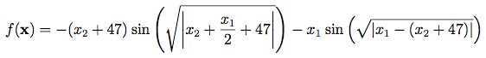
* Holder Table function

https://lh6.googleusercontent.com/UCpwYhyOEodTYbvAxVMwyNpvLyopHwOrGYZLE7Uss6Ay2CrCIR1y3IJyb-g1JE6-Ojw43wEld7XC_qQlh-kOsMXe40Yqg7kZnzOPtWzHxsXTW8baIOV1h16HhIpt5QLomDNozfop

* Levy function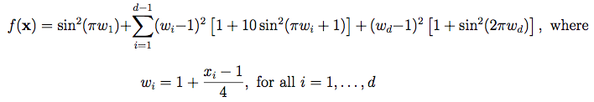
* Rastrigin function

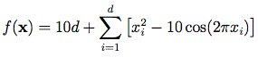

* Sphere function

