Daniel Kissner

CSD-310

Module 5.3 Assignment

February 4, 2024

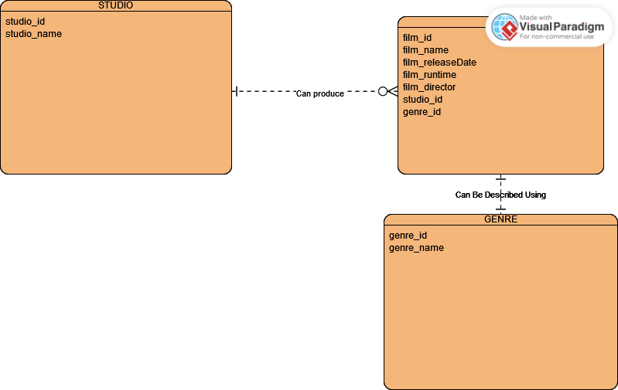

I promise that the top right box is labeled “FILM” but the watermark cuts it off.