Daniel Kissner

CSD 340

Module 1 Assignment 1

March 24, 2024

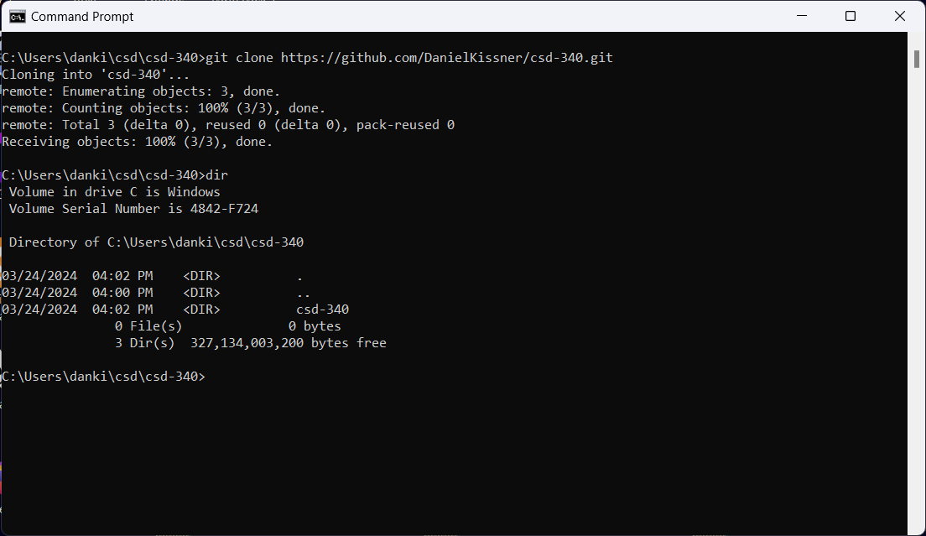

<https://github.com/DanielKissner/csd-340>

