StockMaster ANN Report
Horizon: h1 | Rows evaluated per asset: 600
Model: ANN (MLPRegressor and MLPClassifier pipelines as available)

AAPL
Regression metrics:
MAE | RMSE | R2 | MAPE% | DirAcc
2.7738 | 3.7956 | 0.9750 | 1.3545 | 0.5259
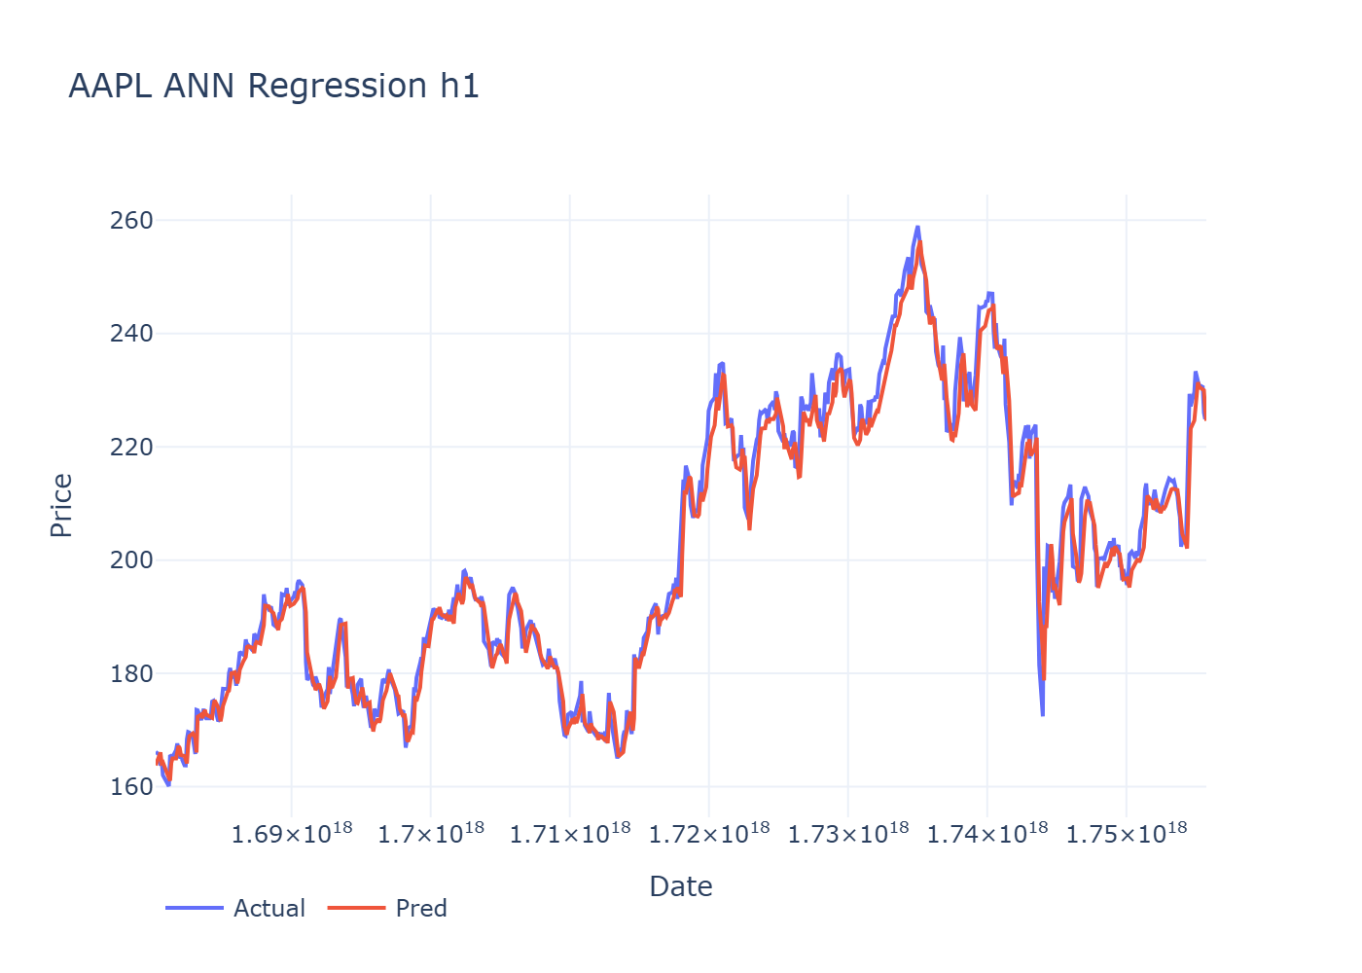
Classification metrics:
Accuracy | Precision | Recall | F1
0.3217 | 0.3750 | 0.3128 | 0.2688

AMZN
Regression metrics:
MAE | RMSE | R2 | MAPE% | DirAcc
2.7506 | 3.8198 | 0.9889 | 1.5749 | 0.4891
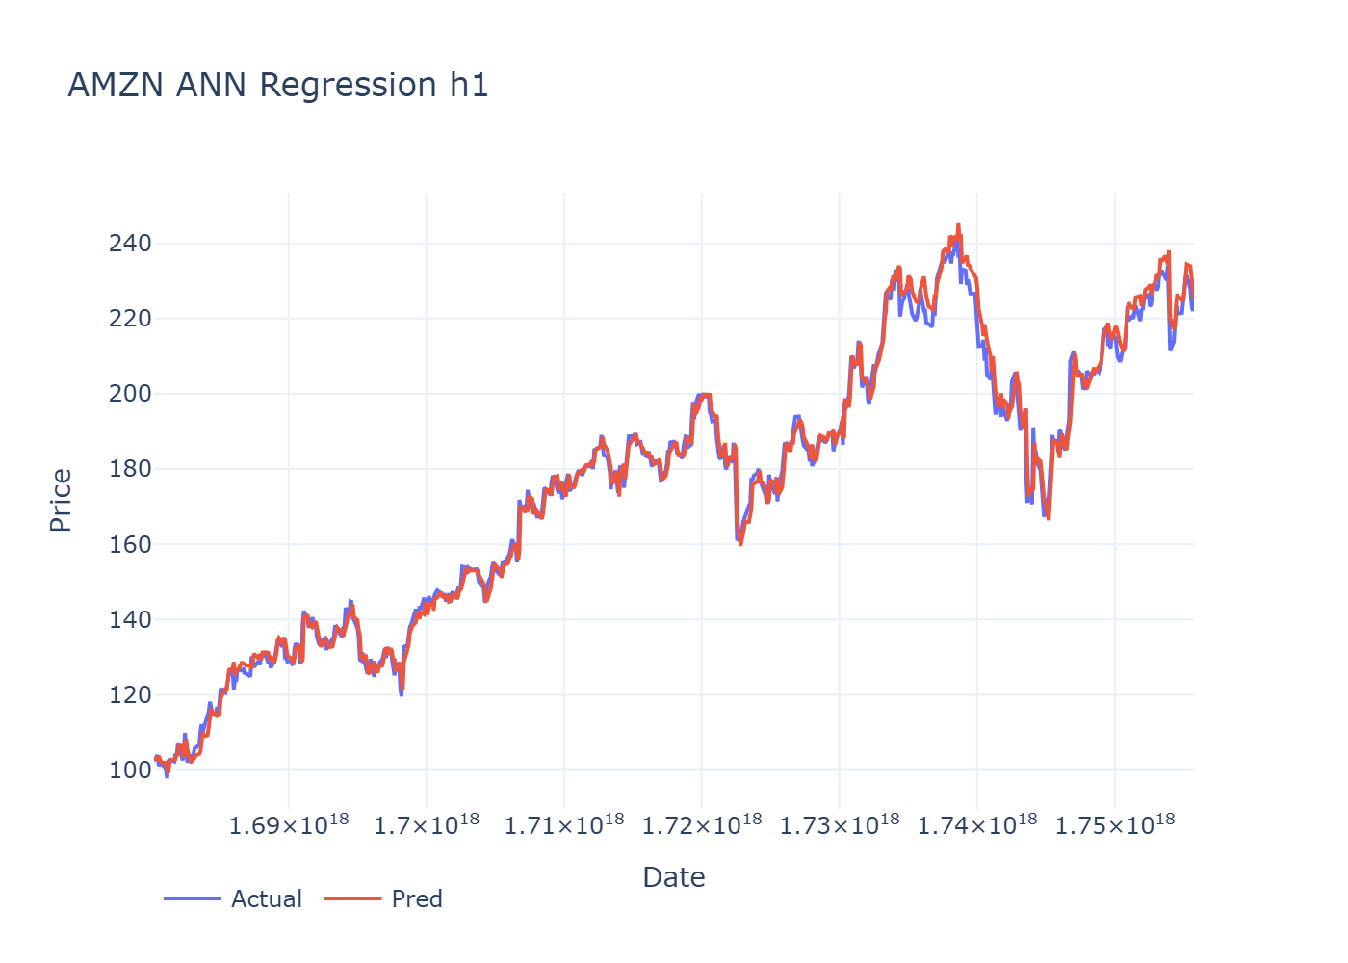
Classification metrics:
Accuracy | Precision | Recall | F1
0.3783 | 0.3215 | 0.3412 | 0.3236

