Daniel Kolodziej

[dkolodz1@hawk.iit.edu](mailto:dkolodz1@hawk.iit.edu)

ITMD-462 Project 2

**Project Description:**

Creation of a php application that is able to create, edit, and delete a note by the user. The application will have a main index page that will display a list of all the notes displaying the notes’ author, subject, body, and last modified time. Upon the index page the user may click on the subject to view the note and have the options to edit and delete the note. If edited or deleted the note and note list is then updated.

**Development Environment:**

The project was completed under the Windows 7 operating system. XAMPP v3.2.2 was used as a local environment. The code was written in Notepad++.

**Installation Instructions:**

There is a folder called NoteEdit, containing php files, “index.php”, “create.php”, “edit.php”, “delete.php”, “note.php”, “FileNoteRepository.php”, “INoteRepository.php”, and “show.php”. There will also be another folder in it called data which holds a data.txt that has serialized information from the notes.

**Insights and Results:**

I learned how to create an application that is able to create, edit, and delete data that is saved to a file. A challenge I faced was with the time recording of the saving/editing. I found the filemtime method but that updated the modified time on all the files because all the files were recorded in to one text file.

**Screenshots:**

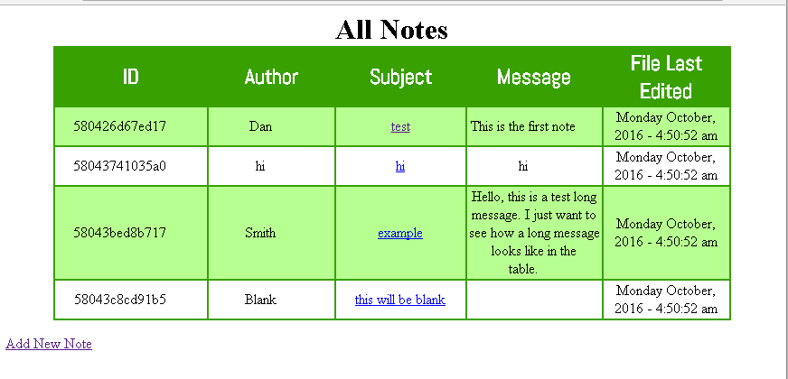

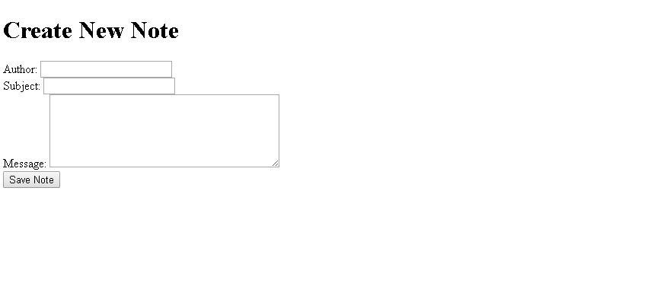

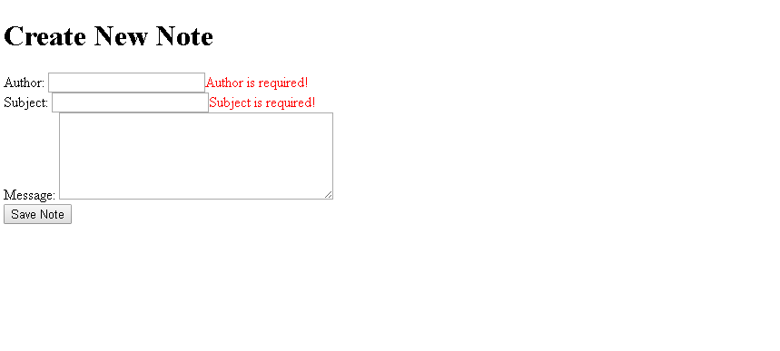

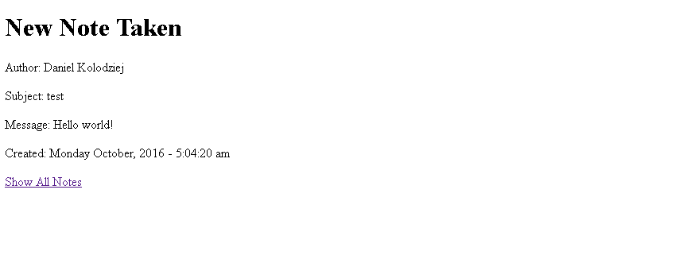

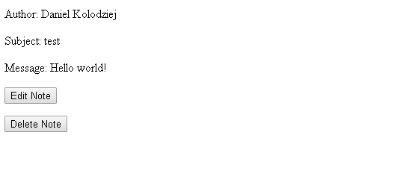

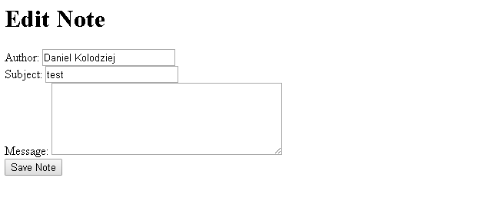

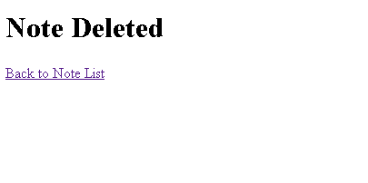

**References:**

http://php.net/manual/en/function.filemtime.php