Daniel Kolodziej

[dkolodz1@hawk.iit.edu](mailto:dkolodz1@hawk.iit.edu)

ITMD-462 Project 3

**Project Description:**

Make an update to a previous project which is the Note taking application. This application should be able to allow a user to create, edit, and delete notes which will be displayed on the index page. The data will be saved and placed into a SQLite database file. Any note changes and updates will be result and an update to the SQLite database file.

**Development Environment:**

The project was completed under the Windows 7 operating system. XAMPP v3.2.2 was used as a local environment. The code was written in Notepad++.

**Installation Instructions:**

There is a folder called NoteEdit, containing php files, “index.php”, “create.php”, “edit.php”, “delete.php”, “note.php”, “FileNoteRepository.php”, “INoteRepository.php”, “show.php”, and “SqliteNoteRepository”. There will also be another folder in it called data which holds a data.txt that has serialized information from the notes as well as a data.sqlite file holding the information in the sqlite database.

**Insights and Results:**

I learned how to create a note taking application that is able to create, edit, and delete data that is saved to a SQLite database. A challenge I faced was with the time recording of the saving/editing. I found the filemtime method but that updated the modified time on all the files because all the files were recorded in to one database.

**Screenshots:**

Index page

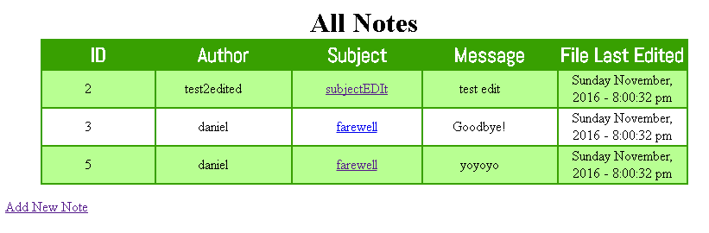

Create

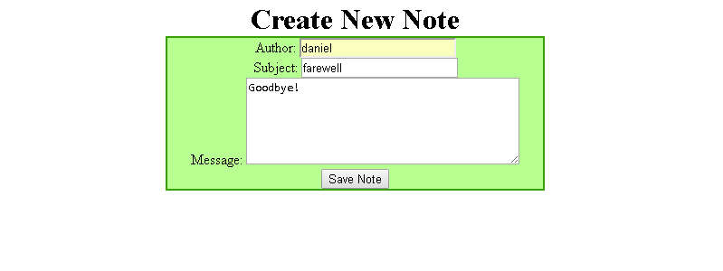

Edit

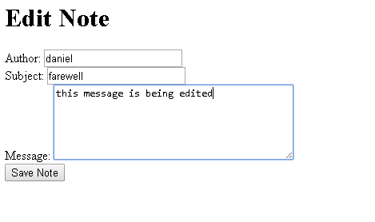

Show

