Daniel Kolodziej

ITMD 413

Final pass gen random

SNAPSHOTS:

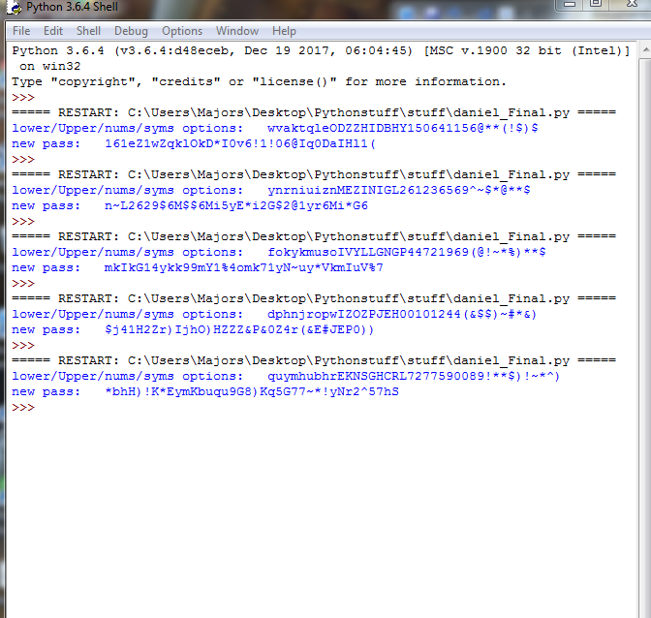

Source code:

#Daniel Kolodziej

#ITMD 413 final

#pass gen

import random

totalOptions="abcdefghijklmnopqrstuvwxyz0123456789ABCDEFGHIJKLMNOPQRSTUVWXYZ~!@#$%^&\*()"

letters="abcdefghijklmnopqrstuvwxyz"

lettersUP="ABCDEFGHIJKLMNOPQRSTUVWXYZ"

numbers="0123456789"

symbols="~!@#$%^&\*()"

password1=""

length1 = random.randint(8,10)

length2 = random.randint(8,10)

length3 = random.randint(8,10)

length4 = random.randint(8,10)

for val in range(length1):

password1 += random.choice(letters)

for val in range(length2):

password1 += random.choice(lettersUP)

for val in range(length3):

password1 += random.choice(numbers)

for val in range(length4):

password1 += random.choice(symbols)

print("lower/Upper/nums/syms options: " + password1)

scramble =""

scrambled=""

scramble = password1

passLen = len(scramble)

for val in range(passLen):

scrambled += random.choice(scramble)

print("new pass: " + scrambled)