

NATIONAL UNIVERSITY
Computer Science Program

CSC 480A
Professor Jeffery Appel, Ph.D.

Software Design Document (Top Level):
Retro Fix Inventory Manager v1.0
January 24, 2016

Prepared for:
Retro Fix Video Games

Prepared by:
Kevin Powell
Eric Bergren
Daniel LaVergne
Eric Sweeten

Approvals
Title | Printed Name | Signature | Date
Client Representative | Rudy Treadwell |  | 1/24/2016
Project Manager | Dr. Jeffrey Appel |  | 1/24/2016
Project Leader | Kevin Powell |  | 1/24/2016
Software Engineering | Eric Sweeten |  | 1/24/2016
Document Control | Daniel LaVergne |  | 1/24/2016
Quality Manager | Eric Bergren |  | 1/24/2016

Revision Change Record
Revision No. | Date | ECO No. | Description | Name | Approval
1 | 1/17/2016 | 0001 | Preliminary Outline | K. Powell
1 | 1/24/2016 | 0002 | Second Draft | K. Powell | Dr. Appel

Table of Contents
1 Scope 5
1.1 System Overview 5
1.2 Glossary 5
1.2.1 Definitions 5
1.2.2 Acronyms 6
1.2.3 Abbreviations 7
1.3 Document Overview 7
2 References 7
3 CSCI Overview 8
3.1 CSCI Architecture 8
3.2 Non-Functional Scenarios and Tactics 11
3.2.1 Quality Attribute Scenarios 11
3.2.2 Quality Tactics 16
3.3 General Constraints 21
3.4 Assumptions and Dependencies 21
3.4.1 Assumptions 21
3.4.2 Dependencies 21

Table of Figures

Figure 3.2.1.1 Performance Quality Attribute Scenarios 11
Figure 3.2.1.2.1 Security Quality Attribute Scenarios 12
Figure 3.2.1.2.2 Security Quality Attribute Scenarios Two 12
Figure 3.2.1.3 Maintainability Quality Attribute Scenarios 13
Figure 3.2.1.4 Correctness Quality Attribute Scenarios 13
Figure 3.2.1.5 Testability Quality Attribute Scenarios 14
Figure 3.2.1.6 Usability Quality Attribute Scenarios 14
Figure 3.2.1.7 Portability Quality Attribute Scenarios 15
Figure 3.2.1.8 Modifiability Quality Attribute Scenarios 15
Figure 3.2.1.9 Availability Quality Attribute Scenarios 16
Figure 3.2.2.1 Performance Quality Tacticts 16
Figure 3.2.2.2 Security Quality Tacticts 17
Figure 3.2.2.3 Maintainability Quality Tacticts 17
Figure 3.2.2.4 Correctness Quality Tacticts 18
Figure 3.2.2.5 Testability Quality Tacticts 18
Figure 3.2.2.6 Usability Quality Tacticts 19
Figure 3.2.2.7 Portability Quality Tacticts 19
Figure 3.2.2.8 Performance Quality Tacticts 20
Figure 3.2.2.9 Performance Quality Tacticts 21

List of Tables

Table 1.2.1 Defintions 5
Table 1.2.2 Acronyms 6
Table 1.2.3 Abbreviations 7

1 Scope

1.1 System Overview
Retro Fix Inventory Manager is a custom designed and developed program for the Retro Fix Video Games store. The program is tailored to fit the inventory and bookkeeping needs of the business. There is built-in support for an administrator to add and manage other users and their access levels. Different users can have varying capabilities to manipulate the database files and information within them for the program.
The primary component that the product will provide the business and the administrator is the ability to create, manipulate, save, store, and load database files which contain all of the relevant information for the store’s inventory data. These functionalities will enable the business to record, track, and save all of the games and merchandise in the current inventory stock.
The user accounts can be created and set by the system administrator. The database loaded through the program requires a login with a password which can be set by the account owner. The necessary database files are essentially password protected and secured by the fact that they inaccessible without the correct password. The files are also stored in a binary format instead of text, so they can not be opened and read directly.
Retro Fix Inventory Manager allows for alteration and customization of the GUI and window that displays the program. The user shall be able to edit the color of the font as well as the background and border. The background of the window can also be changed to a custom image that will be displayed.
Another component of the Retro Fix Inventory Manager program is the ability to sort sections of the database by individual attributes. The contents of the database can be sorted in ascending or descending order by value, loose price, complete price, new price, condition, box, manual, notes or by name. The items can be sorted alphabetically for values with text and any values that are numbers are sorted numerically. The capability to sort the database will allow for simplified browsing of inventory information as well as finding specific elements.

1.2 Glossary

1.2.1 Definitions

Table 1.2.1: Definitions
Terminology | Definition
Operational Concept Document | A document describing the characteristics of a proposed system from the viewpoint of a user of that system.
Software Project Management Plan | A document describing the execution plan for the proposed software application.
Software Requirements Specifications | A document outlining and document the requirements for the proposed software solution.
Solution Strategy | A step-by-step explanation of the strategy to accomplish the project goals.

1.2.2 Acronyms
Table 1.2.2: Acronyms
CSC | Computer Software Component
CSCI | Computer Software Component Interface
CSU | Computer Software Unit
GUI | Graphical User Interface
OCD | Operational Concept Document
JRE | Java Runtime Environment
JVM | Java Virtual Machine
RFIM | Retro Fix Inventory Manager
SPMP | Software Project Management Plan
SRS | Software Requirements Specifications

1.2.3 Abbreviations

Table 1.2.3: Abbreviations
I/O | Input/Output

1.3 Document Overview
The Retro Fix Inventory Manager v1.0 Software Design Document (SDD) is divided into 7 separate and individual sections. Section 1 is the overall introduction to the SDD document as well as any background information regarding the project that it is referencing in particular. Section 2 provides references used in the composition of the document itself. Section 3 is comprised of the Computer Software Component Interface (CSCI). Section 4 is the Detailed Design portion of the document which includes detailed information about each Computer Software Component (CSC) and Computer Software Unit (CSU). Section 5 is the CSCI Data section and Section 6 is the CSCI Data Files Section.

2 References

Powell K., Bergren E., LaVergne D., Sweeten E. (2015). Operational Concept Document. Unpublished Manuscript, CSC 480A Computer Science Project I, National University, United States.

Powell K., Bergren E., LaVergne D., Sweeten E. (2015). Software Project Management Plan. Unpublished Manuscript, CSC 480A Computer Science Project I, National University, United States.

Powell K., Bergren E., LaVergne D., Sweeten E. (2016). Software Requirements Specification. Unpublished Manuscript, CSC 480B Computer Science Project I, National University, United States.

Pressman, R. (2010). Software engineering: A practitioner's approach (7th ed.). New York: McGraw-Hill Higher Education.

3 CSCI Overview

The Retro Fix Inventory Manager program is an independent project and does not have any relationship with any other inventory programs.

The overview of the CSCI will provide a high-level depiction of the important and significant Computer Software Components relevant to the system itself. The Retro Fix Inventory Manager program is a desktop Java application that allows for the complete management and tracking of store inventory for the Retro Fix Video Games store. This CSCI consists of primary CSC components that efficiently enable for the overall functionality of the program. Every CSC that is represented and identified in the high level overview and diagram can potentially be broken down further into sub CSC and CSU components in an effort to further elaborate the functionality of the system architecture. The following are descriptions for all of the properties of the CSCI, each and every CSC as well as their respective sub section CSC and CSU elements.

3.1 CSCI Architecture

Retro Fix Inventory Manager (CSCI)
- View inventory items (CSC)
  - View name (CSU)
  - View loose price (CSU)
  - View complete price (CSU)
  - View new price (CSU)
  - View box (CSU)
  - View manual (CSU)
  - View condition (CSU)
  - View notes (CSU)
  - View value (CSU)
- Add inventory items (CSC)
  - Customize name (CSU)
  - Customize loose price (CSU)
  - Customize complete price (CSU)
  - Customize new price (CSU)
  - Customize box (CSU)
  - Customize manual (CSU)
  - Customize condition (CSU)
  - Customize notes (CSU)
  - Customize manual (CSU)
  - Customize condition (CSU)
  - Customize value (CSU)
- Modify inventory items (CSC)
  - Modify name (CSU)
  - Modify loose price (CSU)
  - Modify complete price (CSU)
  - Modify new price (CSU)
  - Modify box (CSU)
  - Modify manual (CSU)
  - Modify condition (CSU)
  - Modify notes (CSU)
  - Modify manual (CSU)
  - Modify condition (CSU)
  - Modify value (CSU)

- Duplicate inventory item (CSC)
- Delete inventory item (CSC)
- View section (CSC)
- Add section (CSC)
  - Customize name (CSU)
- Modify section (CSC)
  - Customize name (CSU)
- Delete section (CSC)
- View section report (CSC)
  - View printable report for section report (CSU)
  - Modify tab size for printable section report (CSU)
- View complete report (CSC)
  - View printable report for complete report (CSU)
  - Modify tab size for printable complete report (CSU)
- Load database (CSC)
  - Select username (CSU)
  - Select password (CSU)
- Save database (CSC)
- Close database (CSC)
- User management (CSC)
  - Add user name (CSU)
  - Modify user name (CSU)
  - Delete user name (CSU)
  - Modify user abilities (CSC)
    - Modify user’s ability to add items (CSU)
    - Modify user’s ability to modify items (CSU)
    - Modify user’s ability to delete items (CSU)
    - Modify user’s ability to add sections (CSU)
    - Modify user’s ability to modify sections (CSU)
    - Modify user’s ability to delete sections (CSU)
    - Modify user’s ability to order items (CSU)

- Log out (CSC)
- Password management (CSC)
  - Change password (CSU)
- Settings (CSC)
  - Modify background color (CSC)
    - 13 different colors to choose from, all being built-in Java constants for colors, including Black, Blue, Cyan, Dark_Gray, Gray, Green, Light Gray, Magenta, Orange, Pink, Red, White, and Yellow, all of which are their own CSU
- Modify foreground color (CSC)
  - Same as previous (colors) - (CSU)
- Modify border color (CSC)
  - Same as previous (colors) - (CSU)
- Modify background image (CSU)
- Modify “Show invalid numbers” option which shows the user invalid numbers(CSU)
- ”Restore Defaults” option that restores default settings (CSU)

3.2 Non-Functional Scenarios and Tactics

3.2.1 Quality Attribute Scenarios

3.2.1.1 Performance
The performance quality attribute scenario deals with the response time, utilization, and throughput behavior of the system. The source can come from either the administrator or a user account which must be created by the administrator. The stimulus occurs when a user changes data in the Retro Fix Inventory Manager program. With less than one second of latency, the data should be correct and complete.

Figure 3.2.1.1 Performance Quality Attribute Scenarios
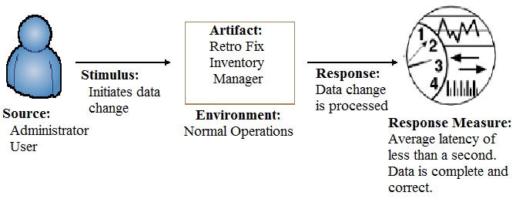

3.2.1.2 Security
There are two components of concern regarding the security quality attribute scenario. The first is the log in process and the second is data storage and encryption. When an administrator or user attempts to log in to the system, the program will authenticate the user name and password. If they cannot be authenticated, the program will deny access to the database. If the user name and password are authenticated, the program will recognize what functions that user is allowed to control. The administrator user has control over all functions and can grant control to any other users.

Figure 3.2.1.2.1 Security Quality Attribute Scenarios
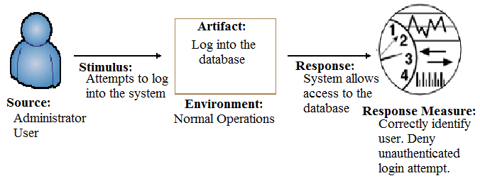
The second component of the security quality attribute scenario is data storage and encryption. The data is saved in binary format which prevents an unauthorized user from viewing it in text format. The program translates the data to make it easily viewable for an authenticated user.

Figure 3.2.1.2.2 Security Quality Attribute Scenarios Two
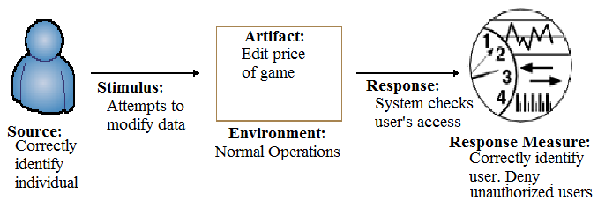

3.2.1.3 Maintainability
The maintainability of the program is very high due to the fact that it is a self contained database. With this there are no outside sources that must connect with it and there are no alterations that can be done from outside the program. The system allows for data entry, alteration, deletion and a few preferences, there should be no issues with maintaining the program due to the simple interactions allowed.

Figure 3.2.1.3 Maintainability Quality Attribute Scenarios
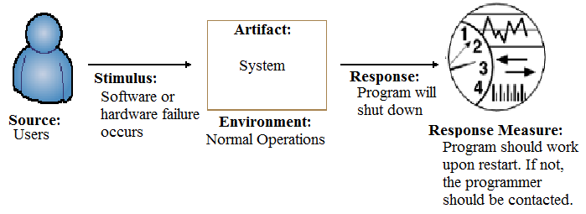

3.2.1.4 Correctness
All information stored in the program is input by the user exactly as it is typed so the information provided will be as accurate as the user makes it. Due to constant changes in inventory, it is important to continue to make changes to keep the information as correct and current as possible. It is also important to keep a set standard for number values in order to keep the calculations done by the program accurate.

Figure 3.2.1.4 Correctness Quality Attribute Scenarios
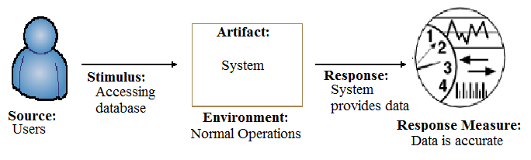

3.2.1.5 Testability
The testability quality attribute scenario regards the ease and accuracy of how well errors and other mistakes can be found and corrected. The developers of the program are also responsible for testing it. They will stimulate the system or system function in order to test it. The system will then attempt to complete the actions requested and the result of that attempt will be the response measure.

Figure 3.2.1.5 Testability Quality Attribute Scenarios
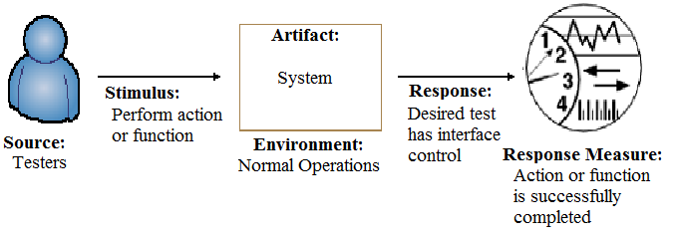

3.2.1.6 Usability
The usability quality attribute scenario concerns how easy it is to learn and use the program. The program is relatively simple and learning and building confidence with the software should be readily attainable for any end-user with basic computer skills. The end-users of the program can provide the usage necessary for minimizing errors to the system under normal circumstances. The desired outcome and response in this particular case requires the needs of the user to cancel the current operation and then measure the response including the criteria that the operation cancel request will occur within one second.

Figure 3.2.1.6 Usability Quality Attribute Scenarios
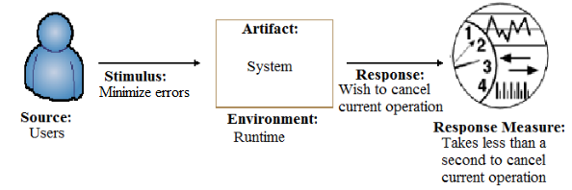

3.2.1.7 Portability
The portability quality attribute scenario is concerned with how well the program adapts to being installed on different platforms. This will be tested by the developers and possibly by the users eventually. The goal is to make the program easily run on multiple platforms, including but not limited to the major ones: Windows, Mac, and Linux. The system includes the program as well as Java.

Figure 3.2.1.7 Portability Quality Attribute Scenarios
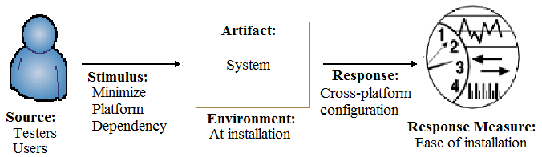

3.2.1.8 Modifiability
The modifiability quality attribute scenario concerns how much effort is needed to implement changes within the software. In this scenario, the administrator or users have to interact and change data within the system. The changes happen during normal operations and the desired response is that the data will be saved quickly and correctly.

Figure 3.2.1.8 Modifiability Quality Attribute Scenarios
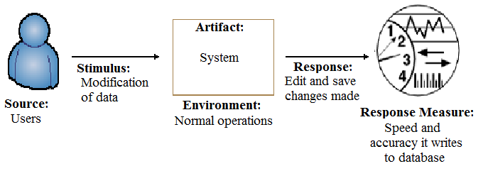

3.2.1.9 Availability
The availability quality attribute scenario is concerned with the amount of time that the program is running correctly and how quickly the program can be running correctly after a failure. In this scenario, a hardware or software error occurs during normal operations and the program terminates. The software is restarted by the user and the desired response is the program restarting and running without error. The user is responsible for correcting any hardware problems as hardware is not included with the program.

Figure 3.2.1.9 Availability Quality Attribute Scenarios
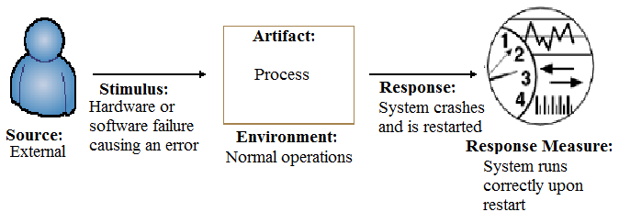

3.2.2 Quality Tactics

3.2.2.1 Performance
The tactic to apply to the performance quality attribute includes resource demand. This is general dependent upon the machine running the program. The program requirements are minimal and it can be run on most modern machines. But the performance will be minimally affected by computational speed and efficiency and the size of the data queues. The necessary available resources must be allocated.

Figure 3.2.2.1 Performance Quality Tactics
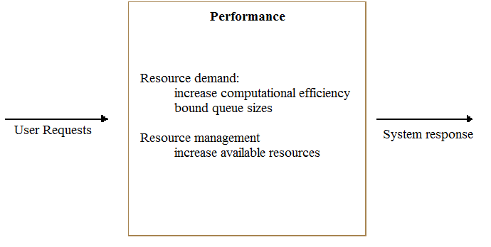

3.2.2.2 Security
The tactic to apply to the security quality attribute is password-protecting the database and only allowing the administrator full access along with encrypting the data so it can not be accessed in text form outside of the program. Both of these tactics were discussed in section 3.2.1.2.
Figure 3.2.2.2 Security Quality Tactics
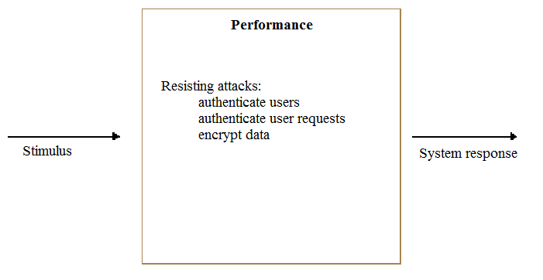

3.2.2.3 Maintainability
The tactic to apply to the maintainability quality attribute is maintaining the software. This is done by keeping Java up-to-date. If the program needs updating, it will need to be done by the programmer. It is unlikely the program will need to be updated as it is self-contained and does not interact with any external devices or programs.

Figure 3.2.2.3 Maintainability Quality Tactics
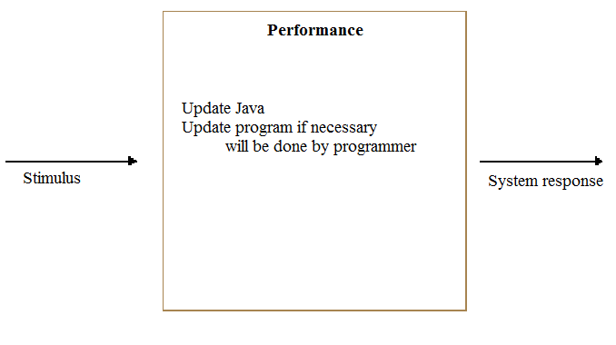
3.2.2.4 Correctness
The appropriate tactic to apply to the correctness quality attribute include data entry specifications, which requires that data entered is of the correct type. Another factor is the enforcement of data specification when retrieving the data from the database. The data must also be displayed uniformly throughout the system.
Figure 3.2.2.4 Correctness Quality Tactics
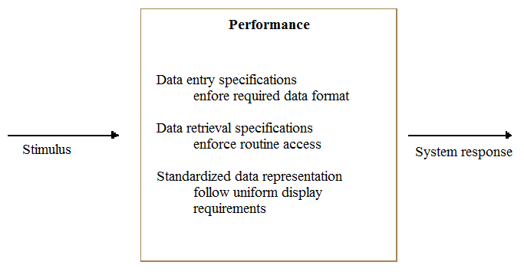

3.2.2.5 Testability
The appropriate tactic to apply to the testability quality attribute include managing input and output, and internal monitoring. These include all of the functions within the program, including but not limited to, add, delete, edit, change font, change background and numerous other functions. By utilizing internal monitoring, faults can more efficiently be detected.

Figure 3.2.2.5 Testability Quality Tactics
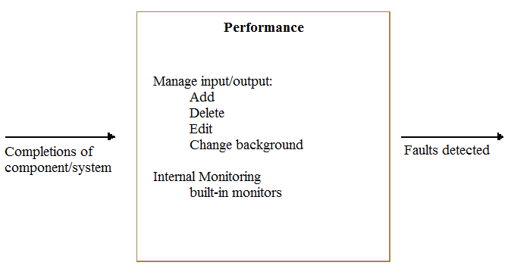

3.2.2.6 Usability
The appropriate tactic to apply to the usability quality attribute is to allow customizable interfaces for different users. The administrator will be able to assign different users with different privileges.

Figure 3.2.2.6 Usability Quality Tactics
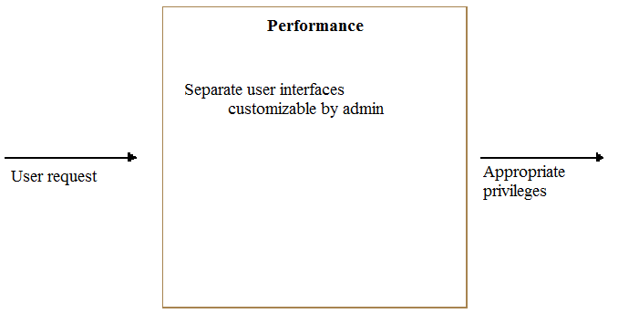
3.2.2.7 Portability
The appropriate tactic to apply to the portability quality attribute is to design the program with multiple platforms in mind. The program should be adaptable to different environments. The desire is to have a program that can easily be installed and run on different platforms.

Figure 3.2.2.7 Portability Quality Tactics
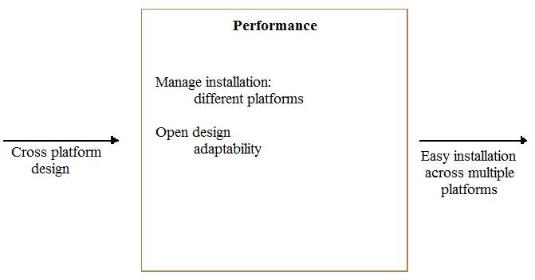
3.2.2.8 Modifiability
The appropriate tactic to apply to the modifiability quality attribute is anticipation and adaptability. The program should anticipate changes to software and hardware and be able to adapt to them with minimal disruption to the user. This will be easier for this program because it is self-contained and does not need to also adjust to external changes.

Figure 3.2.2.8 Modifiability Quality Tactics
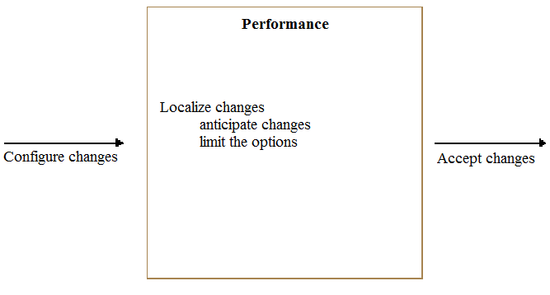

3.2.2.9 Availability
The appropriate tactic to apply to the availability quality attribute depends on the error. The program will give an incorrect-input error if the input data does not match the data type of the cell. If the program crashes, the user must restart the program. If the error continues after inputting the correct data type, the programmer should be contacted. Software errors are the responsibility of the programmer but hardware errors are the responsibility of the user as the program does not come with any hardware.

Figure 3.2.2.9 Availability Quality Tactics
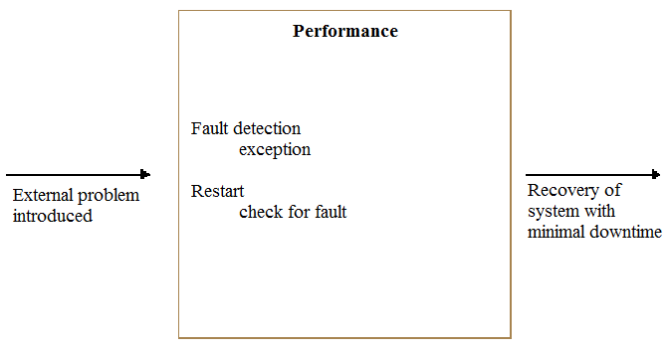

3.3 General Constraints
- Team Retro Fix has approximately a three month window to get the moderate version up and running and ready to be delivered to the customer
- The appropriate documentation must be developed and finished for delivery with the moderate version of the Retro Fix Inventory Manager v1.0 program.
- Team Retro Fix only has four members total to work on the project.
- Team Retro Fix must be able to present the working prototype of the project as well as all of the relevant documentation to a panel within three months time.

3.4 Assumptions and Dependencies

3.4.1 Assumptions
- The user has a computer that is capable of running a Java application.
- The user will either have Java installed or be able to download and install Java for the computer on which the program is being run.
- The user has basic computer skills to navigate an operating system that supports the program as well as the GUI and a Java application.
- The user understands the concept of an administrator and ability to manage users.
3.4.2 Dependencies
- There will be at least one programmer available to maintain the programmer after the final moderate version is delivered to the customer.
- The version of the JRE that is installed on the machine with the program is a compatible version and release of Java.
- Java will continue to be supported and maintained by Oracle.

