

NATIONAL UNIVERSITY
Computer Science Program

CSC 480A
Professor Jeffery Appel, Ph.D.

Software Project Management Plan:
Retro Fix Inventory Manager v1.0
January 6, 2016

Prepared for:
Retro Fix Video Games

Prepared by:
Kevin Powell
Eric Bergren
Daniel LaVergne
Eric Sweeten

Approvals

Title | Printed Name | Signature | Date
Client Representative | Rudy Treadwell |  | 1/6/2016
Project Manager | Dr. Jeffrey Appel |  | 1/6/2016
Project Leader | Kevin Powell |  | 1/6/2016
Software Engineering | Eric Sweeten |  | 1/6/2016
Document Control | Daniel LaVergne |  | 1/6/2016
Quality Manager | Eric Bergren |  | 1/6/2016

Revision Change Record
Revision No. | Date | ECO No. | Description | Name | Approval
1 | 12/13/05 | 0001 | Preliminary Outline | K. Powell
2 | 12/14/05 | 0002 | Second Draft | K. Powell | Dr. Appel
3 | 1/6/2016 | 0003 | Third Draft | K. Powell | Dr. Appel

Table of Contents
1 Introduction 5
1.1 Project Overview 5
1.2 Project Deliverables 5
1.3 Evolution of the SPMP 7
1.4 Reference Materials 7
1.5 Definition and Acronyms 8
2 Project Organization 9
2.1 Process Model 9
2.2 Organizational Structure 10
2.3 Organizational Boundaries and Interfaces 11
2.4 Project Responsibilities 11
3 Managerial Process 12
3.1 Management Objectives and Priorities 12
3.2 Assumptions, Dependencies, Constraints 12
3.2.1 Assumptions 12
3.2.2 Dependencies 12
3.2.3 Constraints 12
3.3 Risk Management 12
3.3.1 Risk Identification 12
3.3.2 Risk Estimation/Projection 13
3.3.3 Risk Evaluation 14
3.3.4 Risk Aversion Options 15
3.4 Monitoring and Controlling Mechanics 19
3.4.1 Risk Monitoring Procedures 19
3.4.2 Contingency Plan 19
3.5 Staffing Plan 19
4 Technical Process 20
4.1 Methods, Tools, and Techniques 20
4.2 Software Documentation 20
4.2.1 Operational Concept Document 20
4.2.2 Software Project Management Plan 20
4.2.3 Software Requirements Specification 20
4.2.4 Software Design Document 20
4.2.5 Software Test Plan 20
4.2.6 Software User Manual 21
4.3 Project Support Functions 21
4.3.1 Configuration Management 21
4.3.2 Software Quality Assurance 21
5 Work Packages, Schedule, and Budget 21
5.1 Work Packages 21
5.2 Dependencies 23
5.3 Resource Requirements 24
5.4 Budget and Resource Allocation 27
5.5 Schedule 28
5.5.1 Requirements Phase 29
5.5.2 Specification Phase 30
5.5.3 Software Design Phase 31
5.5.4 Unit Implementation & Testing Phase 32
5.5.5 Integration & System Testing 33
5.5.6 Software Quality & Master’s Review Board 34
5.6 System Transition Plans 34

List of Figures
Figure 2.1: Process Model 10
Figure 2.2: Organizational Structure 10
Figure 5.1: RFIM V1.0 Work Breakdown Structure. 22
Figure 5.2: Dependency Chart 23
Figure 5.4: Earned Value Management 28
Figure 5.5: Complete Top Level Schedule 28
Figure 5.5.1: Requirements Analysis Phase 29
Figure 5.5.2: Specification Phase 30
Figure 5.5.3: Software Design Phase 31
Figure 5.5.4: Unit Implementation & Testing 32
Figure 5.5.5: Integration & System Testing 33
Figure 5.5.6: Software Quality & Master’s Review Board 34

List of Tables
Table 1.2: Project Deliverables and Associated Information 6
Table 1.5: Definitions 8
Table 1.5.1: Acronyms 8
Table 2.4: Project Responsibilities 11
Table 3.3.2: Risk Estimation/Projection 13
Table 3.3.3: Risk Evaluation 14
Table 5.3: Resource Requirements Budget part 1 24
Table 5.3.1: Resource Requirements Budget part 2 25

1 Introduction
This Software Management Plan (SPMP) is a maintained source document for the use of developing the Retro Fix Inventory Manager software. The software program entitled Retro Fix Inventory Manager is software developed by Team Retro Fix to address and improve the inventory management capabilities for Rudy Treadwell, owner of Retro Fix Video Games. This particular document will define the overall operational functionality of Retro Fix Inventory Manager V1.0. This SPMP document also presents a list of deliverables and the proposed development plan for Team Retro Fix. If there are any changes to this plan they will require review and approval from Team Retro Fix.

1.1 Project Overview
The goal of this project is to provide a working database system for Retro Fix Video Games. This database will be an inventory system for the store that not only keeps track of the amount of specific products and their price but it will also keep track of more specific aspects to this store including the condition of products and accessories that are included or missing.
In order to provide this we will be using Java to develop the database and the interface. Our goal is insure that we create a functional user friendly database which can so all that was stated previously, as well as make sure that the program is expandable. With the limited time and resources we have we won’t be able to create everything that is possible of this project but we want the program to be able to reach better limits like comparing other online prices to those established in the database. So Team Retro Fix will also insure that the program is capable of these expansions as well.

1.2 Project Deliverables
Upon completion of Retro Fix Inventory Manager V1.0 development, Team Retro Fix will deliver the following deliverables to the customer:
- A Retro Fix Inventory Manager V1.0 software prototype
- GUI Section
- Weekly reports
- Training material and packages
- Binder of documents
- Software CD, User documentation
- Software engineering documentation
- Research paper
- Operation Concept Document (OCD)
- Software Project Management Plan (SPMP)
- Software Requirement Specification (SRS)
- Software Design Documentation (SDD)
- Software Test Plan (STP)
- Software User’s Manual (SUM)

Table 1.2: Project Deliverables and Associated Information
Deliverable | Item Detail | Date of Delivery | Location | Quantity
Retro Fix Inventory Manager Prototype
 | GUI | February 2016 | NU  La Jolla, CA | 1
 | Algorithms | February 2016 | NU  La Jolla, CA | 1
 | Database | February 2016 | NU  La Jolla, CA | 1
 | Visual Output | February 2016 | NU  La Jolla, CA | 1
 | Personnel Management | February 2016 | NU  La Jolla, CA | 1
Documentation
 | OCD | December 2 2015 | NU  La Jolla, CA | 3
 | SPMP | December 13 2015 | NU  La Jolla, CA | 2
 | SRS | January 11  2016 | NU  La Jolla, CA | 2
 | SDD | February 2016 | NU  La Jolla, CA | 2
 | Test Plan | February 2016 | NU  La Jolla, CA | 2
User’s Manual |  | February 2016 | NU  La Jolla, CA | 2

1.3 Evolution of the SPMP
Team Retro Fix will have the acting Software Project Manager submit any of the client’s requests to this document in writing to the SPMP working group. The working group is defined as consisting of representatives and members of Team Retro Fix and the clients in order to update the SPMP after a collaborative formal review of the client’s request. To keep everything organized and documented Team Retro Fix will appropriately maintain a copy of the SPMP.

1.4 Reference Materials

Powell K., Bergren E., LaVergne D., Sweeten E. (2015). Operational Concept Document. Unpublished Manuscript, CSC 480A Computer Science Project I, National University, United States.

Pressman, R. (2010). Software engineering: A practitioner's approach (7th ed.). New York: McGraw-Hill Higher Education.

1.5 Definitions and Acronyms

Table 1.5.1: Definitions
Terminology | Definition
Database | Provides the capability of storing all. inventory information. The database access will be limited to the store owner or any personnel with the required password.
Graphical User Interface | A type of interface that allows a user to interface with a computer through graphical components such as icons and other visuals
Operation Concept Document | A document describing the characteristics of a proposed system from the viewpoint of a user of that system.
Operating System | The main software of a computer, that supports the computer’s basic functions
Prototype | The original model on which something is based or formed.

Table 1.5.2: Acronyms
BI | Business Impact
GUI | Graphical User Interface
OCD | Operational Concept Document
OS | Operating System
PR | Process Risk
PSR | Product Size Risk
RCD | Risk Components and Drivers
RFIM | Retro Fix Inventory Manager
SDD | Software Design Documentation
SPMP | Software Project Management Plan
SRS | Software Requirement Specification
SSE | Staffing Size and Experience
STP | Software Test Plan
SUM | Software User’s Manual
TR | Technology Risk

2 Project Organization

2.1 Process Model
Our process model will follow a evolutionary type model. Due to the time frame of our project and the amount of changes that may need to be made this plan fits our needs the best. Team Retro Fix are able to go through this process much faster then in other modeling systems and be detailed as well.
This process is as follows:

- Communication
- Plan
- Modeling
- Construction of project
- Development, Delivery & Feedback

The communication is the open end of this model and is the key to the development. The planning phase is the detail specifications and requirements, this will define our program. In modeling we will create the design and system architecture This is where we decide how we will implement the plan we have developed. The construction of the project is obviously where we will build and debug our program. The last step is the development, delivery and feedback. This is where we will implement the program with the client and get feed back to determine if the product is what the client wants or if we need to go back and make some more changes.

Figure 2.1 is a visual representation of the structure implemented by Team Retro Fix.
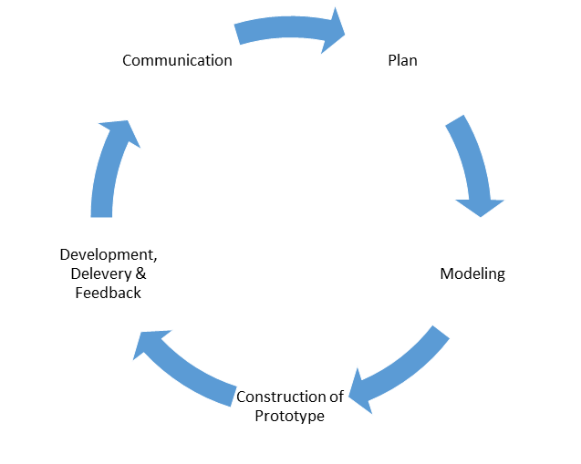
Organizational Structure 2.2

Figure 2.2 is a visual representation of the Team Retro Fix group organizational chart.

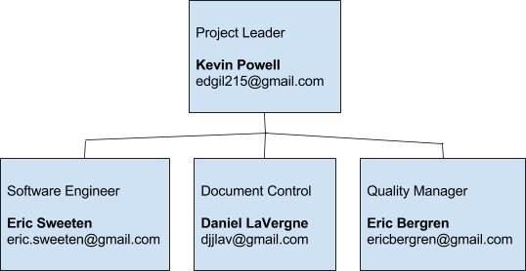
2.12 Organizational Boundaries and Interfaces
The Team Retro Fix project leader is Mr. Kevin Powell. He is responsible for supervising the project and ensuring the team makes all deadlines. It is also his responsibility to delegate tasks to the other team members. Mr. Eric Sweeten is the software engineer. He will be responsible for designing the Retro Fix Inventory Manager. Mr. Daniel LaVergne is the Document Controller. His responsibilities include checking all of the documents for inaccuracies before they are turned in and correcting them. Mr. Eric Bergren is the Quality Manager. His responsibilities include checking all documents and products and ensuring their quality.

2.13 Project Responsibilities
Table 2.4 lists the project responsibilities of roles.
Table 2.4: Project Responsibilities
Role | Individual | Role Description
Project Leader | Kevin Powell | - Performs overall supervision of the project  - Validates configuration management practices  - Maintains project plan  - Delegates requirements gathering  - Member of the software development group
Software Engineer | Eric Sweeten | - Software design and coding  - Member of the software development group  - Primary software developer
Quality Manager | Eric Bergren | - Design tests cases  - Executes tests  - Maintains fault/bug reports  - Member of the software development team
Document Control | Daniel LaVergne | - Oversees and maintains documentation  - Takes meeting documentation  - Member of the software development group

3 Managerial Process

3.1 Management Objectives and Priorities
It is the goal of Team Retro Fix to design a program, Retro Fix Inventory Manager, that will easily and conveniently manage the inventory for the client. The management goals are to set and meet all deadlines and maintain a high level of communication with the client so as to satisfy their requirements as well as get feedback for future versions of the software.

3.2 Assumptions, Dependencies, Constraints

3.2.1 Assumptions
- The user has a computer that is capable of running a Java application.
- The user will either have Java installed or be able to download Java for their computer.
- The user has basic computer skills to navigate a GUI and a Java application.
3.2.2 Dependencies
- There will be one programmer available to maintain the programmer after the final moderate version is delivered to the customer.
- Java will continue to be supported and maintained by Oracle.
3.2.3 Constraints
- Team Retro Fix has about a three month window to get the moderate version up and running and ready to be delivered to the customer, along with all appropriate documentation.
- Team Retro Fix only has four members total to work on the project.

3.3 Risk Management
Risk #1: CRR - Inadequate training
Risk #2: CRR - Technical support issues
Risk #3: TR - Overall security - Not just the password being hacked, but the operating system being hijacked by malware and information being otherwise retrieved, including inventory information from the database.
Risk #4: PR - Undetected problems
Risk #5: RCD - Data integrity - database may become corrupt due to bad hard drive or other issue
Risk #6: TR - Password hacked
Risk #7: TR - Change of OS - If customer changes to an operating system that does not support Java, the application will be unusable.
Risk #8: TR - Multi-platform issues - Layout managers are used with the Java app to account for multi-platforms, but even then the sizes of certain components are not always known and the way GUI components look on various operating systems are not always known.
Risk #9: SSE - Demand of more/better features - If the customer demands more features or an improvement on current features, the experience of the team members might not be adequate to satisfy the demands.
Risk #10: PSR - Application is too small and lacks features.
Risk #11: PSR - Application is too large, causing very high cost and development time.
Risk #12: PR - Changes to application beyond first version given to customer may cause confusion.
Risk #13: BI - Other software introduced to customer from competitors
Risk #14: DE - Java may not be supported by customer’s computer

Table 3.3.2: Risk Estimation/Projection
No. | Risk | Category | Probability | Impact
1 | Inadequate training | CRR | 1 | 3
2 | Technical support issues | CRR | 1 | 2
3 | Overall security | TR | 1 | 4
4 | Undetected problems | PR | 1 | 2
5 | Data integrity | RCD | 1 | 4
6 | Password hacked | TR | 1 | 3
7 | Change of OS | TR | 1 | 4
8 | Multi-platform issues | TR | 2 | 2
9 | Demand of more/better features | SSE | 2 | 2
10 | Application too small | PSR | 2 | 2
11 | Application too large | PSR | 1 | 1
12 | Changes lead to confusion | PR | 1 | 1
13 | Competitor software introduced | BI | 3 | 4
14 | Java not supported | DE | 1 | 2

Table 3.3.3: Risk Evaluation
No. | Risk | Category | Probability | Impact | Priority
13 | Competitor software introduced | BI | 3 | 4 | 12
3 | Overall security | TR | 1 | 4 | 4
5 | Data integrity | RCD | 1 | 4 | 4
7 | Change of OS | TR | 1 | 4 | 4
8 | Multi-platform issues | TR | 2 | 2 | 4
9 | Demand of more/better features | SSE | 2 | 2 | 4
10 | Application too small | PSR | 2 | 2 | 4
1 | Inadequate training | CRR | 1 | 3 | 3
6 | Password hacked | TR | 1 | 3 | 3
2 | Technical support issues | CRR | 1 | 2 | 2
4 | Undetected problems | PR | 1 | 2 | 2
14 | Java not supported | DE | 1 | 2 | 2
11 | Application too large | PSR | 1 | 1 | 1
12 | Changes lead to confusion | PR | 1 | 1 | 1

3.3.4 Risk Aversion Options

Risk #1: CRR - Inadequate training

- Risk aversion option - Ensure the customer is properly trained on the basics of navigating the GUI of a modern computer operating system and a Java application, and basic file operations.
- Risk monitoring procedures - After the customer receives the product, follow-up with them to see if they’re successful in using it.
- Risk mitigation - If it turns out to be the case the customer is unfamiliar with the basics of how to navigate a modern operating system and Java application, we would recommend YouTube videos to show him how as well as other resources in the community he can utilize.

Risk #2: CRR - Technical support issues

- Risk aversion options - Technical support issues basically encompasses technical features of the program the customer is confused on how to use. To ensure this doesn’t happen, Team Retro Fix will include a help menu in the application itself.
- Risk monitoring procedures - Just like with the “inadequate training” risk above, we will follow up with the customer to see if they’re successful in using the application. If they are having technical support issues, the answer would be no.
- Risk mitigation - Team Retro Fix would ensure the customer is familiar with the help menu available in the application, which will explain in detail the ins and outs of Retro Fix Inventory Manager.

Risk #3: TR - Overall security - Not just the password being hacked, but the operating system being hijacked by malware and information being otherwise retrieved, including inventory information from the database.

- Risk aversion options - There are two ways to write files in Java Team Retro Fix is aware of - through regular, readable printing as well as unreadable binary files. Team Retro Fix will use binary files to ensure they are unable to be read by non-authorized users, so only those who log on to the application with the required password may access the information within them.
- Risk monitoring procedures - We can only ensure we use appropriate anti-malware software on our end as we test the application.
- Risk mitigation - Team Retro Fix will ensure the customer uses anti-malware software while using Retro Fix Inventory Manager.

Risk #4: PR - Undetected problems

- Risk aversion options - Team Retro Fix software developer Eric Sweeten will spend a lot of time ensuring Retro Fix Inventory Manager is bug free and runs smoothly without flaw.
- Risk monitoring procedures - Retro Fix Inventory Manager will be rigorously tested by not only the software developer, but all team members of Team Retro Fix, before being given to the customer.
- Risk mitigation - If there turns out to be a bug in the program, the software developer will be notified and the bug will be corrected as quickly and efficiently as possible, with an upgraded version of the application handed back to the customer.

Risk #5: RCD - Data integrity - database may become corrupt due to bad hard drive or other issue

- Risk aversion options - Ensure the computers Retro Fix Inventory Manager are run on are not too old, especially their hard drives, to prevent a corruption in the hard disk. Also ensure enough memory is available to save files.
- Risk monitoring procedures - If there is an error with saving a file, or a database file does not load, then there is a problem.
- Risk mitigation - Ensure there is enough memory available on the hard disk, or whatever disk you are loading from. Ensure you have read/write privileges to that disk.

Risk #6: TR - Password hacked

- Risk aversion options - Java has a GUI component for a password field, showing asterisks instead of the password as a password is being types in. This will be used so no one can oversee the password as it’s being typed in.
- Risk monitoring procedures - If the database has values that has been changed since the customer’s last login, you know someone may have got ahold of the password and made unauthorized changes to the database.
- Risk mitigation - If the password becomes hacked, it must immediately be changed.

Risk #7: TR - Change of OS - If customer changes to an operating system that does not support Java, the application will be unusable.

- Risk aversion options - The customer should never change to an operating system that does not support Java. Most operating systems do, so this should be an easy aversion.
- Risk monitoring procedures - If Java states it is unsupported by your operating system, then you will know at that point you cannot run Retro Fix Inventory Manager on your computer until you change operating systems.
- Risk mitigation - You may change operating systems or perhaps get a virtual operating system that can run Retro Fix Inventory Manager.

Risk #8: TR - Multi-platform issues - Layout managers are used with the Java app to account for multi-platforms, but even then the sizes of certain components are not always known and the way GUI components look on various operating systems are not always known.

- Risk aversion options - Retro Fix Inventory Manager can be tested on multiple platforms to ensure the GUI components align neatly. This will depend on the operating systems used by the various group members.
- Risk monitoring procedures - Once the application is ran on an operating system other than Windows 10, and it’s reported to be slightly off in the arrangement of its GUI components, then we will know there’s an issue.
- Risk mitigation - This can be counteracted by repositioning the GUI components that are off alignment.

Risk #9: SSE - Demand of more/better features - If the customer demands more features or an improvement on current features, the experience of the team members might not be adequate to satisfy the demands.

- Risk aversion options - Team Retro Fix will make Retro Fix Inventory Manager simple, user-friendly, and efficient to achieve the desired goal of maintaining a basic inventory system for Retro Fix Video Games.
- Risk monitoring procedures - If the customer requests features to be improved upon, the team members of Team Retro Fix will see if their experience and skill level can satisfy the request
- Risk mitigation - Application features can be improved upon.

Risk #10: PSR - Application is too small and lacks features.

- Risk aversion options - Our prototype and moderate versions are pretty set in what we plan to implement with them, so this risk is mainly with the customer and if they feel the application is too small and lacks features.
- Risk monitoring procedures - Team Retro Fix will ask the customer what he thinks of the application, and if the customer requests additional features, we will know the application lacked desired features.
- Risk mitigation - Desired features can be added to the application.

Risk #11: PSR - Application is too large, causing very high cost and development time.

- Risk aversion options - Team Retro Fix will make the program as simple and efficient as what was requested the application be able to do. Any more complexity may lead to this risk.
- Risk monitoring procedures - If the customer complains the application is unnecessarily complex, Team Retro Fix will know they should have made it simpler.
- Risk mitigation - Improve upon Retro Fix Inventory Manager to make it even simpler than it already is, if that is even possible.

Risk #12: PR - Changes to application beyond first version given to customer may cause confusion.

- Risk aversion options - Do not make any versions past the first version we give the customer unless additional features or modifications are requested.
- Risk monitoring procedures - If the customer states they are confused, we will know we need to clarify the help section or make something otherwise more clear.
- Risk mitigation - Make a simplified prototype version of the application with a more thorough help menu and simpler interface

Risk #13: BI - Other software introduced to customer from competitors

- Risk aversion options - Offer our product for a deal the customer cannot refuse, in order to deter them from seeking software from elsewhere
- Risk monitoring procedures - If the customer tells us he is not satisfied with our application or otherwise tells us he is considering getting a similar app from somewhere else
- Risk mitigation - If at all possible, offer the application at an even lowered cost or promise additional features in a newer version.

Risk #14: DE - Java may not be supported by customer’s computer

- Risk aversion options - Ensure the customer’s computer supports Java
- Risk monitoring procedures - If the customer tells us Java is not supported by his computer, we will know he needs to get Java because it’s probably not installed and just needs an installation.
- Risk mitigation - Install Java on the customer’s computer. We will explain to the customer how to do it, and if he is unable to, we will assist him in person.

3.4 Monitoring and Controlling Mechanisms

3.4.1 Risk Monitoring Procedures
- These risk monitoring procedures will be applied to each and every one of the monitored risks that fall above the line as outlined for the risk evaluation table.
- Continual evaluation and monitoring of all the systems and their processes.
- Higher risks will take precedence over lower ones and the risks will be handled individually on a risk by risk basis.
- Continuous interaction with the client, any and all significant changes that need to be made must require client approval.

3.4.2 Contingency Plan
If any of the higher precedence risk occur then the following steps will take place. This procedure will be followed for any of the monitored risks that are provided above the line.
- The user will interact with the development team about the issues that arise. The issues will be taken note of and then alerting of any recurring instances shall be done efficiently.
- If there is an overall security breach then all of the usernames and passwords will be erased and reassigned.
- All relevant records should be set to be blocked for a specific period of time. Backup records can include documents and records on paper. There should also be an emergency back up hard drive in place of power failure or other disabling issues.
- If there are any software compatibility issues they will be addressed appropriately in a worst case scenario. A functional stand-alone application will be available for substitution in the event of a malfunction.
These risk aversion tactics and methods should be enough to suffice in preventing the risks from occurring.

3.5 Staffing Plan
There are four people total who will be working on this project, including Eric Bergren, Daniel LaVergne, Kevin Powell, and Eric Sweeten. The required skill levels include basic computer knowledge including that of word processing documents, and basic programming skills in Java as well. All personnel were obtained in the group formation at the start of the CSC 480A class. All of the personnel came into the project with all the required skill sets necessary, therefore no additional training was required. Each individual member of the group has their own tasks and responsibilities to provide to the group. Each member of the group possesses the necessary skills to meet online in a video chat and work on documentation collaboratively in a Google docs environment. Kevin Powell is the Project Leader, Eric Sweeten is the primary Software Engineer, Daniel LaVergne is in charge of Document Control, Eric Bergren is the overall Quality Manager. Each member of the team will be expected to contribute equally to the generation and completion of each piece of documentation as well as their individually assigned roles. At the end of the project, only one person will be necessary to maintain the final program, Retro Fix Inventory Manager. The person that will be assigned to the maintenance of the software program will be the software developer, Eric Sweeten.
4 Technical Process

All Retro Fix team members will be using the same tools and methods for document creation and software development. All document creation and maintenance will be done through Google Docs for the sake of real time collaboration and Microsoft Office as well. All software development for the program will be done using the Java programming language.

4.1 Methods, Tools, and Techniques
In order to build, test, integrate, document, deliver, modify, and maintain the project deliverables, Microsoft Office and Google Docs will be used for all word processing requirements. Microsoft Project will also be utilized for the creation of Gantt charts and any appropriate diagrams to be included in the documentation. For all programming requirements, a Java development environment and compiler will be used.

4.2 Software Documentation
The software documentation will include the Operational Concept Document (OCD), Software Requirements Specification (SRS), Software Design Document (SDD), Software Test Plan (STP), and Software User’s Manual (SUM). All documents will be produced using both Google Docs and Microsoft Word.

4.2.1 Operational Concept Document
The OCD provides the conceptual design for Retro Fix Inventory Manager and provides and overview of its features and functionality.

4.2.2 Software Project Management Plan
The Software Project Management Plan is a continually managed source document that is utilized for the development of Retro Fix Inventory Manager. This particular document defines the operational functionality of Retro Fix Inventory Manager, its scope and capabilities. The document provides a list of deliverable features and products for Retro Fix Inventory Manager as well as identifying Team Retro Fix’s proposed development plan.

4.2.3 Software Requirements Specification
The STS contains details about product perspective, product functions, product constraints, and user characteristics.

4.2.4 Software Design Document
The Software Design Document is an overall representation of the Retro Fix Inventory Manager. This document will contain information specifically related to the architecture of the program.

4.2.5 Software Test Plan
The STP will contain information about all testing processing throughout the development of Retro Fix Inventory Manager. It will show the testing techniques, requirements, and personnel responsible for each task during testing.
4.2.6 Software User’s Manual
The SUM will provide help to all users of Retro Fix Inventory Manager on how to operate the program. It will also identify hardware and software requirements to run the program.

4.3 Project Support Functions
There are key umbrella activities that are involved with project support functions. One is software project management, as well as formal technical reviews. This also is made up of software quality assurance, software configuration management, and work product preparation and production. There is also consideration for reusability management, measurement, and risk management. This also includes the formally developed plans for configuration management, software quality assurance, or verification and validation will not be able to be established due to time constraints. There are some informal methods that are described in this section for this project.

4.3.1 Configuration Management
Configuration Management will be accomplished through identification of all the software configuration items. One member of Team Retro Fix shall assume the responsibility and duties of maintaining the configuration list. All of the items will be submitted to the team member that is maintaining the configuration list with the intention to maintain a base line copy and then distribute a working copy to the developers. Each and every time and item is appended or modified the version number will be incremented. When the item is returned to the team member maintaining the configuration list it will be updated and the new version will then be distributed to all of the developers.

4.3.2 Software Quality Assurance
Software Quality Assurance methods and principles will consist of regular peer reviews as well as consultations with user representatives. All members of Team Retro Fix will help with the development of all the deliverable documentation together collaboratively. Throughout the development phases all the members of Team Retro Fix will finish code reviews as they are distributed for new items.

5 Work Packages, Schedule, and Budget

5.1 Work Packages
Work Packages can be divided into three separate functional areas of Software Engineering, Software Implementation, and Software Quality. The software engineering has the requirement of all of the necessary engineering research, designing and planning effort as well as all of the documentation that is required in order to support it. Software Implementation is involved with modules of programming as well as software integration. Software Quality is composed of all of the testing and refining of the design and documentation of the development

Figure 5.1 Retro Fix Inventory Manager V1.0 Work Breakdown Structure

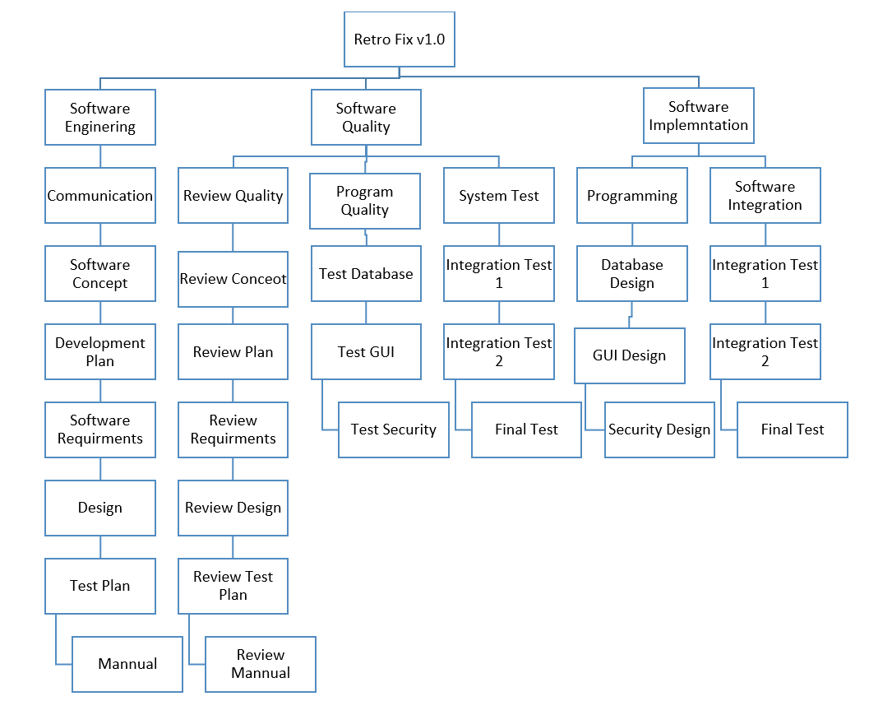

5.2 Depenencies

Figure 5.2 Identifies the dependencies of the work packages.
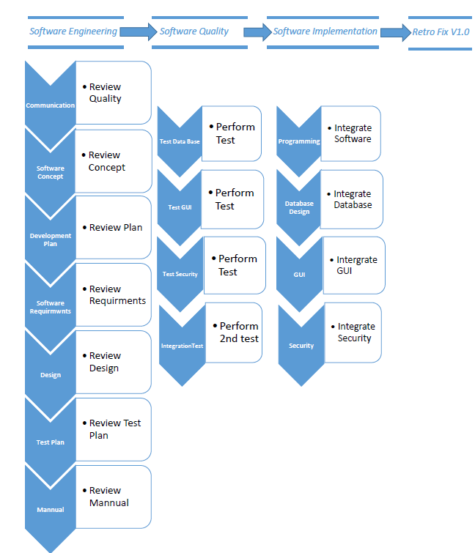

5.3 Resource Requirements
The resources required to complete the project is primarily a total compilation of man hours of computer time provided by all members of Team Retro Fix. Each member of the team will utilize their own computers in order to contribute individually to the project. The software that will be utilized throughout the project are web browsers, Microsoft Word, a Java development environment and compiler, and Microsoft Project. The hardware requirements for the creation and documentation of the project will be met by the members with their own personal computers. There is also hardware that is required at the Retro Fix Video Games store and its owner Rudy Treadwell. The office that each member of Team Retro Fix will occupy is the space in which their personal computer is set up. The only travel that is required will be made by team member Eric Sweeten who knows the owner of the store Rudy Treadwell as a personal contact. The rest of the interaction between members of Team Retro Fix will take place solely online due to the fact that everyone lives in different cities of the United States. The maintenance that is required for the project includes basic maintenance of the Retro Fix Inventory Manager program. If any issues arise a Team Retro Fix member can address the problem with a fix or slightly newer version of the program. The most likely team member to take care of this maintenance would be Team Retro Fix member Eric Sweeten, who is the lead software developer for the project program.

Table 5.3: Resource Requirements Budget part 1
Area | Task | # Persons | Personnel | Computer Time
Software Engineering
 | Research | 2 | Software Engineer | 8
 | Operational Concept | 4 | Software Engineer | 10
 | Development Plan | 4 | Software Engineer | 6
 | Software Requirements | 2 | Software Engineer | 6
 | Software Design | 2 | Software Engineer | 20
 | Test Plan | 2 | Test Engineer | 5
 | Software Manual | 2 | Technical Writer | 4
Software Implementation
 | Database Design | 2 | Database Designer | 6
 | Graphical User Interface | 2 | Graphics Designer | 6
 | Security Design | 2 | Programmer | 2
 | Interface Modules | 2 | Programmer | 4
Quality/Test Program
 | Refine Concept | 1 | Software Engineer | 2
 | Refine Plan | 1 | Software Engineer | 3
 | Finalize Requirements | 1 | Software Engineer | 5
 | Refine Design | 1 | Software Engineer | 8
 | Refine Test Plan | 1 | Program Manager | 5
 | Refine Manual | 1 | Technical Writer | 2
Unit Quality
 | Database Testing | 1 | Test Engineer | 5
 | GUI Test | 1 | Test Engineer | 5
 | Security Test | 1 | Test Engineer | 2
 | Interface Test | 1 | Test Engineer | 5
System Quality
 | RFIM Integration Test | 1 | Test Engineer | 6
Table 5.3.1: Resource Requirements Budget part 2
Area | Support Software | Computer Hardware | Facilities | Travel
Software Engineering
 | Office Tools | Standard Office Computer | Office | None
 | Modeling Tools | Standard Office Computer | Office | None
Software Implementation
 | Database Program | Standard Office Computer | Office | None
 | Graphics Program | Standard Office Computer | Office | None
 | Development Software | Standard Office Computer | Office | None
Software Integration
 | Development Software | Standard Office Computer | Office | None
Quality/Test Program
Engineering Quality
 | Office Tools | Standard Office Computer | Office | None
 | Modeling Tools | Standard Office Computer | Office | None
Unit Quality
 | Development Software | Standard Office Computer | Office | None
System Quality
 | Development Software | Standard Office Computer | Office | None

5.4 Budget and Resource Allocation
The budget and resources required can best be represented in a table. Table 5.4 defines and projects the planned budget allocation throughout the project. These values will be updated accordingly as more precise figures are found during the development of the project.

Table 5.4 Budget.
Task | Cumulative Time | Earned Value
Research | 8 | $720
Operational Concept | 18 | $1620
Development Plan | 24 | $2160
Software Requirements | 30 | $2700
Software Design | 50 | $4500
Test Plan | 55 | $4950
Software Manual | 59 | $5310
Database Design | 65 | $5850
Graphical User Interface | 71 | $6390
Security Design | 73 | $6570
Interface Modules | 77 | $6930
Refine Concept | 79 | $7110
Refine Plan | 82 | $7380
Finalize Requirements | 87 | $7830
Refine Design | 95 | $8550
Refine Test Plan | 100 | $9000
Refine Manual | 102 | $9180
Database Testing | 107 | $9630
GUI Test | 112 | $10,080
Security Test | 114 | $10,260
Interface Test | 119 | $10,710
RFIM Integration Test | 125 | $11,250

Figure 5.4 Earned Value Management.
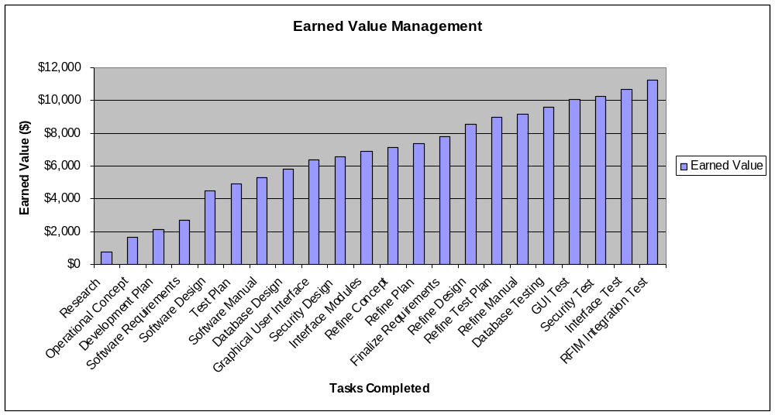

5.5 Schedule
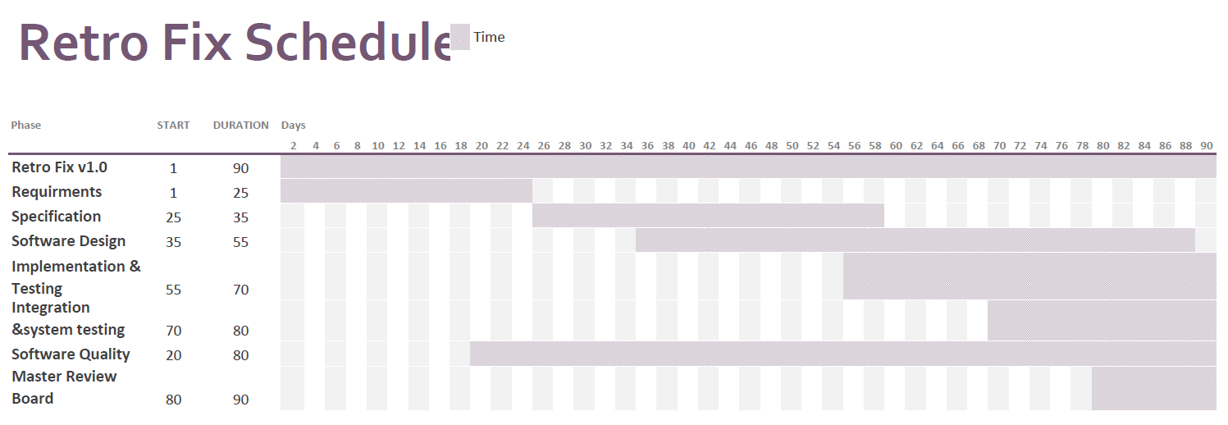

5.5.1 Requirements Phase
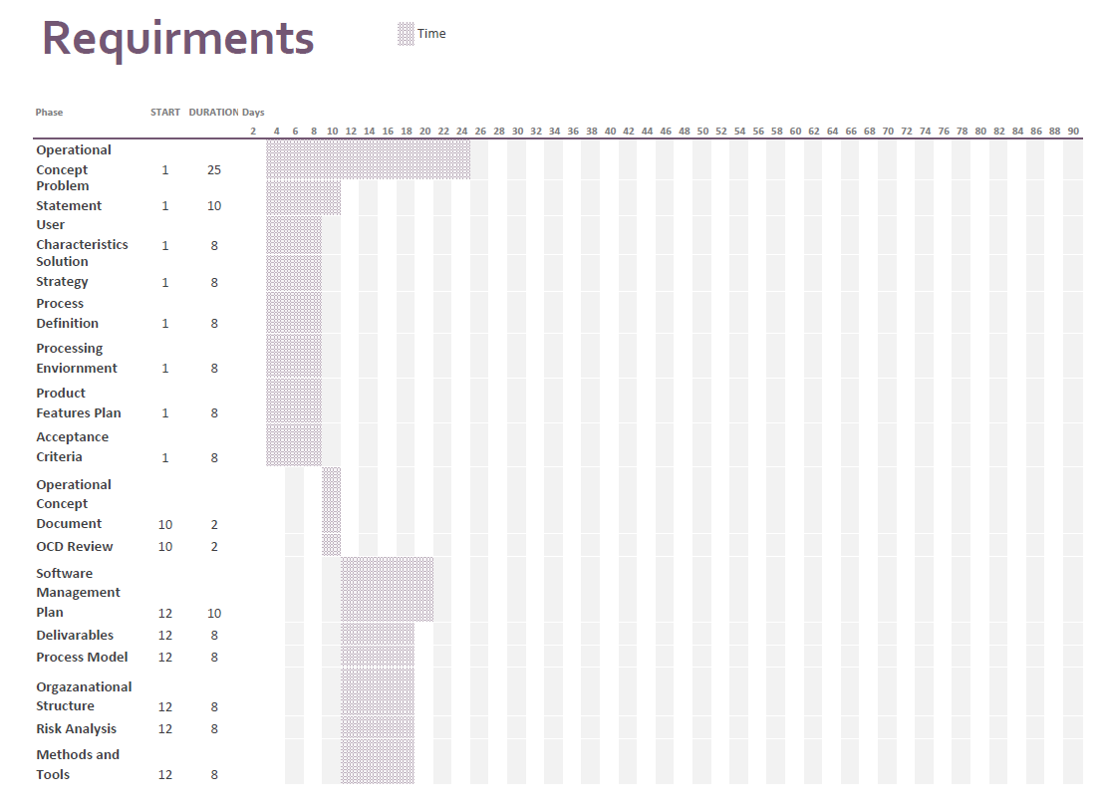

5.5.2 Specification Phase
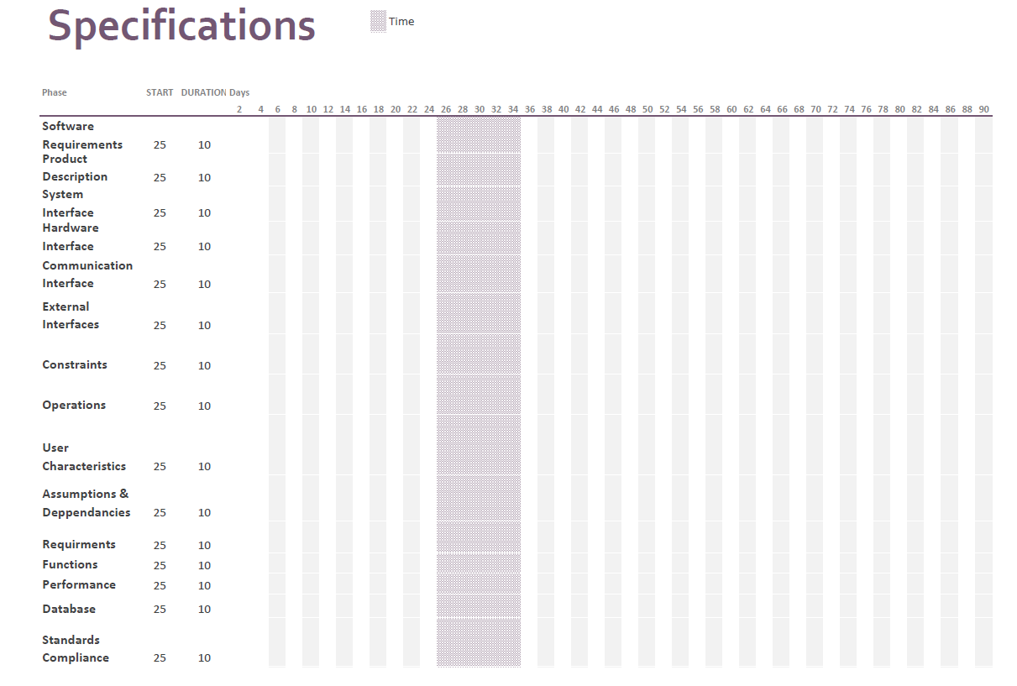

5.5.3 Software Design Phase
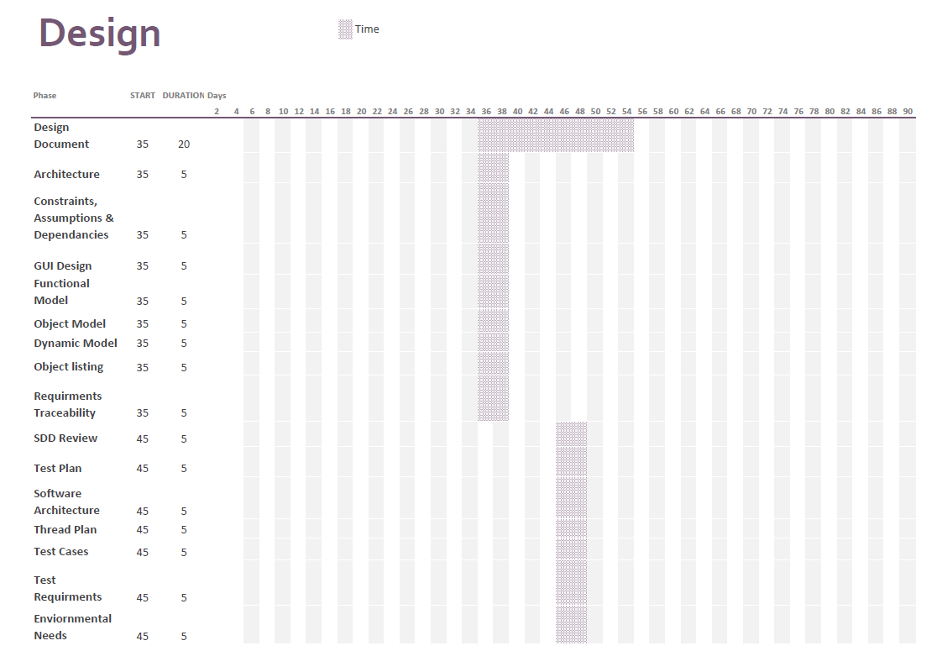

5.5.4 Unit Implementation & Testing Phase
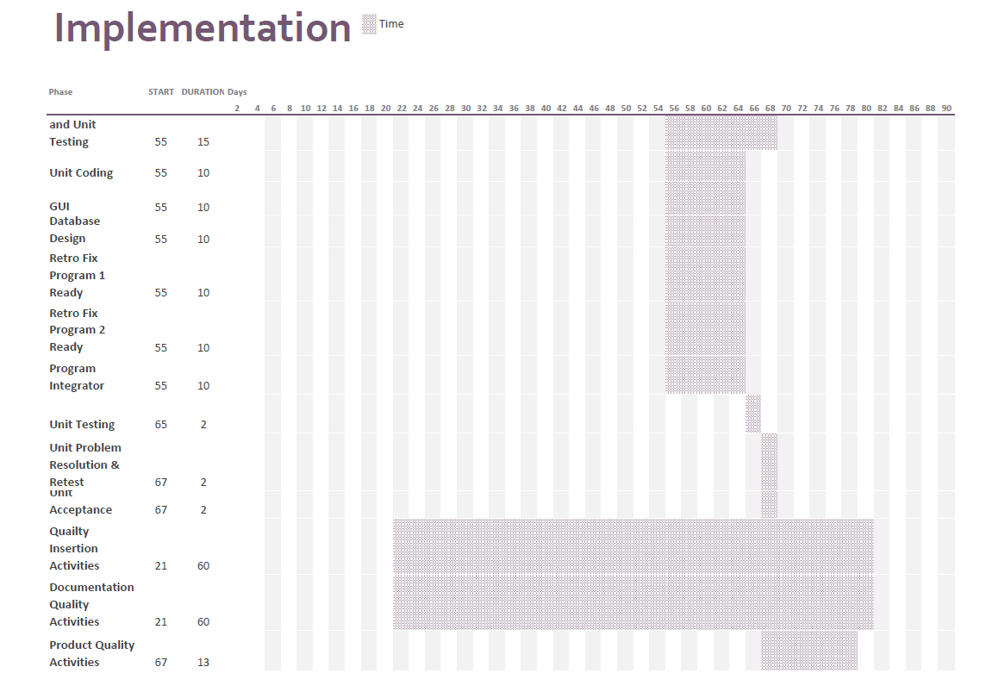

5.5.5 Integration & System Testing
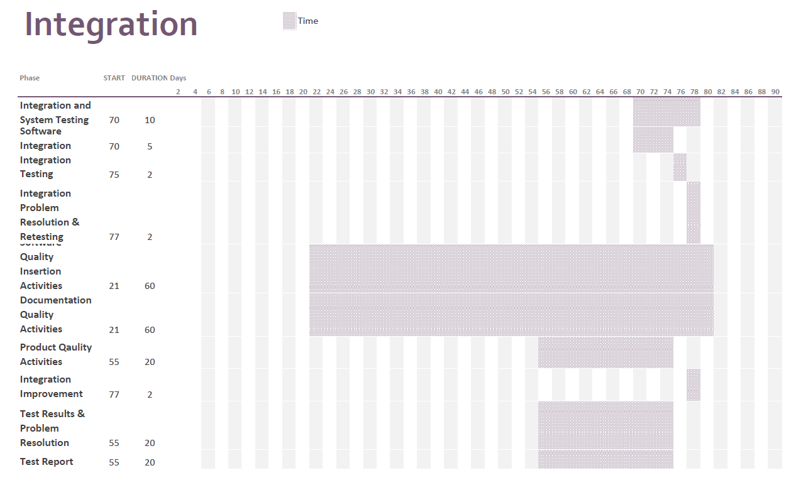

5.5.6 Software Quality & Master’s Review Board
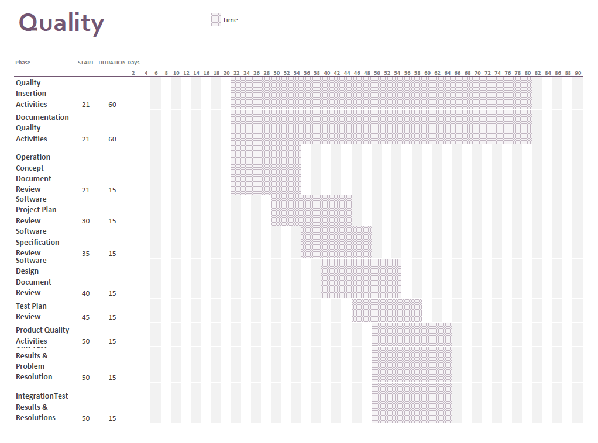

5.6 System Transition Plans
The owner of Retro Fix Video Games, Mr. Rudy Treadwell, will have an easy transition from his current system to the new software that is provided by Team Retro Fix in the form of the program that they will develop. Mr Treadwell will just need to install the new program, Retro Fix Inventory Manager onto his existing computer system in the store. Once the new system is in place he can enter all of his current inventory into the program by referencing the spreadsheets that he currently utilizes through Microsoft Excel. Once all of the relevant data is entered into the database of the Retro Fix Inventory Manager program it can be saved into a database file and accessed for use in the store’s daily operations. This transition will be quick and seamless and only requires a small amount of data entry in order to get the new database up to date with the current inventory of the store.

